Supplementary Figure 1
The schematic diagram showing the workflow in the paper.
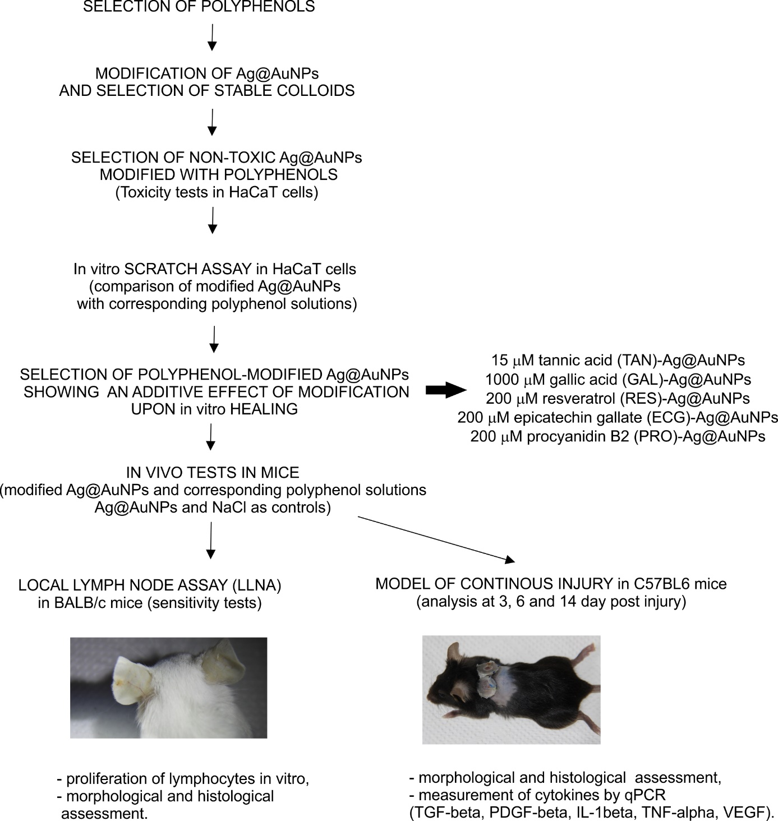

Supplementary Figure 2
General morphology of wounds after treatment with unmodified and polyphenol-modified Au@AgNPs. Representative microphotographs of hematoxylin-eosin stained wound sections at 6 and 14 day post injury. Modified and unmodified Au@AgNPs as well as solutions of polyphenols used for modification were applied at 5 µg/ml in saline. Magnification x 400.
Abbreviations: NPs – Au@AgNPs, ECG – epicatechin gallate modified, GAL- gallic acid modified, PRO – procyanidin B2 modified, RES – resveratrol modified, TAN – tannic acid modified.
