Ultrasound combined with core cross-linked nanosystem for enhancing penetration of Doxorubicin prodrug/beta-Lapachone into tumors
Qianyan Li ¹, Wei Hou ¹, Meixuan Li ¹, Hemin Ye ¹, Huanan Li^{*1} and Zhibiao Wang^{*1, 2}
¹ State Key Laboratory of Ultrasound in Medicine and Engineering, College of Biomedical Engineering, Chongqing Medical University, 1Yixueyuan Road, Yuzhong District, Chongqing, 400016, China.
² Chongqing Key Laboratory of Biomedical Engineering, Chongqing Medical University, 1Yixueyuan Road, Yuzhong District, Chongqing, 400016, China.
Correspondence: Huanan Li
State Key Laboratory of Ultrasound in Medicine and Engineering, College of Biomedical Engineering, Chongqing Medical University, Chongqing, 400016, China.
Tel +86 023 68485021
Fax +86 023 68485021
E-mail: 102733@ cqmu.edu.cn
Zhibiao Wang
State Key Laboratory of Ultrasound in Medicine and Engineering, College of Biomedical Engineering, Chongqing Medical University, Chongqing, 400016, China.
Chongqing Key Laboratory of Biomedical Engineering, Chongqing Medical University, Chongqing, 400016, China.
Tel +86 023 68485021
Fax +86 023 68485021
E-mail: wangzb@cqmu.edu.cn

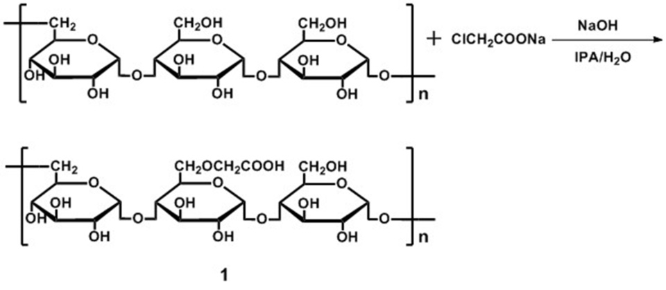
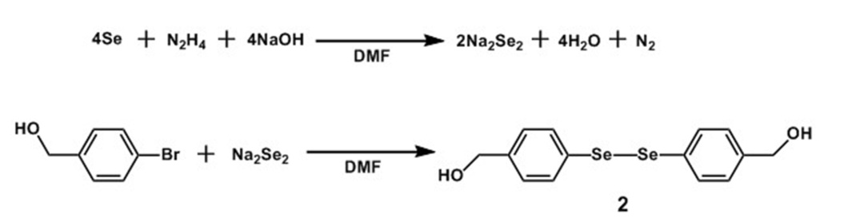
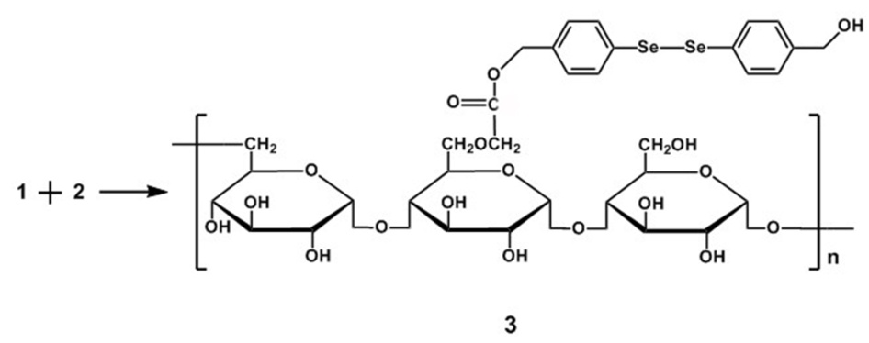
Scheme S1. Synthesis of Pu-HBSe

Scheme S2. The synthetic route for the ROS-responsive prodrug BDOX

Figure S1. The characterization of Pu-HBSe. a) ¹H NMR and b) FTIR spectrum of CMP, HBSe and Pu-HBSe.
Figure S2. ¹H NMR spectrum of compound (1), DOX and BDOX.
Figure S3. Size distribution of BDOX-NCS a), BDOX-CCS b) and β-Lapachone/BDOX-NCS c) measured by DLS (n=3).

Figure S4. Effect of concentrations on I1/I3 ratios of pyrene in aqueous non-cross-linked Pu-HBSe a) and cross-linked Pu-HBSe b) solution (n=6).

Table S1 IC₅₀ at different weight ratios of DOX/β-Lapachone (n=6)
Weight ratios of DOX/β-Lapachone | 1:0 | 8:2 | 6:4 | 5:5 | 4：6 | 2:8 | 0:1
IC₅₀ (HepG2: mg L⁻¹) | 1.853±0.32 | 0.097±0.12 | 0.138±0.17 | 0.167±0.18 | 0.189±0.21 | 0.439±0.34 | 1.512±0.34

Table S2 IC₅₀ of different formulations nanosized drug delivery system (n=6)
Samples | DOX·HCl | BDOX NCS | BDOX CCS | β-Lapachone/BDOX-NCS | β-Lapachone/BDOX-CCS
IC₅₀ (HepG2: mg L⁻¹) | 1.853±0.32 | 2.043±0.083 | 1.923±0.086 | 0.237±0.109 | 0.229±0.109

Figure S5. a) In vivo tumor tissues average radiant efficiency of different formulations in HpeG2 tumors. b) Quantitative biodistribution analysis of the free DOX and US + β-Lapachone/BDOX-CCS in mice by measuring the DOX ﬂuorescence intensity in the major organs and tumors at 24 h. Data are means ± SD of three independent experiments. **p<0.01.
Figure S6. 24 h, 48 h following intravenous injection, the excised tumors (about volume of 100 mm³) were developed into frost slices, and then the DOX fluorescence distribution in entire tumors was revealed by CLSM observation. Nuclei stained blue with DAPI.

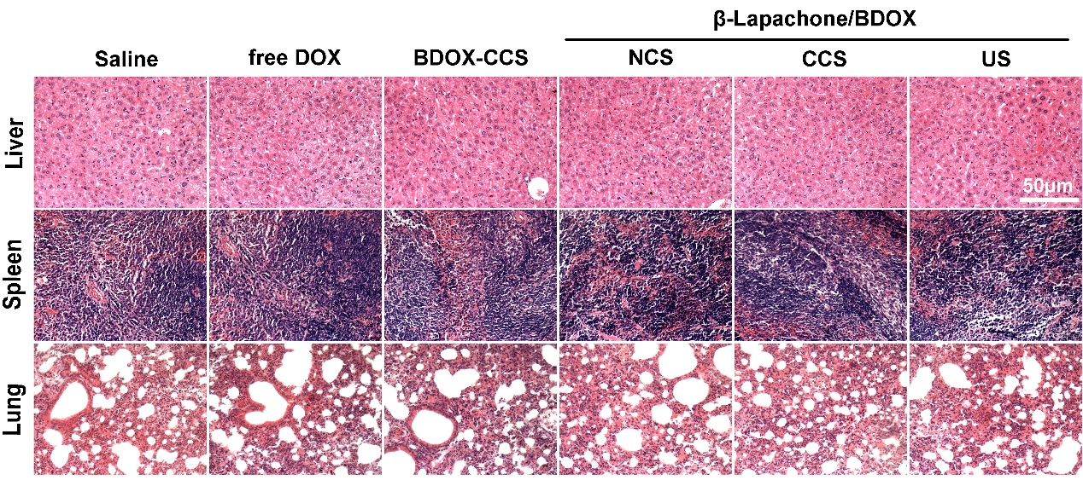
Figure S7. Hematoxylin and eosin (H&E) staining of Liver, Spleen and Lung.
Figure S8. Integrate optical density (IOD) of PCNA a) and TUNEL b) expression were calculated by Image-Pro Plus software from immunohistochemical images (n=6). **p<0.01.

