Supplementary materials
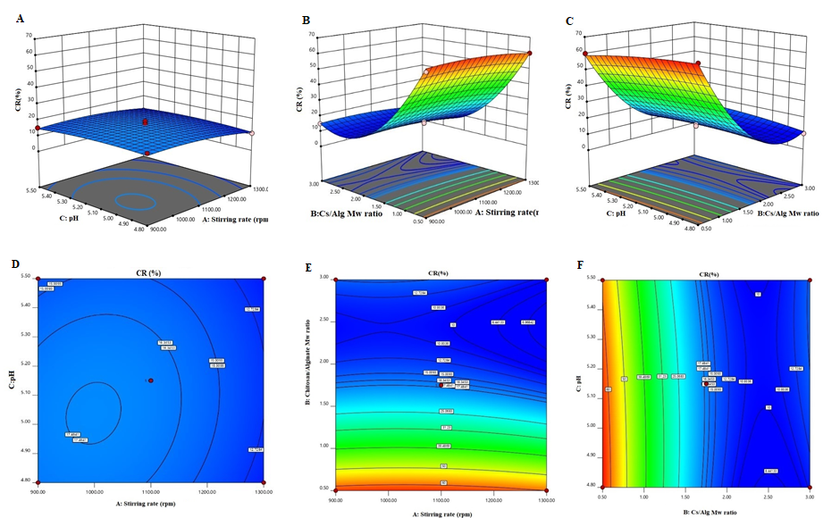
Supplementary Figure 1. 3D Response surface plots (A−C) and contour plots (D−F) for the mean CR (%) of Cs/Alg/B NPs. 3D and contour graphs are the preservative relative relationship between two variables on the CR (%) of Cs/Alg/B NPs. Contour plots show a three-dimensional surface on a two-dimensional plane. It graphs two predictor variables X Y on the y-axis and a response variable Z as contours. CR: cumulative release (%), Cs/Alg/B NPs: rhBMP-2 loaded chitosan/alginate nanoparticles.

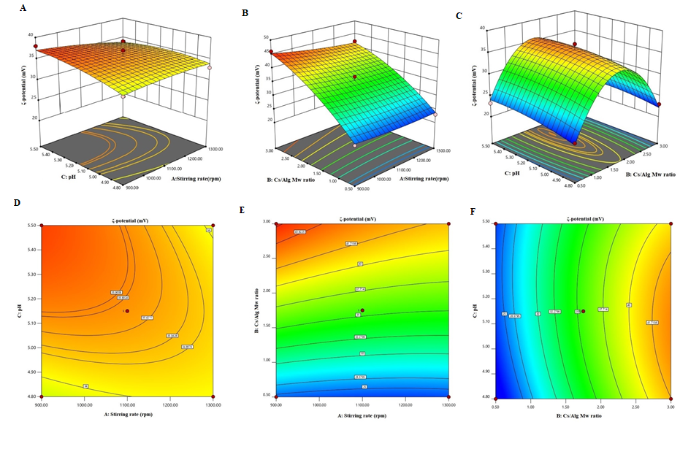
Supplementary Figure 2. 3D Response surface plots (A−C) and contour plots (D−F) for the mean ζ-potential of Cs/Alg/B NPs. 3D and contour graph are the preservative relative relationship between two variables on the ζ-potential of Cs/Alg/B NPs. Contour plots show a three-dimensional surface on a two-dimensional plane. It graphs two predictor variables X Y on the y-axis and a response variable Z as contours. Cs/Alg/B NPs: rhBMP-2 loaded chitosan/alginate nanoparticles.

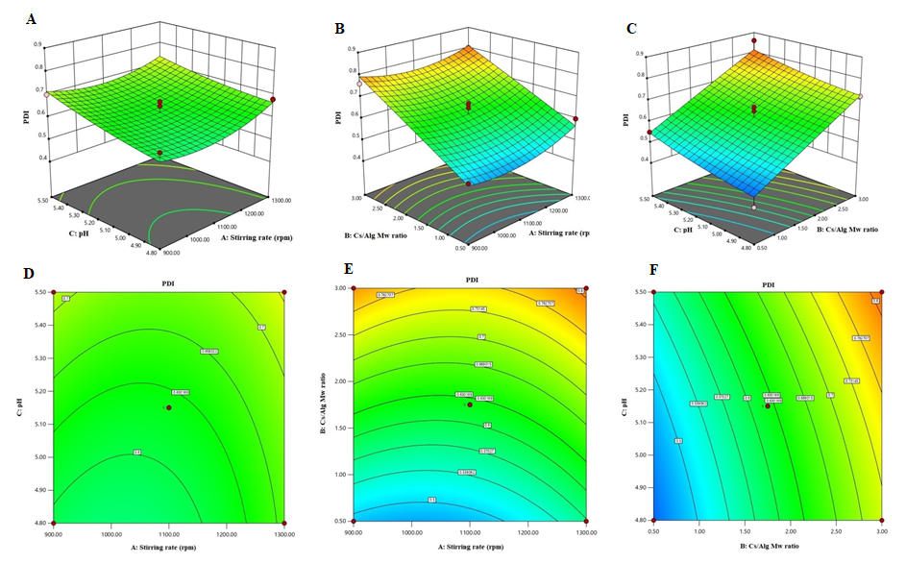
Supplementary Figure 3. 3D Response surface plots (A−C) and contour plots (D−F) for the mean PDI of Cs/Alg/B NPs. 3D and contour graphs are preservative relative relationships between two variables on the PDI of Cs/Alg/B NPs. Contour plots show a three-dimensional surface on a two-dimensional plane. It graphs two predictor variables X Y on the y-axis and a response variable Z as contours, PDI: polydispersity index, Cs/Alg/B NPs: rhBMP-2 loaded chitosan/alginate nanoparticles.

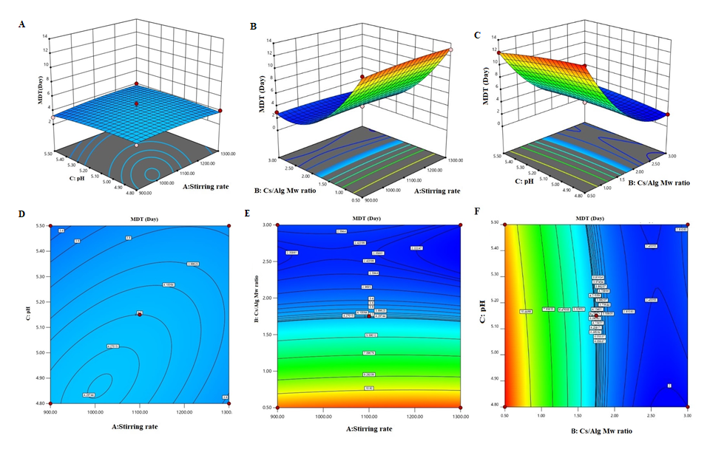
Supplementary Figure 4. 3D Response surface plots (A−C) and contour plots (D−F) for the mean MDT of Cs/Alg/B NPs. 3D and contour graphs are the preservative relative relationship between two variables on the MDT of Cs/Alg/B NPs. Contour plots show a three-dimensional surface on a two-dimensional plane. It graphs two predictor variables X Y on the y-axis and a response variable Z as contours. MDT: morphological degradation time, Cs/Alg/B NPs: rhBMP-2 loaded chitosan/alginate nanoparticles.

Supplementary Figure 5. Extra micrograph SEM images of optimized Cs/Alg/B NPs Cs/Alg Mw ratio =1, stirring rate =5, pH=5.3, Cs/Alg/B NPs: rhBMP-2 loaded chitosan/alginate nanoparticles.

