Table S1. Defining Characteristics of Debility in the SPIROMICS Cohort
Phenotypic Characteristic | Measure | Range | MCID | Units | Ref | Expected Normal Value | Criterion for being Disabled | Group Mean (SD) | Weight
Breathlessness | mMRC | 0-4 | 1 |  | ¹ | 0 | ≥3 | 1.02 (0.96) | -0.384
Self-reported aerobic capacity | VSAQ |  | 1 | (METs) | ² | >8 | <5 | 5.56 (2.89) | 0.381
Functional exercise capacity | 6MWD | 0-600 | 28 | (m) | ³ | 500 | <250 | 412.6 (121.4) | 0.259
Physical health status | SGRQ(a) | 0-60 | 4 |  | ⁴ | <20 | >60 | 43.4 (25.6) | -0.446
Disease specific health status | CAT | 0-40 | 1.6 |  | ⁵ | <10 | >20 | 13.3 (8.3) | -0.406
Fatigue | FACIT-F | 0-52 | 10 |  | ^{6,7} | >40 | <50 | 81.6 (19.3) | +0.386
General health status | SF-12(p) | 0-100 | 2.5 |  | ^{8,9} | >80 | <20 | 36.3 (15.3) | +0.356
We classified debility as those individuals with ≥4 disability criteria. MCID=minimum clinically important difference, mMRC=modified Medical Research Council scale for breathlessness, VSAQ=Veterans Specific Activity Questionnaire, METs=metabolic equivalents (oxygen uptake of 3.5 ml/kg/min), 6MWD=6-minute walking distance, SGRQ(a)=St George's Respiratory Questionnaire activity score, CATscore=COPD Assessment Test, FACIT-F=FACT Clinical Trials score, SF-12(p)=physical component of the Short Form 12 health status instrument. The weights are the coordinates of the first eigenvector from the principal component analysis, which we have called ‘disability score.’

References Used to Derive MCID and Criterion for being Disabled
1. Bestall JC, Paul EA, Garrod R, Garnham R, Jones PW, Wedzicha JA. Usefulness of the Medical Research Council (MRC) dyspnoea scale as a measure of disability in patients with chronic obstructive pulmonary disease. Thorax 1999;54:581-6.
2. Myers J, Do D, Herbert W, Ribisl P, Froelicher VF. A nomogram to predict exercise capacity from a specific activity questionnaire and clinical data. Am J Cardiol 1994;73:591-6.
3. Puhan MA, Chandra D, Mosenifar Z, et al. The minimal important difference of exercise tests in severe COPD. Eur Respir J 2011;37:784-90.
4. Jones PW. St. George's Respiratory Questionnaire: MCID. COPD 2005;2:75-9.
5. Kon SS, Canavan JL, Jones SE, et al. Minimum clinically important difference for the COPD Assessment Test: a prospective analysis. Lancet Respir Med 2014;2:195-203.
6. Nordin A, Taft C, Lundgren-Nilsson A, Dencker A. Minimal important differences for fatigue patient reported outcome measures-a systematic review. BMC Med Res Methodol 2016;16:62.
7. Cella D, Eton DT, Lai JS, Peterman AH, Merkel DE. Combining anchor and distribution-based methods to derive minimal clinically important differences on the Functional Assessment of Cancer Therapy (FACT) anemia and fatigue scales. J Pain Symptom Manage 2002;24:547-61.
8. Alonso J, Ferrer M, Gandek B, et al. Health-related quality of life associated with chronic conditions in eight countries: results from the International Quality of Life Assessment (IQOLA) Project. Qual Life Res 2004;13:283-98.
9. Alma H, de Jong C, Tsiligianni I, Sanderman R, Kocks J, van der Molen T. Clinically relevant differences in COPD health status: systematic review and triangulation. Eur Respir J 2018;52.
Table S2. Clinical Characteristics of Never Smokers and GOLD Stage 0 Subjects with and without Respiratory Disability
 | With Disability  (n= 41) | Without Disability  (n=828) | P-value
Age (years) | 55.7 (8.6) | 60.0 (9.9) | 0.006
Sex (n, % within category) |  |  | 0.032*
Men | 12 (29%) | 384 (46%)
Women | 29 (71%) | 444 (54%)
Race (% within category) |  |  | 0.040*
White | 22 (54%) | 571 (69%)
Non-white | 19 (46%) | 257 (31%)
BMI (kg/m²) | 31.6 (5.6) | 29.0 (5.0) | 0.001
FEV₁ (L) | 2.51 (0.62) | 2.80 (0.72) | 0.011
FEV₁ (% predicted) | 91.8 (15.0) | 97.5 (13.0) | 0.006
Exacerbation history (n, % within category) |  |  | 0.002
None in previous year | 35 (85%) | 795 (96%)
1 exacerbation | 3 (7%) | 22 (3%)
≥2 exacerbations | 3 (7%) | 11 (1%)
Air Trapping -856 HU (%) | 6.0 (6.1) | 7.8 (9.5) | 0.081
Emphysema <-950 HU (%) | 1.4 (2.5) | 1.6 (1.9) | 0.545
Pi10 Whole Tree (mm) | 3.72 (0.07) | 3.69 (0.08) | 0.087
Average Pi10 of 5 paths (mm) | 3.73 (0.08) | 3.70 (0.09) | 0.036
WBC (cells/mcL) | 7.5 (2.4) | 6.6 (2.0) | 0.004
CRP (mcg/mL) | 8.8 (7.5) | 5.7 (12.5) | 0.074
Fibrinogen (mg/mL) | 5.1 (1.1) | 5.1 (1.4) | 0.837
SERPINA1 (mg/mL) | 1.9 (0.3) | 1.9 (0.5) | 0.800
IL-8 (pg/mL) | 8.2 (4.9) | 8.6 (7.4) | 0.703
IL-6 (pg/mL) | 2.8 (4.5) | 4.2 (14.6) | 0.125
sRAGE (ng/mL) | 2.9 (3.0) | 3.4 (2.5) | 0.338
GDF-15 (ng/L) | 351 (117) | 343 (175) | 0.665

Values are Mean (SD)
Respiratory disability is defined as having ≥4 disabled characteristics (see methods). *Chi-squared tests showing significant associations between disability and both sex and race. BMI=body mass index, FEV₁=forced expiratory volume in one second, GOLD=Global Initiative for Obstructive Lung Disease, HU=Hounsfield Units, Pi10= square root of the wall area for a “theoretical airway” with an internal perimeter of 10 mm, WBC=white blood cell count, CRP=C-reactive protein, SERPINA1=serpin family A, member 1 gene, IL-8=interleukin 8, IL-6=interleukin 6, sRAGE=soluble receptor for advanced glycation end products, GDF-15= growth differentiation factor-15.

Table S3. Clinical Characteristics of GOLD Stages 1 and 2 Subjects with and without Respiratory Disability
 | With Disability  (n= 111) | Without Disability  (n=880) | P-value
Age (years) | 60.1 (9.0) | 66.2 (7.9) | <0.001
Sex (n, % within category) |  |  | <0.001*
Men | 47 (42%) | 529 (60%)
Women | 64 (58%) | 351 (40%)
Race (% within category) |  |  | <0.001*
White | 76 (68%) | 747 (85%)
Non-white | 35 (32%) | 133 (15%)
BMI (kg/m²) | 28.9 (6.5) | 27.6 (5.0) | 0.050
FEV₁ (L) | 1.91 (0.64) | 2.15 (0.66) | <0.001
FEV₁ (% predicted) | 68.2 (13.6) | 75.0 (15.8) | <0.001
Exacerbation history (n, % within category) |  |  | <0.001
None in previous year | 88 (79%) | 802 (91%)
1 exacerbation | 13 (12%) | 62 (7%)
≥2 exacerbations | 10 (9%) | 16 (2%)
Air Trapping -856 HU (%) | 20.7 (15.4) | 24.6 (15.7) | 0.015
Emphysema <-950 HU (%) | 5.1 (5.5) | 7.0 (7.4) | 0.001
Pi10 Whole Tree (mm) | 3.73 (0.09) | 3.70 (0.08) | <0.001
Average Pi10 of 5 paths (mm) | 3.75 (0.11) | 3.71 (0.10) | 0.001
WBC (cells/mcL) | 7.5 (2.4) | 7.1 (1.9) | 0.082
CRP (mcg/mL) | 9.5 (13.2) | 5.1 (8.0) | 0.015
Fibrinogen (mg/mL) | 5.5 (1.6) | 5.2 (1.4) | 0.208
SERPINA1 (mg/mL) | 2.0 (0.5) | 2.0 (0.5) | 0.978
IL-8 (pg/mL) | 11.6 (9.3) | 9.9 (14.3) | 0.195
IL-6 (pg/mL) | 3.9 (9.7) | 3.7 (15.7) | 0.868
sRAGE (ng/mL) | 2.8 (1.8) | 3.1 (2.3) | 0.219
GDF-15 (ng/L) | 384 (171) | 387 (179) | 0.878

Values are Mean (SD)

Respiratory disability is defined as having ≥4 disabled characteristics (see methods). *Chi-squared tests showing significant associations between disability and both sex and race. BMI=body mass index, FEV₁=forced expiratory volume in one second, GOLD=Global Initiative for Obstructive Lung Disease, HU=Hounsfield Units, Pi10= square root of the wall area for a “theoretical airway” with an internal perimeter of 10 mm, WBC=white blood cell count, CRP=C-reactive protein, SERPINA1=serpin family A, member 1 gene, IL-8=interleukin 8, IL-6=interleukin 6, sRAGE=soluble receptor for advanced glycation end products, GDF-15= growth differentiation factor-15.

Table S4. Clinical Characteristics of GOLD Stages 3 and 4 Subjects with and without Respiratory Disability
 | With Disability  (n= 163) | Without Disability  (n=390) | P-value
Age (years) | 62.3 (7.2) | 65.8 (7.4) | <0.001
Sex (n, % within category) |  |  | 0.808*
Men | 92 (56%) | 178 (58%)
Women | 71 (44%) | 131 (42%)
Race (% within category) |  |  | 0.419*
White | 129 (79%) | 254 (82%)
Non-white | 34 (21%) | 55 (18%)
BMI (kg/m²) | 26.4 (5.7) | 26.4 (7.8) | 0.959
FEV₁ (L) | 0.91 (0.32) | 1.09 (0.33) | <0.001
FEV₁ (% predicted) | 31.6 (9.3) | 38.4 (7.8) | <0.001
Exacerbation history (n, % within category) |  |  | <0.001
None in previous year | 104 (64%) | 255 (83%)
1 exacerbation | 31 (19%) | 41 (13%)
≥2 exacerbations | 28 (17%) | 13 (4%)
Air Trapping -856 HU (%) | 55.8 (15.7) | 50.0 (16.7) | <0.001
Emphysema <-950 HU (%) | 21.7 (12.4) | 18.9 (12.5) | 0.018
Pi10 Whole Tree (mm) | 3.73 (0.08) | 3.73 (0.08) | 0.973
Average Pi10 of 5 paths (mm) | 3.75 (0.11) | 3.75 (0.10) | 0.921
WBC (cells/mcL) | 7.8 (2.5) | 7.4 (2.2) | 0.181
CRP (mcg/mL) | 8.1 (7.5) | 7.2 (12.4) | 0.437
Fibrinogen (mg/mL) | 6.0 (1.6) | 5.5 (1.4) | 0.009
SERPINA1 (mg/mL) | 2.0 (0.7) | 1.9 (0.5) | 0.312
IL-8 (pg/mL) | 9.5 (7.8) | 9.3 (6.8) | 0.899
IL-6 (pg/mL) | 2.1 (7.4) | 4.2 (18.6) | 0.098
sRAGE (ng/mL) | 2.2 (2.0) | 2.6 (2.4) | 0.174
GDF-15 (ng/L) | 349 (153) | 380 (175) | 0.061

Values are Mean (SD)

Respiratory disability is defined as having ≥4 disabled characteristics (see methods). *Chi-squared tests showing significant associations between disability and both sex and race. BMI=body mass index, FEV₁=forced expiratory volume in one second, GOLD=Global Initiative for Obstructive Lung Disease, HU=Hounsfield Units, Pi10= square root of the wall area for a “theoretical airway” with an internal perimeter of 10 mm, WBC=white blood cell count, CRP=C-reactive protein, SERPINA1=serpin family A, member 1 gene, IL-8=interleukin 8, IL-6=interleukin 6, sRAGE=soluble receptor for advanced glycation end products, GDF-15= growth differentiation factor-15.

Table S5. Estimates of Model for Exacerbation Rate using Zero-Inflated Poisson Regression and Presence of ≥4 Disability Characteristics

Table S6. Estimates of Model for Exacerbation Rate using Zero-Inflated Poisson Regression and Respiratory Disability Score as a Continuous Variable

Figure S1. Study Participant Flow Diagram
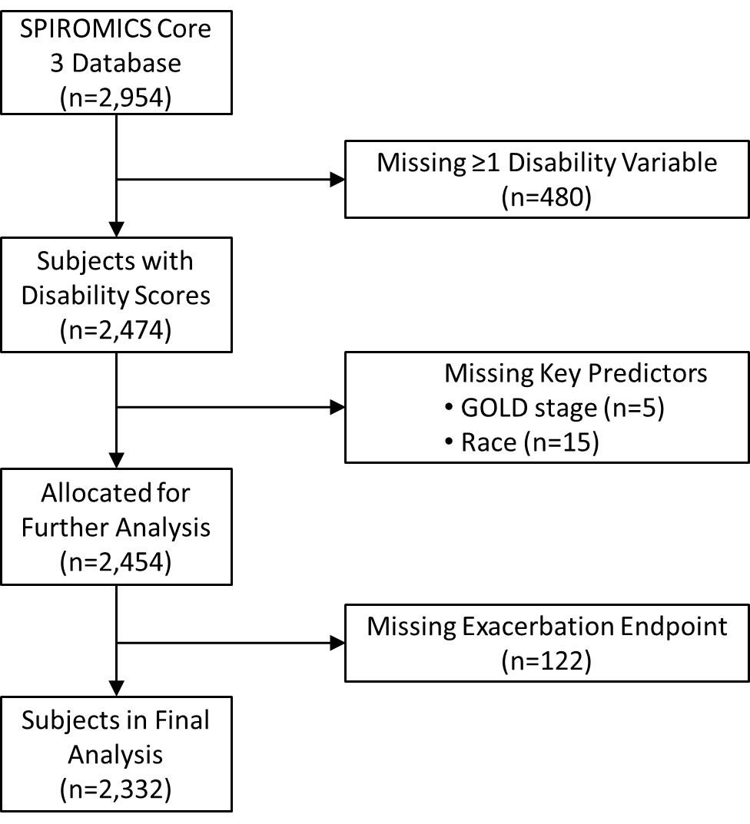

Figure S1. Study participant flow diagram showing reasons why some participants were excluded because of having missing data.

