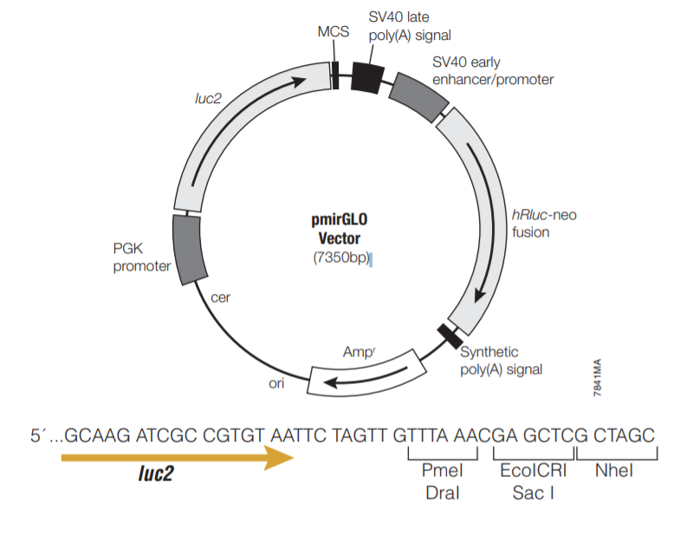
Figure S1: The illustration of luciferase vector construction,

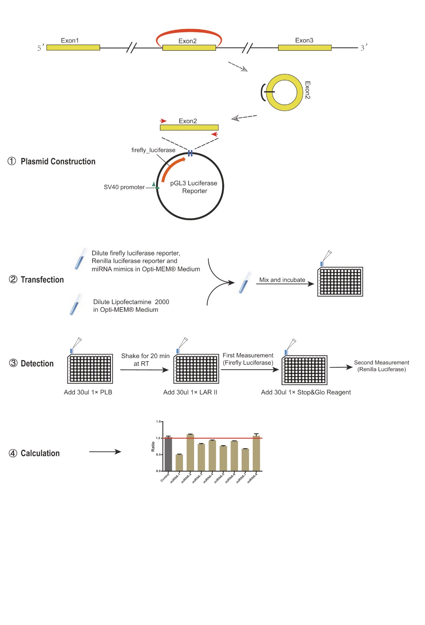
Figure S2: The schematic illustration of luciferase screening assay.

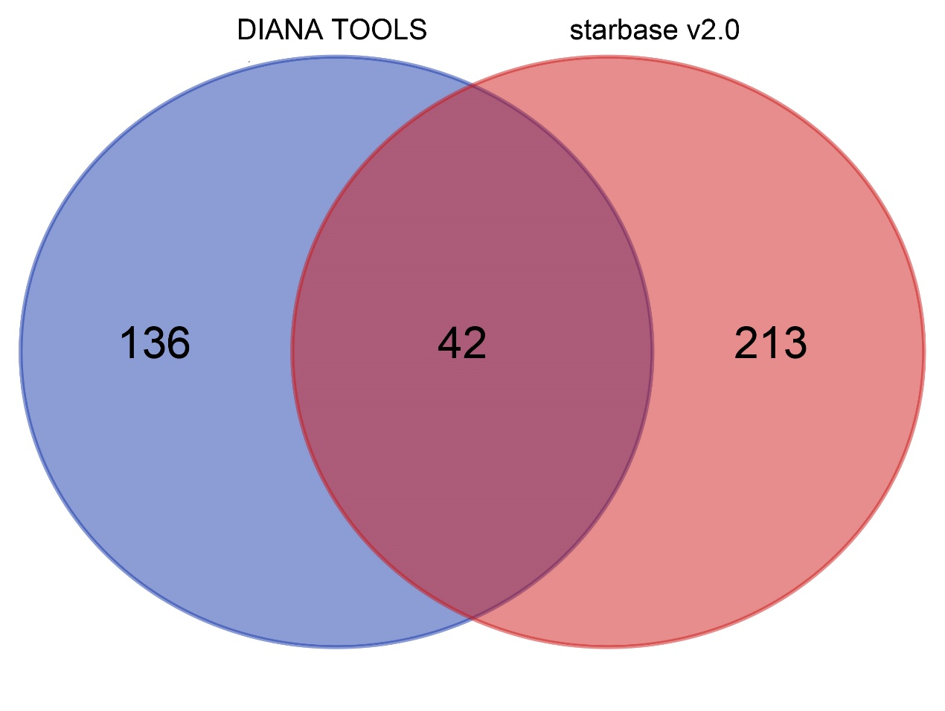
Figure S3: The Venn diagram of miRNAs predicted by two bioinformatics tools

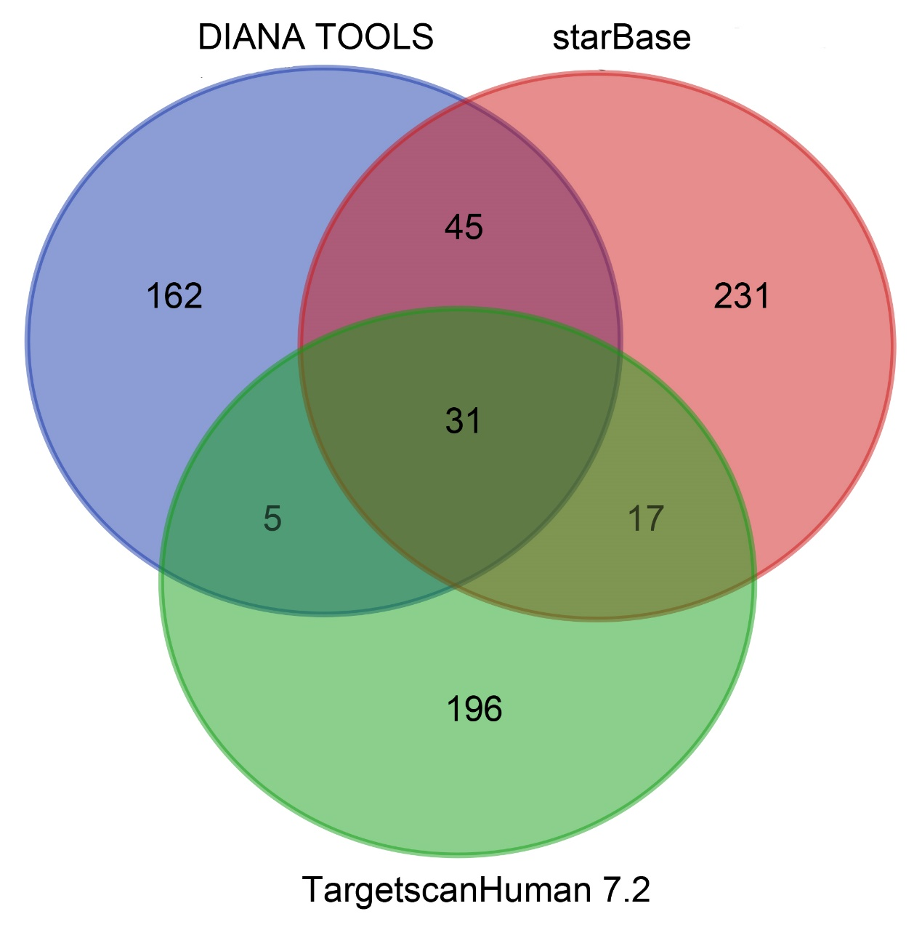
Figure S4: The Venn diagram of target genes predicted by three biominformatics tools.

