Supporting information
Supplemental File 1 and Supplemental File 5. The raw data in CAOV3 and OVCAR3 cell line. This table include the raw data about the expression of candidate HKGs in CAOV3 and OVCAR3 cells under hypoxia environment exposure;
Supplemental File 2 and Supplemental File 6. The analysis in CAOV3 and OVCAR3 cell line. The results of geNorm and NormFinder according to the raw data in CAOV3 and OVCAR3 cells.
Supplemental File 3 and Supplemental File 7. The average expression stability value (M) was calculated by geNorm for each gene in CAOV3 and OVCAR3 cells cultured under normoxia and hypoxia.
Supplemental File 4 and Supplemental File 8. Pairwise variation (V) between the normalization factors (Vn and Vn + 1) was used to determine the optimal number of reference genes for normalization
Supplemental File 9. The Raw data utilized in this manuscript. This table was the raw data used in this manuscript.

Supplemental File1: Cq value of the eight candidate reference genes in CAOV3 cells after exposure to hypoxia

 | GAPDH | β-actin | 18S RNA | TUBB | PPIA | RPL13A | TBP | SDHA
Control | 23.34 | 20.25 | 20.07 | 21.06 | 21.47 | 18.79 | 24.17 | 25.73
Control | 23.50 | 20.46 | 20.06 | 20.46 | 22.33 | 18.91 | 23.96 | 26.17
Control | 23.31 | 20.46 | 20.23 | 20.48 | 21.83 | 18.89 | 24.52 | 26.01
Control | 23.34 | 20.37 | 20.07 | 20.86 | 22.67 | 18.98 | 24.39 | 25.41
HY 24H | 22.85 | 20.84 | 19.78 | 21.17 | 21.36 | 18.39 | 23.50 | 25.67
HY 24H | 23.03 | 21.89 | 20.48 | 21.90 | 21.61 | 18.62 | 25.23 | 25.84
HY 24H | 22.68 | 20.88 | 20.36 | 20.71 | 22.06 | 18.77 | 24.65 | 26.18
HY 24H | 22.81 | 21.68 | 20.66 | 21.86 | 21.94 | 18.64 | 25.60 | 26.57

Supplemental File2: The results of geNorm and NormFinder according to the raw data in CAOV3

geNorm | GAPDH | β-actin | 18S RNA | TUBB | PPIA | RPL13A | TBP | SDHA
Control | 2.33E+01 | 2.03E+01 | 2.01E+01 | 2.11E+01 | 2.15E+01 | 1.88E+01 | 2.42E+01 | 2.57E+01
Control | 2.35E+01 | 2.05E+01 | 2.01E+01 | 2.05E+01 | 2.23E+01 | 1.89E+01 | 2.40E+01 | 2.62E+01
Control | 2.33E+01 | 2.05E+01 | 2.02E+01 | 2.05E+01 | 2.18E+01 | 1.89E+01 | 2.45E+01 | 2.60E+01
Control | 2.33E+01 | 2.04E+01 | 2.01E+01 | 2.09E+01 | 2.27E+01 | 1.90E+01 | 2.44E+01 | 2.54E+01
HY 24H | 2.29E+01 | 2.08E+01 | 1.98E+01 | 2.12E+01 | 2.14E+01 | 1.84E+01 | 2.35E+01 | 2.57E+01
HY 24H | 2.30E+01 | 2.19E+01 | 2.05E+01 | 2.19E+01 | 2.16E+01 | 1.86E+01 | 2.52E+01 | 2.58E+01
HY 24H | 2.27E+01 | 2.09E+01 | 2.04E+01 | 2.07E+01 | 2.21E+01 | 1.88E+01 | 2.47E+01 | 2.62E+01
HY 24H | 2.28E+01 | 2.17E+01 | 2.07E+01 | 2.19E+01 | 2.19E+01 | 1.86E+01 | 2.56E+01 | 2.66E+01
M < 1.5 | 0.038 | 0.041 | 0.027 | 0.041 | 0.040 | 0.032 | 0.037 | 0.032

NormFinder | Gene name | Stability value |  | Best gene | 18S RNA
 | GAPDH | 0.450 |  | Stability value | 0.071
 | β-actin | 0.464
 | 18S RNA | 0.071 |  | Best combination of two genes | GAPDH and β-actin
 | TUBB | 0.456 |  | Stability value for best combination of two genes | 0.110
 | PPIA | 0.459
 | RPL13A | 0.326
 | TBP | 0.393
 | SDHA | 0.249

Supplemental File3: The average expression stability value (M) was calculated by geNorm for each gene in CAOV3 cells cultured under normoxia and hypoxia

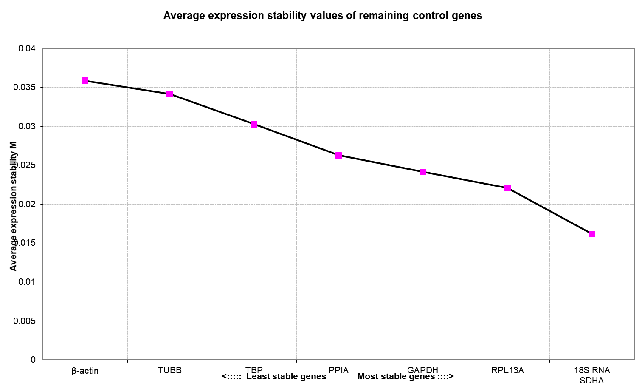

Supplemental File4: Pairwise variation (V) between the normalization factors (Vn and Vn + 1) was used to determine the optimal number of reference genes for normalization in CAOV3
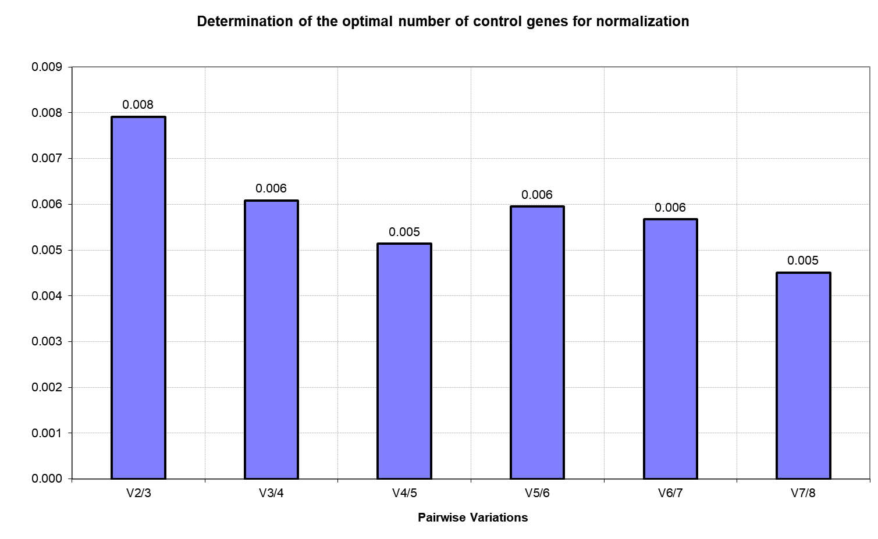

Supplemental File5: Cq value of the eight candidate reference genes in OVCAR3 cells after exposure to hypoxia

 | GAPDH | β-actin | 18S RNA | TUBB | PPIA | RPL13A | TBP | SDHA
Control | 23.96 | 20.74 | 20.72 | 21.29 | 21.40 | 18.90 | 23.79 | 26.28
Control | 23.45 | 19.96 | 20.98 | 20.97 | 22.80 | 19.24 | 24.31 | 26.24
Control | 23.88 | 19.93 | 19.97 | 20.83 | 21.61 | 19.34 | 24.46 | 26.47
Control | 23.39 | 19.83 | 20.82 | 21.35 | 23.08 | 18.80 | 25.10 | 25.87
HY 24H | 22.62 | 20.61 | 20.08 | 22.11 | 22.23 | 18.30 | 23.37 | 25.86
HY 24H | 22.93 | 21.70 | 20.80 | 22.04 | 21.49 | 19.47 | 25.78 | 25.55
HY 24H | 23.18 | 21.63 | 20.17 | 20.73 | 22.66 | 19.24 | 25.19 | 26.66
HY 24H | 23.22 | 21.22 | 21.27 | 21.81 | 21.71 | 18.67 | 25.55 | 27.40

Supplemental File6: The results of geNorm and NormFinder according to the raw data in OVCAR3

geNorm | GAPDH | β-actin | 18S RNA | TUBB | PPIA | RPL13A | TBP | SDHA
Control | 2.40E+01 | 2.07E+01 | 2.07E+01 | 2.13E+01 | 2.14E+01 | 1.89E+01 | 2.38E+01 | 2.63E+01
Control | 2.35E+01 | 2.00E+01 | 2.10E+01 | 2.10E+01 | 2.28E+01 | 1.92E+01 | 2.43E+01 | 2.62E+01
Control | 2.39E+01 | 1.99E+01 | 2.00E+01 | 2.08E+01 | 2.16E+01 | 1.93E+01 | 2.45E+01 | 2.65E+01
Control | 2.34E+01 | 1.98E+01 | 2.08E+01 | 2.14E+01 | 2.31E+01 | 1.88E+01 | 2.51E+01 | 2.59E+01
HY 24H | 2.26E+01 | 2.06E+01 | 2.01E+01 | 2.21E+01 | 2.22E+01 | 1.83E+01 | 2.34E+01 | 2.59E+01
HY 24H | 2.29E+01 | 2.17E+01 | 2.08E+01 | 2.20E+01 | 2.15E+01 | 1.95E+01 | 2.58E+01 | 2.56E+01
HY 24H | 2.32E+01 | 2.16E+01 | 2.02E+01 | 2.07E+01 | 2.27E+01 | 1.92E+01 | 2.52E+01 | 2.67E+01
HY 24H | 2.32E+01 | 2.12E+01 | 2.13E+01 | 2.18E+01 | 2.17E+01 | 1.87E+01 | 2.56E+01 | 2.74E+01
M < 1.5 | 0.051 | 0.061 | 0.047 | 0.056 | 0.062 | 0.048 | 0.055 | 0.049

NormFinder | Gene name | Stability value |  | Best gene | 18S RNA
 | 18S RNA | 0.319 |  | Stability value | 0.319
 | SDHA | 0.348
 | RPL13A | 0.356 |  | Best combination of two genes | GAPDH and β-actin
 | TUBB | 0.429 |  | Stability value for best combination of two genes | 0.167
 | TBP | 0.504
 | PPIA | 0.535
 | GAPDH | 0.536
 | β-actin | 0.603

Supplemental File7: The average expression stability value (M) was calculated by geNorm for each gene in OVCAR3 cells cultured under normoxia and hypoxia

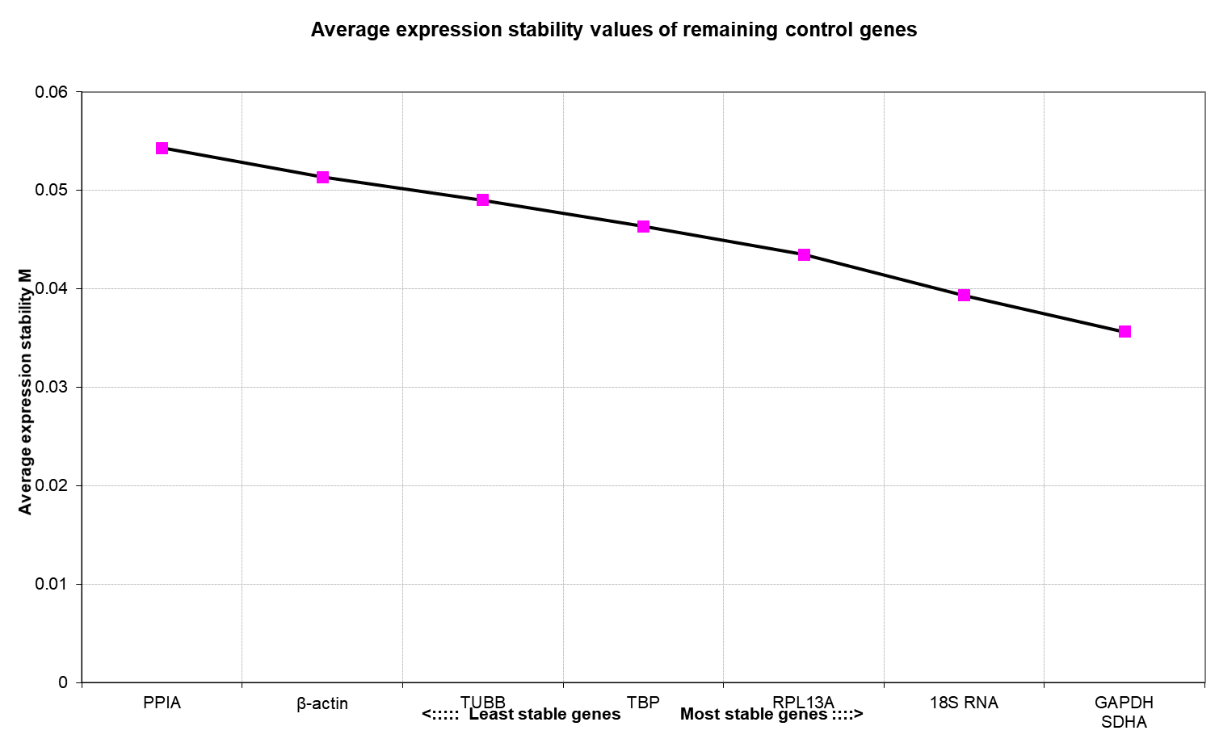

Supplemental File8: Pairwise variation (V) between the normalization factors (Vn and Vn + 1) was used to determine the optimal number of reference genes for normalization in OVCAR3
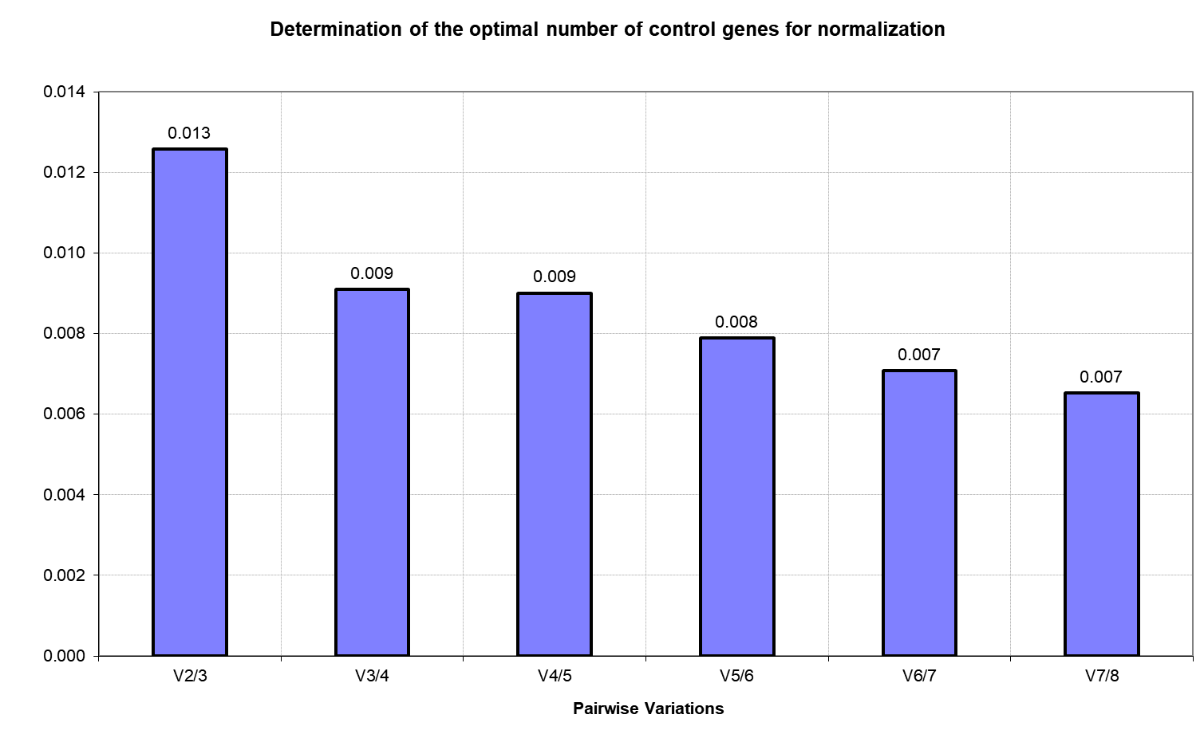

Supplemental File9: The Raw data utilized in this manuscript.

 | GAPDH | β-actin | 18S RNA | TUBB | PPIA | RPL13A | TBP | SDHA
Control | 23.82 | 21.01 | 23.29 | 21.38 | 16.73 | 18.93 | 24.77 | 26.44
Control | 23.64 | 21.10 | 23.37 | 21.36 | 17.02 | 18.59 | 24.64 | 26.07
Control | 23.37 | 21.00 | 23.15 | 21.32 | 16.64 | 18.74 | 24.24 | 26.17
Control | 23.46 | 20.82 | 23.32 | 21.21 | 16.72 | 18.48 | 24.45 | 26.03
HY 24H | 23.84 | 22.13 | 23.95 | 22.38 | 17.18 | 19.16 | 25.08 | 26.39
HY 24H | 24.02 | 21.87 | 23.91 | 22.14 | 17.57 | 19.14 | 25.48 | 26.36
HY 24H | 23.96 | 21.91 | 23.93 | 22.28 | 17.26 | 19.34 | 25.13 | 26.55
HY 24H | 24.06 | 22.03 | 24.00 | 22.08 | 17.47 | 19.26 | 25.75 | 26.51

Supplemental File10: the details of SKOV-3 cells

Supplemental File11: the details of OVCAR-3 cells

Supplemental File12: the details of CAOV-3 cells

