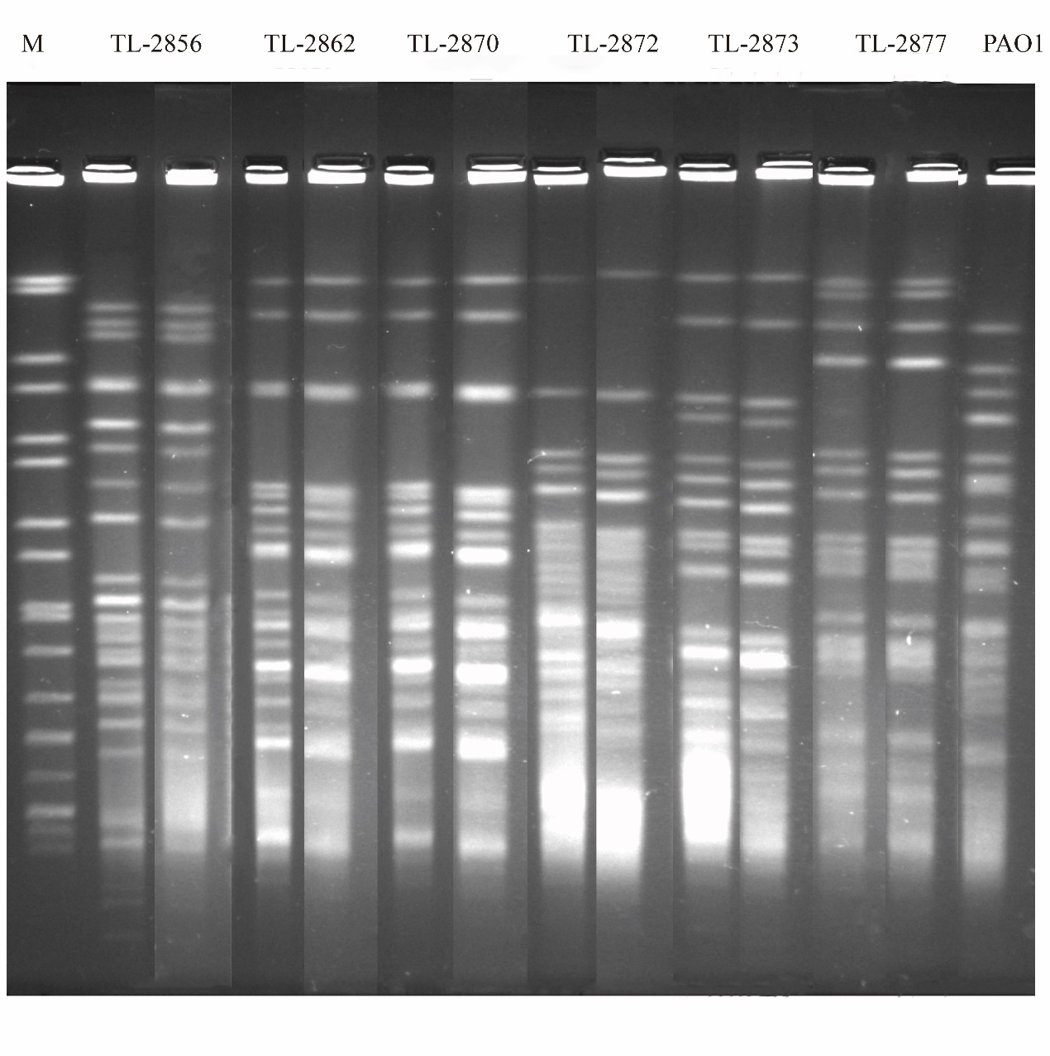
Figure S1 PFGE profiles of 6 heteroresistance and their respective native strains (the former of strain number of electrophoresis channel was a representative native strain and the latter was a heteroresistance). M, Salmonella enterica var. Braenderup H9812.

Figure S2 SDS-PAGE analysis of the outer-membrane proteins of the studied strains. Lanes: M, molecular mass marker; 1, PAO1; 2, susceptible population TL-2892; 3-8, heteroresistant population TL-2856, TL-2862, TL-2870, TL-2872, TL-2873 and TL-2877, respectively; 9-14, resistant isolate TL-2854, TL-2858, TL-2859, TL-2878, TL-2958 and TL-2997, respectively. The black arrow represents OprD.

