Dual receptor-targeted and redox-sensitive polymeric micelles self-assembled from a folic acid-hyaluronic acid-SS-vitamin E succinate polymer for precise cancer therapy
Yue Yang,¹ Yunjian Li,¹ Kai Chen,¹ Ling Zhang,² Sen Qiao,¹ Guoxin Tan,¹ Fen Chen,^{1, 3, 4, *} Weisan Pan^{1, *}
1 School of Pharmacy, Shenyang Pharmaceutical University, Shenyang 110016, People’s Republic of China
2 Department of Biotherapy, Cancer Research Institute, The First Affiliated Hospital of China Medical University, Shenyang 110001, People’s Republic of China
3 Key Laboratory of Ministry of Education for TCM Viscera-State Theory and Applications, Liaoning University of Traditional Chinese Medicine, Shenyang 110847, People’s Republic of China
4 Zhejiang Jingxin Pharmaceutical Co., Ltd, Zhejiang 312500, People’s Republic of China
* Corresponding author:
Weisan Pan
School of Pharmacy, Shenyang Pharmaceutical University, Shenyang 110016, People’s Republic of China
Tel.: +86 24 4352 0533
Fax: +86 24 4352 0533
Email address: pppwwwsss@163.com
Fen Chen
Key Laboratory of Ministry of Education for TCM Viscera-State Theory and Applications, Liaoning University of Traditional Chinese Medicine, Shenyang 110847, People’s Republic of China
Tel.: +86 24 3120 7125
Fax: +86 24 3120 7125
Email address: chenfen1121@163.com

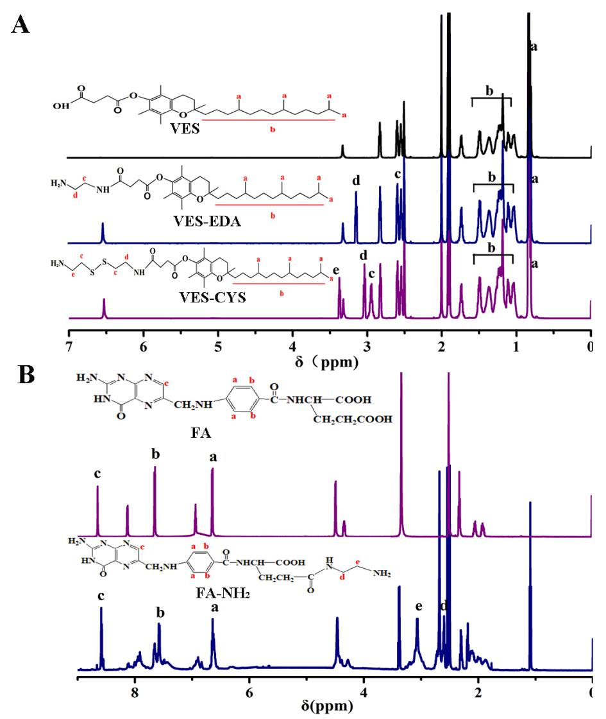
Figure S1 ¹H-NMR spectra of (A) VES, VES-EDA and VES-CYS (B) FA and FA-NH₂ in DMSO-d₆

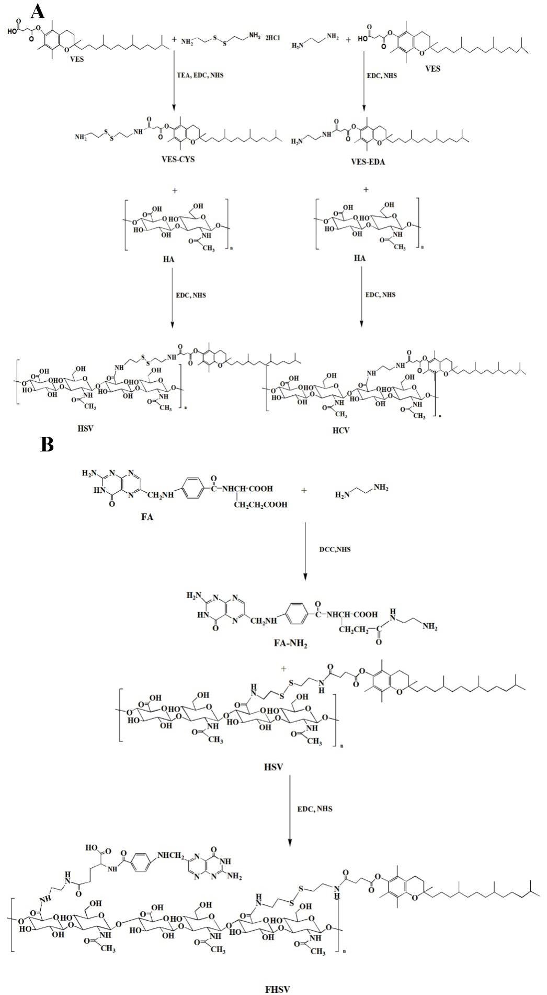
Figure S2 Synthesis scheme of (A) HCV and HSV (B) FHSV

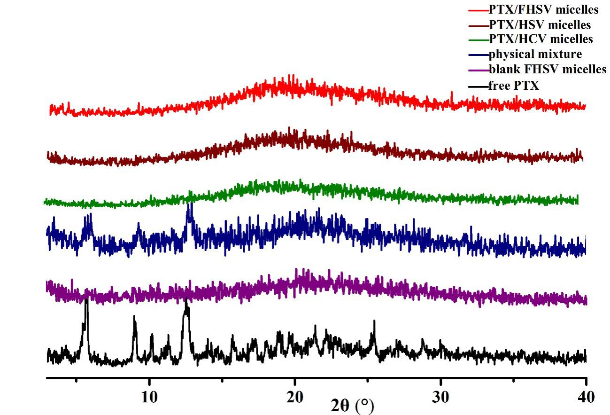
Figure S3 X-ray diffraction patterns of PTX, blank micelles, physical mixture of PTX and blank FHSV micelles, PTX/HCV micelles, PTX/HSV micelles and PTX/FHSV micelles

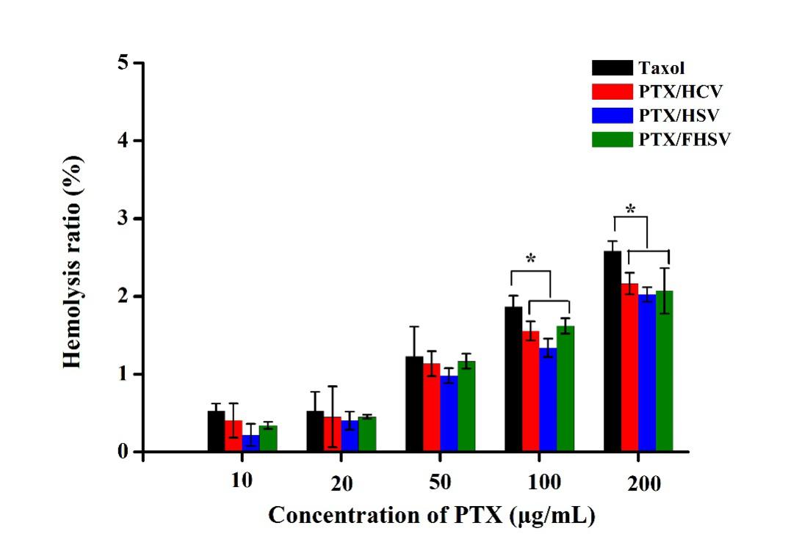
Figure S4 Hemolysis ratio of Taxol and PTX-loaded micelles (n=3). *p < 0.05.

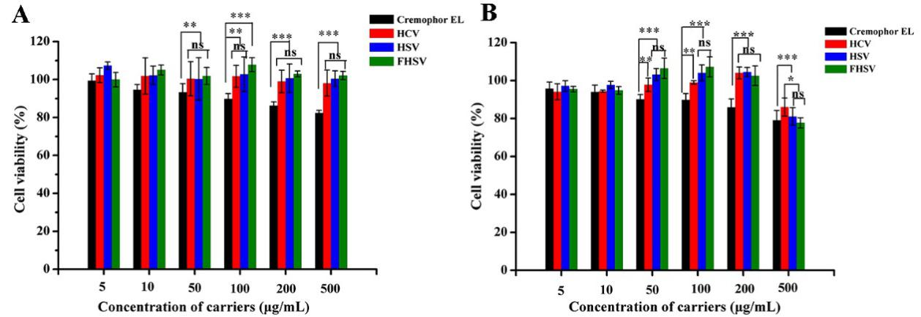
Figure S5 Cytotoxicity of blank carriers against (A) NIH3T3 cells and (B) MCF-7 cells (n=6). *p < 0.05; **p < 0.01; ***p < 0.001; ns, p > 0.05.

