Virtual screening and optimization of novel mTOR inhibitors for radiosensitization of hepatocellular carcinoma

Supplementary Materials

Contents
Figure S1 1
Figure S2 2
Figure S3 2
MD simulations 3
Western blot assays 6
Figure S8 7
¹H-NMR spectra of compound 1a 9
¹³C-NMR spectra of compound 1a 10
MS spectra of compound 1a 10
¹H-NMR spectra of compound 1b 11
¹³C-NMR spectra of compound 1b 12
MS spectra of compound 1b 12
¹H-NMR spectra of compound 1c 12
¹³C-NMR spectra of compound 1c 13
MS spectra of compound 1c 13
¹H-NMR spectra of compound 1d 14
¹³C-NMR spectra of compound 1d 14
MS spectra of compound 1d 15
¹H-NMR spectra of compound 2a 15
¹³C-NMR spectra of compound 2a 16
MS spectra of compound 2a 17
¹H-NMR spectra of compound 2b 17
¹³C-NMR spectra of compound 2b 18
MS spectra of compound 2b 19
¹H-NMR spectra of compound 2c 19
¹³C-NMR spectra of compound 2c 20
MS spectra of compound 2c 20
¹H-NMR spectra of compound 2d 21
¹³C-NMR spectra of compound 2d 22
MS spectra of compound 2d 22
¹H-NMR spectra of compound 2e 23
¹³C-NMR spectra of compound 2e 23
MS spectra of compound 2e 24
¹H-NMR spectra of compound 2f 25
¹³C-NMR spectra of compound 2f 25
MS spectra of compound 2f 26
¹H-NMR spectra of compound 2g 27
¹³C-NMR spectra of compound 2g 27
MS spectra of compound 2g 28
¹H-NMR spectra of compound 2h 28
¹³C-NMR spectra of compound 2h 29
MS spectra of compound 2h 29
¹H-NMR spectra of compound 2i 30
¹³C-NMR spectra of compound 2i 31
MS spectra of compound 2i 31
¹H-NMR spectra of compound 2j 32
¹³C-NMR spectra of compound 2j 32
MS spectra of compound 2j 33
¹H-NMR spectra of compound 3a 34
¹³C-NMR spectra of compound 3a 34
MS spectra of compound 3a 35
¹H-NMR spectra of compound 3b 35
¹³C-NMR spectra of compound 3b 36
MS spectra of compound 3b 36
¹H-NMR spectra of compound 3c 37
¹³C-NMR spectra of compound 3c 38
MS spectra of compound 3c 38
¹H-NMR spectra of compound 3d 39
¹³C-NMR spectra of compound 3d 40
MS spectra of compound 3d 40
¹H-NMR spectra of compound 3e 41
¹³C-NMR spectra of compound 3e 41
MS spectra of compound 3e 42
¹H-NMR spectra of compound 3f 43
¹³C-NMR spectra of compound 3f 43
MS spectra of compound 3f 44
¹H-NMR spectra of compound 3g 44
¹³C-NMR spectra of compound 3g 45
MS spectra of compound 3g 45
¹H-NMR spectra of compound 3h 46
¹³C-NMR spectra of compound 3h 47
MS spectra of compound 3h 47

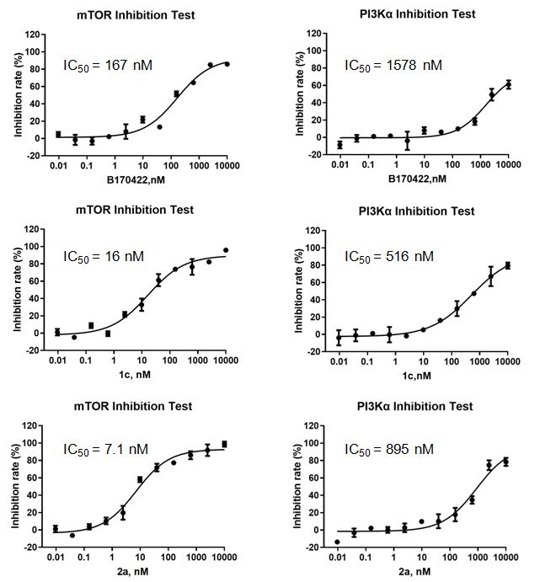
Figure S1 Enzyme inhibitory activities of B170422, 1c and 2a against mTOR and PI3Kα.

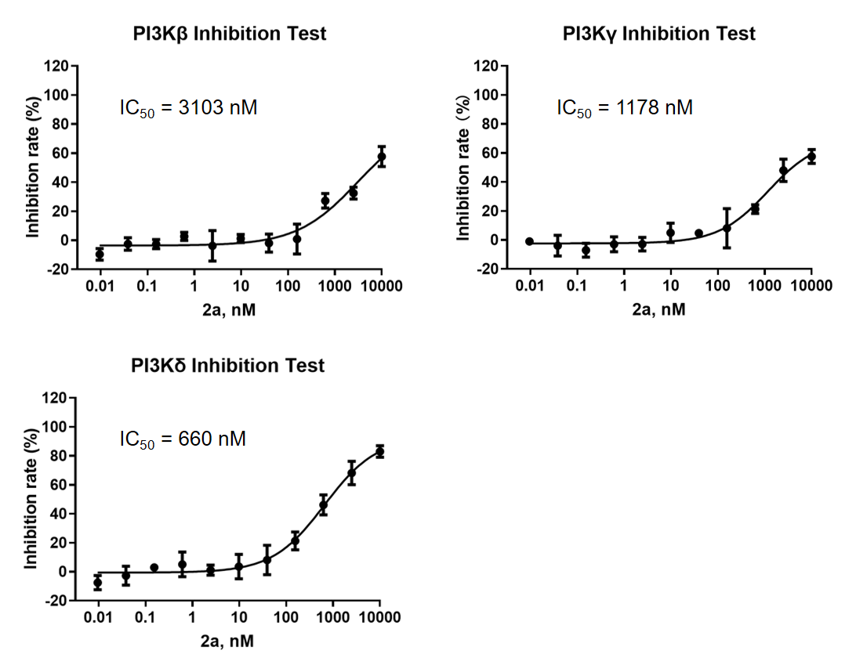
Figure S2 Enzyme inhibitory activities of 2a against PI3Kβ, PI3Kγ and PI3Kδ.

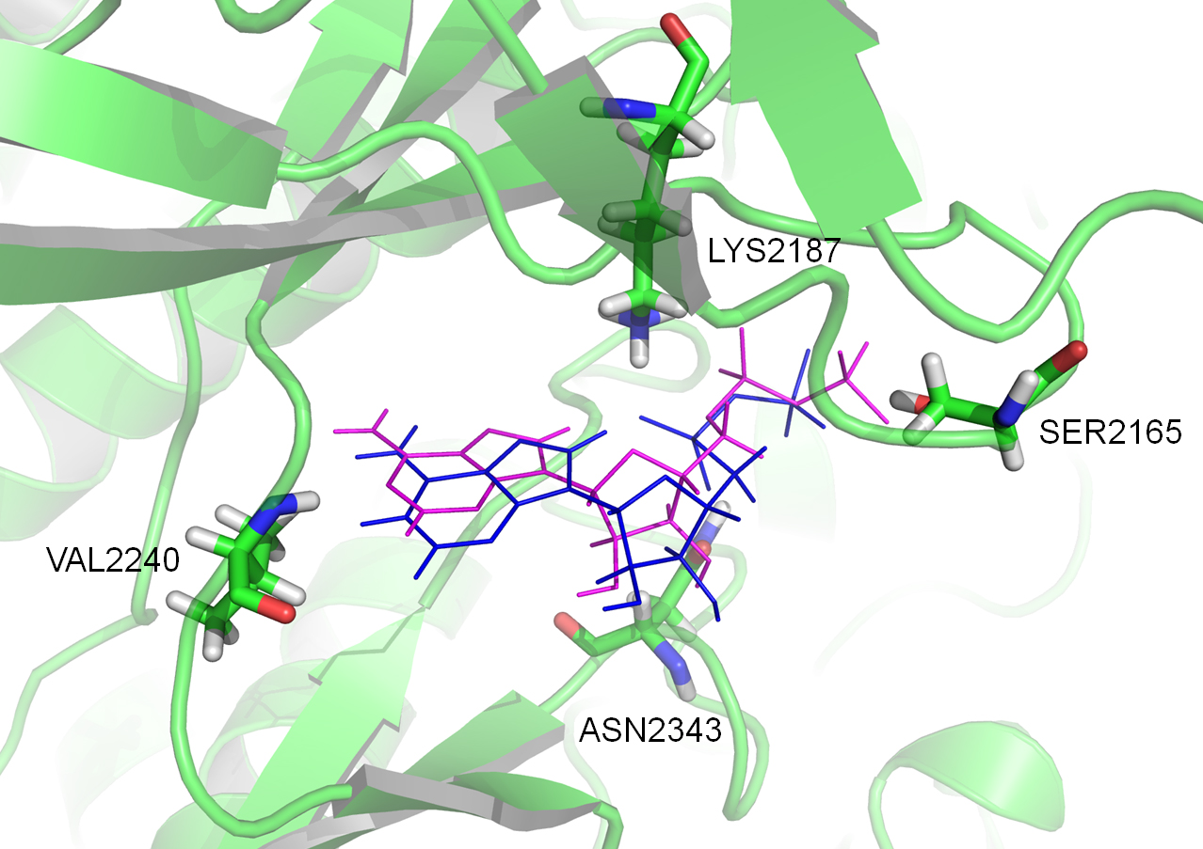
Figure S3 Re-docking study for the co-crystal reference ligand in 4JVS. Blue: the original conformation of the ligand in 4JSV; Red: the virtual docking conformation of ligand.

MD simulations
MD simulation: MD simulations were performed using GROMACS 2016.3.¹⁻³ The Amber99sb-ildn force field was used to simulate the protein, acpype³ (http://bio2byte.be/acpype/) was used to generate small-molecule topologies based on gaff force field, and the water molecules were modeled using TIP3P.^{4,5} The size of the simulation box was set so that each atom of the protein was more than 1.0 nm away from the box. The box was filled with water molecules, and water molecules were replaced with Cl⁻ ions to make the simulation system electrically neutral. Then, the steepest descent energy-reduction method was used to simulate and optimize the system, reducing any unreasonable contacts or atom overlap. The restricted MD simulation was used to balance the system under the regular and isothermal isobaric ensembles, respectively. The Verlet frog jumping algorithm was used to solve Newton’s equations of motion, and the integration step was set to 2 fs. During the calculation, the Lennard-Jones function was used to calculate the Van der Waals force. The non-bond truncation distance was set to 1.2 nm. The bond length of all atoms was constrained by the LINCS algorithm. The particle mesh Ewald method was used to calculate long-range electrostatic interactions.⁶ The dot width was set to 0.16 nm. Periodic boundary conditions were used during the simulation. All MD simulations were performed under an isothermal isostatic ensemble at a temperature of 298.15 K and a pressure of 1 atmosphere. The temperature and pressure were controlled by the V-rescale and Parrinello–Rahman methods, respectively, and the temperature and pressure coupling constants were 0.1 and 0.5 ps, respectively. The MD simulation time of the system was 100 ns.

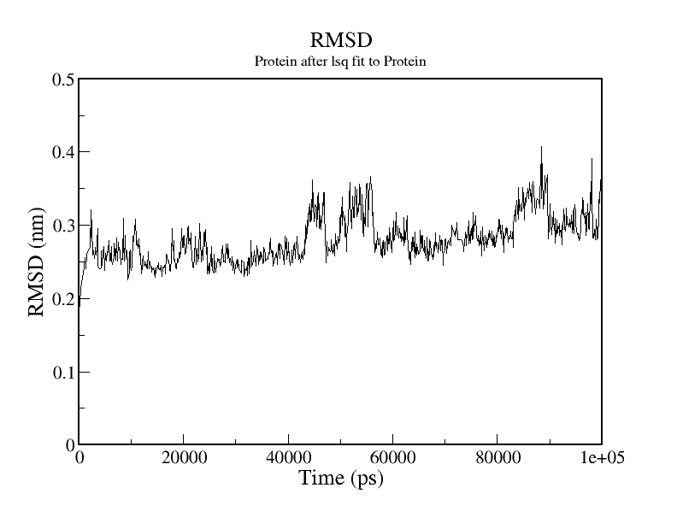
Figure S4 Changes in protein root-mean-square deviation (RMSD) values during the molecular dynamics simulation.

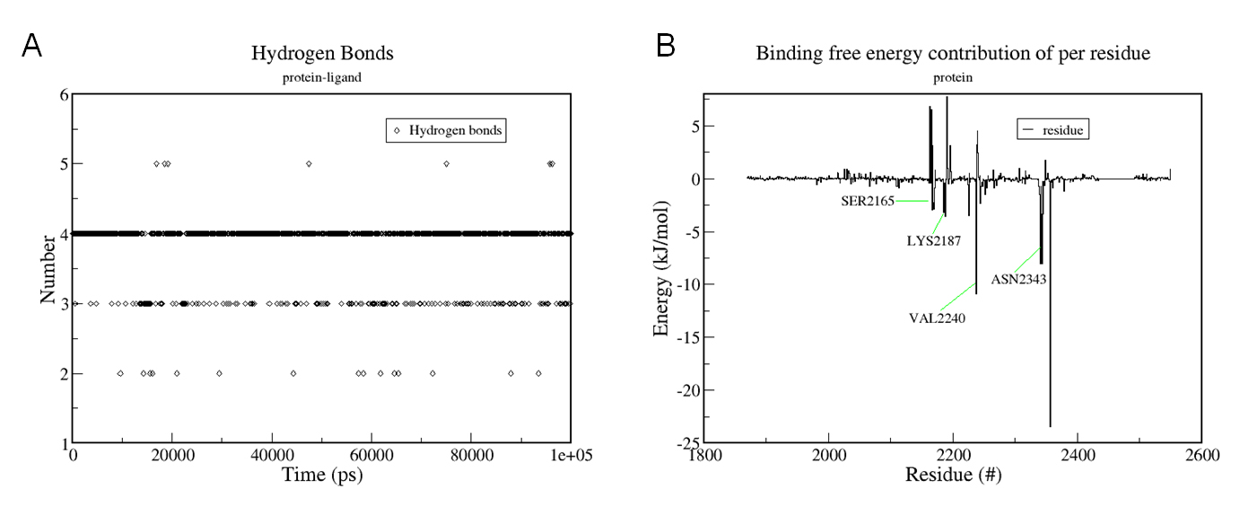
Figure S5 (A) The number of hydrogen bonds during the molecular dynamics simulation; (B) Residual energy contribution.

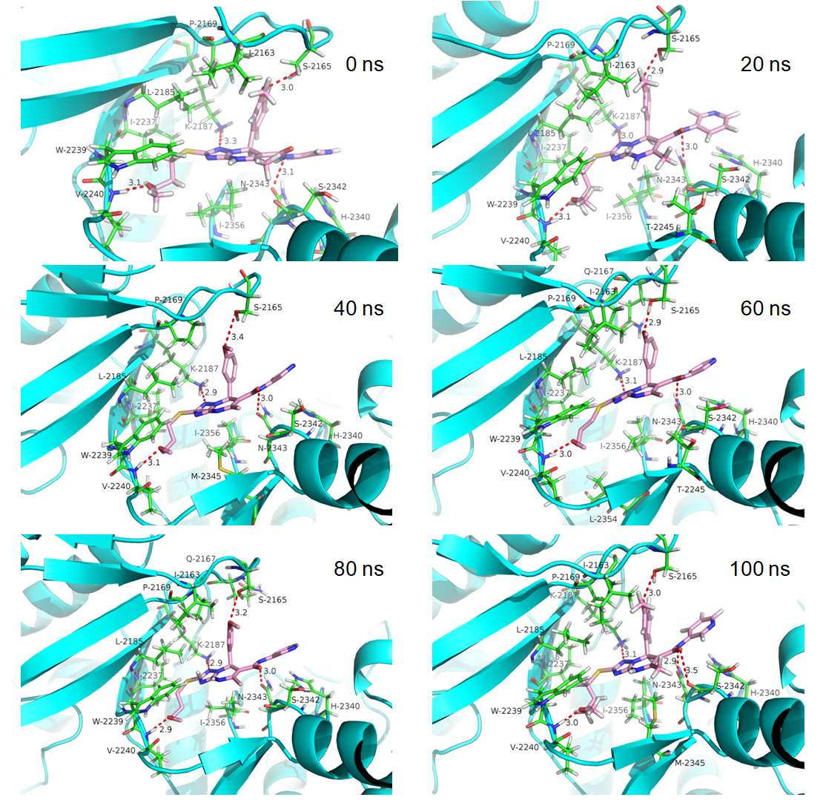
Figure S6 mTOR-B170422 interaction diagram in 0 ns, 20 ns, 40 ns, 60 ns, 80ns and 100 ns during the molecular dynamics simulation.
Molecular docking showed that B170422 formed stable hydrogen bonds with SER2165, LYS2187, VAL2240, and ASN2343 in mTOR. MD simulations of the docking model (protein–B170422) were used to further demonstrate the stability of the four key hydrogen bonds. The MD simulation results showed that the overall residual base fluctuation of the protein was less than 0.4 nm (Figure S4 in Supplementary Materials), suggesting that the structure of the protein binding with B170422 was stable. The number of hydrogen bonds formed between the protein and B170422 was analyzed using the gmx hbond program. The results showed that there were only four hydrogen bonds in the whole simulation (Figure S5A), and they existed most of the time during the simulation process (Figure S6). Simulation system files were output every 20 ns (from 0 to 100 ns); these data showed that the four hydrogen bonds were stable (Figure S6). In addition, the MD simulation results demonstrated that the four amino acids made a great contribution to the stable binding between the protein and B170422 (Figure S5B).

Western blot assays
MHCC97-H cells (5x10⁶ cells per 75T flask) were incubated for 24 h following pretreatment with solvent control, rapamycin, 2a and GSK2126458 for 12 h. The dosing concentrations of rapamycin, 2a and GSK2126458 all were set to 1 μmol/L. At the end of the exposure period, cells were lysed in RIPA (Radio Immunoprecipitation Assay) buffer (Cell Signaling Technology, Danvers, MA, USA). Protein concentration was determined using the Pierce bicinchoninic acid protein assay kit (Thermo Fisher Scientific, Inc.) according to the manufacturer’s instructions. Protein samples (40 μg) were loaded into each well of a 10–12% polyacrylamide gel and separated by sodium dodecyl sulfate polyacrylamide gel electrophoresis (Millipore, Billerica, USA). The membrane was blocked with 5% skim milk in Tris-buffered saline with 0.1% Tween-20 and incubated with antibodies (1:1000) at 4 °C. β-actin was employed as the loading control. Rabbit antibodies against human phospho-p70S6K, p70S6K, phospho-AKT (Ser473), AKT, β-actin and secondary antibodies were purchased from Cell Signaling Technology (Danvers, MA, USA).⁷⁻⁹
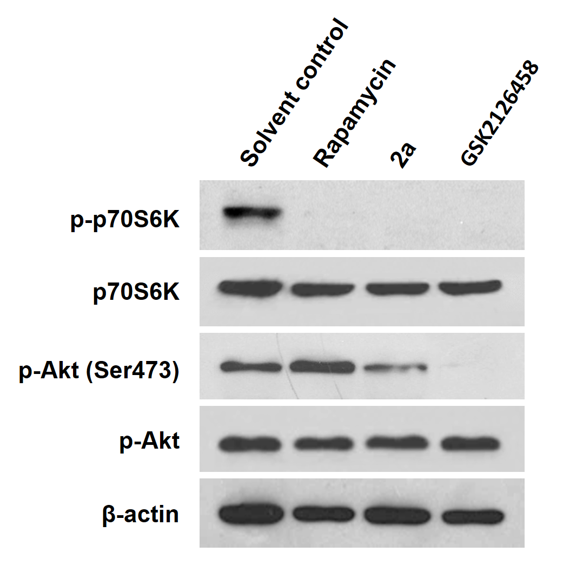
Figure S7 the inhibitory effect of compounds on mTORC1 and mTORC2.
The inhibitory activitiy of 2a on mTORC1 and mTORC2 was examined by western blot analysis (Figure S7). Phospho-p70S6K1 and phospho-AKT (Ser473) are downstream effectors of mTORC1 and mTORC2, respectively. Rapamycin (mTORC1 specific inhibitor) and GSK2126458 (mTORC1/mTORC2 dual inhibitor) were selected as the control agents. The results of the analysis showed that 2a had a definite inhibitory effect on both mTORC1 and mTORC2, and the inhibitory effect on mTORC1 was stronger than that on mTORC2.

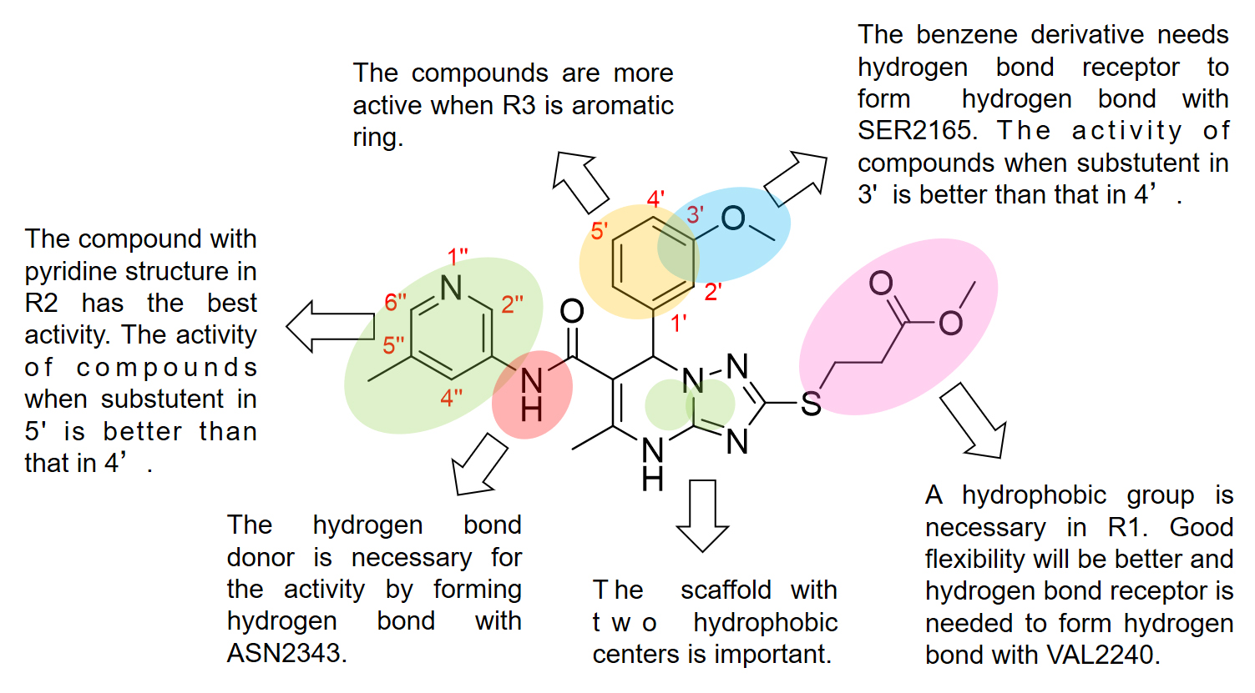
Figure S8 Structure-activity relationship of compound 2a.

References
1. Berendsen HJ, van der Spoel D, van Drunen R. GROMACS: a message-passing parallel molecular dynamics implementation. Computer physics communications. 1995;91(1-3):43-56.
2. Van Der Spoel D, Lindahl E, Hess B, Groenhof G, Mark AE, Berendsen HJ. GROMACS: fast, flexible, and free. Journal of computational chemistry. 2005;26(16):1701-1718.
3. Abraham MJ, Murtola T, Schulz R, et al. GROMACS: High performance molecular simulations through multi-level parallelism from laptops to supercomputers. SoftwareX. 2015;1:19-25.
4. Lu JB, Qiu YQ, Baron R, Molinero V. Coarse-Graining of TIP4P/2005, TIP4P-Ew, SPC/E, and TIP3P to Monatomic Anisotropic Water Models Using Relative Entropy Minimization. J Chem Theory Comput. 2014;10(9):4104-4120.
5. Price DJ, Brooks CL. A modified TIP3P water potential for simulation with Ewald summation. J Chem Phys. 2004;121(20):10096-10103.
6. Kawata M, Nagashima U. Particle mesh Ewald method for three-dimensional systems with two-dimensional periodicity. Chem Phys Lett. 2001;340(1-2):165-172.
7. Lu CC, Chiang JH, Tsai FJ, et al. Metformin triggers the intrinsic apoptotic response in human AGS gastric adenocarcinoma cells by activating AMPK and suppressing mTOR/AKT signaling. International journal of oncology. 2019;54(4):1271-1281.
8. Hu Y, Tao Y, Hu J. Cannabinoid receptor 2 deletion deteriorates myocardial infarction through the down-regulation of AMPK-mTOR-p70S6K signaling-mediated autophagy. Bioscience reports. 2019;39(4):BSR20180650.
9. Su CC, Hsieh KL, Liu PL, et al. AICAR Induces Apoptosis and Inhibits Migration and Invasion in Prostate Cancer Cells Through an AMPK/mTOR-Dependent Pathway. International journal of molecular sciences. 2019;20(7):1647-1660.

The ¹H-NMR and ¹³C-NMR spectra of all samples were obtained in DMSO-d₆ solution. The MS spectra of all samples were obtained in methanol solution.
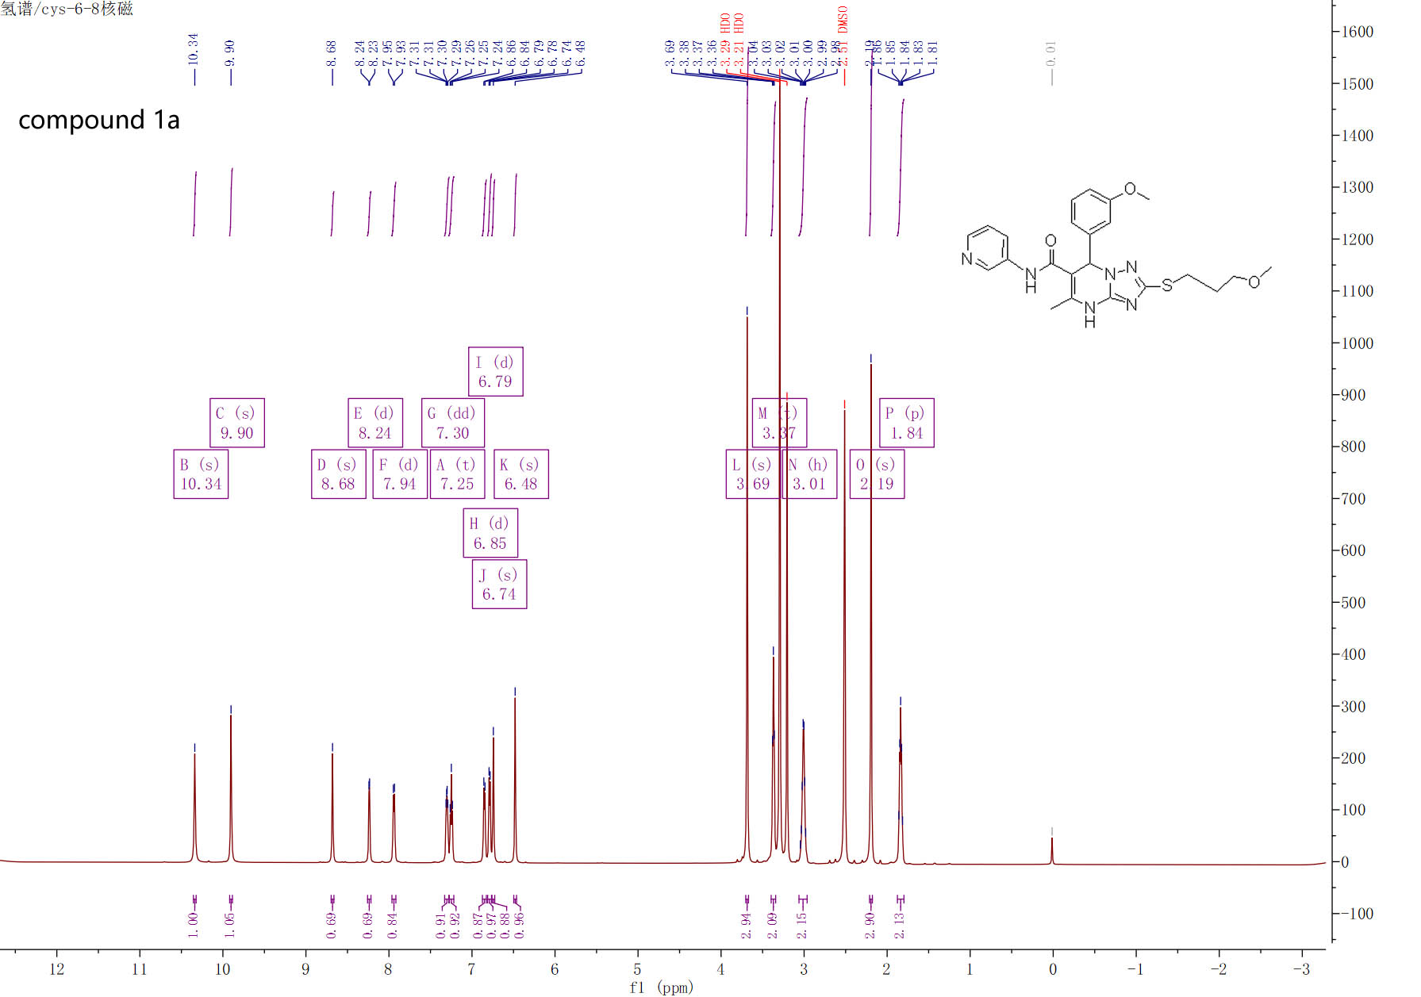

¹H-NMR spectra of compound 1a

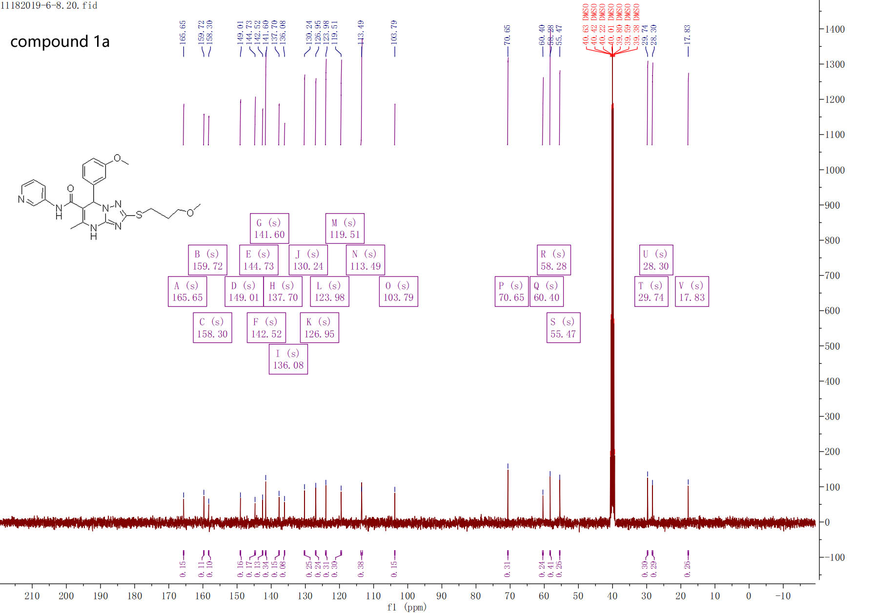

¹³C-NMR spectra of compound 1a
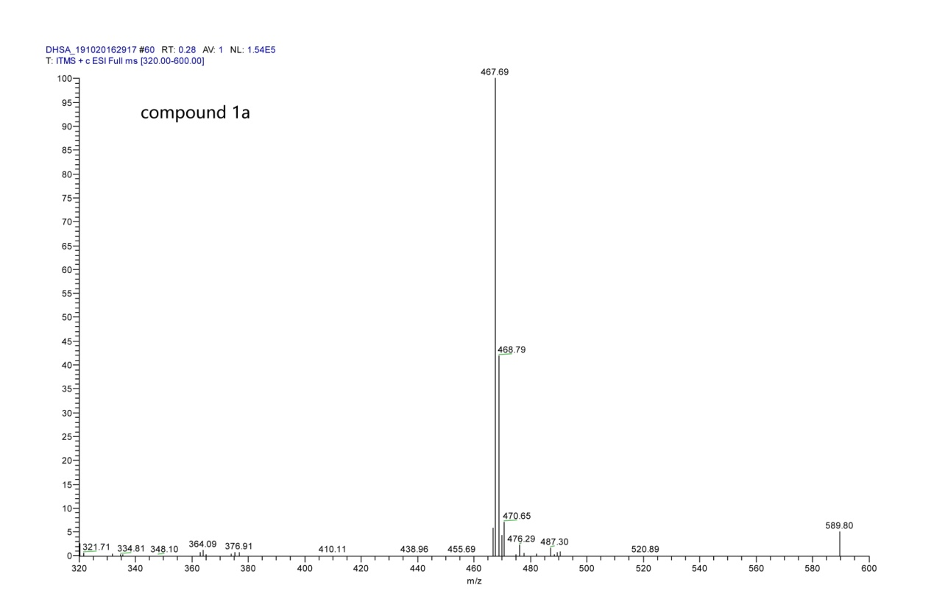

MS spectra of compound 1a

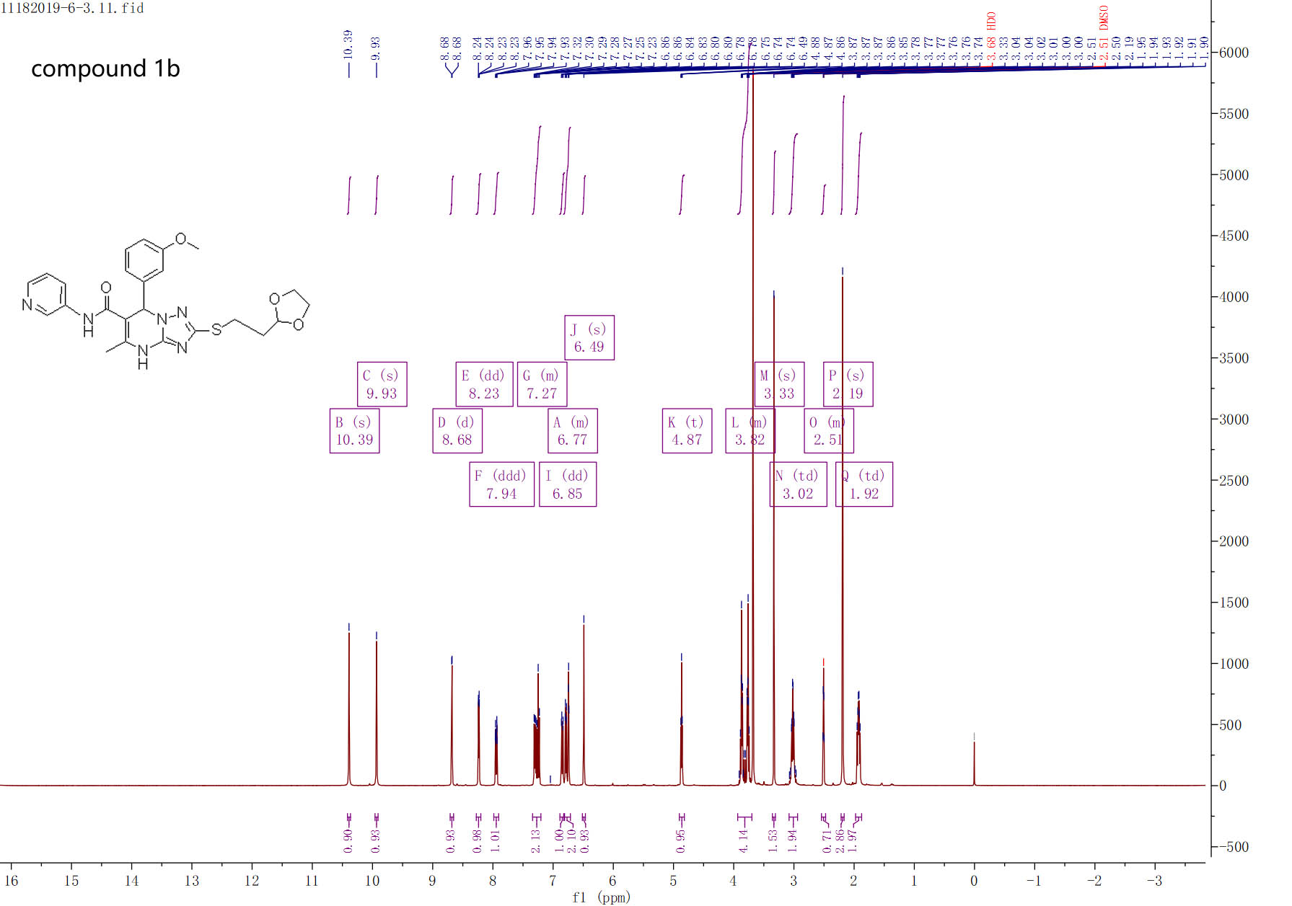

¹H-NMR spectra of compound 1b

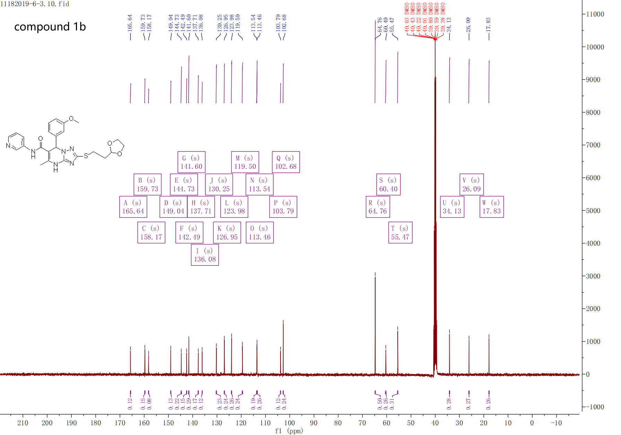

¹³C-NMR spectra of compound 1b

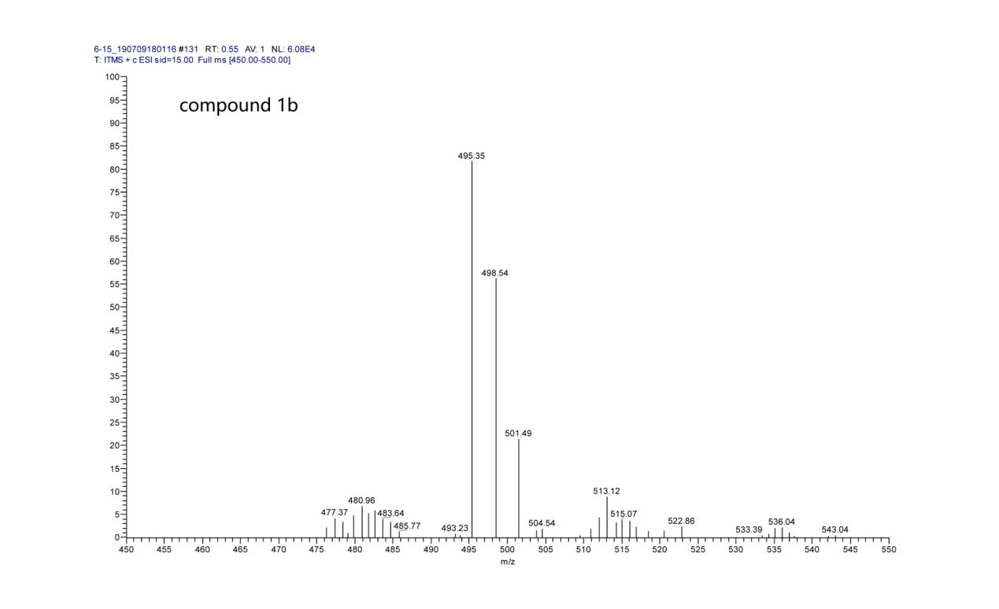

MS spectra of compound 1b
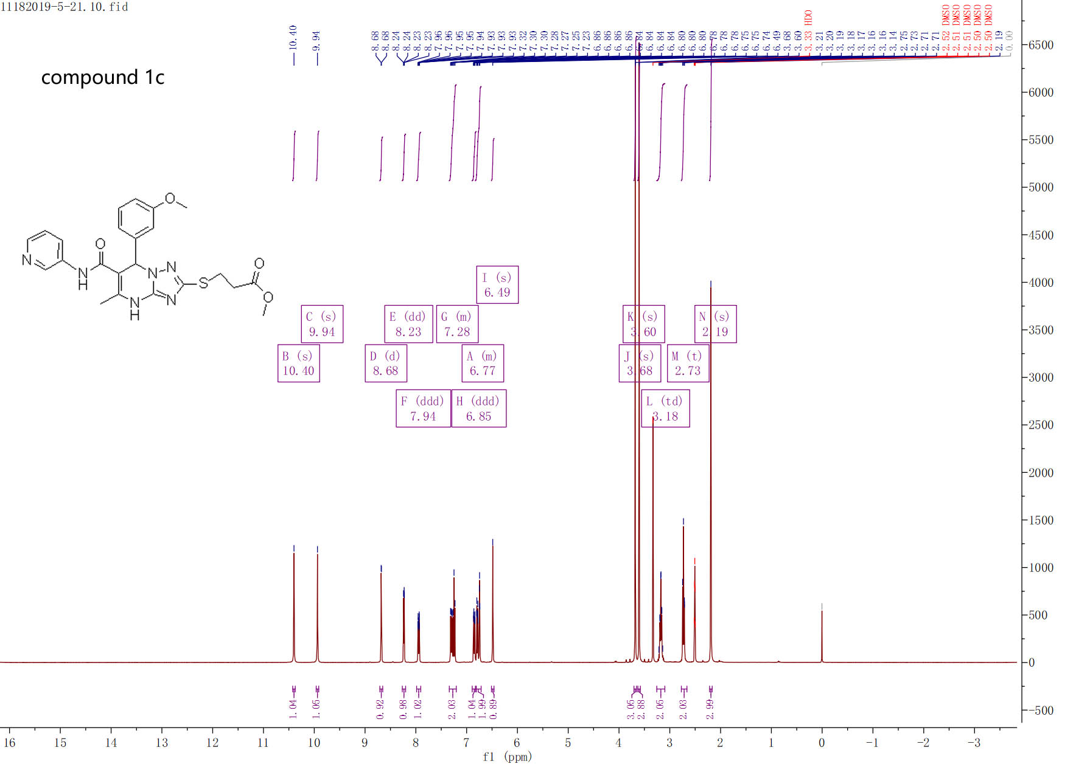

¹H-NMR spectra of compound 1c

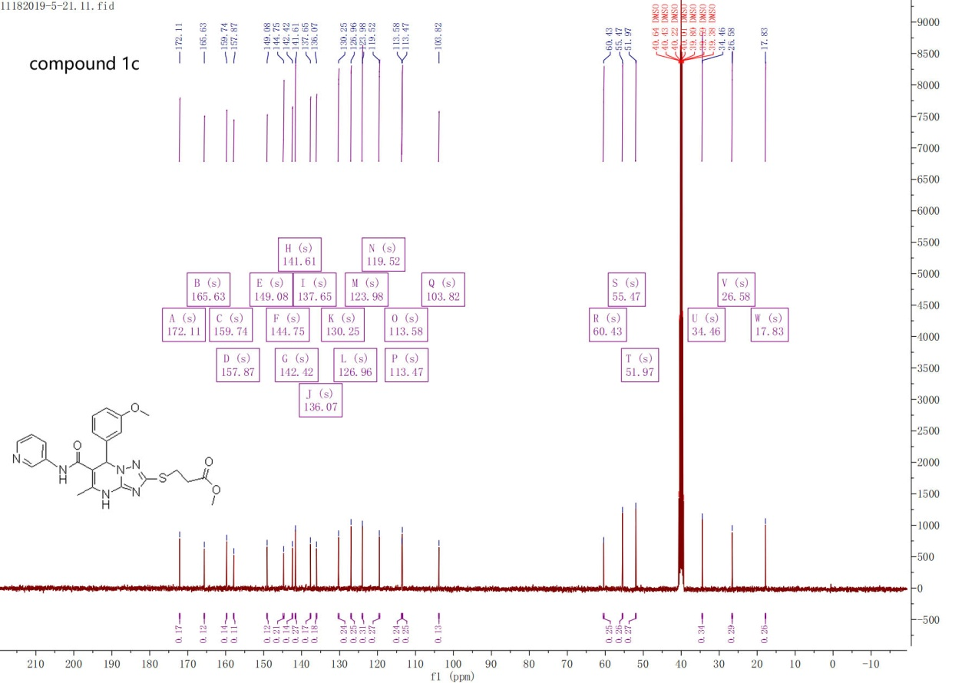

¹³C-NMR spectra of compound 1c
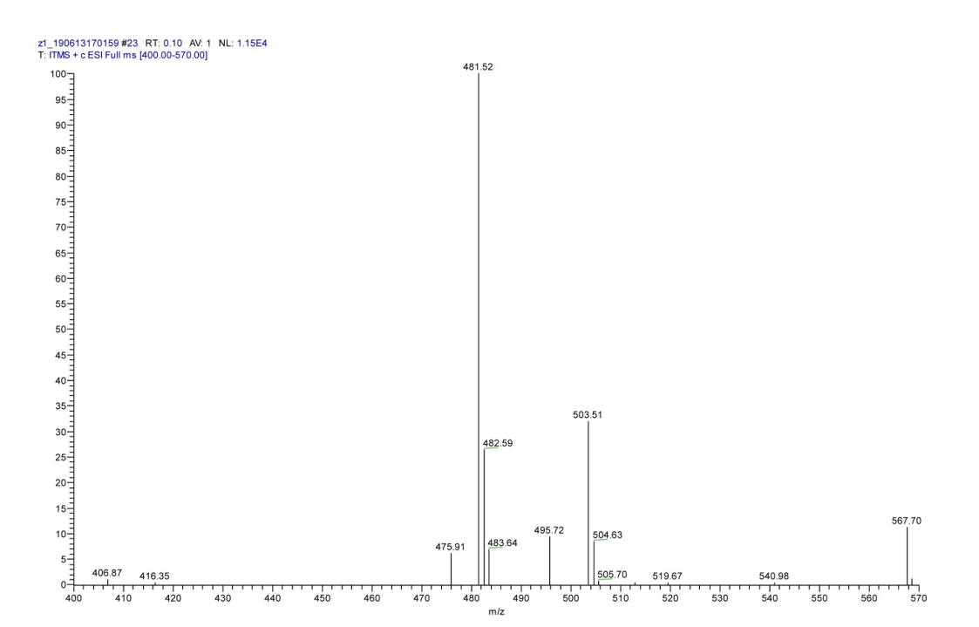

MS spectra of compound 1c

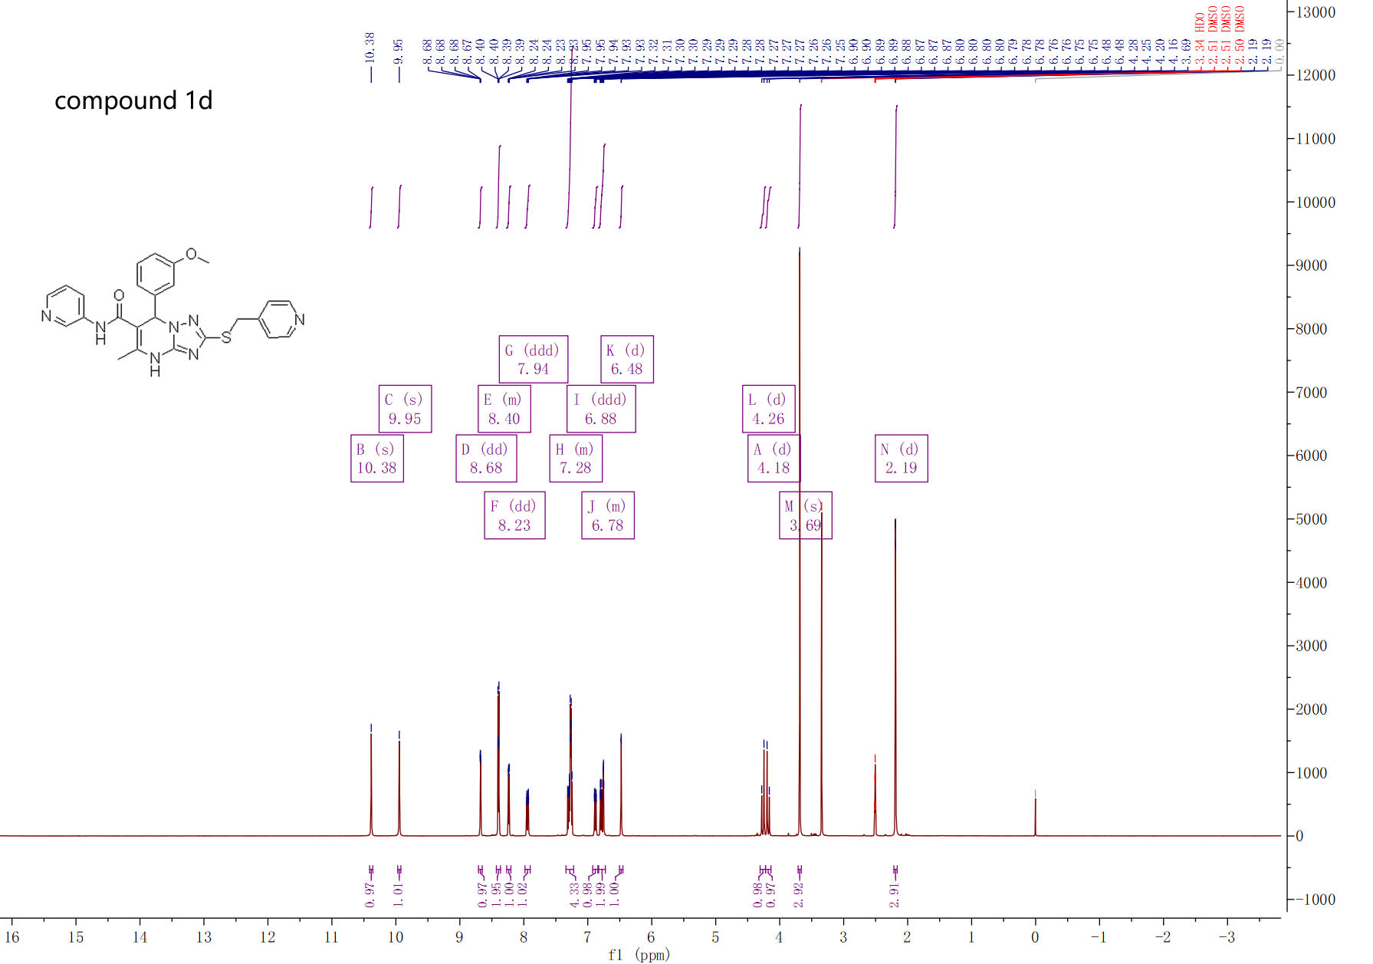

¹H-NMR spectra of compound 1d
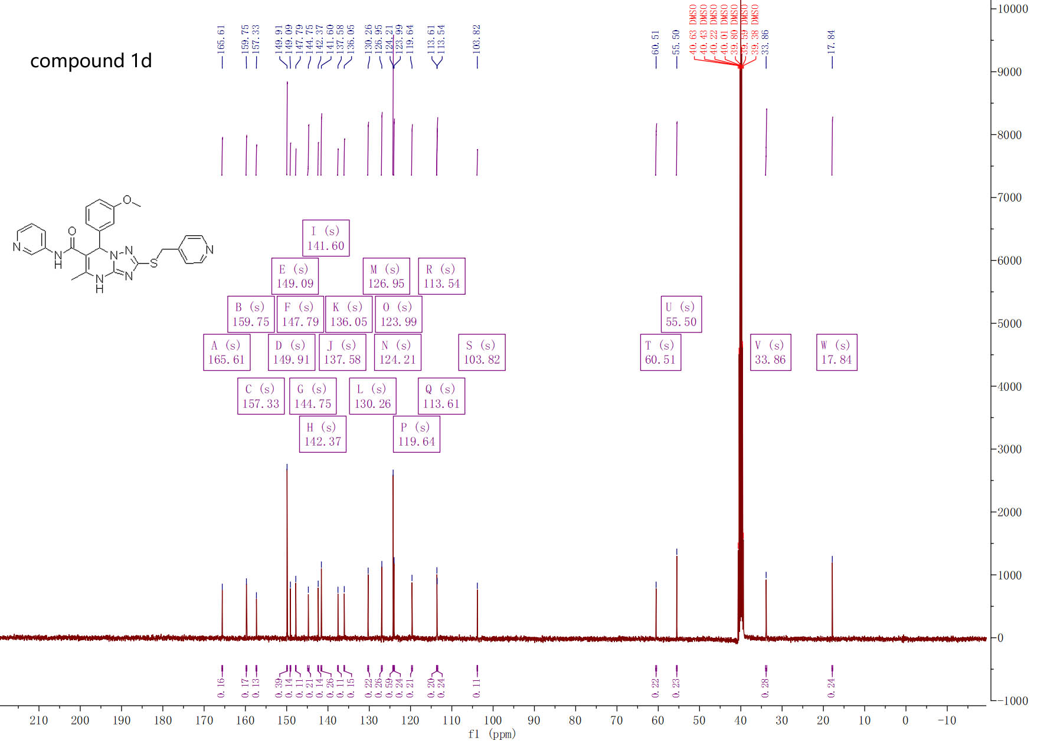

¹³C-NMR spectra of compound 1d

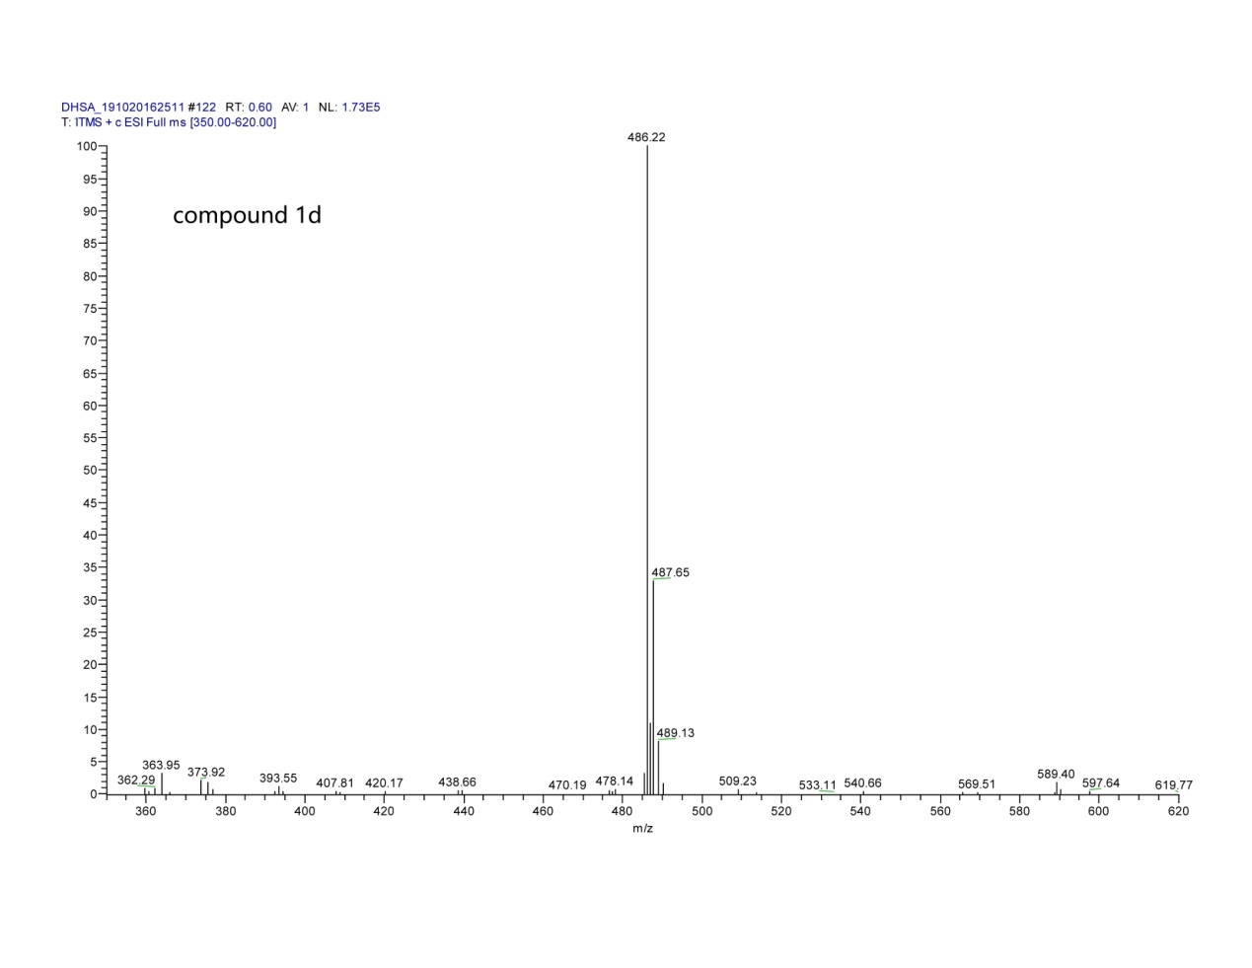
MS spectra of compound 1d

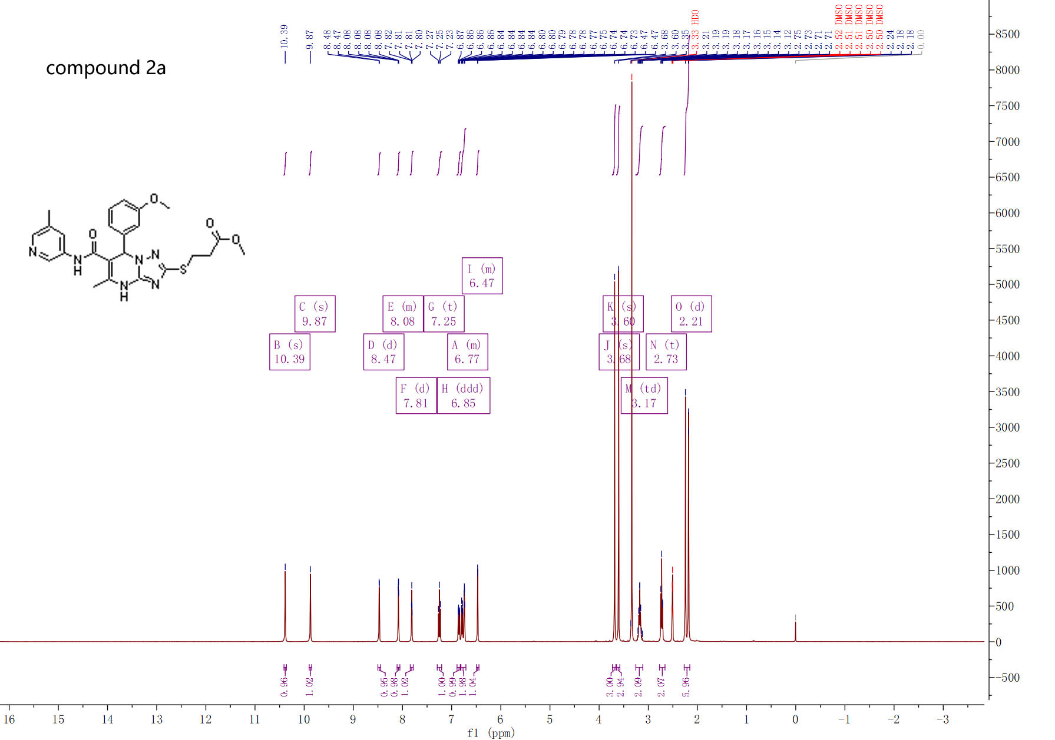

¹H-NMR spectra of compound 2a

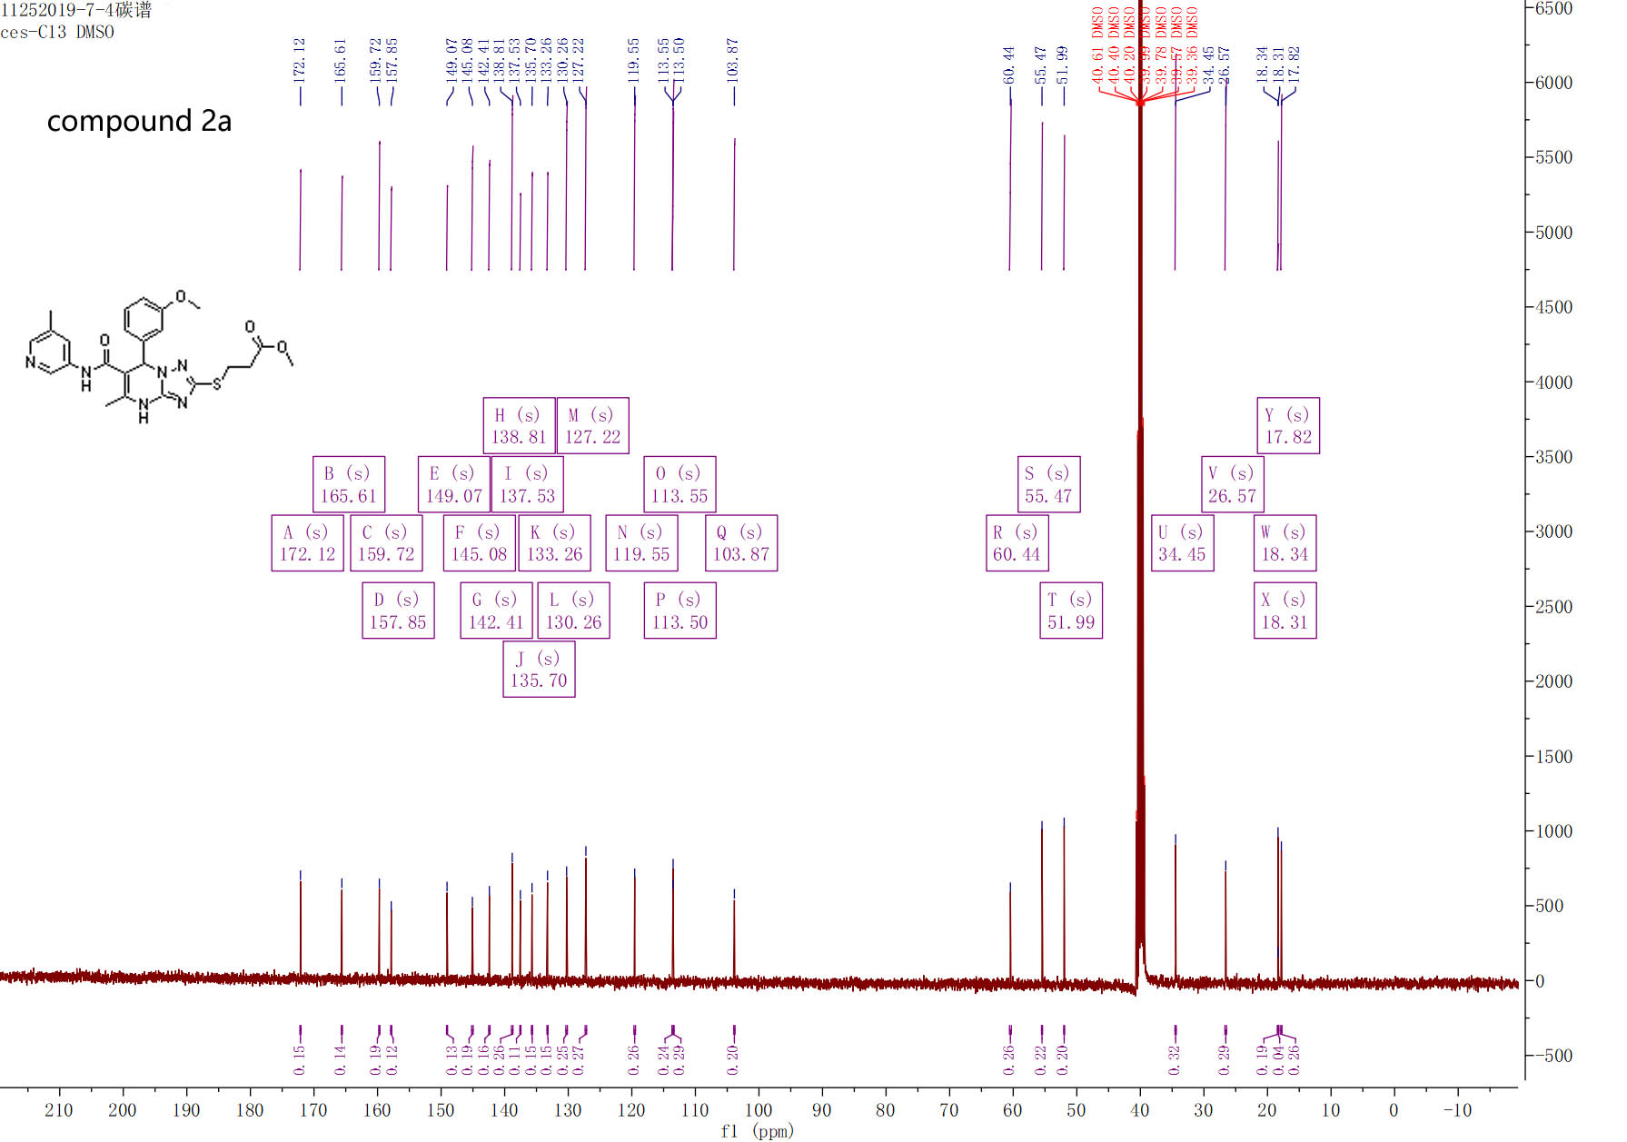

¹³C-NMR spectra of compound 2a

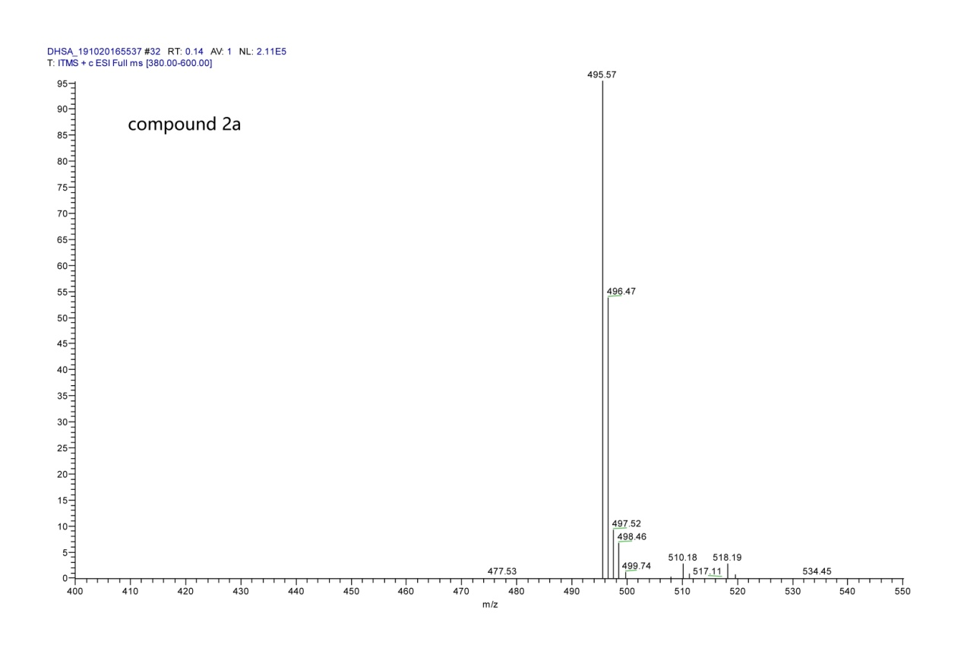

MS spectra of compound 2a

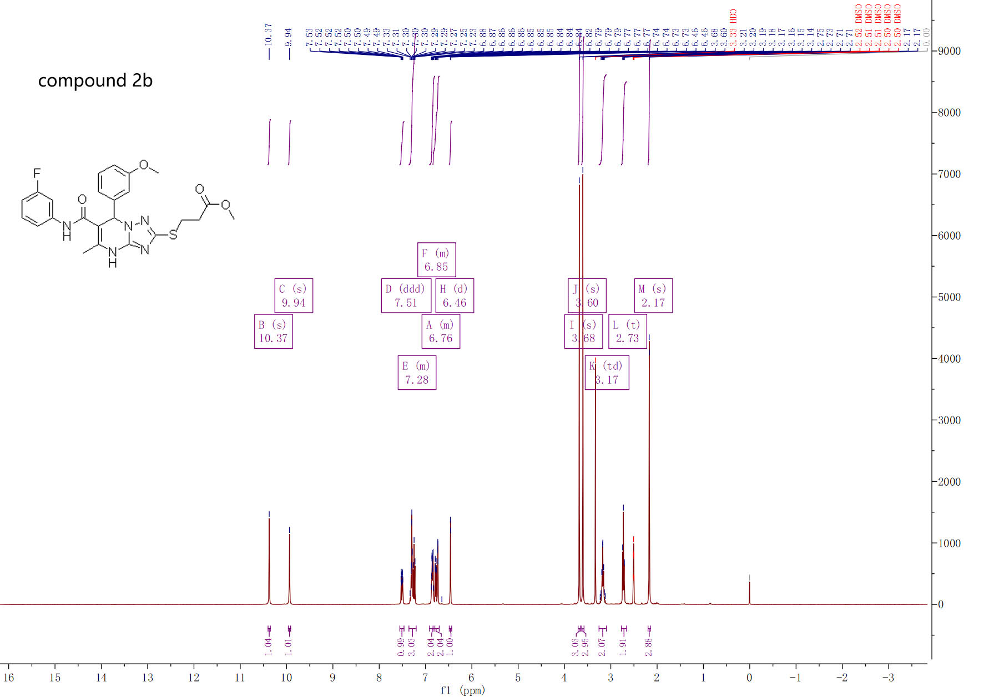

¹H-NMR spectra of compound 2b

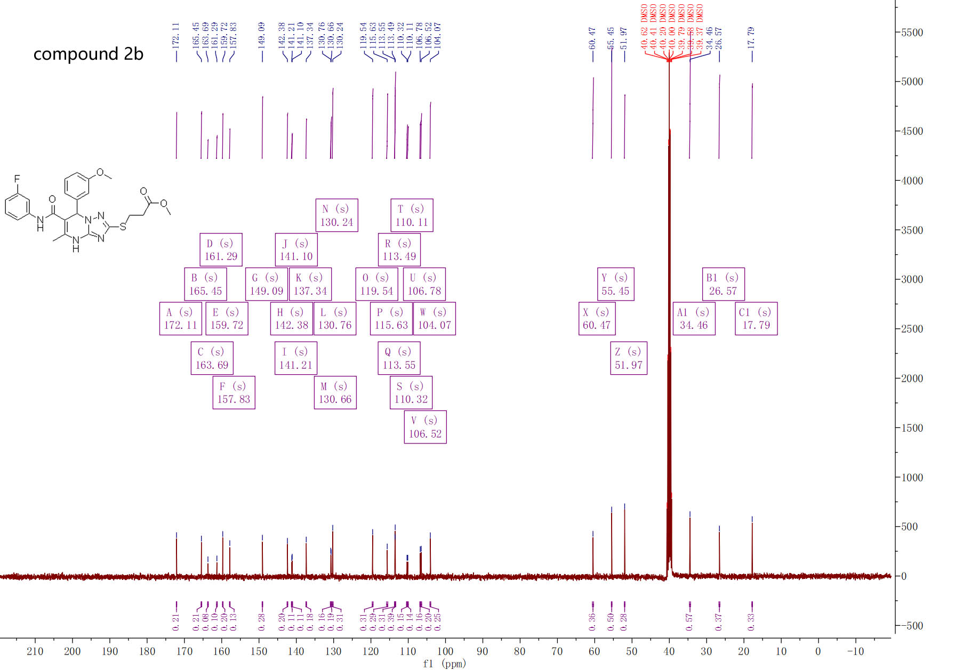

¹³C-NMR spectra of compound 2b

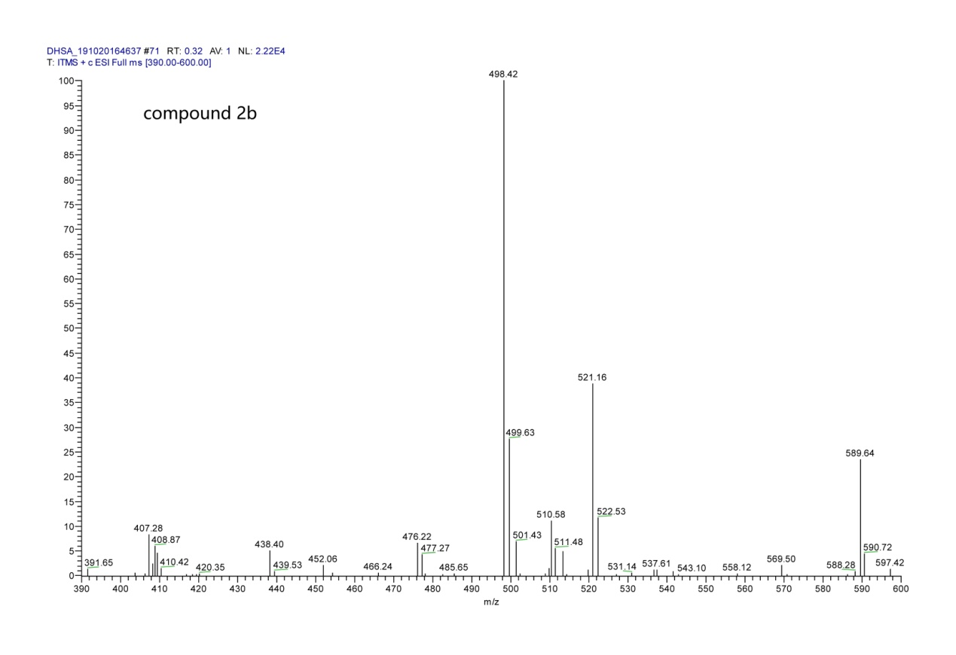

MS spectra of compound 2b

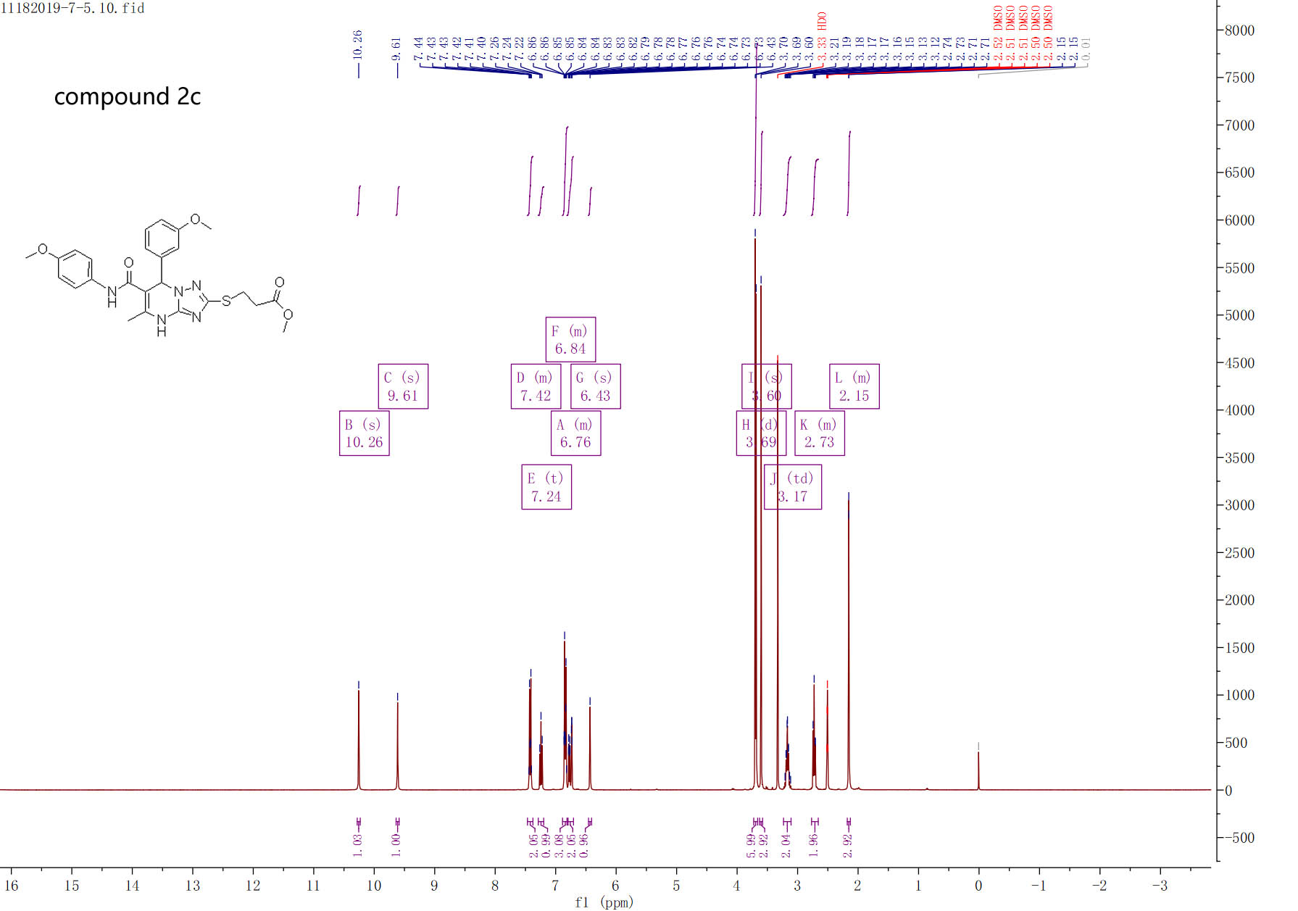

¹H-NMR spectra of compound 2c

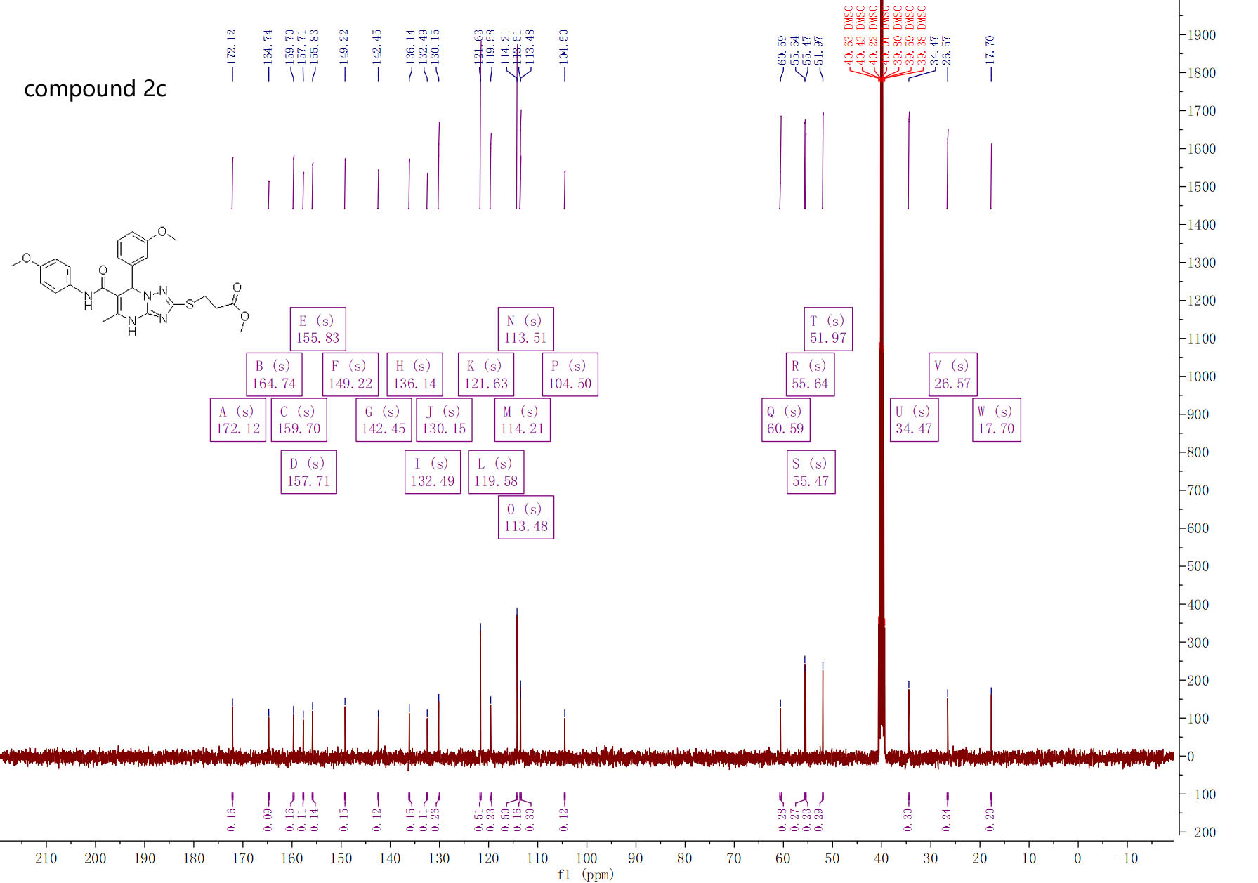

¹³C-NMR spectra of compound 2c

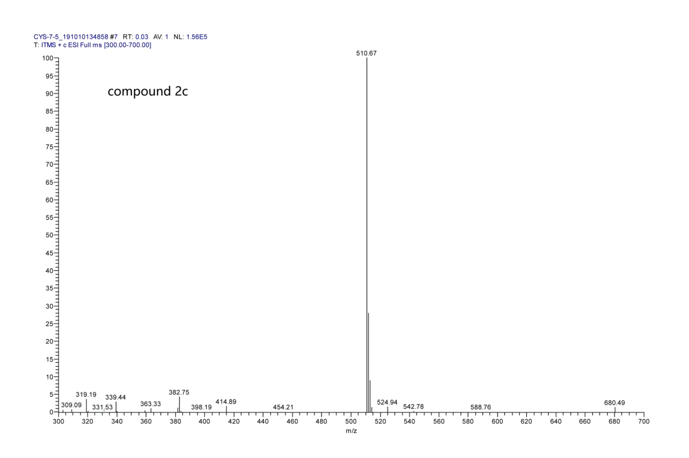

MS spectra of compound 2c

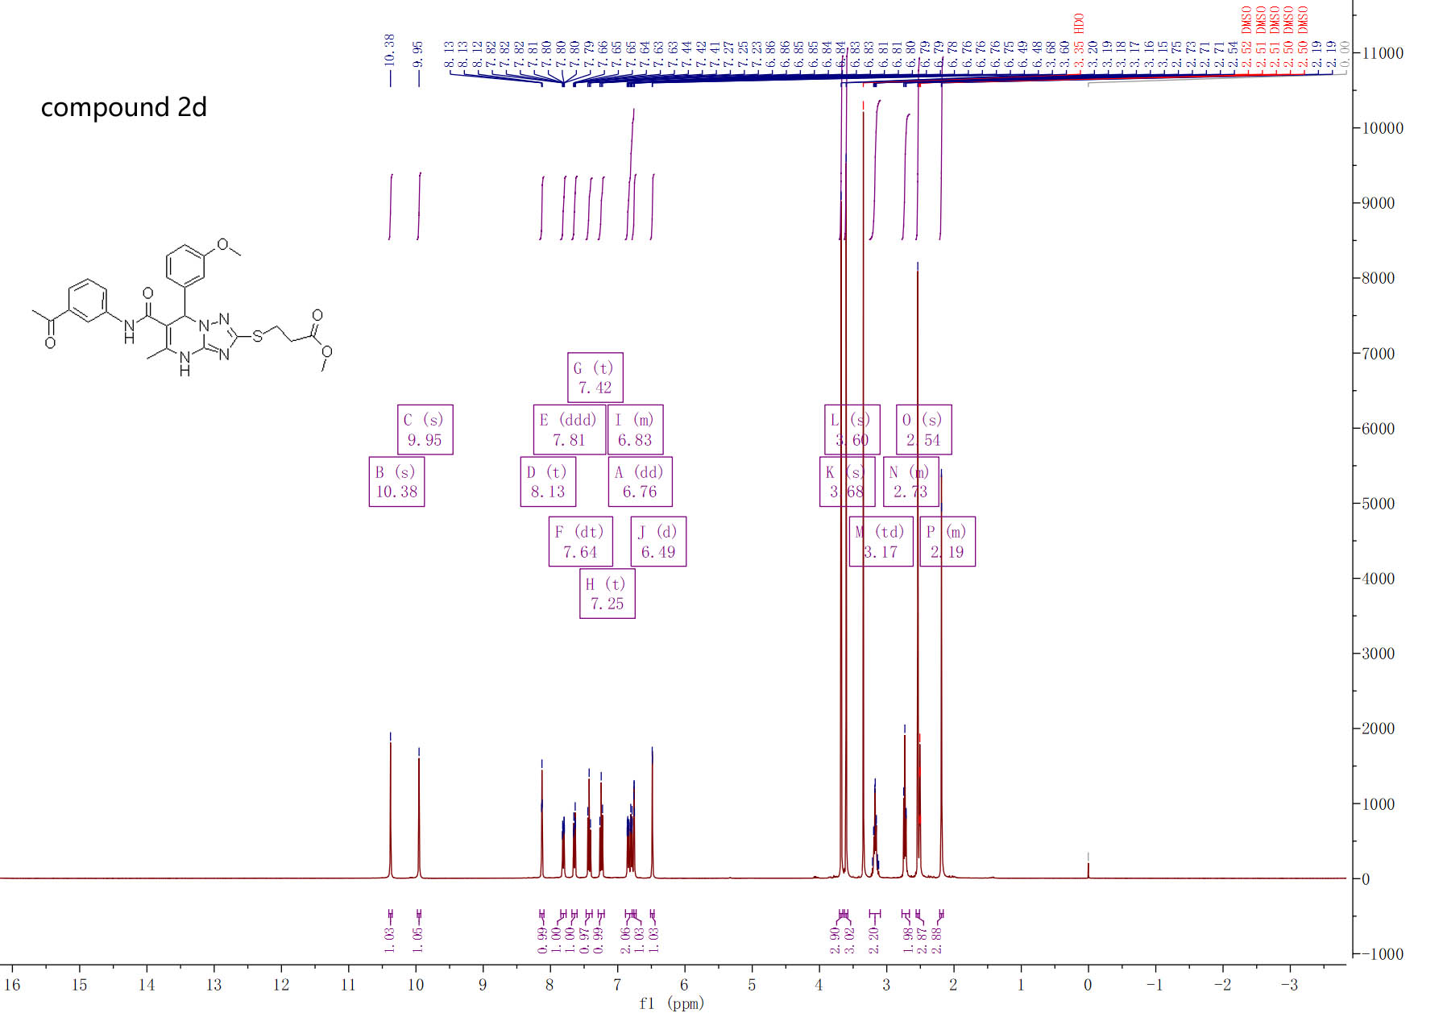

¹H-NMR spectra of compound 2d

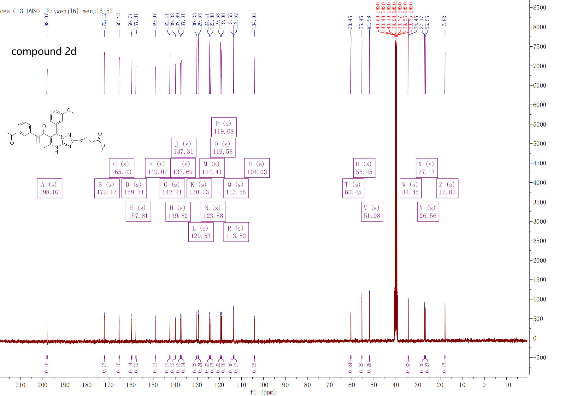

¹³C-NMR spectra of compound 2d

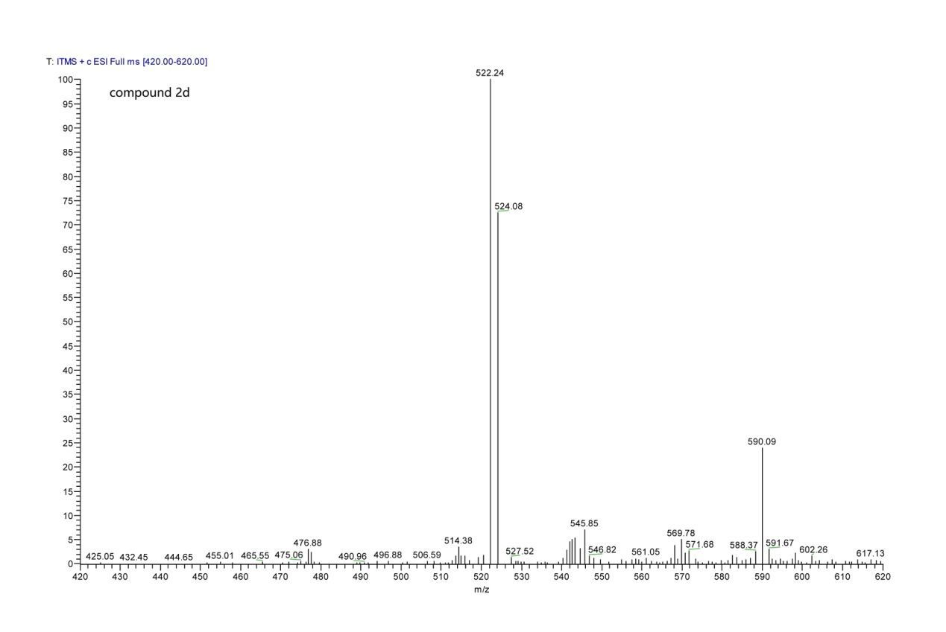

MS spectra of compound 2d

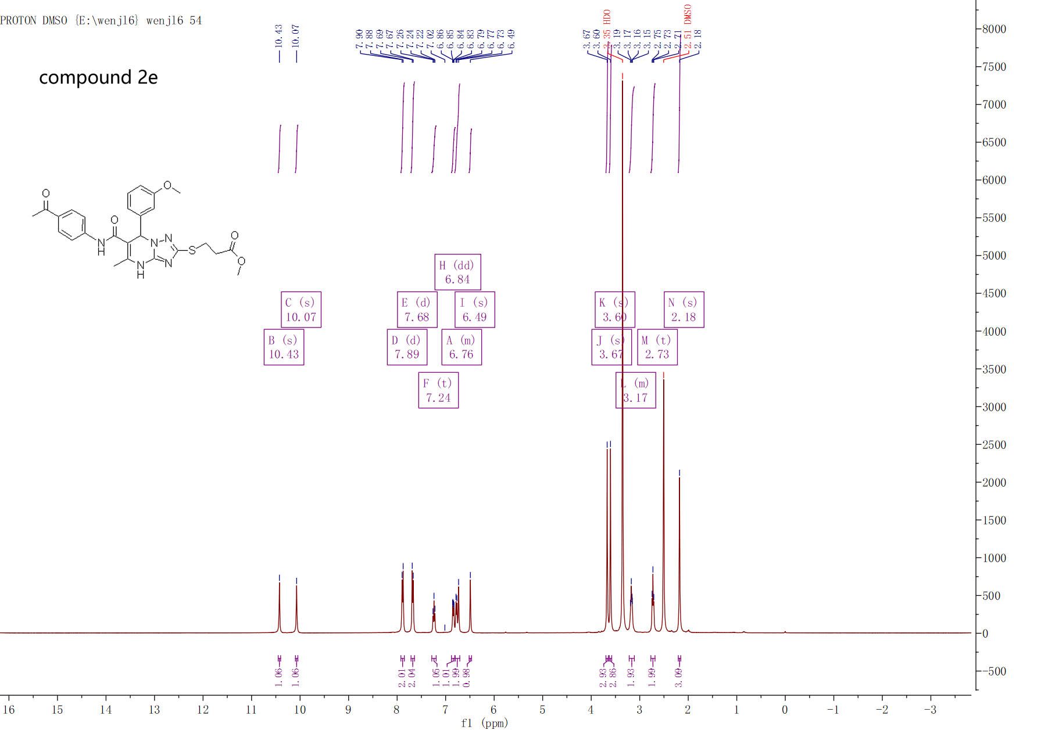

¹H-NMR spectra of compound 2e

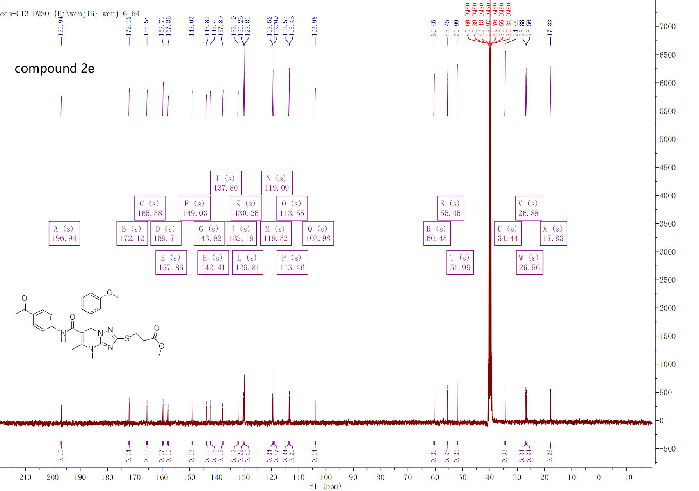

¹³C-NMR spectra of compound 2e

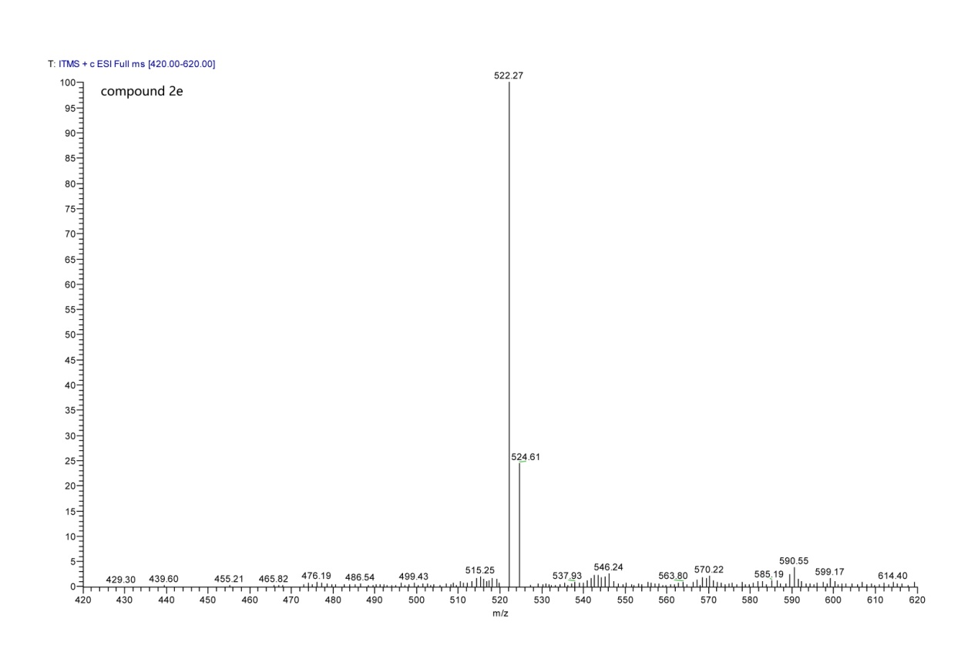

MS spectra of compound 2e

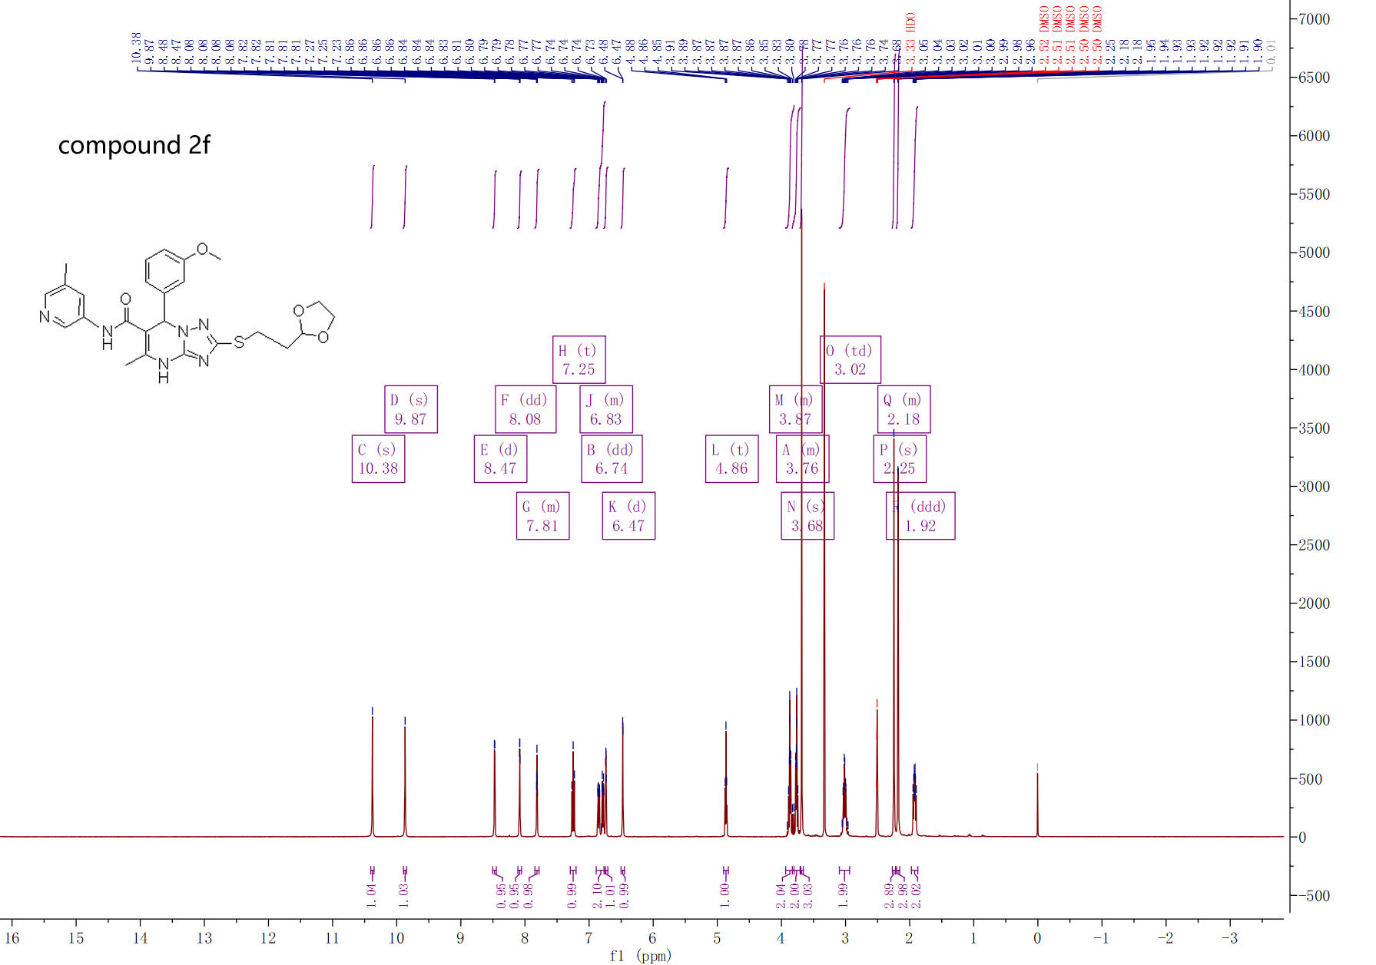

¹H-NMR spectra of compound 2f

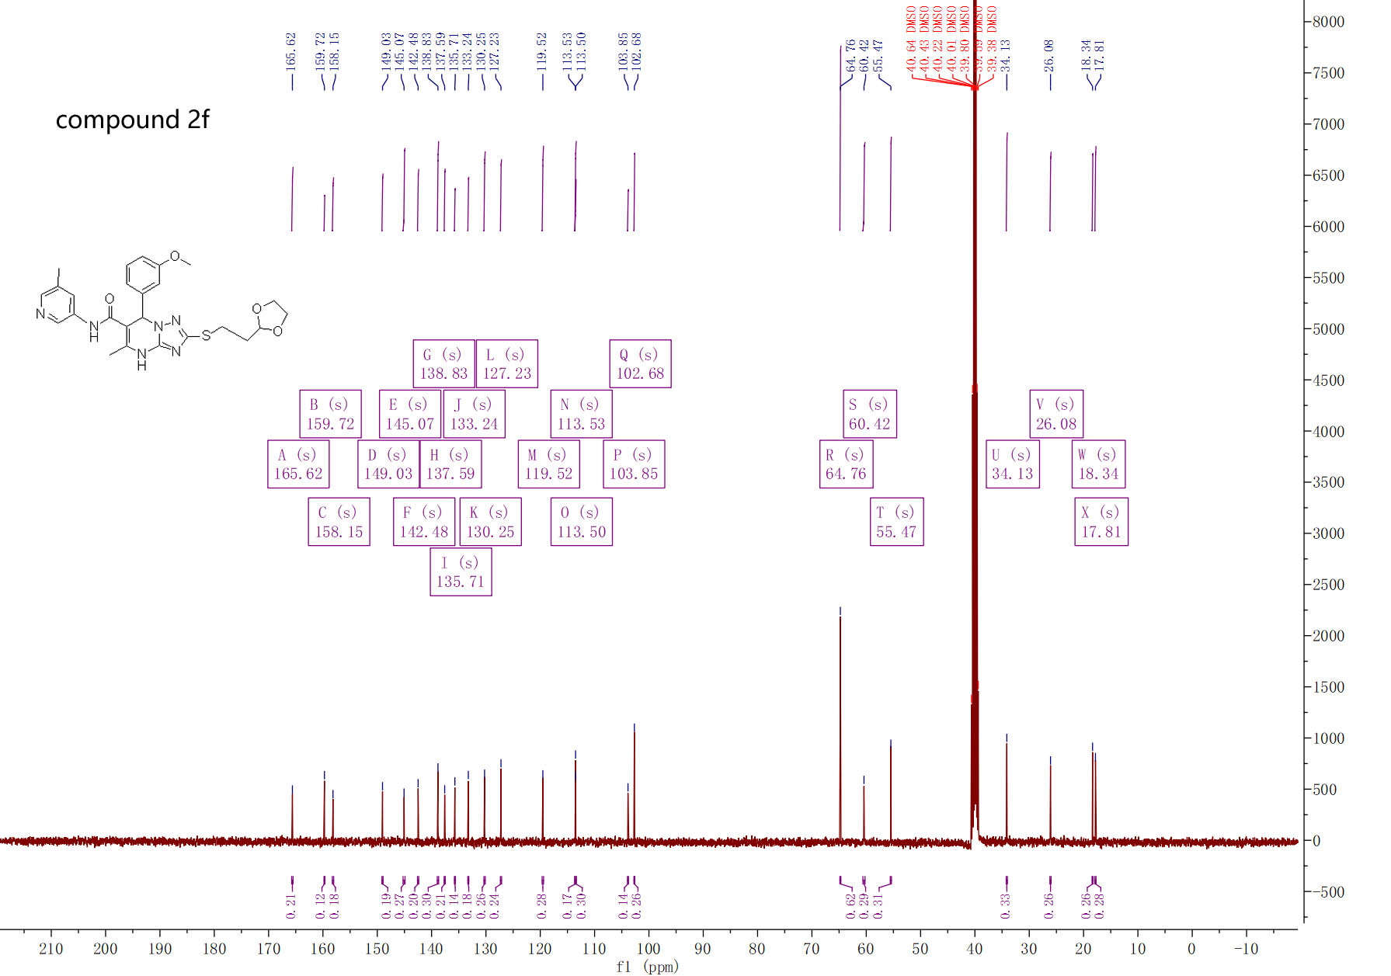

¹³C-NMR spectra of compound 2f

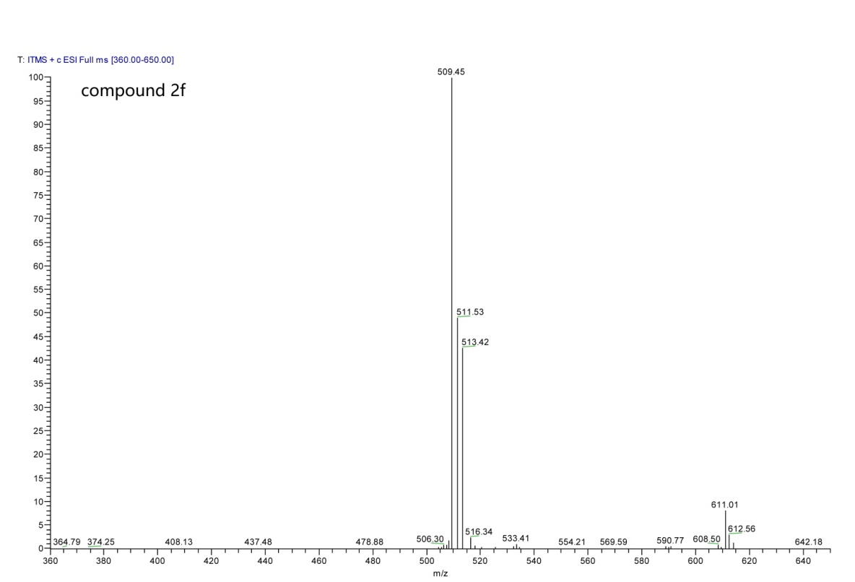

MS spectra of compound 2f

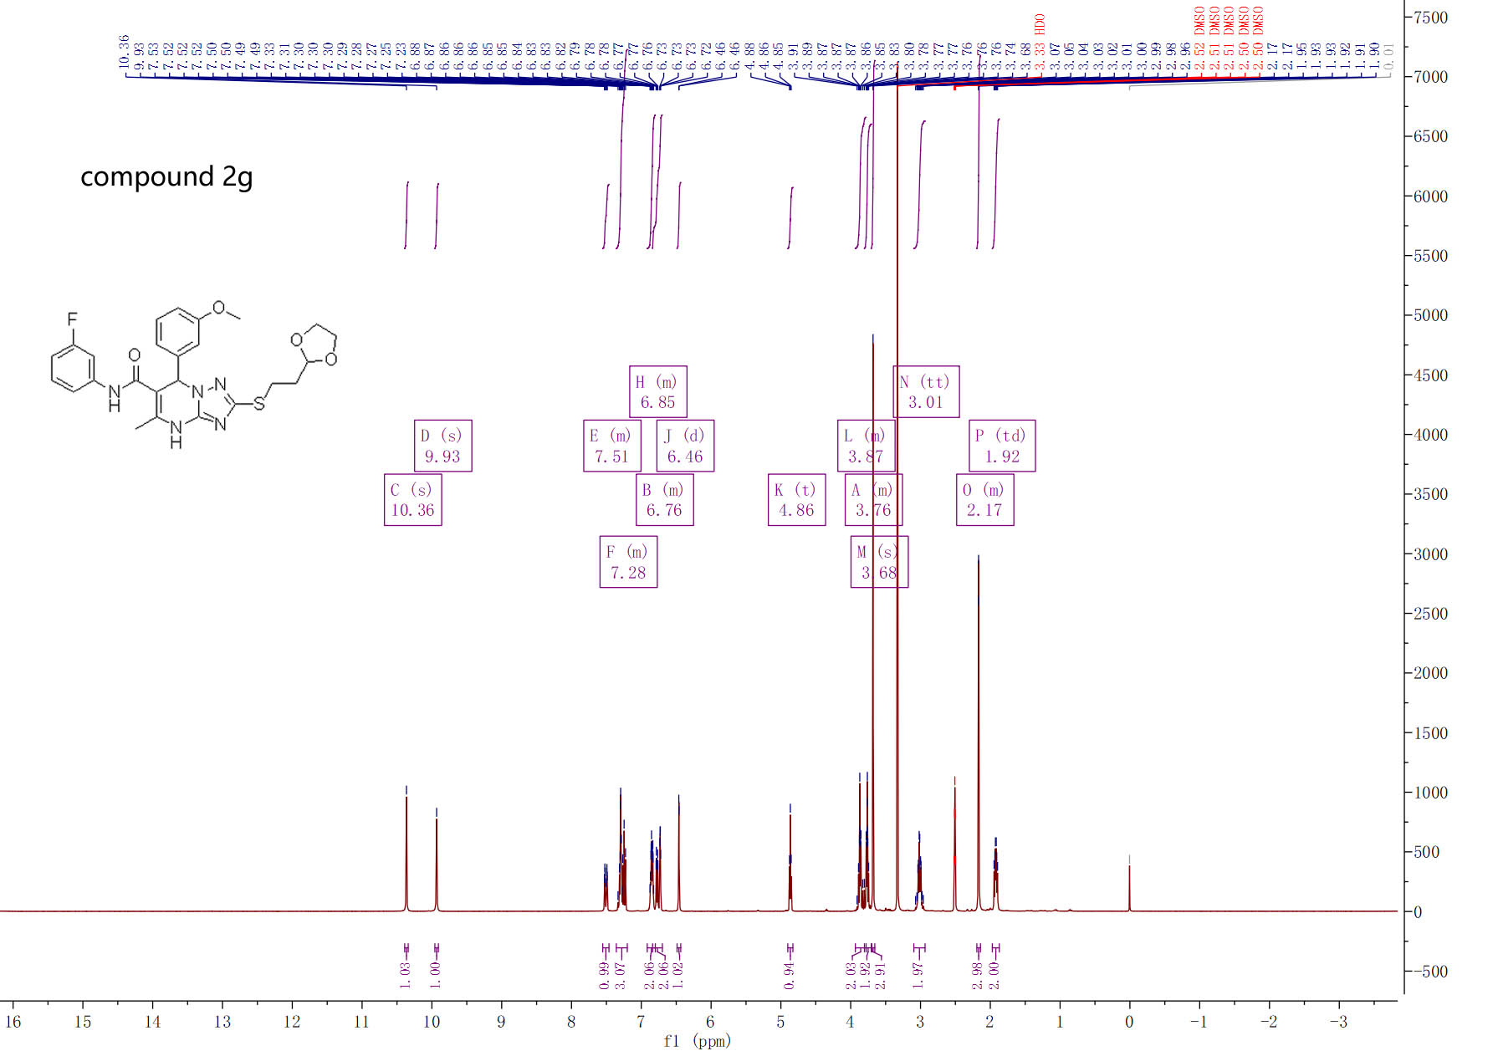

¹H-NMR spectra of compound 2g

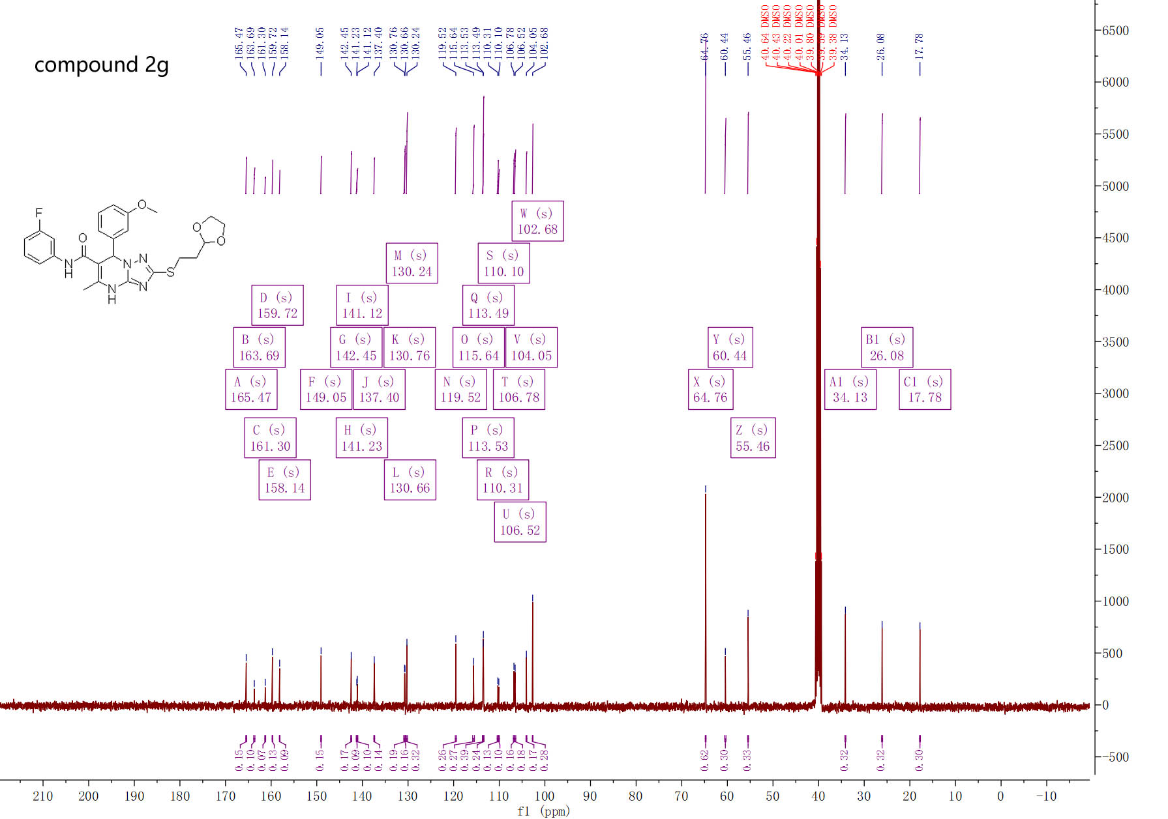

¹³C-NMR spectra of compound 2g

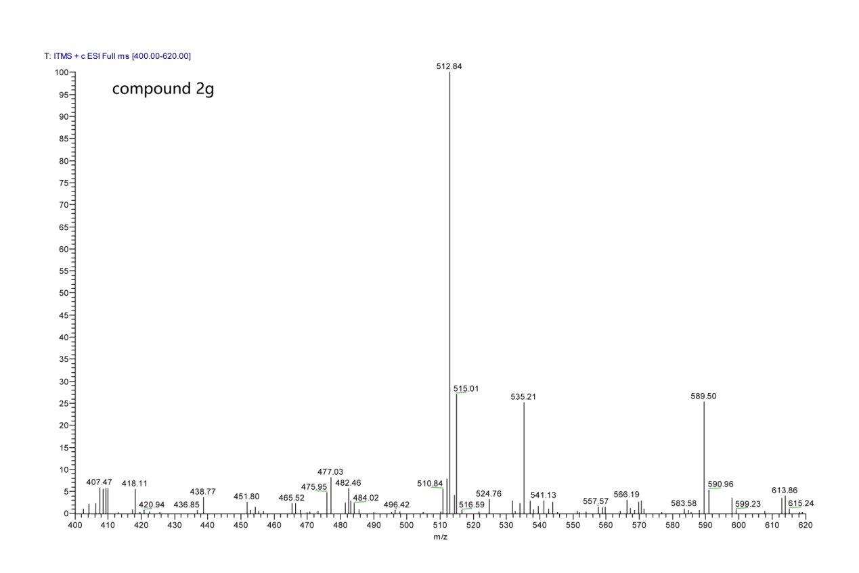

MS spectra of compound 2g

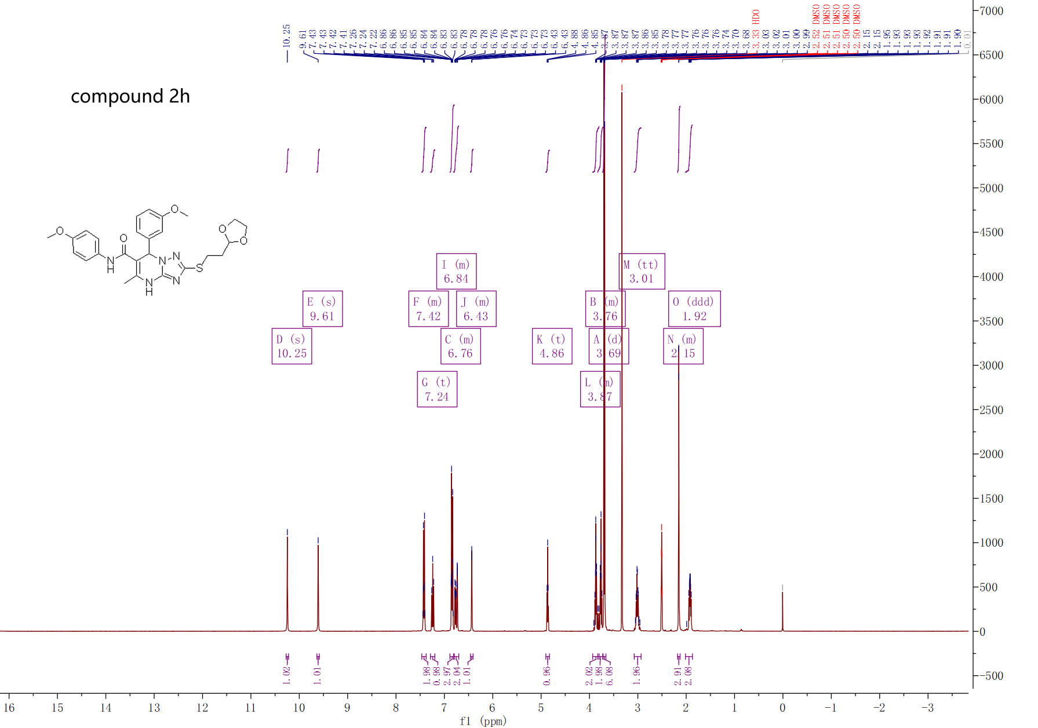

¹H-NMR spectra of compound 2h

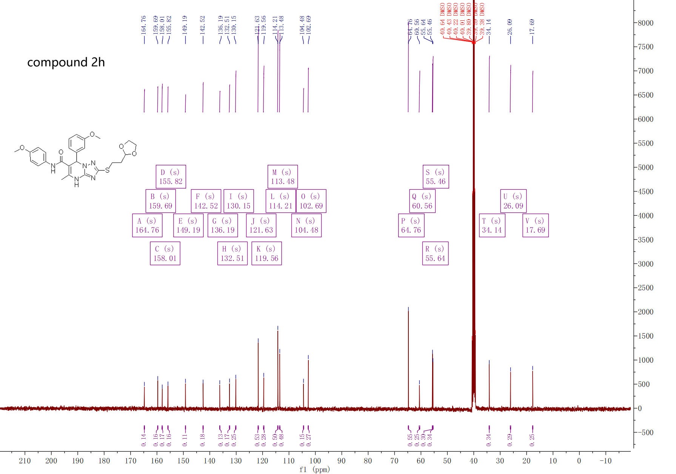

¹³C-NMR spectra of compound 2h

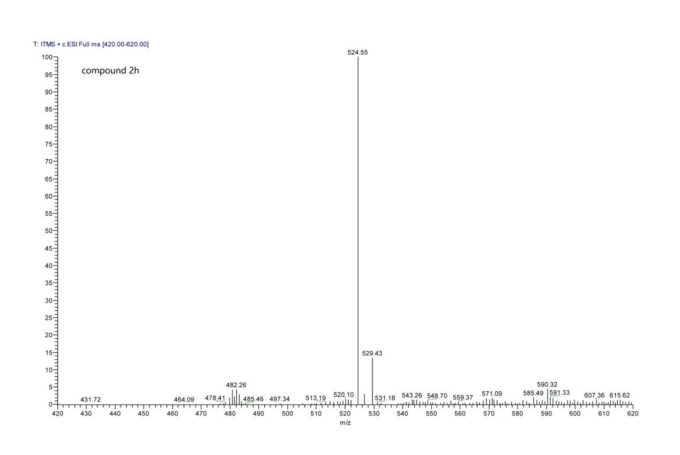

MS spectra of compound 2h

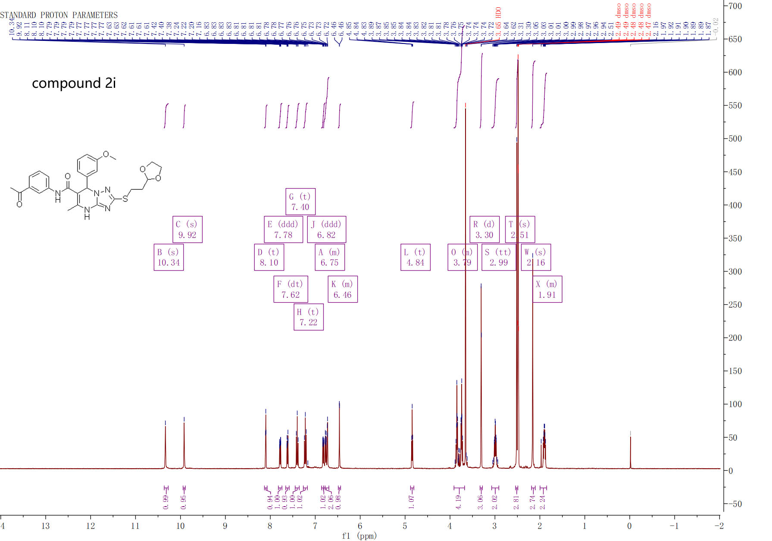

¹H-NMR spectra of compound 2i

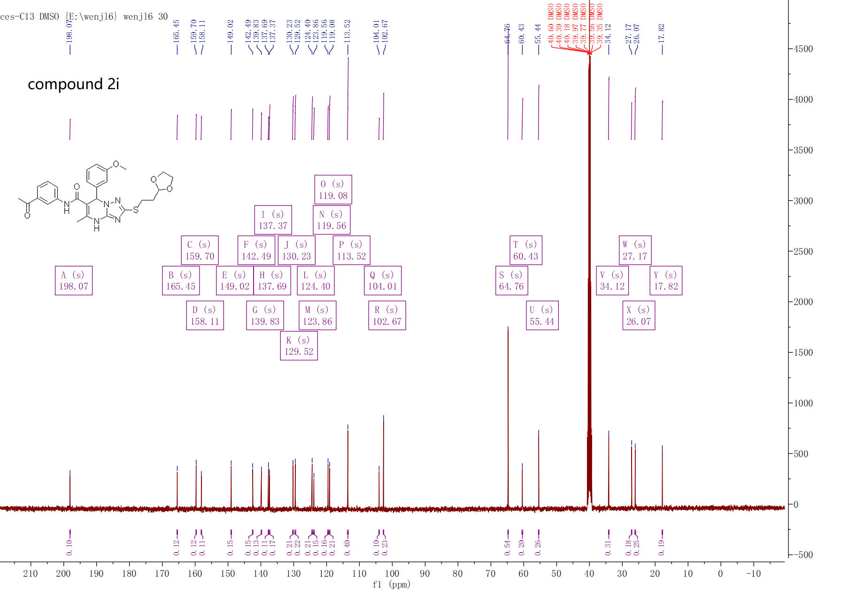

¹³C-NMR spectra of compound 2i
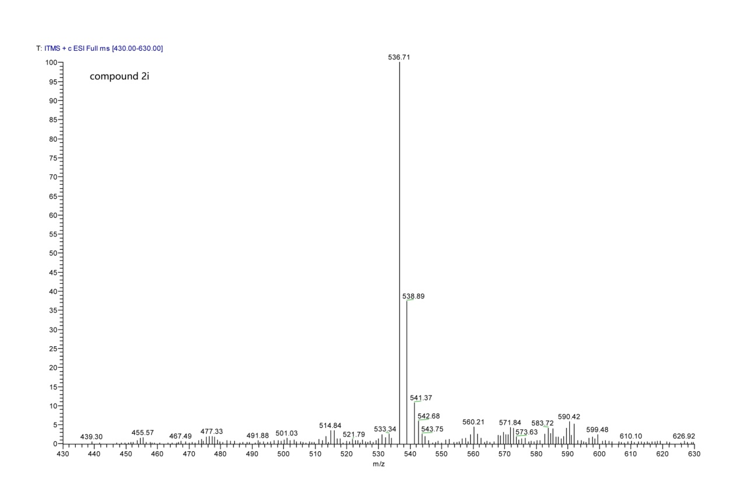

MS spectra of compound 2i

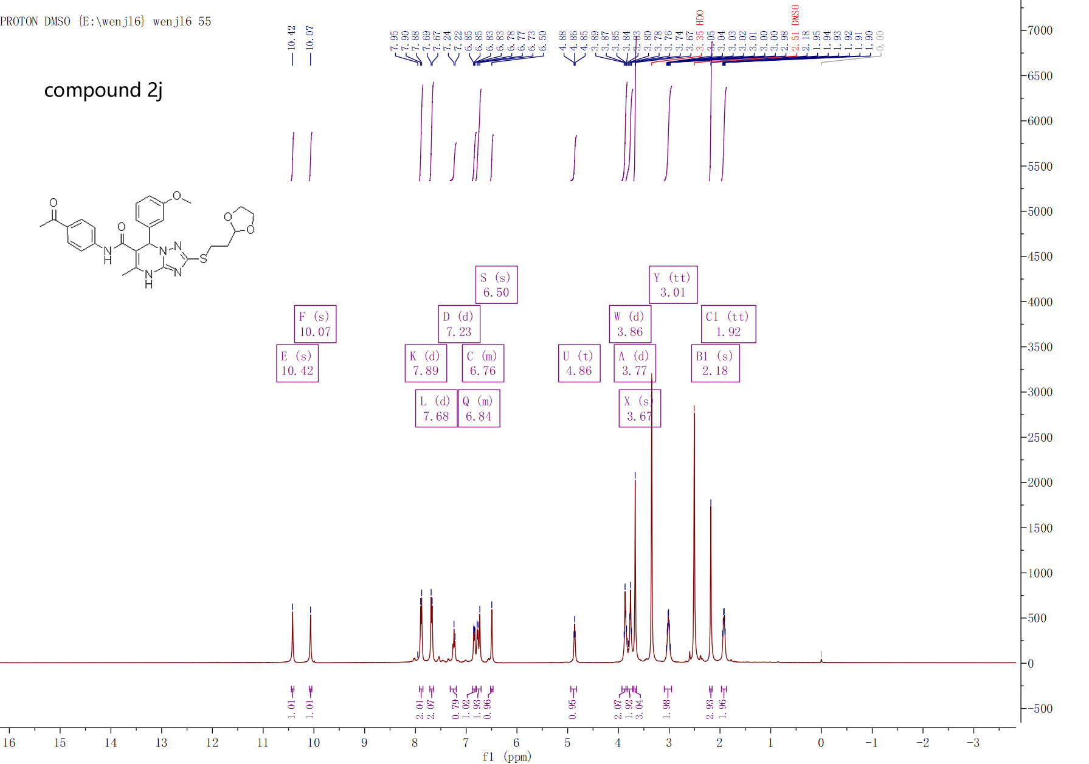

¹H-NMR spectra of compound 2j

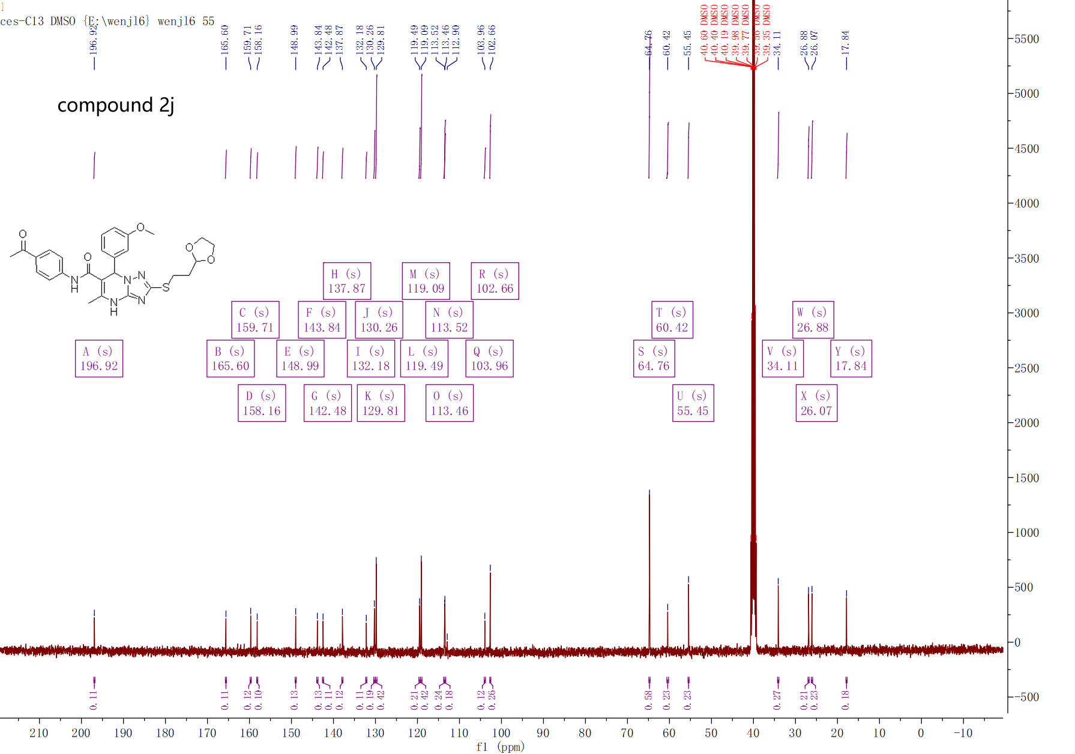

¹³C-NMR spectra of compound 2j

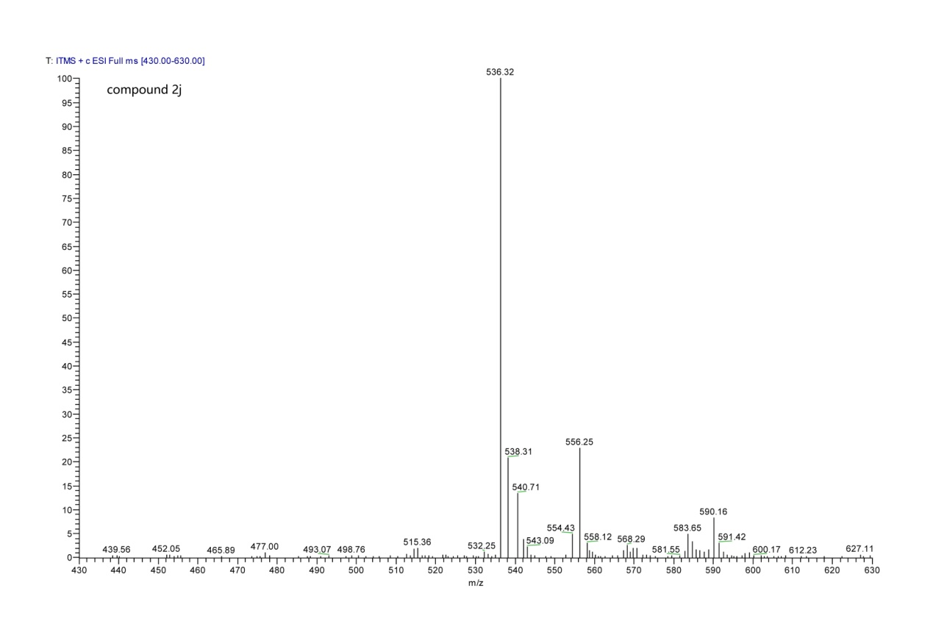

MS spectra of compound 2j

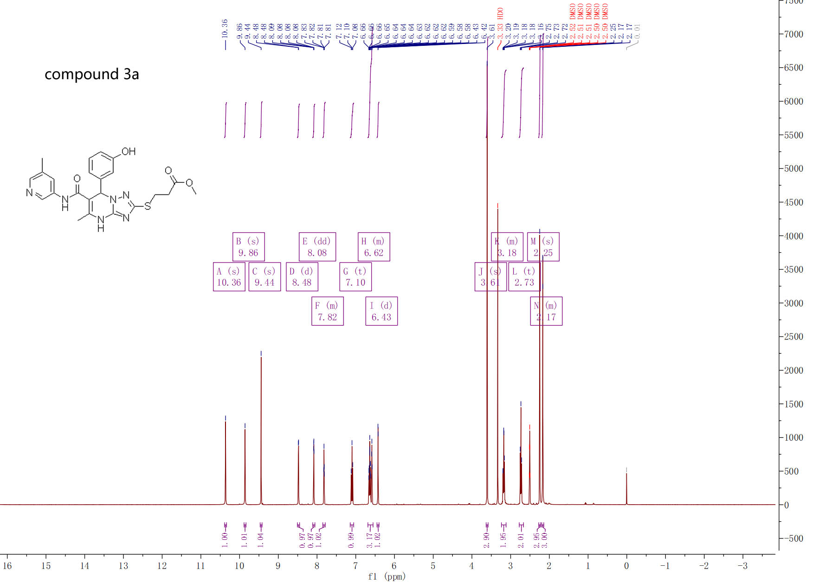

¹H-NMR spectra of compound 3a

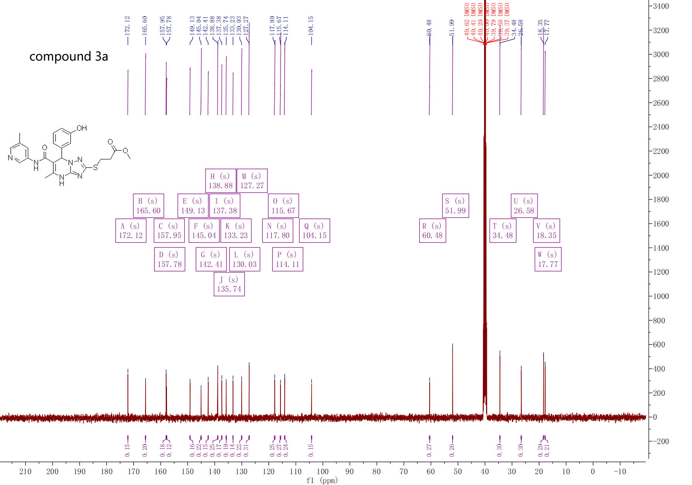

¹³C-NMR spectra of compound 3a
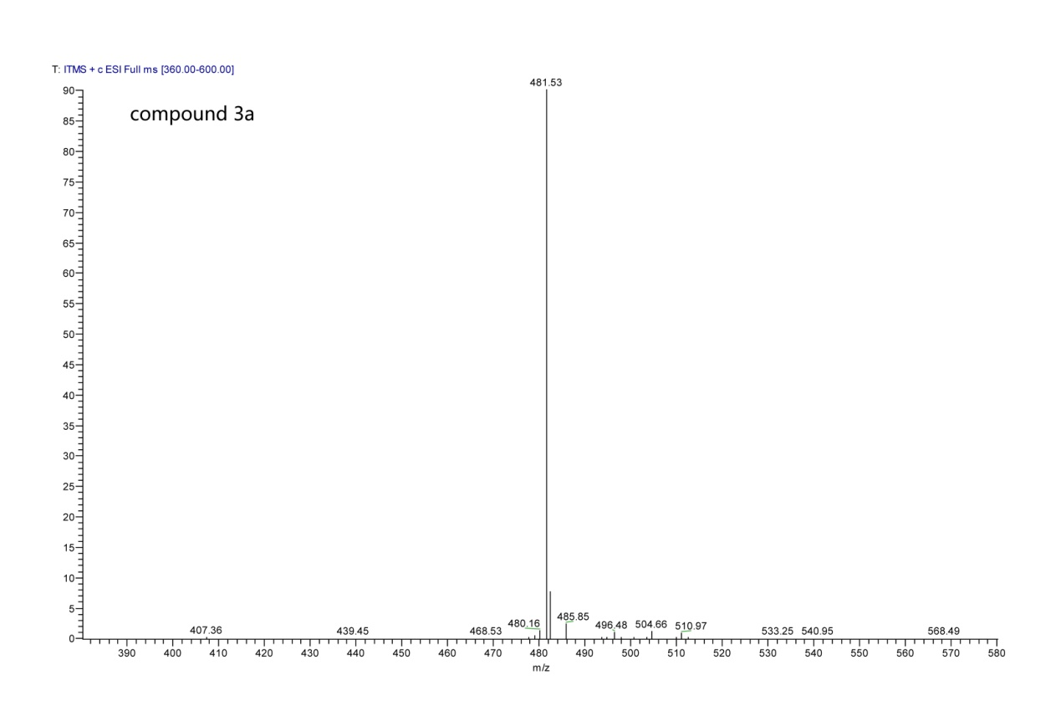

MS spectra of compound 3a

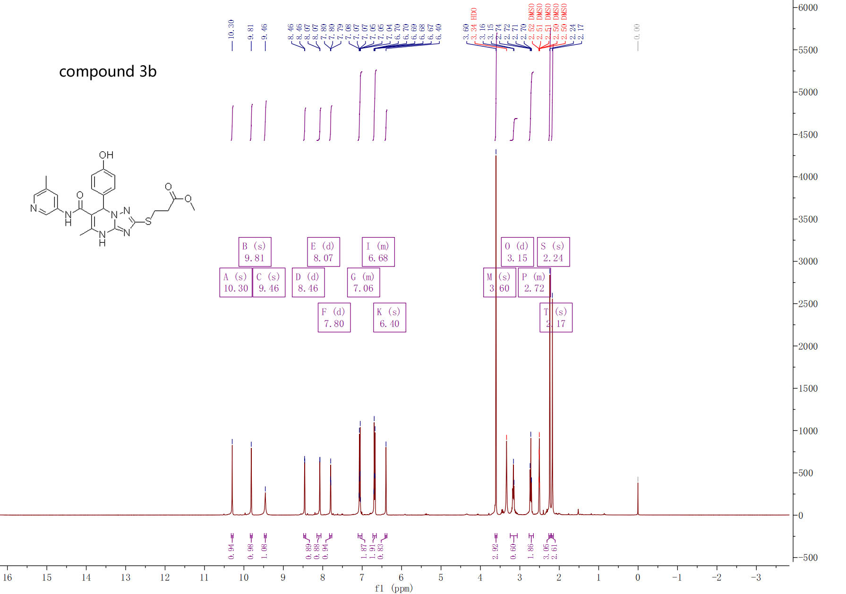

¹H-NMR spectra of compound 3b

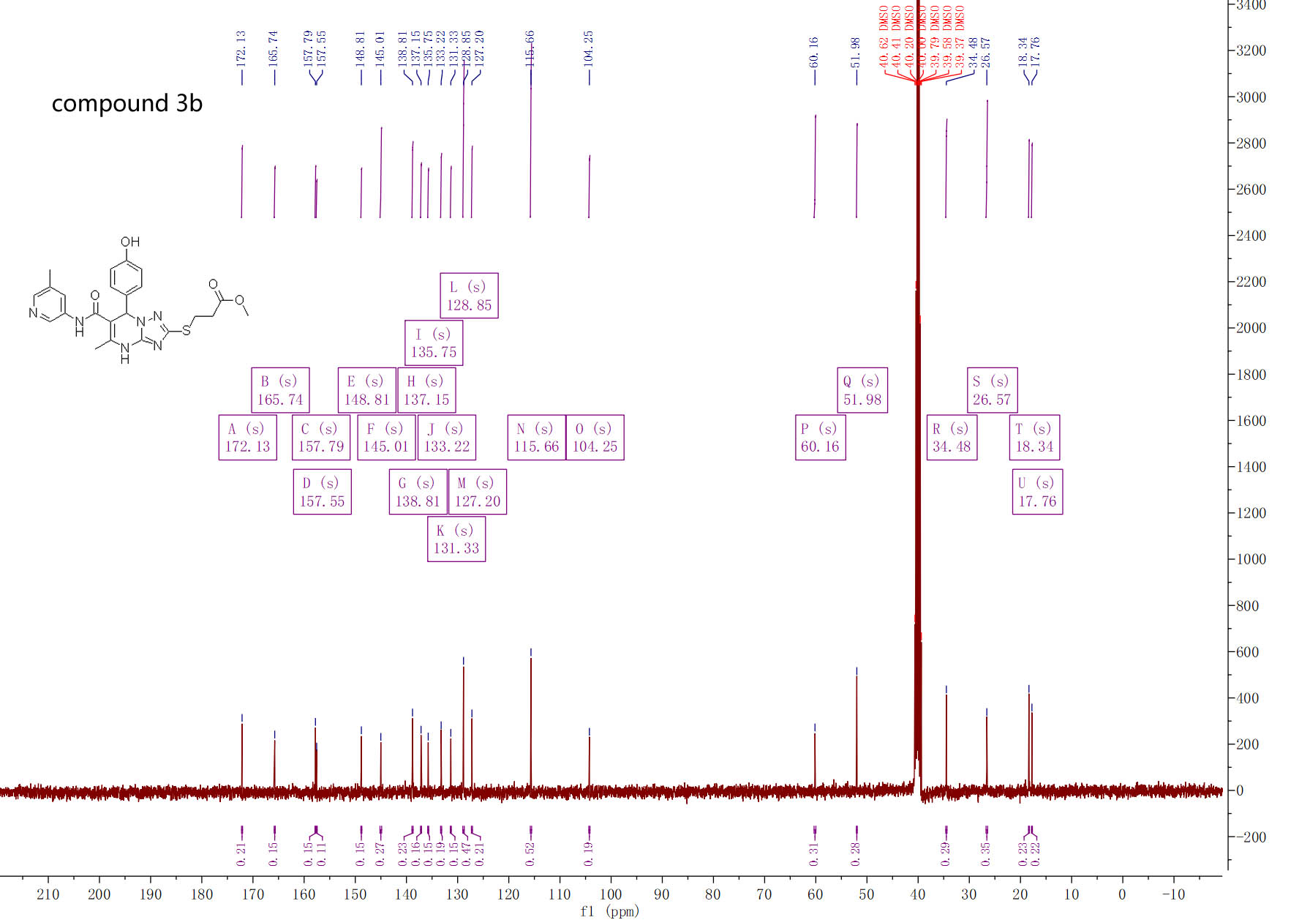

¹³C-NMR spectra of compound 3b

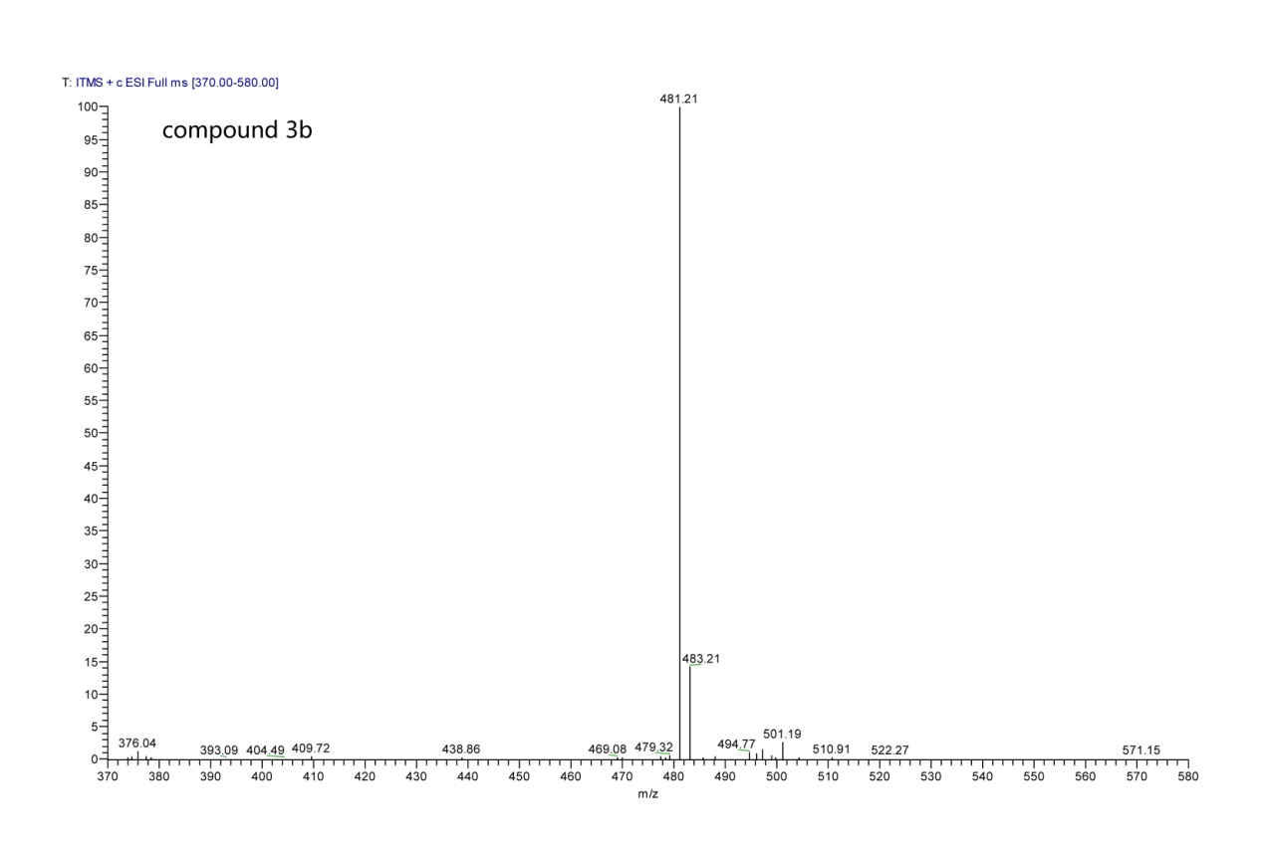

MS spectra of compound 3b

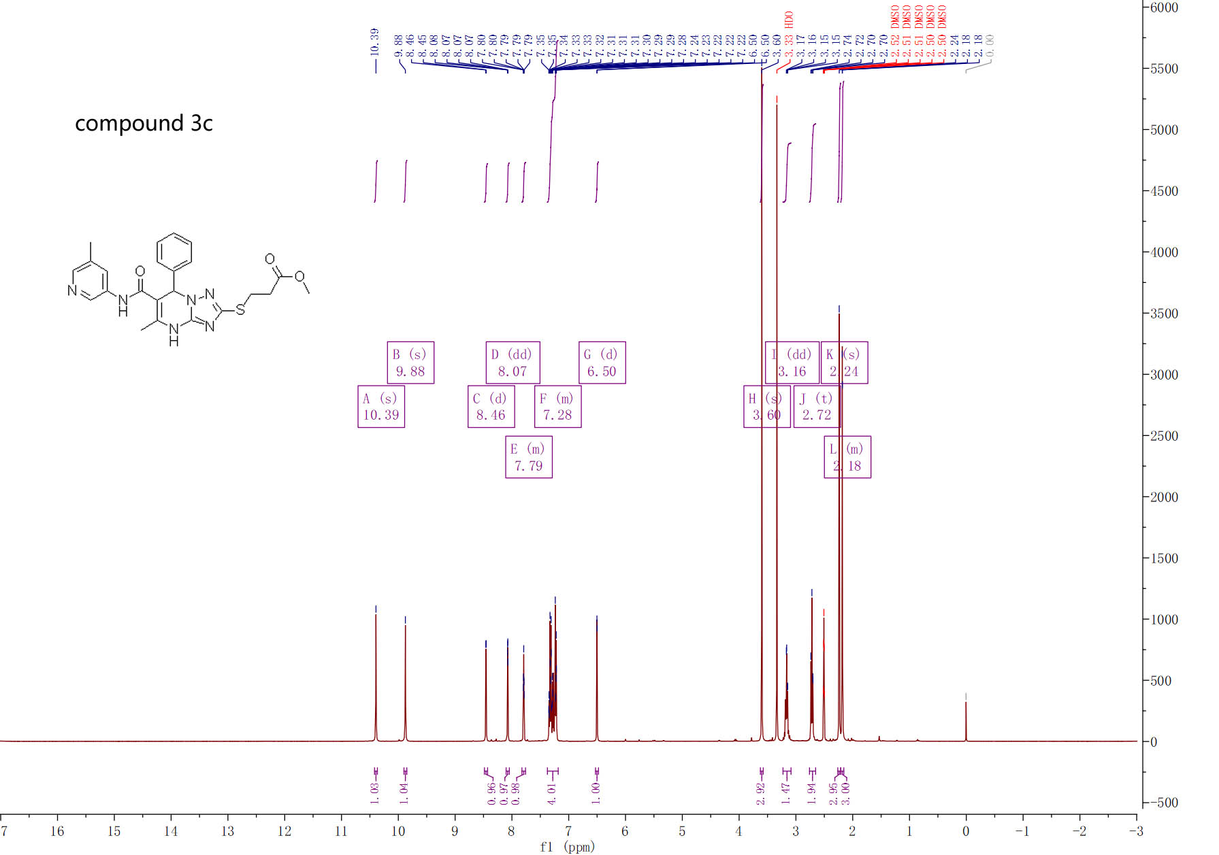

¹H-NMR spectra of compound 3c

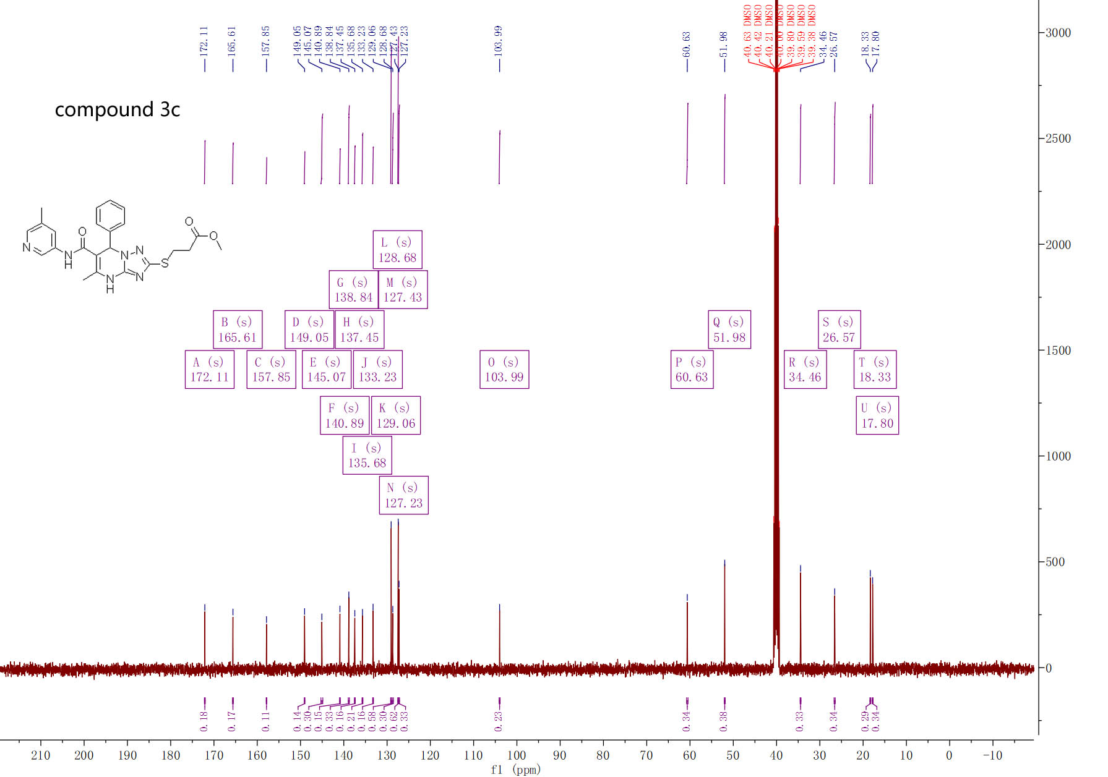

¹³C-NMR spectra of compound 3c

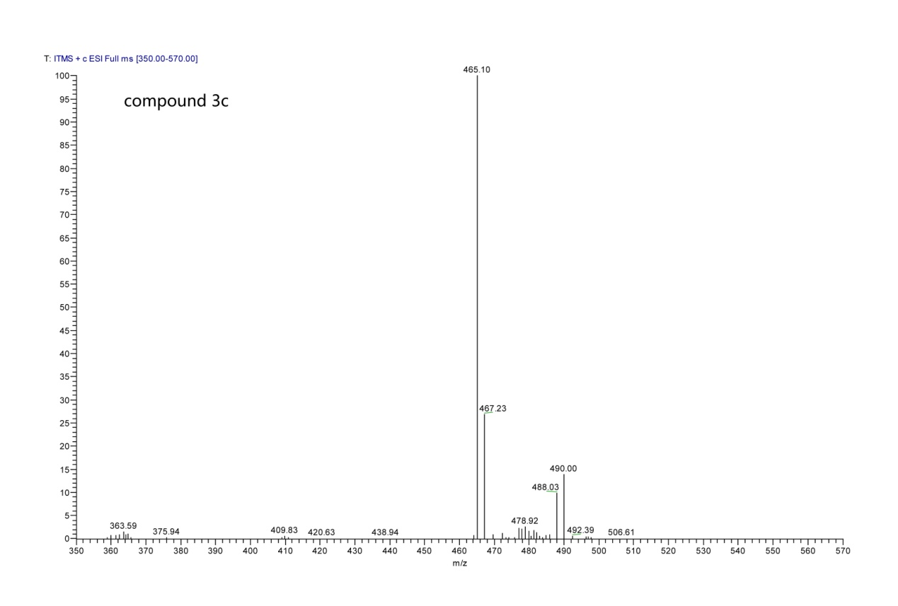

MS spectra of compound 3c

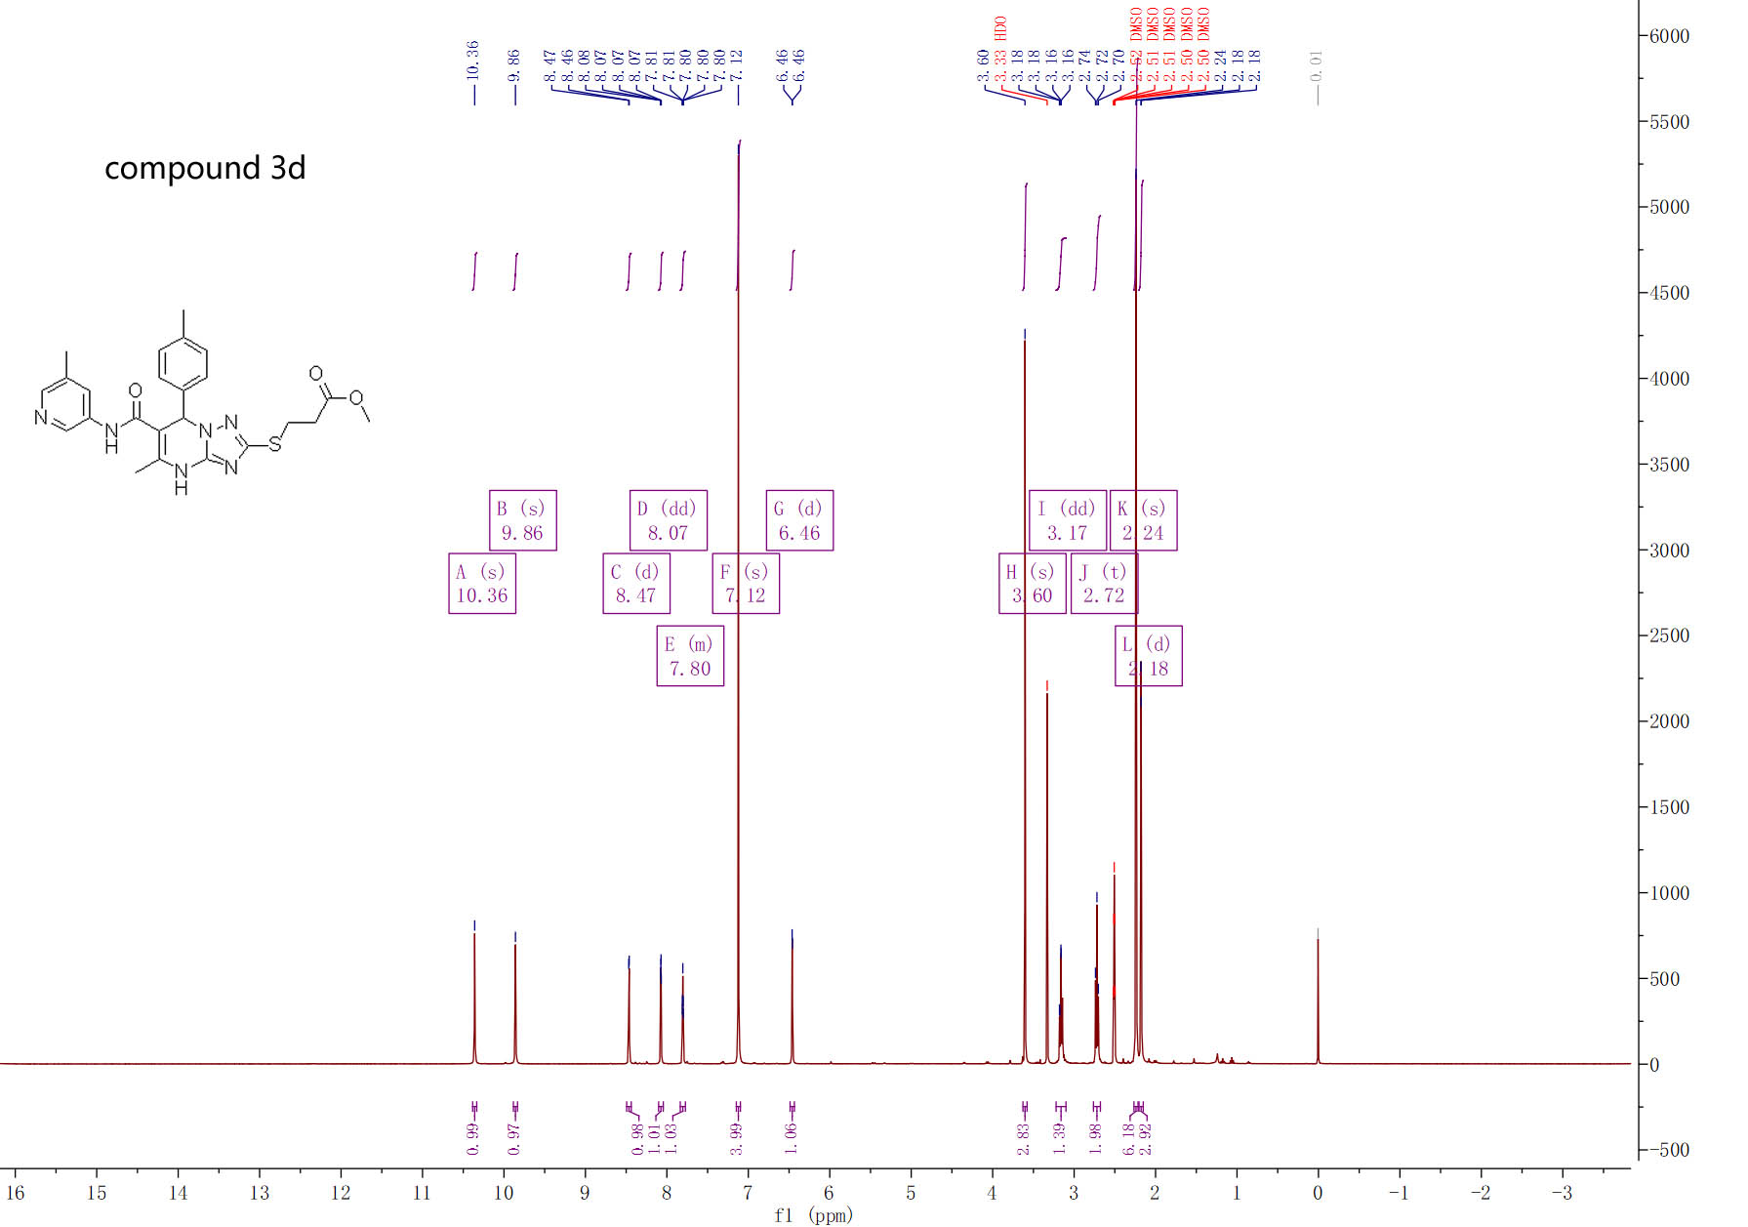

¹H-NMR spectra of compound 3d

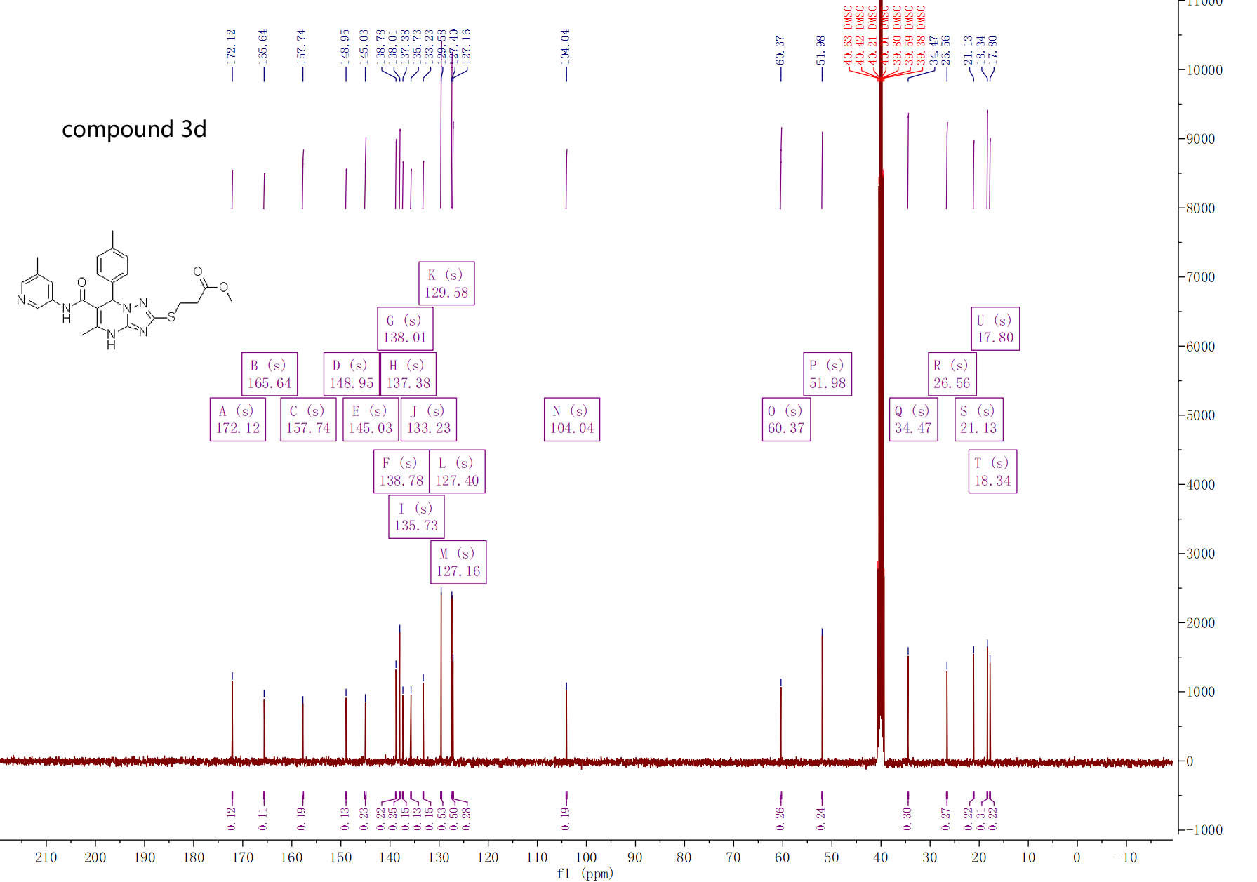

¹³C-NMR spectra of compound 3d

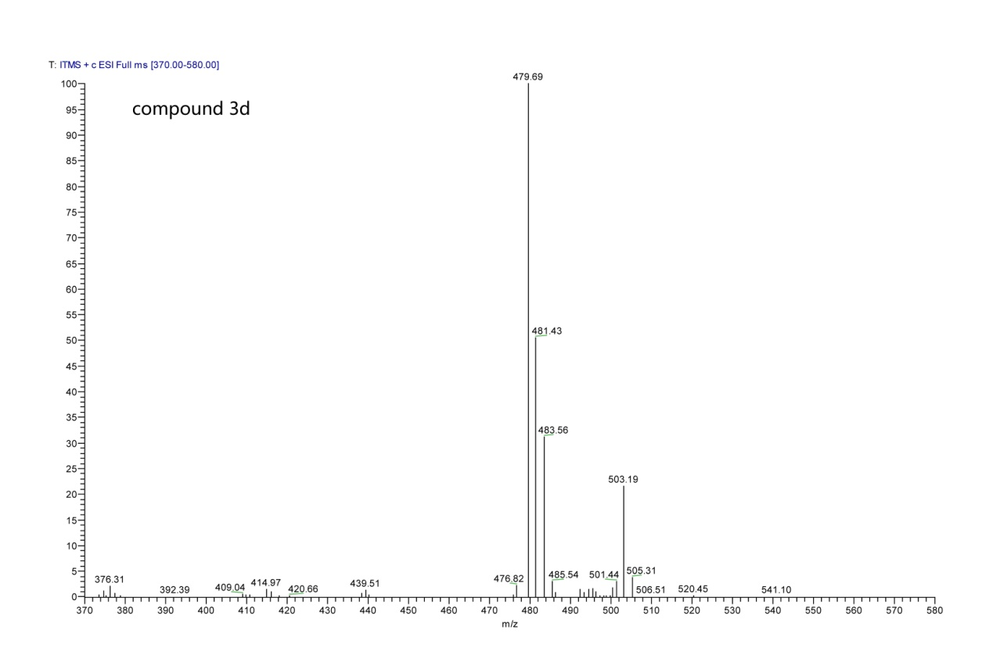

MS spectra of compound 3d

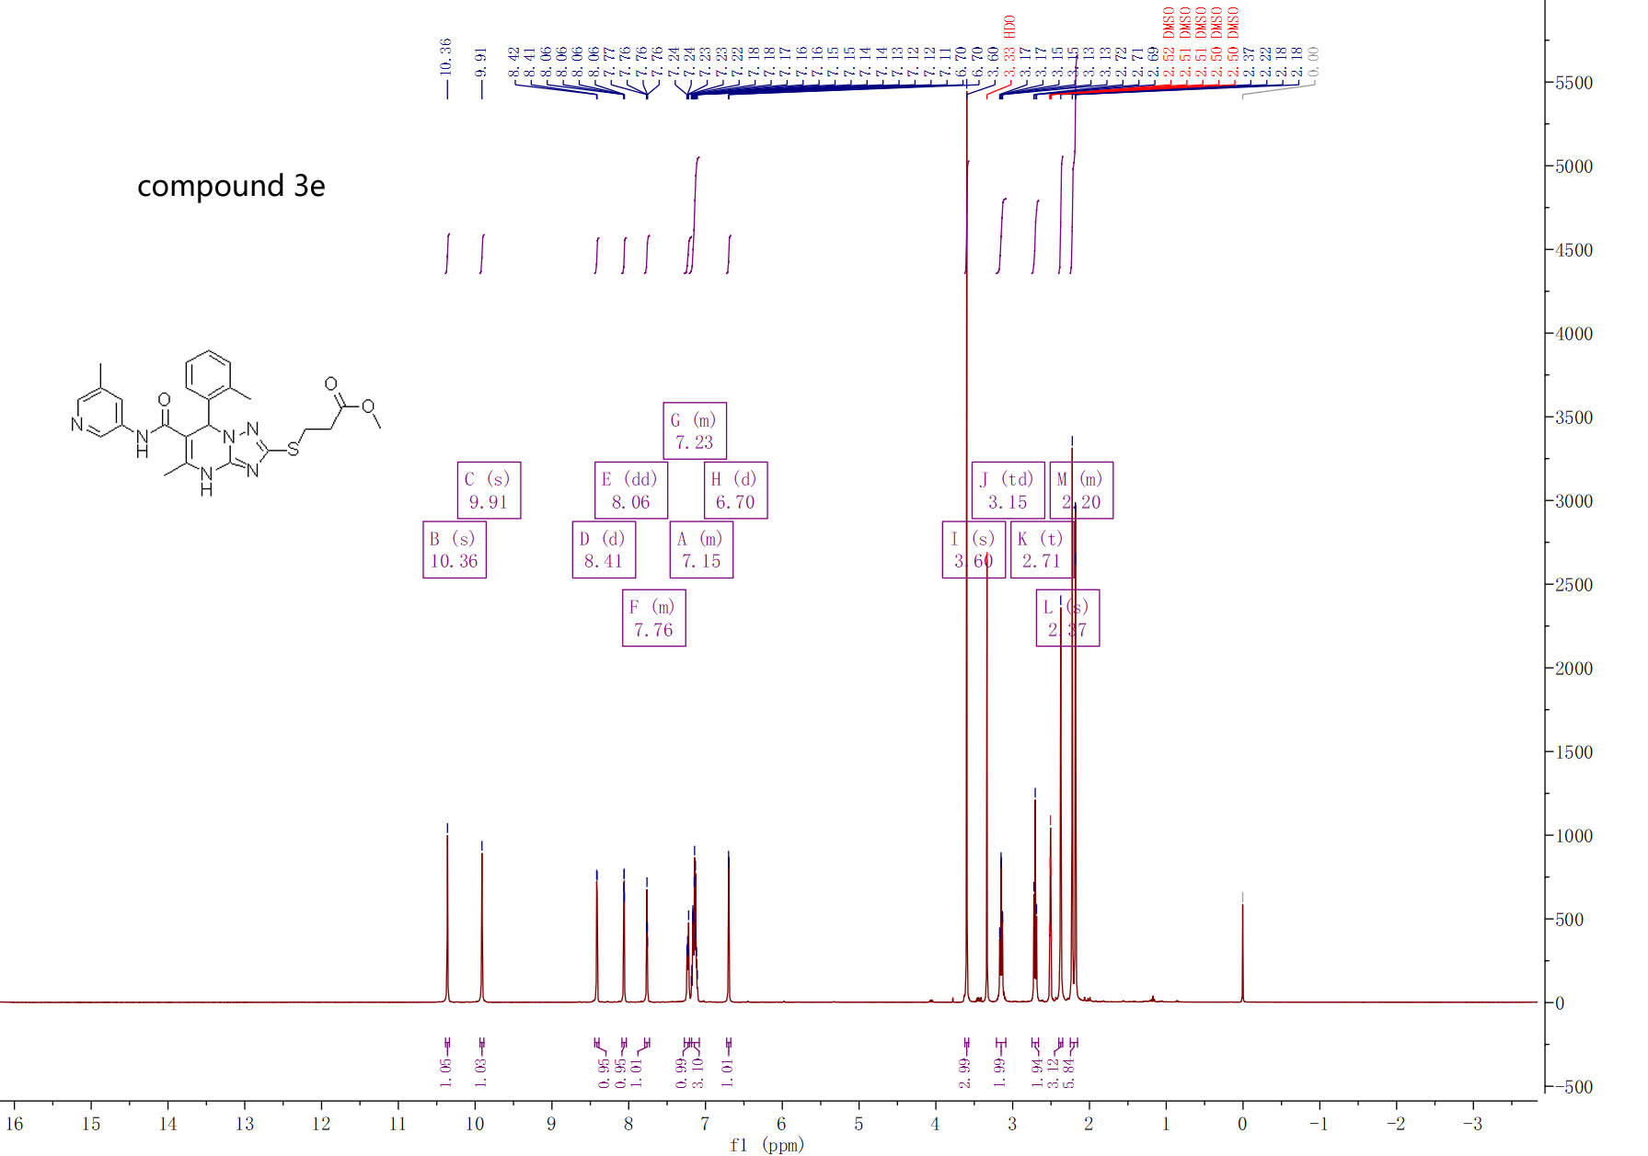

¹H-NMR spectra of compound 3e

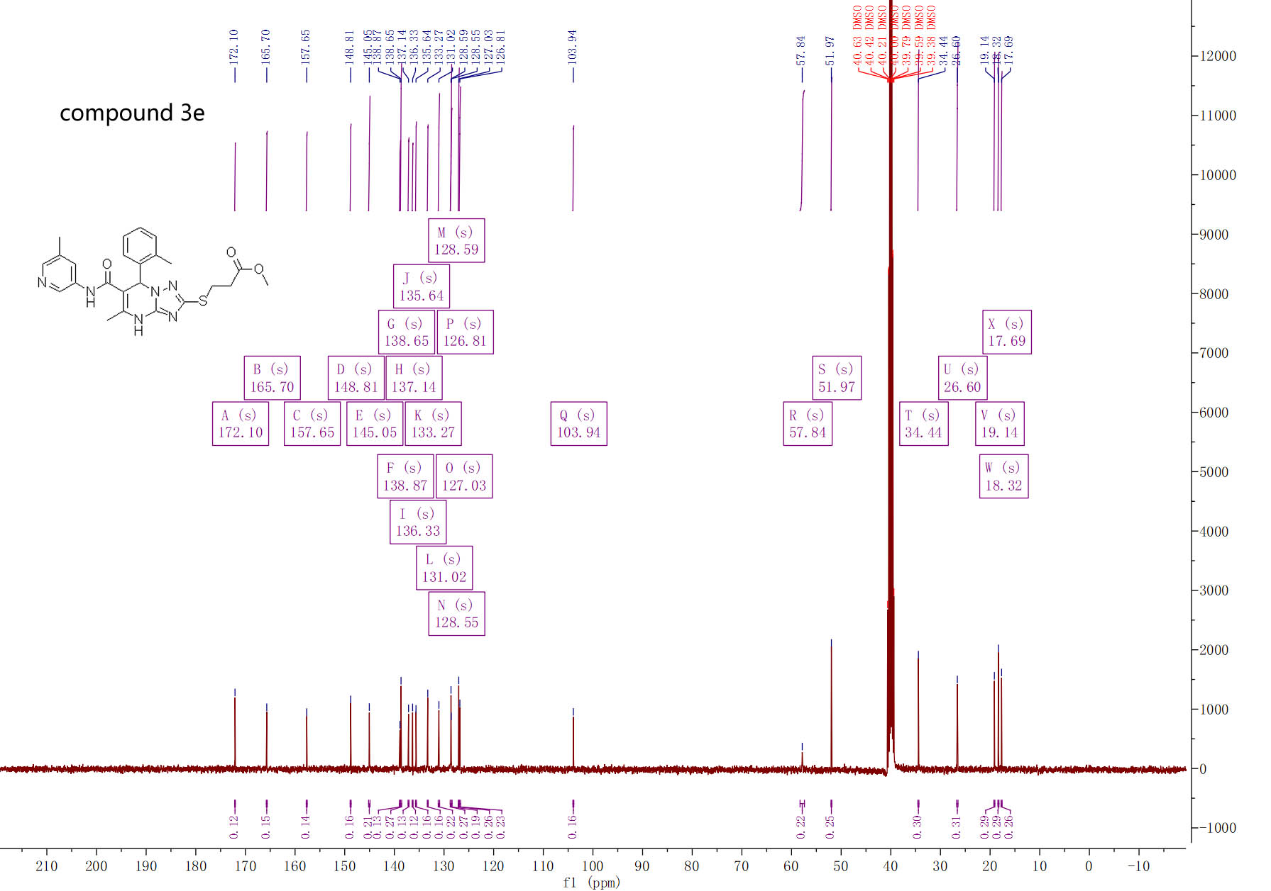

¹³C-NMR spectra of compound 3e

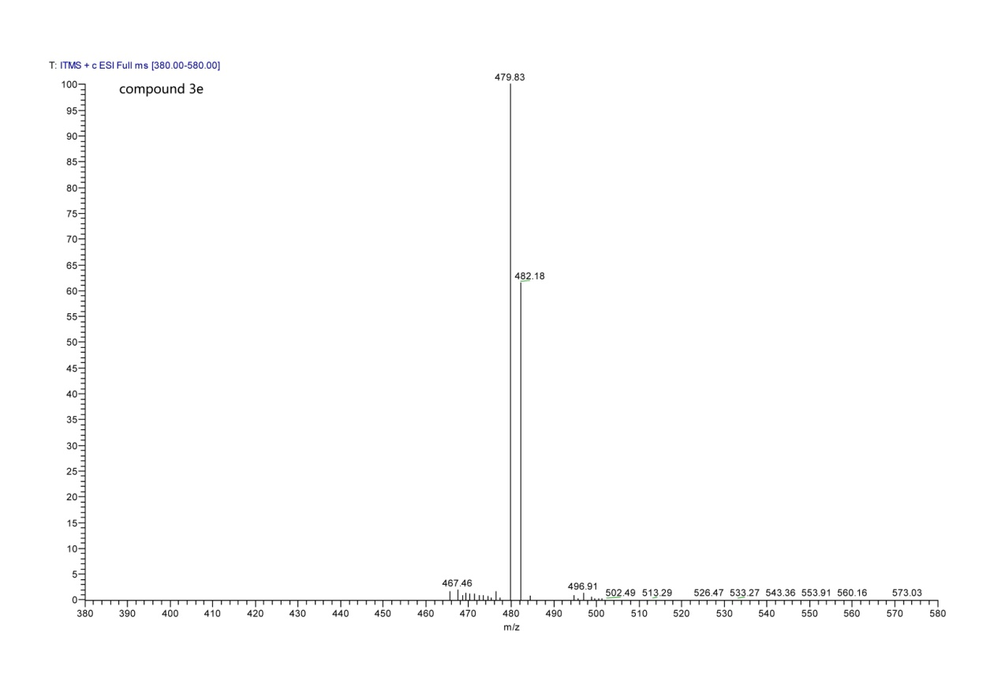

MS spectra of compound 3e

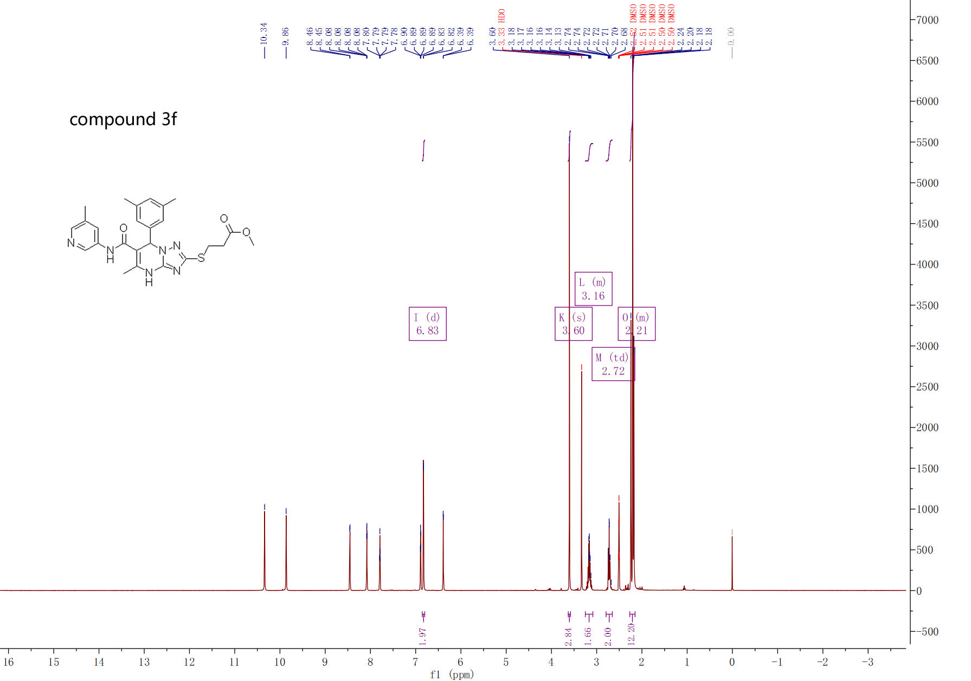

¹H-NMR spectra of compound 3f

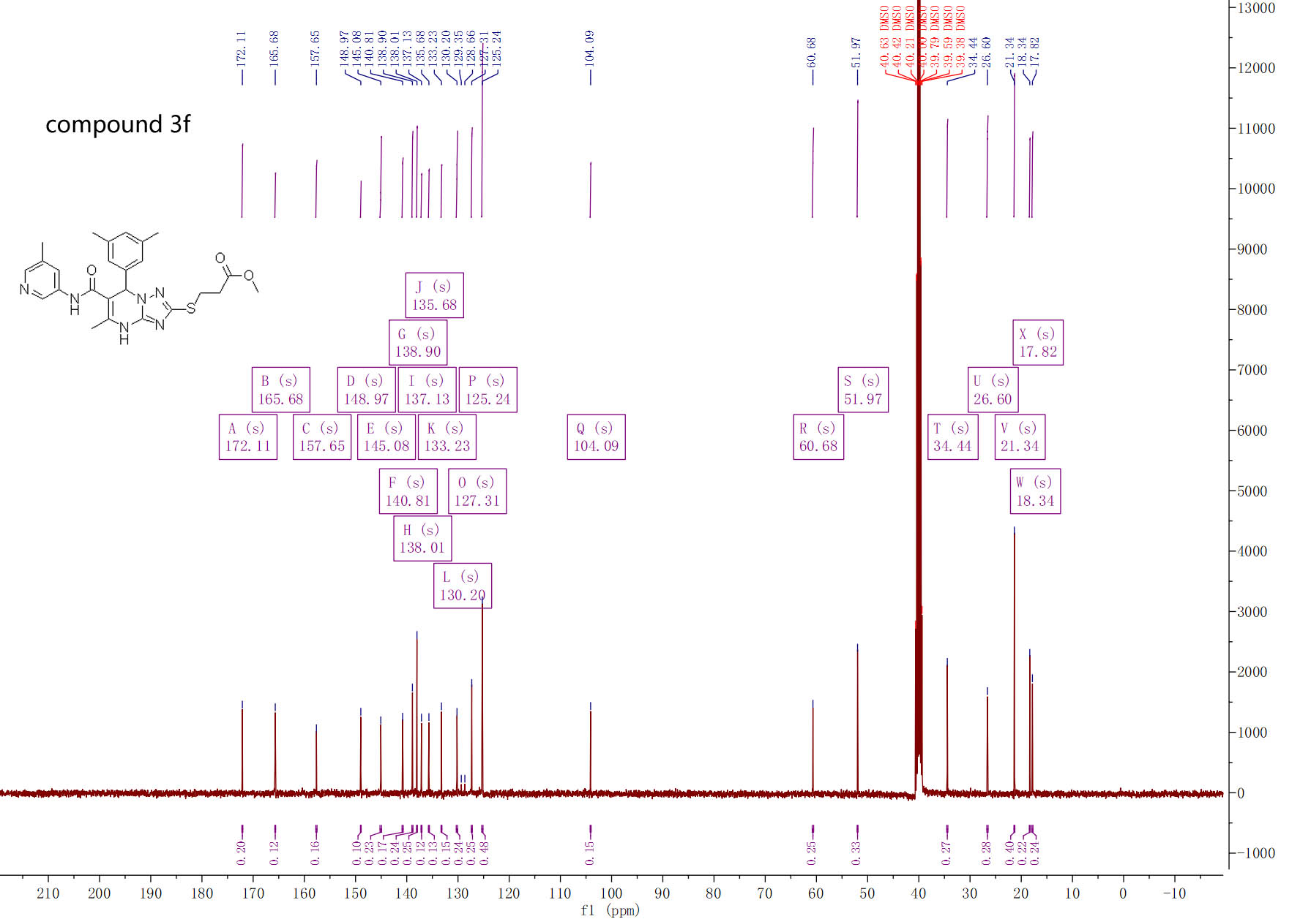

¹³C-NMR spectra of compound 3f

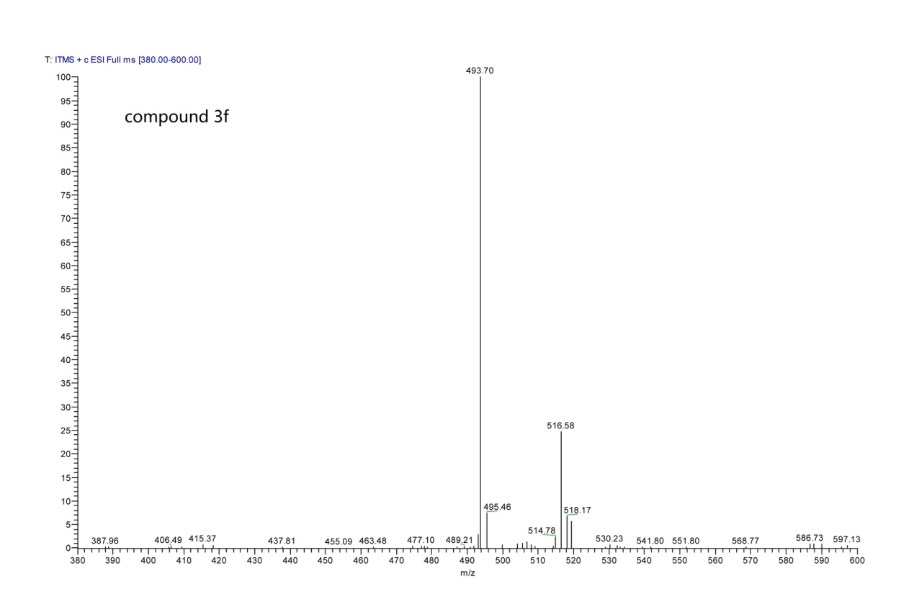

MS spectra of compound 3f

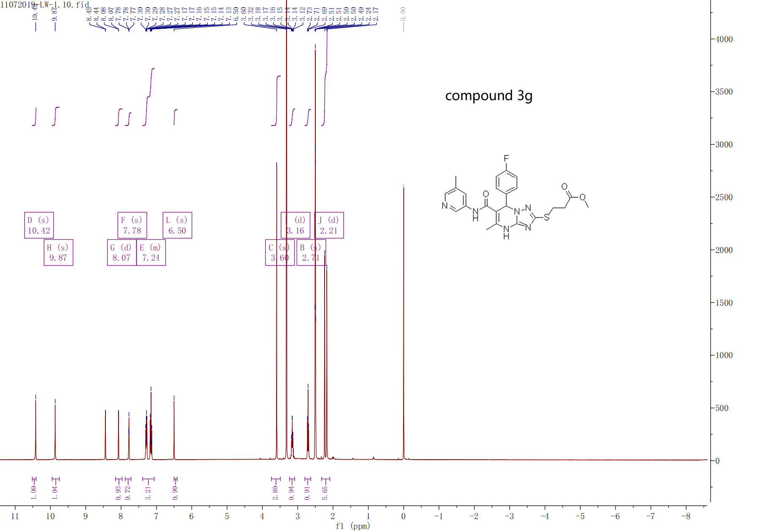

¹H-NMR spectra of compound 3g

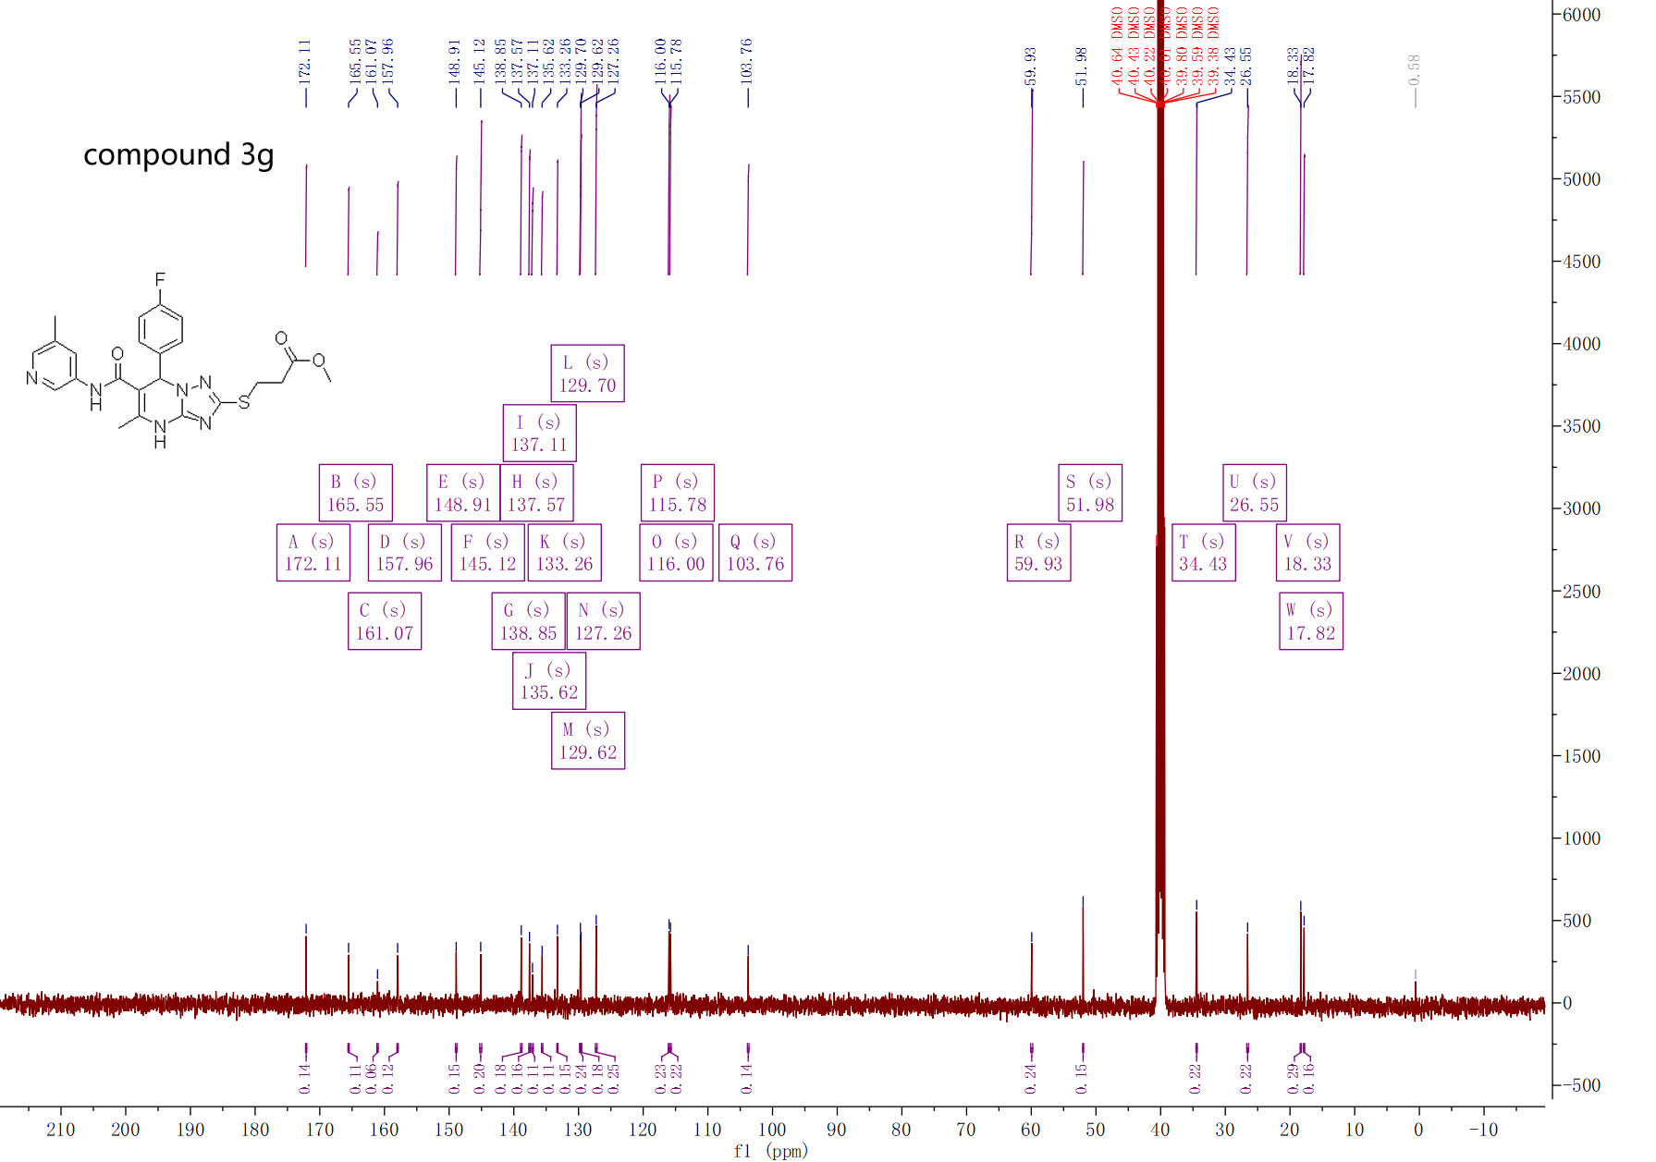

¹³C-NMR spectra of compound 3g
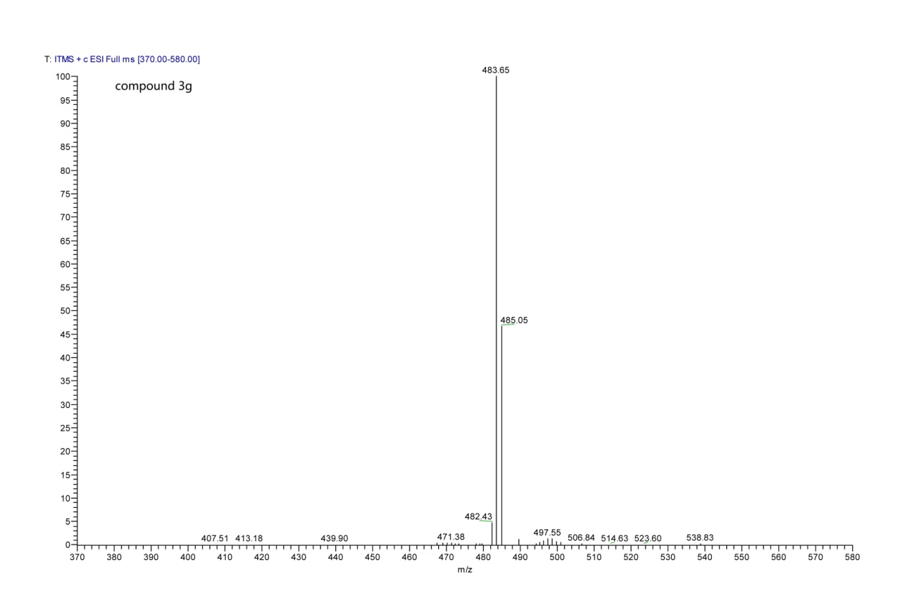

MS spectra of compound 3g

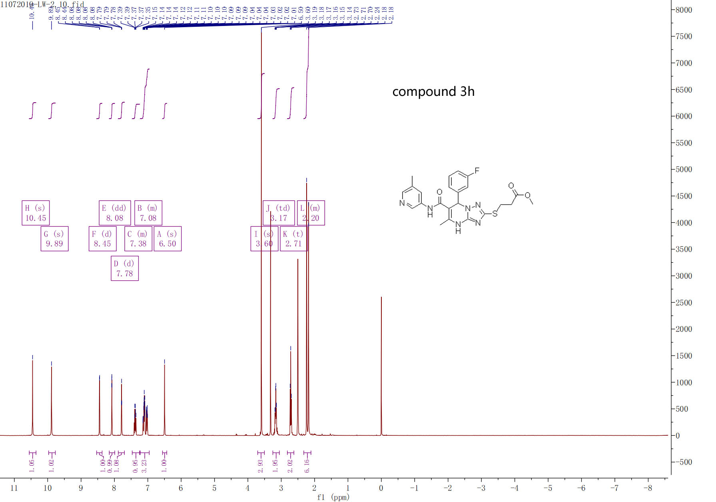

¹H-NMR spectra of compound 3h

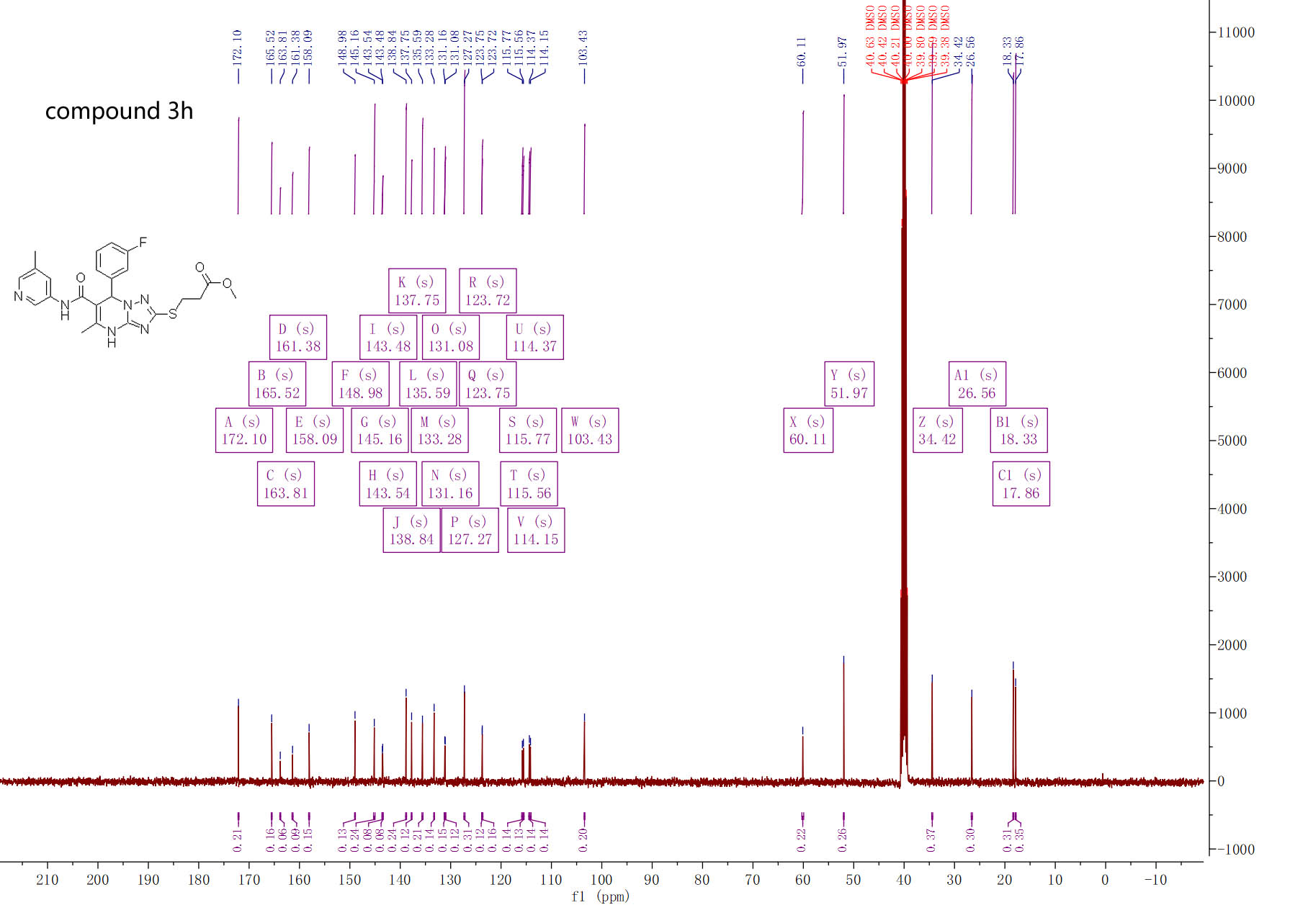

¹³C-NMR spectra of compound 3h

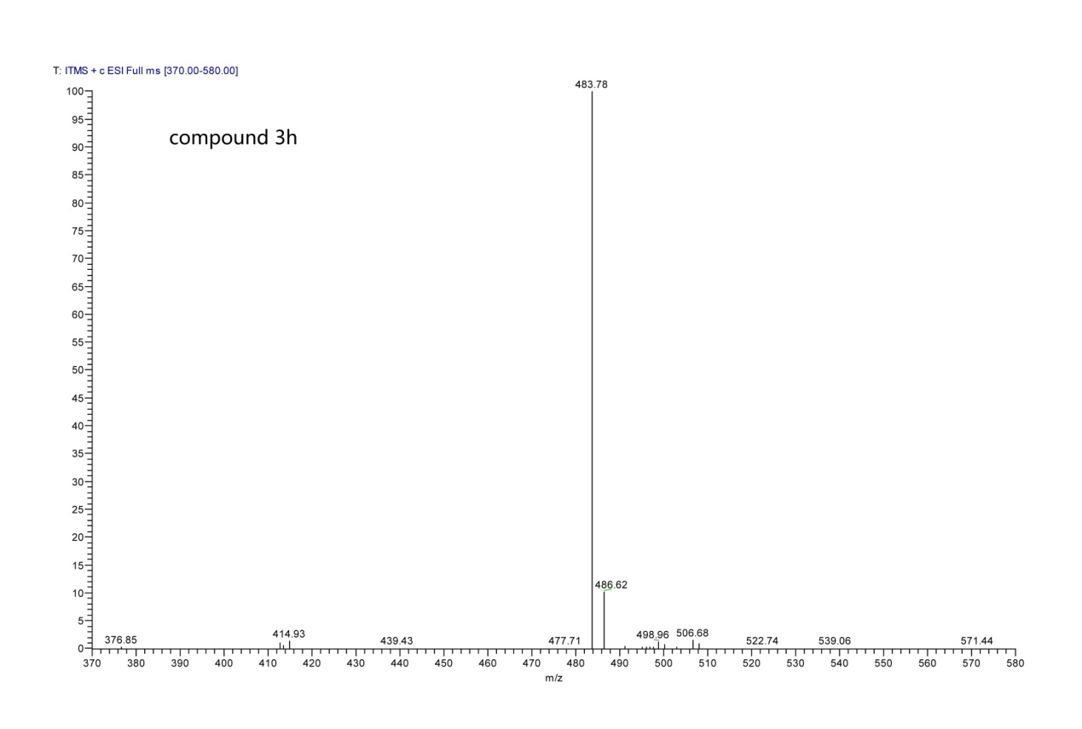

MS spectra of compound 3h

