Supplementary Data

Materials and Methods
Tetrachloroauric acid (HAuCl₄.3H₂O), trisodium citrate (Na₃C₆H₅O₇) (99%), tetrakis (hydroxymethyl) phosphonium chloride (THPC), hydroxylamine hydrochloride (HONH₂·HCl) (Sigma, Aldrich, USA), hexadecyltrimethylammonium bromide (CTAB, 98%), and dithiolated-polyethylene glycol (SH-PEG₄₀₀-SH) was prepared by the Polymer Laboratory at Hacettepe University. Sodium borohydride (NaHBr₄), silver nitrate (AgNO₃, 99%), ascorbic acid, and Milli Q grade I distilled water were used in all steps of the experiments. DLD-1 Duke’s type colorectal adenocarcinoma cells and fibroblast cell lines were supplied by SAP Institute (Turkey) and Kirikkale Bioengineering Department (Turkey), respectively. All reagents were used as received without further purification. For analytical experiments, a transmission electron microscope (JEOL JEM 1010, FEI model Tecnai) operating at a 120 kV accelerating voltage was used to evaluate the crystallography of the gold nanostructures. A JASCO V-530 UV spectrophotometer was used to analyze the chemical structure of the nanoparticles.

Gold nanoparticle (AuNPs) preparation and characterization
A piranha-etch solution (3:1 v/v) consisting of a mixture of sulfuric acid (H₂SO₄), hydrogen peroxide (H₂O₂) and aqua regia mixture containing nitric acid and hydrochloric acid at a 1:3 molar ratio was applied to remove organic impurities from the nanoparticles due to the high sensitivity of gold nanostructures to impurities. Tetrachloroauric acid trihydrate (HAuCl₄. 3H₂O) (300 mL, 0.5 mM) was heated to boiling for 5 minutes where it was placed into a 100 mL flask. An aliquot of a 30 mL trisodium citrate reagent (38.8 mM) was added to a previous colloidal gold solution under vigorous stirring. Stirring of the solution continued to see the changes in color from colorless, dark grey and finally transparent reddish wine to reach room temperature. The AuNP dispersion was centrifuged at 12,000 rpm for 15 min and the precipitate portion was collected after discarding of the supernatant. The AuNP dispersion was characterized by a visible region UV spectrophotometer (JASCO, 530V) for chemical structure. A ζ-sizer device (MALVERN, 3000 HSA) was used for size distribution measurements. A transmission electron microscope (TEM) JEOL JEM 1010 was used to determine the X-ray crystallography of the nanostructures and their sizes.

Gold nanorod (AuNRs) synthesis
Gold nanorods were prepared through a two stage synthesis. Firstly, gold nanoparticles were prepared in the form of a “seed solution”. The process was continued by growing gold seeds to reach a desired gold nanorod morphology. The second step was known as the “growth solution”. The preparation stages are as below:

.
Briefly, hexadecytrimethylammoniumbromide (CTAB, 98%) and 5 ml at 0.20 M was added to 5.0 mL of 5×10⁻⁴ M HAuCl₄ under vigorous stirring. 0.5 mL of an ice-cold NaHBr₄ solution (0.01 M) was changed to the precursor to form a brownish yellow color of gold seeds. Strong stirring continued at 25 ºC.

Growth of gold seeds to form nanorods with a plasmonic band less than 850 nm
A silver nitrate solution (0.15 mL, 0.004 M) was added to a flat bottom flask. 5 mL of 0.20 M CTAB was added to the AgNO₃ solution at room temperature. The second step was initiated by adding 5.0 mL 0.001 M HAuCl₄ to the previous solution (CTAB/ AgNO₃) where stirring continued for additional minutes under vigorous mixing. An aliquot of 70 µL of 0.0788 M ascorbic acid was added to solution A to reduce gold ions to atomic gold seeds in the form of nanorods. The color of the growth solution changed from yellow to colorless.

Synthesis of ultrafine AuNPs (UFAuNPs)
The preparation of ultrafine gold nanoparticles (UFAuNPs) was conducting according to the Duff method. Briefly, in a round bottom (100 mL) flask, 50 mL of distilled water and 1.5 mL of 0.2 mM of sodium hydroxide was added. 2 mL of HAuCl₄, 3H₂O (20 mM) was added to a reactor under stirring and 1 mL of a THPC solution (1.2 mL of 80%THPC diluted at 100 mL DW) was added to a gold solution (2mL, 25 mM). The orange-brownish color of the solution signified UFAuNP formation with average diameter sizes around 2-4 nm.

Large size gold nanoparticle (LSAuNPs) synthesis
Large size gold nanoparticles (LSAuNPs) 70-80 nm in diameter were synthesized according the method suggested by Ziegler. The gold seeds (13-16 nm in diameter) were used as growth nuclei which were characterized by visible and UV light spectrophotometer (519 nm). Briefly, the first growth step was initiated by using ascorbic acid (4×10⁻⁴ M) and was continued by applying defined amounts of 0.013 M CTAB and tetrachloroauic acid (0.29 mM) to the reaction medium at 35°C under stirring. 200 µl of a seed AuNPs solution was added to 1.38 mL of a HAuCl₄ solution and the LSAuNPs dispersion was centrifuged at 10,000 rpm for 20 min. The settled portion of LSAuNPs was separated after discarding the supernatant and was analyzed by UV-vis spectrophotometry. The remarkably shift in UV-vis spectrum (LSPR peak wavelength at 522 nm) proved the successful growth of the gold nanoparticles (LSAuNPs formation as figure 2) in this step. For this, nanoparticles from the previous step (first stage of growth up) were used as gold seeds. The gold nanoparticles (200 µL) from the previous stage were charged to the reactor that contained 2.77 mL HAuCl₄ and 3H₂O (0.29 mM) in the presence of CTAB (0.013 M). Ascorbic acid (4×10⁻⁴ M) was added to reaction to reduce the gold ions (Au³⁺) to gold atoms (Au⁰) and the growth stages were repeated a few times. The visible and UV spectrophotometry of gold nanoparticles showed shifts at 529 nm, 541 nm, 560 nm and stretched to 571 nm (Figure S1).
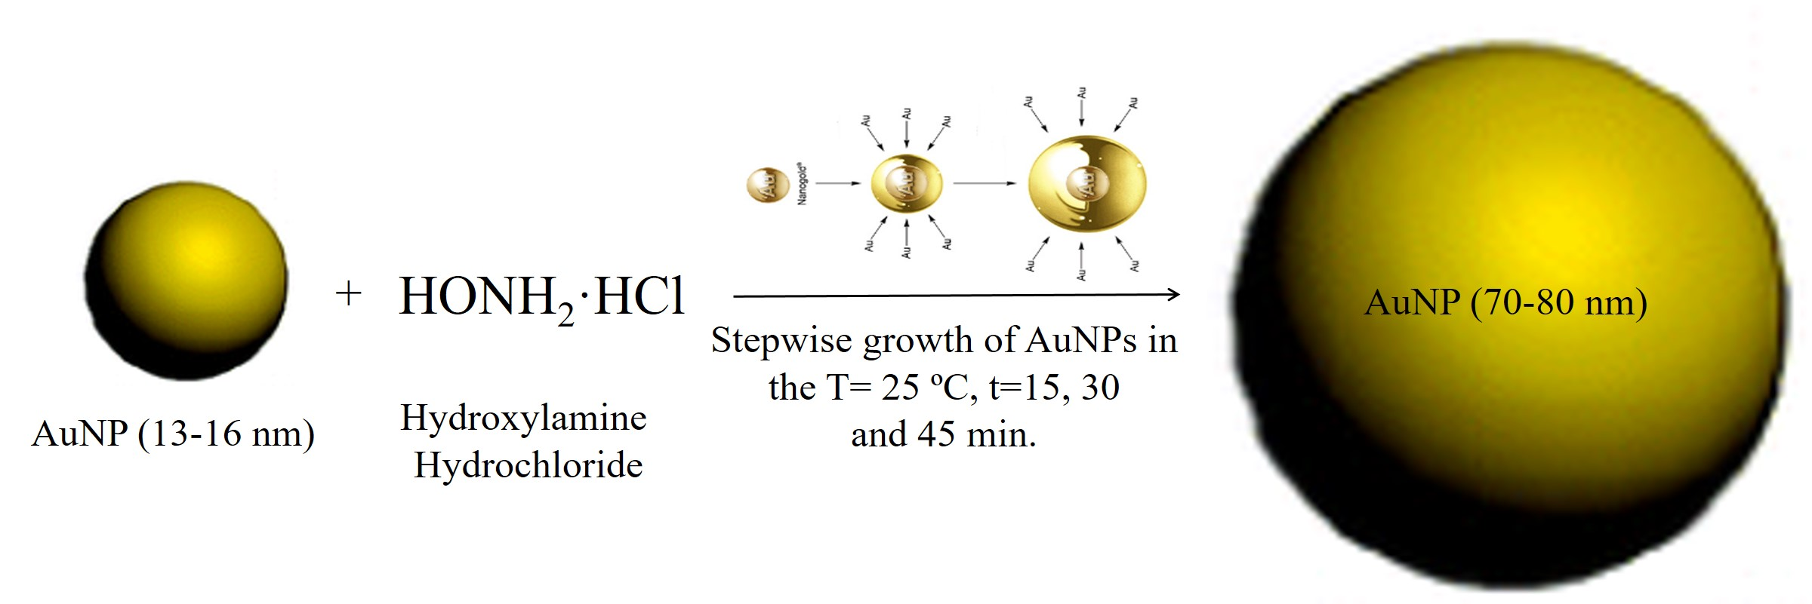
Fig. S1. Schematic illustration of AuNPs grow via the LAuNPs synthesis method

Pimpled gold nanospheres (PGNSs) formation via biopolymer linkers
Partial decoration of LSAuNPs by UFAuNPs was completed via a grafting mechanism. Grafting passed via organic linkers between UFAuNPs and LSAuNPs. A total amount of 3 mL of LSAuNPs were added to a round bottom reactor and sonicated for 10 minutes. The media pH value was adjusted to around 4-5 by the drop-wise addition of hydrochloric acid (0.1M) to the reaction media. HCL was added to create active sites (H⁺) on the gold nanoparticle surfaces which increased the self-assembled activity of nanoparticles for the attachment of linker molecules (dithiol terminated PEG₄₀₀). Thiol terminated polyethylene glycol acts as a bio-conjugation agent to provide a robust covalent attachment between LSAuNPs and UFAuNPs which is mandatory for PGNS fabrication. A portion of the 20 µL of 1×10⁻⁵ M thiol terminated PEG₄₀₀ (SH-PEG₄₀₀-SH) was added to the LSAuNPs dispersion. Several trials were conducted with different concentrations of thiol terminated PEG₄₀₀ with LSAuNPs to optimize the proper concentration of the reagent. Optimal conditions with ionic bonds (without aggregation) was obtained after several trials for concentrations of 10⁻³-10⁻⁸ M of –SH-PEG₄₀₀-SH- as the linker molecule. The reaction progressed with the conjugation of –SH groups in the head of the linker molecule to LSAuNPs. After this stage, the pH value was adjusted (to around 11) to prevent uncontrolled bonding of LSAuNPs together. The synthesized nanoparticles were centrifuged at 10,000 rpm for 15 min. to separate unattached linker molecules from the reaction medium. After adjusting the medium’s pH to 4-5, the gold nanoparticle activity increased to attach the UFAuNPs to the –SH tail functional group of –SH-PEG400-SH- (Fig. S2). Hence, UFAuNPs (45 mL of 80µg/mL) were reacted with LSAuNPs under 10 min at a 200 rpm magnetic stirrer and was left undisturbed overnight. The synthesized nanolens dispersion was centrifuged at 10,000 rpm for 15 minutes to remove unattached moieties, such as excess –SH-PEG400-SH- molecules and unused gold nanoparticles. The PGNSs dispersion was stored in 4°C for the photothermal assessment needed for further experiments (Fig. S2).

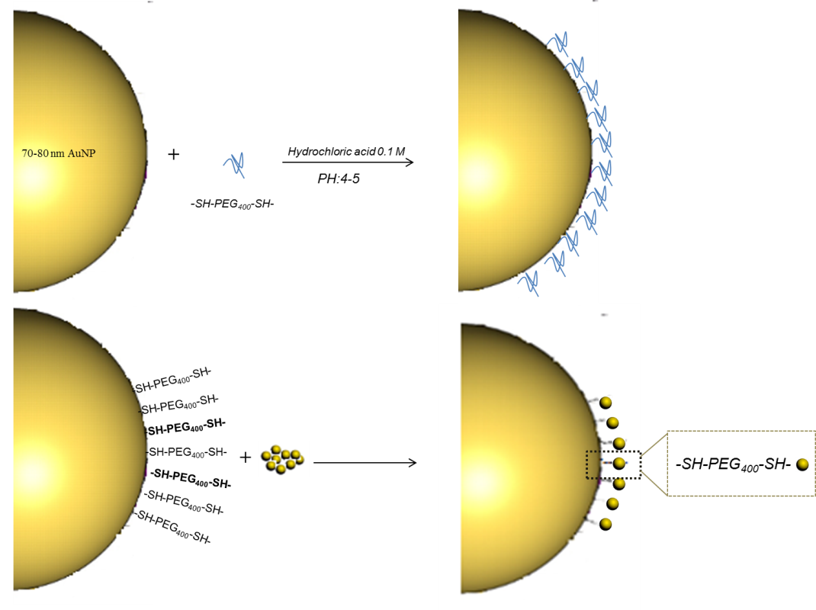
Fig S2. Schematic illustration of the attached UFAuNPs to LSAuNPs via the linker molecule (dithiol terminated polyethylene glycol) (SH-PEG₄₀₀-SH) in PGNSs preparation
Characterization of gold nanoparticles (AuNPs) and nanorods (AuNRs)
Figure S3 (left) reveals the LSPR of gold nanoparticles (AuNPs) in the visible UV-vis spectrum. 519 nm has been defined as the maximum absorbance wavelength (LSPR) of conventional gold nanoparticles. The TEM image indicates the crystallography and accurate size of the synthesized gold nanoparticles in figure S3 (middle). The size distribution plot of the nanoparticles (AuNPs) is presented in figure S3 (right). The size distribution showed that more than 79% of gold nanoparticles were 13-16 nm in diameter.

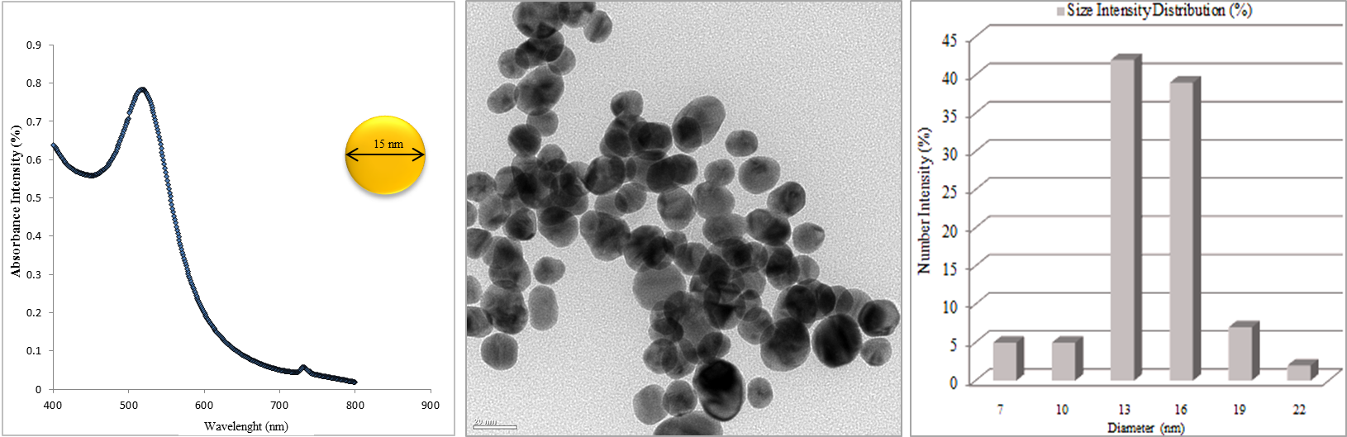

Fig S3: UV–vis region spectrum showing the LSPR peaks of conventional Au nanoparticles centered at 519 nm (left). The inset shows a typical TEM image of the Au nanoparticles with an edge length of 15±2.5 nm (FEI, Tecnai, 120 kv) (middle) and the size distribution chart of gold nanoparticles measured by TEM (Right) which showed more than 79% of nanoparticles 13-16 nm in diameter.

In figure S4, the LSPR of the synthesized AuNRs were characterized by UV–vis spectrophotometry (JASCO, V 530). The image (left) illustrates double LSPR peaks in absorbance intensity for the gold nanorods at 527 nm (transverse) and 753 nm (longitudinal). Also, the TEM image showed both the crystallography and accurate size of the AuNRs. The UV-vis spectra are comparable with the same nanostructures per TEM images. The TEM image showed 75±3.2 nm in the longitudinal and 25±4.7 nm in transverse directions with an aspect ratio value of 3.2.

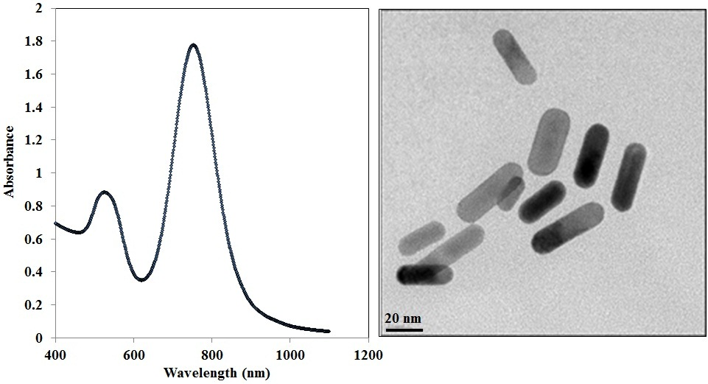

Fig S4: Plots of the extinction spectrum of Au nanorods with plasmon resonance centered at 527 nm (T) and 753 nm (L). Inset TEM image of Au nanorods (FEI, Tecnai,120 kv)

Biocompatibility assessment (upper concentration limit) of the nanoparticles
The biocompatibility assessment of the nanostructures was completed using MTT assays. Briefly, fibroblast cells were added (10³ cells) into DMEM (Dulbecco’s Modified Eagle) medium which consisted of 45 mL of DMEM, 50 mL of 10% fetal bovine serum (FBS, Invitrogen), antibiotics (5mL of 100 U penicillin/0.1 mg/mL streptomycin to a total of 1% and final concentrations of 50 units/mL) and 5 mL of 2 mM glutamine. The cells were centrifuged at 1000 rpm for 5 min when were moved into the secondary cultivation flask (75 cm³ volume). The cells remained in an incubator (37ºC and 95% O₂) for 1 day. The cultured cells after ~% 80 confluence (~2.5×10⁴ cells) were transferred to 24 cavity plates. 200 µL of the 1.03×10¹³ NPs/mL at different morphologies (PGNSs, AuNPs and AuNRs) were added to each cavity. Cytometery was used for determining the number of cells. Hoechst 33342 (2µl/mL) and propodium iodide (2µl/mL) was applied to stain cells for further observation. The necrosis experienced by cells was observed by a FITC (450-520 nm) filter equipped on a fluorescent microscope. Table S4 indicates the viability of DLD-1 cells in the presence of PGNSs, AuNRs and AuNPs at their upper concentration (1.03×10¹³ NPs/mL).
Cell cultivation
Briefly, cell culture was initiated by the immediate de-freezing of cells form -80 °C to 37 °C in a water bath. The vial contents were transferred to 15 mL sterile tube with 10 mL of culture medium (DMEM) centrifuged at 200 G for 5 minutes and the supernatant was discarded. Cells were then spread for a few hours and were visualized under a microscope after incubation in a humidified, 5% CO₂ and 37 °C environment for 1 day to assure a confluent monolayer was grow (80%) in a flask. The medium was removed and cells were washed with PBS to remove the residual medium. Trypsin EDTA was added and incubated at 37 °C for 2 minutes and observed by a microscope to see the cells detach followed by adding 2 mL of medium to stop trypsinization. Cells were then added to a new flask, diluted as appropriate into the flask, and were incubated at 37°C then replaced with fresh culture medium every 2-3 days. After trypsinization of the cells, a 4 × dilution was prepared by mixing of 10 µL of cells and 2 drops (10 µL) of trypan blue. Counting was carried out under a light microscope.
In vitro assay for photothermal therapy
Tables S1, S2, and S3 are provided showing the apoptosis and necrosis for the DLD-1 cells through the addition of gold nanoparticles at various morphologies and concentrations and also by exposure to various laser powers (4W/cm², 2W/cm² and 1W/cm²) via plasmonic photothermal therapy.

Table S1: Cell death values of DLD-1 cells incubated with PGNSs via photothermal therapy
Nanophotosen-sitizer  Concentra-  tion  Laser power | 10¹³ Particles/mL |  | 10¹² Particles/mL |  | 10¹¹ Particles/mL
 | Apoptosis (%) | Necrosis (%) | Apoptosis (%) | Necrosis (%) | Apoptosis (%) | Necrosis (%)
4W/cm² | 68.75±3.8 | 26.21±2.2 | 36.58±2.6 | 22.4±1.2 | 21.12±1.4 | 14.76±2
2W/cm² | 45.67±1.9 | 24.3±0.8 | 30.64±1.4 | 23±0.7 | 12.90±1 | 12.6±1
1W/cm² | 21.12±0.8 | 16.49±1 | 15.26±0.7 | 21.67±2.7 | 9.98±0.9 | 7.43±0.6

Table S2: Cell death values of DLD-1 cells incubated with AuNRs via photothermal therapy
Nanophotosen-sitizer  Concentra-  tion  Laser power | 10¹³ Particles/mL |  | 10¹² Particles/mL |  | 10¹¹ Particles//mL
 | Apoptosis (%) | Necrosis (%) | Apoptosis (%) | Necrosis (%) | Apoptosis (%) | Necrosis (%)
4W/cm² | 52.66±2.9 | 21.22±1.5 | 28.02±3.5 | 19.2±1.8 | 18.77±2.3 | 12.67±2
2W/cm² | 22.44±1.8 | 19.0±1.7 | 22.89±2.6 | 16.8±0.7 | 16.77±2.4 | 8.97±4
1W/cm² | 20.22±3 | 18.3±0.9 | 17.84±1.9 | 14.3±1.7 | 12.50±2.1 | 6.8±2.9

Table S3: Cell death of DLD-1 cells incubated by AuNPs via photothermal therapy
Nanophotosen-sitizer  Concentra-  tion  Laser power | 10¹³ Particles/mL |  | 10¹² Particles/mL |  | 10¹¹ Particles/mL
 | Apoptosis (%) | Necrosis (%) | Apoptosis (%) | Necrosis (%) | Apoptosis (%) | Necrosis (%)
4W/cm² | 37.54±4.2 | 16.32±3.1 | 26.32±2.5 | 8.33±1.9 | 15.78±3.6 | 1.96±0.8
2W/cm² | 32.81±2.8 | 13.33±1.8 | 17.94±3.1 | 8.12±2.2 | 14.25±2.4 | 4.45±2.2
1W/cm² | 16.28±3 | 11.11±3 | 13.51±1.3 | 6.33±1.9 | 10.23±1.7 | 4.49±0.9

Table S4: Cell viability results of PGNSs obtained from MTT assays of DLD-1 and fibroblast cells
 | Cell viability (%) DLD-1, 24 h (mean value) | Cell viability (%) fibroblasts, 12 h (mean value)
10 µg/mL (2.5 ×10⁹ NPs/mL) | 98.5 | 98.8
50 µg/mL (1.25 ×10¹⁰ NPs/mL) | 96.4 | 97.2
100 µg/mL (2.5 ×10¹¹ NPs/mL) | 95 | 95.6
200 µg/mL (0.89×10¹² NPs/mL) | 92.3 | 94.4
300 µg/mL (1.03×10¹³ NPs/mL) | 89.4 | 94.2
400 µg/mL (2.06×10¹⁴ NPs/mL) | 87.2 | 88.4
500 µg/mL (4.12×10¹⁵ NPs/mL) | 83.7 | 84.1

Table S5: Apoptosis and necrosis values for DLD-1 cells via laser irradiation without nanoparticle incubation and nanoparticle incubation without laser irradiation (control group)
 | Apoptosis (%) | Necrosis (%)
Laser irradiation without nanoparticle incubation (control group) | 8.06±2.6 | 3.75±1.1
Nanoparticles incubation without laser irradiation (control group) | 1.45±0.6 | 2.0±0.5

Figure S5 shows the fluorescent microscope images of DLD-1 cells during PPTT using two different nanoparticle concentrations. The top row images relate to a high concentration (1.03×10¹³ PGNSs/mL) for apoptosis and necrosis cell death of DLD-1 cells (images A and B) and the bottom row with a lower concentration of nanoparticles (1.03×10¹¹ PGNSs/mL) exposed to a 808 nm, 4 W/cm² laser power (image C and D). Image (A) shows the much higher number of dead cells than apoptosis with a lower concentration of nanoparticles. Necrosis (images B and D) did not show any obvious differences which indicated a lower dependency of necrosis in cells to toxic heat generated by the photothermal therapy. In other words, the high biocompatibility of the nanolens morphology occurred with high cell viability at high and low concentrations of nanoparticles.
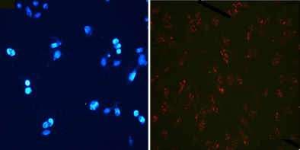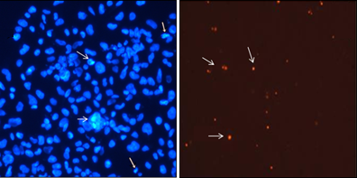
500 µm
500 µm
C
D
A
B
500 µm
500 µm
S5: Fluorescent microscope images of apoptosis (A and C) and necrosis (B and D) of DLD-1cells via photothermal therapy when exposed to PGNSs. The top figures relate to 1.03×10¹³ PGNSs/mL and the bottom images relate to 1.03×10¹¹ PGNSs/mL exposed to a 808 nm, 4 W/cm² laser

Alexa fluor 488 phalloidin and hoechst 33342 dual staining of fibroblasts under photothermal therapy
Figure S6 presents structural damage of fibroblasts in the case of nucleus fragmentation and cell membrane disposal as indicated by Alexa Fluor 488 Phalloidin and Hoechst 33342 dye staining after photothermal therapy. As seen in image S6 (A), in the presence of PGNSs, the parts of the actin filaments were disposed which obviously represents the harmful effect of PGNS mediated photothermal therapy. The comparison between figures 13 (A) and S6 (A) gives information about the greater sensitivity of DLD-1 cells than fibroblast cells against PGNSs mediated photothermal therapy. This means that the DLD-1 cells experienced more morphological damage to both the nucleus and cell membrane. Figure S6 (B) shows the heat damage effect of photothermal therapy produced by AuNRs. As seen in figure S6 (B), the structural damage to the nucleus and cell membrane filaments were less than that in figure S6 (A). Figure S6 (C) shows the damage AuNPs caused on fibroblasts via PPTT. As seen in this image, no clear changes were seen in cells for both intercellular organelles and in the cellular skeleton. A comparison between the images clarifies the structural changes of cells in figure S6 and figure 13 shows the greater sensitivity of DLD-1 cells than fibroblasts against the toxic heat effect of photothermal therapy.
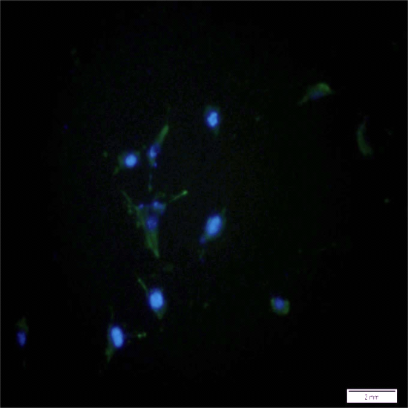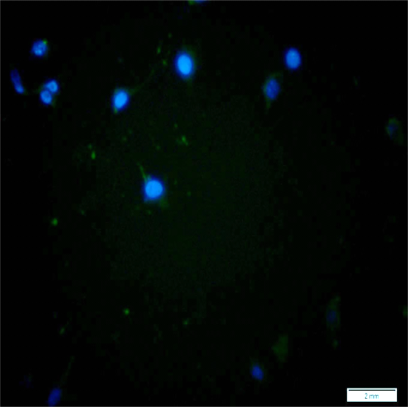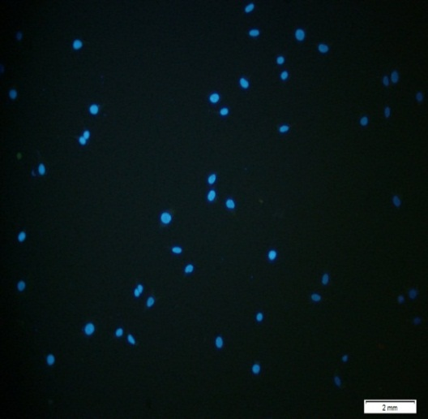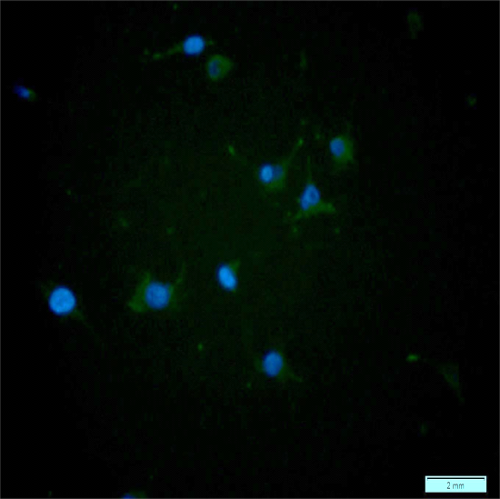
2 mm
2 mm
2 mm
2 mm
A
B
C
D
Fig. S6: Illustration of fluorescence images showing the structural damages to fibroblast cells by 1.03×10¹³ PGNSs/mL and a laser at 808 nm with: A) PGNSs, B) AuNRs, C) AuNPs and D) no nanoparticles
Results and discussion of apoptosis and necrosis on DLD-1 cells via photothermal therapy
The photothermal damage of fibroblasts in the form of apoptosis and necrosis values are demonstrated in tables S6 to S10 and also in figure S6. In image S5, different nanostructures were incubated with cells. Rupture and fragmentation occurred between the cellular skeleton and nucleus. The lower photothermal injury to DLD-1 cells was noticeable. In figure S5.B of the AuNRs group, not only was the thermal damage level lower than for the PGNSs, but also, cell disintegration was lower than the same condition (in DLD-1 cells) which provides evidence that fibroblasts are more resistant to the thermal effects of laser hyperthermia.

Table S6: Photothermal damage of fibroblast cells incubated with conventional PGNSs
Nanophotosen-sitizer  Concentra-  tion  Laser power | 10¹³ Particles/mL |  | 10¹² Particles/mL |  | 10¹¹ Particles/mL
 | Apoptosis (%) | Necrosis (%) | Apoptosis (%) | Necrosis (%) | Apoptosis (%) | Necrosis (%)
4W/cm² | 41.33±4.2 | 16.6±2 | 27.5±2.2 | 9.8±1.9 | 23.95±1.6 | 8.5±0.7
2W/cm² | 30.88±3.5 | 15.76±1.5 | 22.22±3 | 8.45±2.4 | 24.65±4 | 7.64±1
1W/cm² | 19.72±2.3 | 11.4±0.8 | 15.78±1.0 | 6.53±2 | 19.44±3.2 | 6.85±1

Table S7: Photothermal therapy damage effects on fibroblast cells by AuNRs
Nanophotosen-sitizer  Concentra-  tion  Laser power | 10¹³ Particles/mL |  | 10¹² Particles/mL |  | 10¹¹ Particles/mL
 | Apoptosis (%) | Necrosis (%) | Apoptosis (%) | Necrosis (%) | Apoptosis (%) | Necrosis (%)
4W/cm2 | 34.06±4.2 | 12.2±2.9 | 27.39±2.6 | 8.12±3.2 | 22.64±1.5 | 4.18±3.4
2W/cm2 | 28.33±1.8 | 11.67±2 | 16.93±3.6 | 5.21±2.1 | 14.7±3.2 | 6.27±3
1W/cm2 | 21.85±3 | 10.69±1.9 | 14.53±2.7 | 3.65±0.7 | 15.18±2.1 | 4.12±2.9

Table S8: Photothermal damage of fibroblast cells incubated with conventional AuNPs

Nanophotosen-sitizer  Concentra-  tion  Laser power | 10¹³ Particles/mL |  | 10¹² Particles/mL |  | 10¹¹ Particles/mL
 | Apoptosis (%) | Necrosis (%) | Apoptosis (%) | Necrosis (%) | Apoptosis (%) | Necrosis (%)
4W/cm2 | 28.84±3.2 | 9.04±1.8 | 19.60±2.5 | 8.31±1 | 17.69±2.7 | 2.8±0.7
2W/cm2 | 19.04±2 | 8.1±2 | 14.89±3 | 5.02±3 | 14.34±1 | 7.2±0.7
1W/cm2 | 16.34±2.5 | 7.12±1.4 | 11.32±2.5 | 4.0±0.7 | 12.08±1.3 | 5.8±1.4

Table S9: Cell viability results of different nanoparticles on fibroblast cells

 | Apoptosis (%) | Necrosis (%) | Cell viability (%)
1.03×10¹³ Particle/mL (PGNSs) | 3.98±0.7 | 2.64±0.7 | 93.38
1.03×10¹² Particle/mL (AuNRs) | 3.38±1.2 | 3.90±1.5 | 92.72
1.03×10¹¹ Particle/mL (AuNPs) | 0.0±0 | 3.40±1 | 96.60

Table S10: Photothermal therapy apoptosis and necrosis results related to the control group in fibroblast cells in control groups

 | Apoptosis (%) | Necrosis (%)
Laser irradiation without nanoparticles incubation | 8.06±2.6 | 3.75±1.1
Neither laser irradiation nor nanoparticle incubation | 1.45±0.6 | 2.0±0.5

According to the necrotic cells results (S6 tables), both DLD-1 cells and fibroblast cells incubated with nanoparticles experienced marketed cell damage after laser illumination via photothermal therapy. From the S6-table, the values showed that the highest necrosis belonged to a 4 W/cm² laser power induction with AuNRs (11.67%) and the laser power where the minimum cell damage occurred was at 1 W/cm² (figure S7).

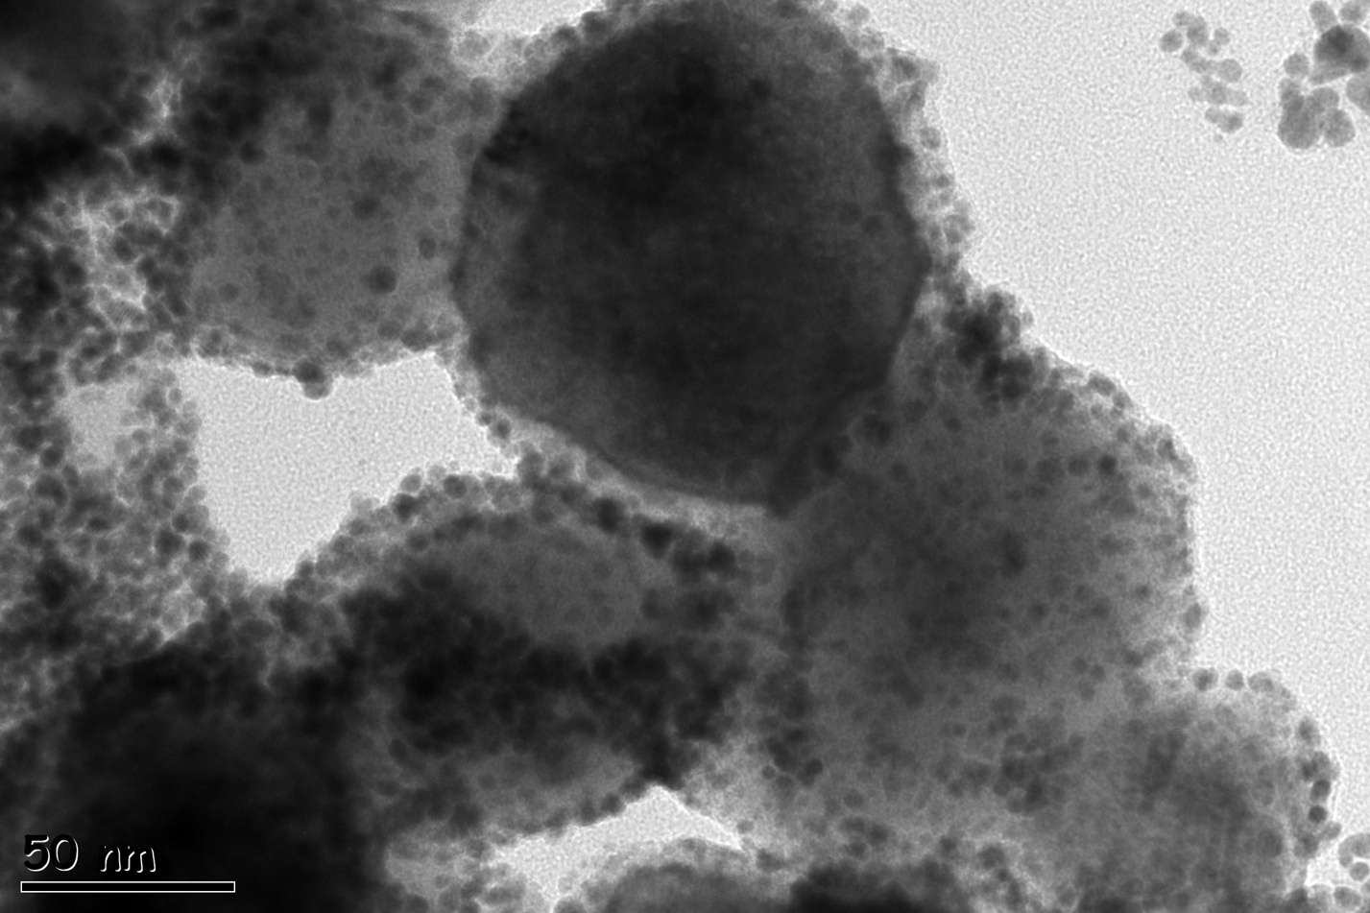
Fig. S7: TEM micrograph of gold NPs on the surface

