Supplementary
Results
Outcomes
A VTE was diagnosed at the same date as a first cancer for 483 subjects, while a VTE was diagnosed at the same date as a second cancer for 39 subjects.
Among the 11,908 patients with a VTE, 1,400 had a history of VTE prior to study entry. 291 of these 1,400 VTEs possibly represented the same event since the time interval between the first VTE diagnosis (before study entry) and the second VTE diagnosis (after study entry) was less than 90 days. This is reflected in the lower IR of VTE in the 0-6 month period in the sensitivity analyses. For the remaining 1,109 patients who were diagnosed with a VTE prior to study entry and then experienced a second, subsequent, VTE in the study, the time span between the two VTE diagnoses was > 90 days (median 3,018 days, 25th-75th percentile, 1,089-5 635 days).
First cancer and VTE in unexposed subjects
The IR of VTE in unexposed subjects (i.e. without a second cancer diagnosis) was markedly higher during the initial six months after the first cancer diagnosis than in subsequent time. The 0-6 month IR of VTE was 31.6 per 1000 p-y (95% CI, 30.6–32.5) while the IR decreased rapidly by increasing time since the first cancer diagnosis to 5.2 per 1000 p-y (95% CI, 5.1–5.4) for VTEs later than 2 years after the first cancer diagnosis (Table 3, Figure 1). However, the effect of time since diagnosis was dependent of the first cancer type. For unexposed patients with a first breast or prostate cancer, the IR of VTE declined from 0-6 month IRs of VTE of 11.9 per 1000 p-y, 95% CI, 10.9–13.0, and 15.8 per 1000 p-y, 95% CI, 14.5–17.3, respectively, while for patients with a first lung cancer the 0-6 month IR of VTE was 64.6 per 1000 p-y, 95% CI, 61.7–67.8. The difference between 0-6 months IRs of VTE and VTEs later than two years after the first cancer diagnosis was thus markedly larger for patients with a first lung cancer, meaning that time since cancer diagnosis has a larger impact on the risk of VTE in patients with lung cancer than in patients with breast or prostate cancer, on an additive scale (Table 3).
Second cancer and VTE
The association with time since second cancer differed based on the VTE risk category of the second cancer. The association was strongest for high and very high VTE-risk second cancer types, where 34.3 and 45.7 fewer VTEs per 1000 p-y were observed later than two years after the second cancer than in the initial six months after a second cancer, respectively. The association with time since second cancer diagnosis was weaker in intermediate/low VTE risk second cancers, where the corresponding IR difference was 8.4 per 1000 p-y (Figure 2, Supplementary Table 2).
Tables and figures
Supplementary table 1. Categorization of second cancers as very-high VTE-risk, high VTE-risk or intermediate/low VTE-risk second cancer.
Very-high VTE-risk second cancer  Stomach, pancreas, brain |  | High VTE-risk second cancer  Lung, colorectal, esophagus, kidney,Mb. Hodgkin and other aggressive lymphomas, myeloma, bladder, testicular, gynecologic, leukemias, other types |  | Intermediate/low VTE-risk second cancer  Breast, prostate, indolent lymphoma, other types
ICD-10 group | ICD-10 codes | ICD-10 group | ICD-10 codes | ICD-10 group | ICD-10 codes
7 | C16.0-16.9 | 16+17 | C32.0-34.9 | 28 | C50.0-50.9
13 | C25.0-25.9 | 9+10 | C18.0-21.9 | 36 | C61.0-61.9
42 | C70.0-72.9, D42.0-43.9 | 6 | C15.0-15.9 |  | C82.0-82.1, C82.5-82.9, C83.0, C88.0-88.9, C90.2-90.3
 |  | 38+39 | C64.0-64.9, C65.065.9 | 1,2,3,4,5 | C00.0-14.9
 |  | 40 | C66.0-68.9 | 15+16 | C30.0-32.9
 |  | 44 | C81.0-81.9
 |  | 45 | C82.2, C83.1, C83.3x,C83.5x, C83.7x, C83.8x, C84.0-86.9
 |  | 46 | C88.0-88.9
 |  | 47 | C90.0-90.1
 |  | 48 | C91.0-95.9  D45.0-47.9
 |  | 8 | C17.0-17.9
 |  | 11+12 | C22.0-24.9
 |  | 14 | C26.0-26.9
 |  | 18 | C37.0-37.9  74.0-75.9
 |  | 19 | C38.0-38.9
 |  | 20 | C39.0-39.9  C76.0-76.9  C80.0-80.9
 |  | 21 | C40.0-41.9
 |  | 22 | C43.0-43.9
 |  | 24,25,26,27 | C45.0-49.9
 |  | 29,30,31,32,33,34 | C51.0-58.9
 |  | 35+37 | C60.0-60.9, C63.0-63.9, C62.0-62.9
 |  | 41 | C69.0-69.9
 |  | 43 | C73.0-73.9

Supplementary table 2. Incidence rates of VTE by time since second cancer diagnosis according to second cancer VTE-risk group.
Time since second  cancer diagnosis | Intermediate/low VTE-riskª |  |  | High VTE-risk^{b} |  |  | Very high VTE-risk^{c}
Time since second  cancer diagnosis | n (VTE) | IR | 95% CI | n (VTE) | IR | 95% CI | n (VTE) | IR | 95% CI
0-6 months | 24 | 17.7 | 11.9-26.5 | 266 | 43.2 | 38.3-48.7 | 32 | 69.2 | 48.9-97.8
6-12 months | 18 | 15.8 | 10.0-25.1 | 84 | 18.1 | 14.6-22.4 | 10 | 40.4 | 21.7-75.1
1-2 years | 16 | 8.8 | 5.4-14.4 | 103 | 15.1 | 12.5-18.4 | 10 | 39.2 | 21.1-72.9
>2 years | 49 | 9.3 | 7.0-12.3 | 163 | 8.9 | 7.6-10.4 | 10 | 23.5 | 12.7-43.8
ª Breast, prostate, indolent lymphoma, chronic leukaemia
^{b} Lung, colorectal, oesophagus, kidney, aggressive lymphoma, myeloma, bladder, testicular, gynaecologic, other types
^{c} Stomach, pancreas, brain

Supplementary table 3. Sensitivity analysis. Incidence rates (per 1000 p-y) of VTE by increasing time since first/second cancer diagnosis according to when patients were diagnosed with second cancer.
First cancer type  Time since first cancer diagnosis | Without second cancer |  |  | Second cancer, all VTE risk groups combined
First cancer type  Time since first cancer diagnosis |  |  |  | Time since second cancer
First cancer type  Time since first cancer diagnosis |  |  |  | 0-6 months |  |  | - months |  |  | 1-2 years |  |  | > 2 years
 | n (VTE) | IR | 95% CI | n (VTE) | IR | 95% CI | n (VTE) | IR | 95% CI | n (VTE) | IR | 95% CI | n (VTE) | IR | 95% CI
First cancer, total
0-6 months | 3380 | 26.3 | 25.4-27.2 | 51 | 35.2 | 26.8-46.4 | na | na | na | 23 | 14.0 | 9.3-21.1 | na | na | na
6-12 months | 1106 | 10.3 | 9.7-10.9 | 15 | 31.4 | 18.9-52.0 | na | na | na | na | na | na | na | na | na
1-2 years | 1198 | 6.7 | 6.4-7.1 | 34 | 40.2 | 28.7-56.3 | 7 | 11.0 | 5.2-23.1 | 15 | 15.9 | 9.6-26.4 | na | na | na
>2 years | 4079 | 4.9 | 4.8-5.1 | 204 | 40.7 | 35.5-46.7 | 68 | 18.0 | 14.2-22.8 | 74 | 13.3 | 10.6-16.6 | 131 | 9.4 | 7.9-111.1
Breast
0-6 months | 400 | 9.8 | 8.9-10.8 | 8 | 32.0 | 16.0-64.0 | 3 | 14.6 | 4.7-45.3 | na | na | na | 5 | 4.2 | 1.7-10.0
6-12 months | 239 | 6.2 | 5.5-7.1 | na | na | na | na | na | na | na | na | na | 3 | 4.9 | 1.6-15.2
1-2 years | 305 | 4.4 | 3.9-4.9 | 9 | 38.1 | 19.8-73.2 | na | na | na | 5 | 18.1 | 7.5-43.5 | 10 | 9.3 | 5.0-17.3
>2 years | 1573 | 3.8 | 3.8-4.0 | na | na | na | na | na | na | 30 | 12.8 | 8.9-18.3 | na | na | na
Prostate
0-6 months | 365 | 12.5 | 11.4-13.8 | na | na | na | 7 | 25.2 | 12.0-52.8 | 7 | 16.7 | 8.0-35.0 | na | na | na
6-12 months | 149 | 5.6 | 4.7-6.5 | na | na | na | 3 | 28.6 | 9.2-88.8 | na | na | na | na | na | na
1-2 years | 281 | 6.1 | 5.4-6.8 | na | na | na | 4 | 20.4 | 7.7-54.3 | 6 | 21.9 | 9.8-48.7 | 8 | 13.2 | 6.6-26.3
>2 years | 1073 | 6.4 | 6.0-6.8 | na | na | na | na | na | na | 19 | 17.8 | 11.3-27.8 | 25 | 12.6 | 8.5-18.6
Colorectal
0-6 months | 1217 | 37.0 | 35.0-39.1 | 23 | 38.9 | 25.8-58.5 | na | na | na | na | na | na | na | na | na
6-12 months | 341 | 12.4 | 11.1-13.8 | na | na | na | na | na | na | 6 | 31.8 | 14.3-70.7 | na | na | na
1-2 years | 323 | 7.2 | 6.5-8.0 | 10 | 39.1 | 21.0-72.7 | na | na | na | 4 | 13.1 | 4.9-35.0 | na | na | na
>2 years | 1078 | 5.4 | 5.1-5.7 | na | na | na | 17 | 14.4 | 8.9-23.1 | 21 | 11.5 | 7.5-17.6 | na | na | na
Lung
0-6 months | 1398 | 54.3 | 51.5-57.2 | na | na | na | na | na | na | na | na | na | 6 | 18.2 | 8.2-40.6
6-12 months | 377 | 25.6 | 23.1-28.3 | na | na | na | 4 | 108.7 | 40.8-289.6 | 0 | 0 | 0 | na | na | na
1-2 years | 289 | 17.4 | 15.5-19.5 | 5 | 60.4 | 25.1-145.2 | na | na | na | 0 | 0 | 0 | 0 | 0 | 0
>2 years | 355 | 7.7 | 7.0-8.6 | 8 | 25.8 | 12.9-51.6 | 8 | 34.4 | 17.2-68.9 | 4 | 12.0 | 4.5-31.9 | 7 | 8.4 | 4.0-17.6

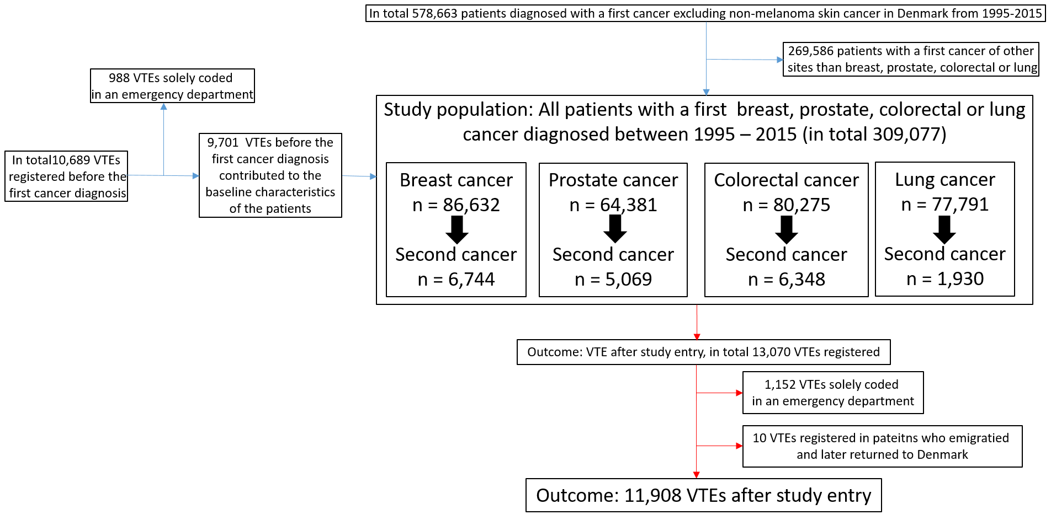
Supplementary figure 1. Consort diagram showing the study population and outcome.
Supplementary figure 2. Incidence rates (per 1000 person years) and adjusted incidence rate ratios of VTE, adjusted estimates are depicted in the forest plot.
Supplementary figure 3. Adjusted incidence rate ratios of VTE for subjects free of VTE at study entry, estimates are depicted in the forest plot

