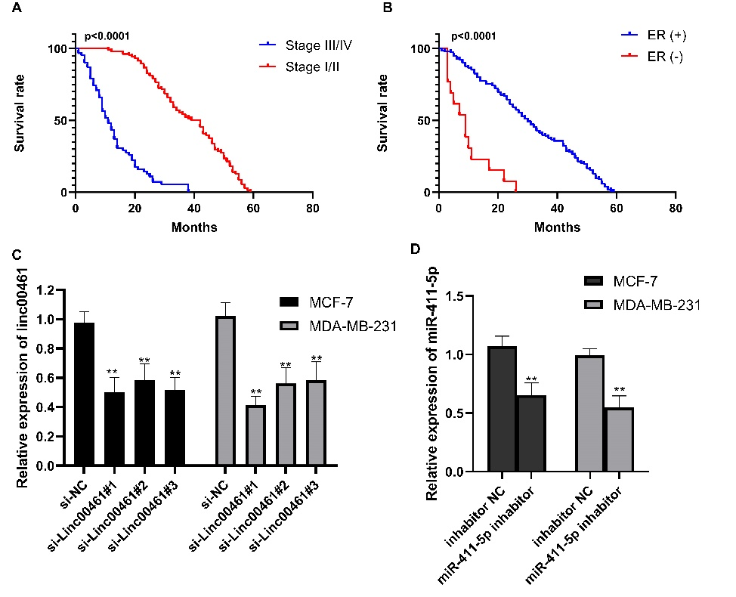
Supplemental Figures A Kaplan-Meier survival analysis was used to assess tumor stage and BC patients' overall survival. B Kaplan-Meier survival analysis was used to assess ER status and BC patients' overall survival. C LINC00461 expression in LINC00461 down-regulated MCF-7 and MDA-MB-231 cell lines. D miR-411-5p expression in miR-411-5p down-regulated MCF-7 and MDA-MB-231 cell lines. Data represent the mean ± SD. **P <0.01. The experiments were independently repeated at least three times.

