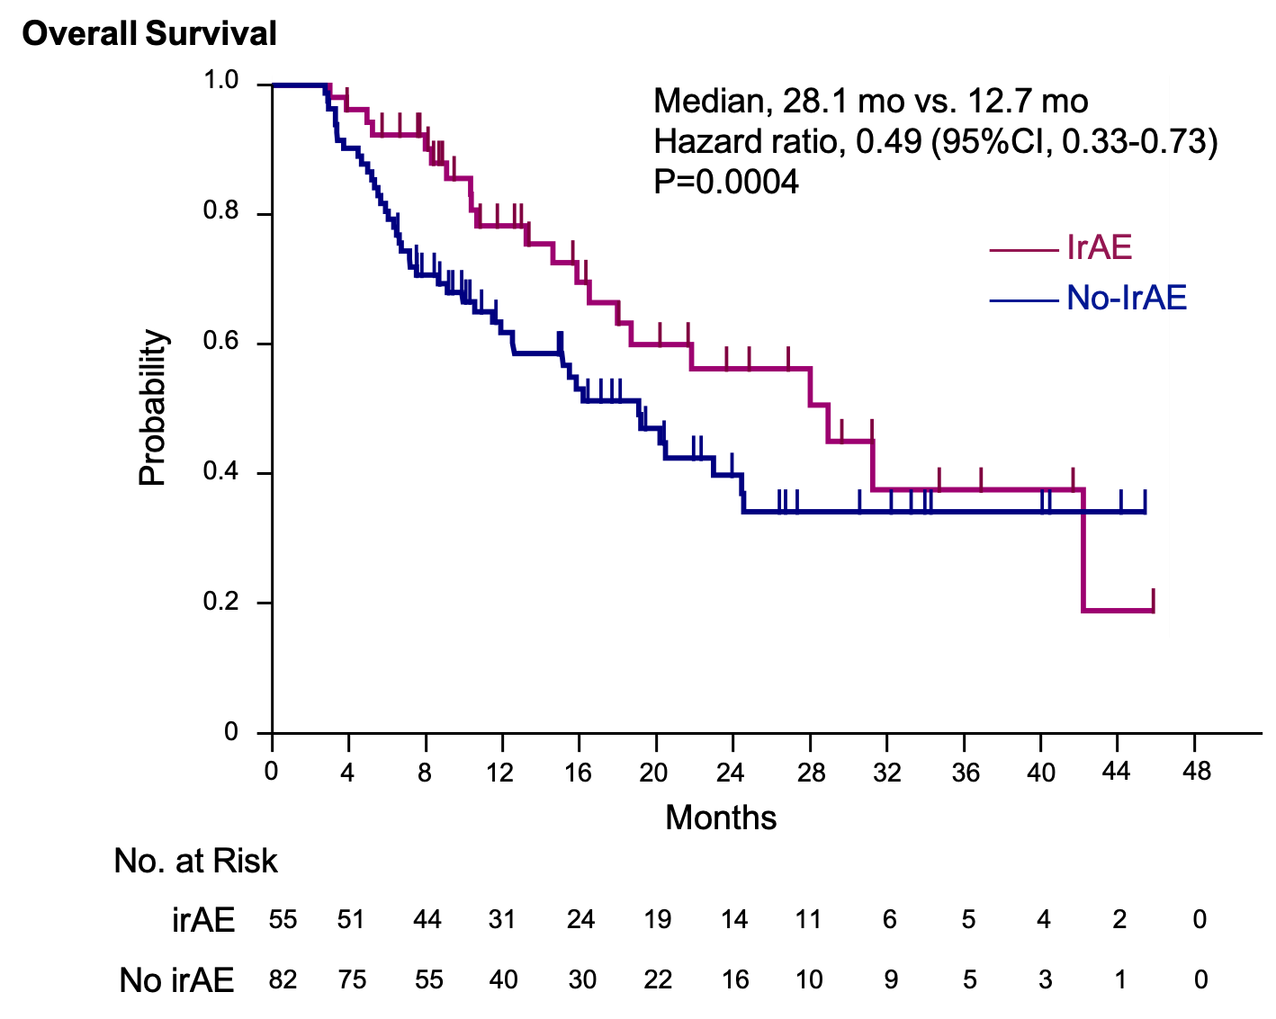
Supplementary Figure 1 Kaplan–Meier estimation of overall survival
The Kaplan–Meier estimates of overall survival in the irAE (patients who developed irAE within 2.7 months since initiation of ICIs) and no-irAE groups (hazard ratio adjusted according to the primary tumor). Patients who had events within 2.7 months were excluded.
Abbreviation: ICIs, immune checkpoint inhibitors; irAE, immune-related adverse events.
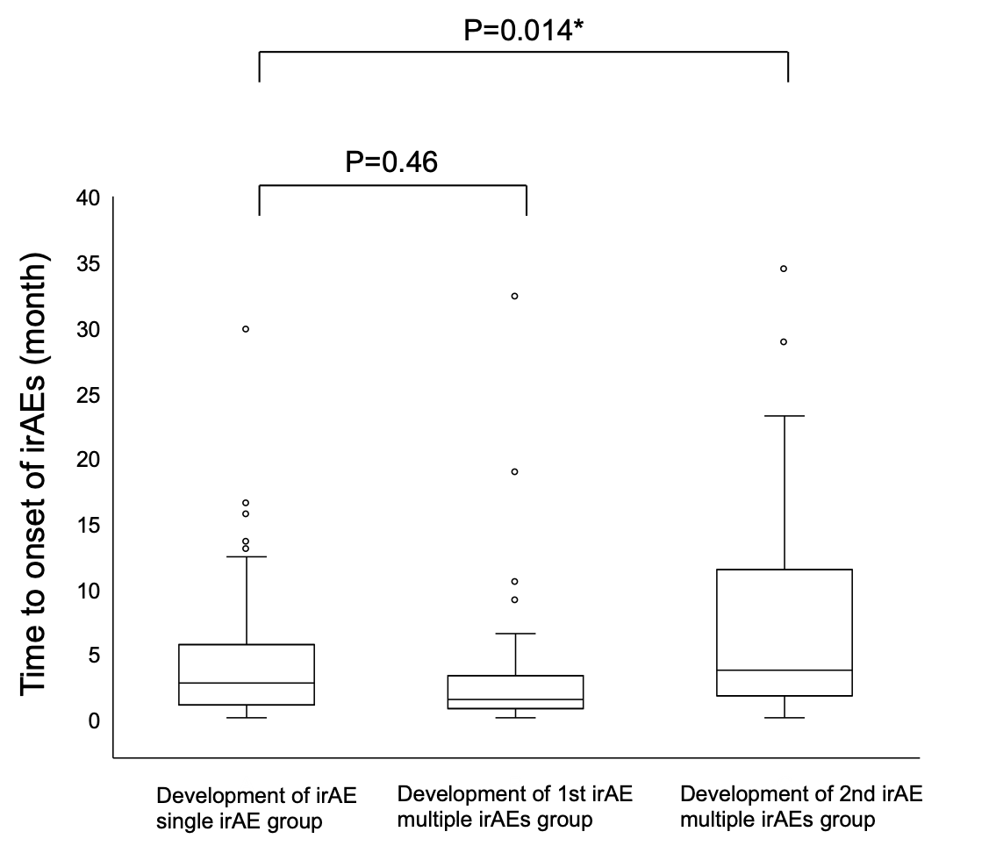

Supplementary Figure 2 Box plot of time-to-onset of any irAE
Abbreviation: irAE, immune-related adverse events.

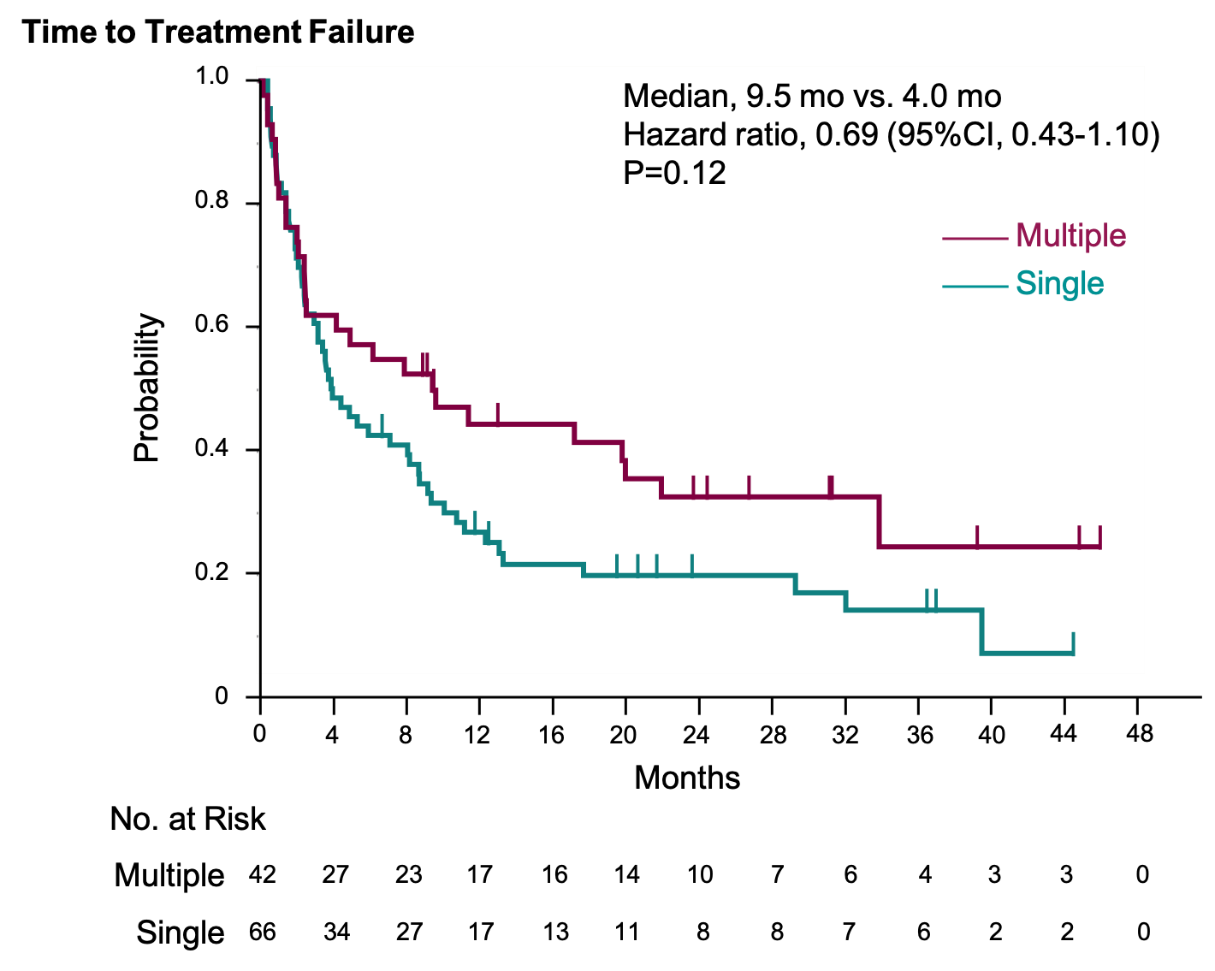
Supplementary Figure 3 Kaplan–Meier estimation of overall survival
The Kaplan–Meier estimates of time to treatment failure in the multiple irAEs and single irAE groups (hazard ratio adjusted according to the primary tumor).
Abbreviation: irAE, immune-related adverse events.

