Supplementary materials

Figure S1. Synthetic route of 2DA-FITC-PTX.

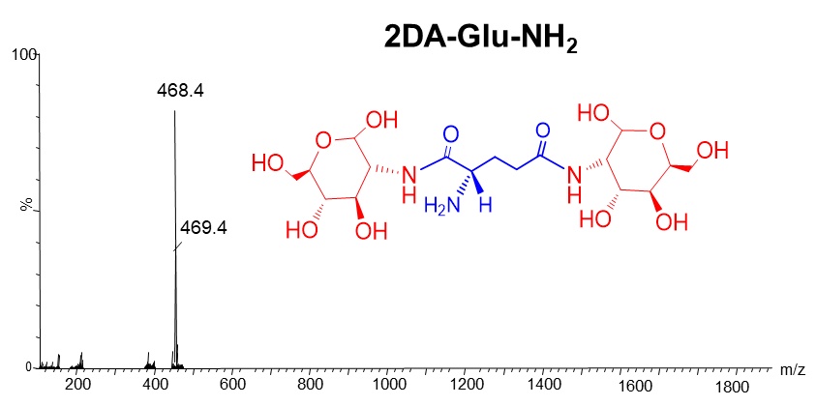

Figure S2: 2DA-Glu-NH₂ LC-MS：[M + H]⁺] = 468.4 calc:469.4.

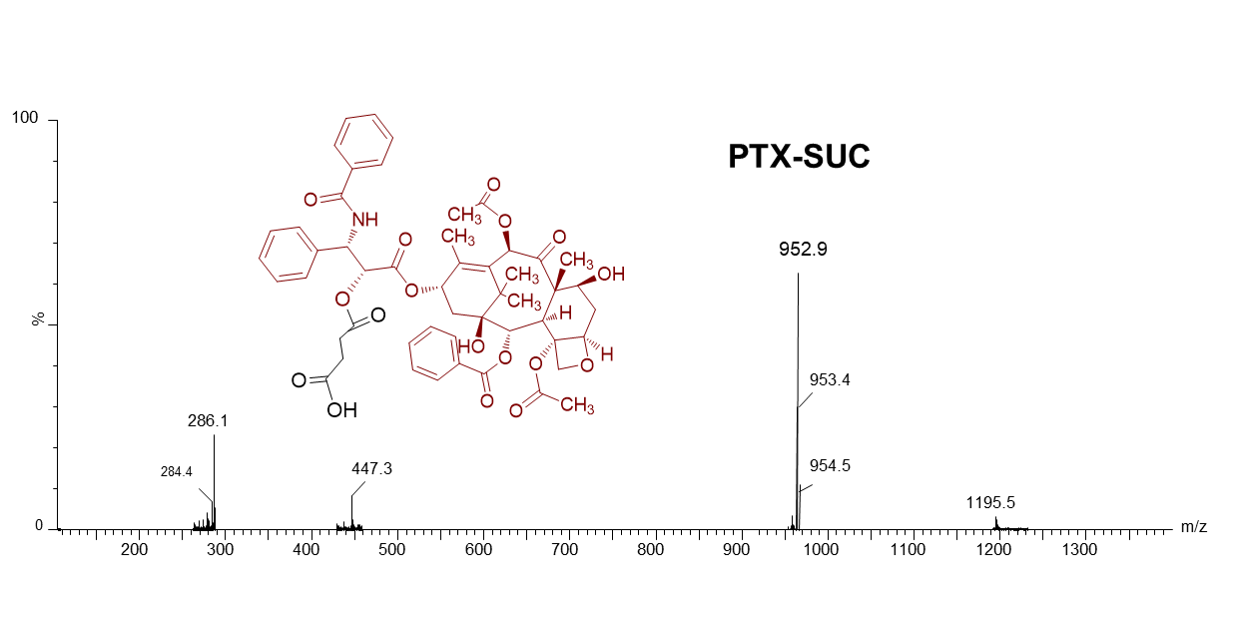
Figure S3: PTX-SUC LC-MS：[M + H] ⁺ =952.9 calc: 953.9

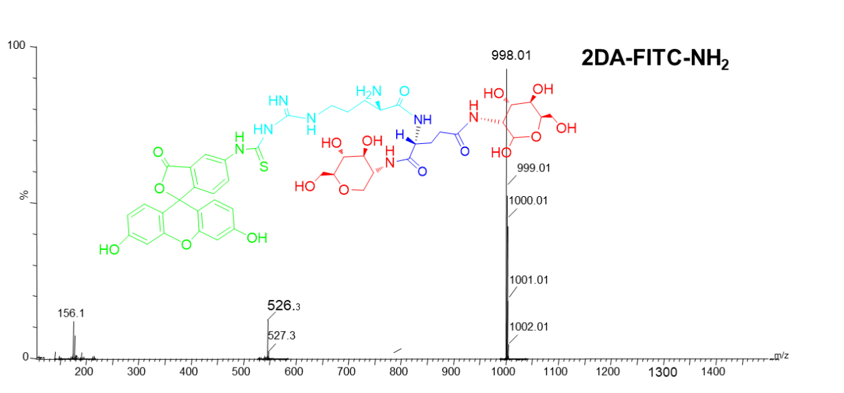

Figure S4: 2DA-FITC-NH₂ LC-MS：[M + H] ⁺ = 998.9 calc: 999.9

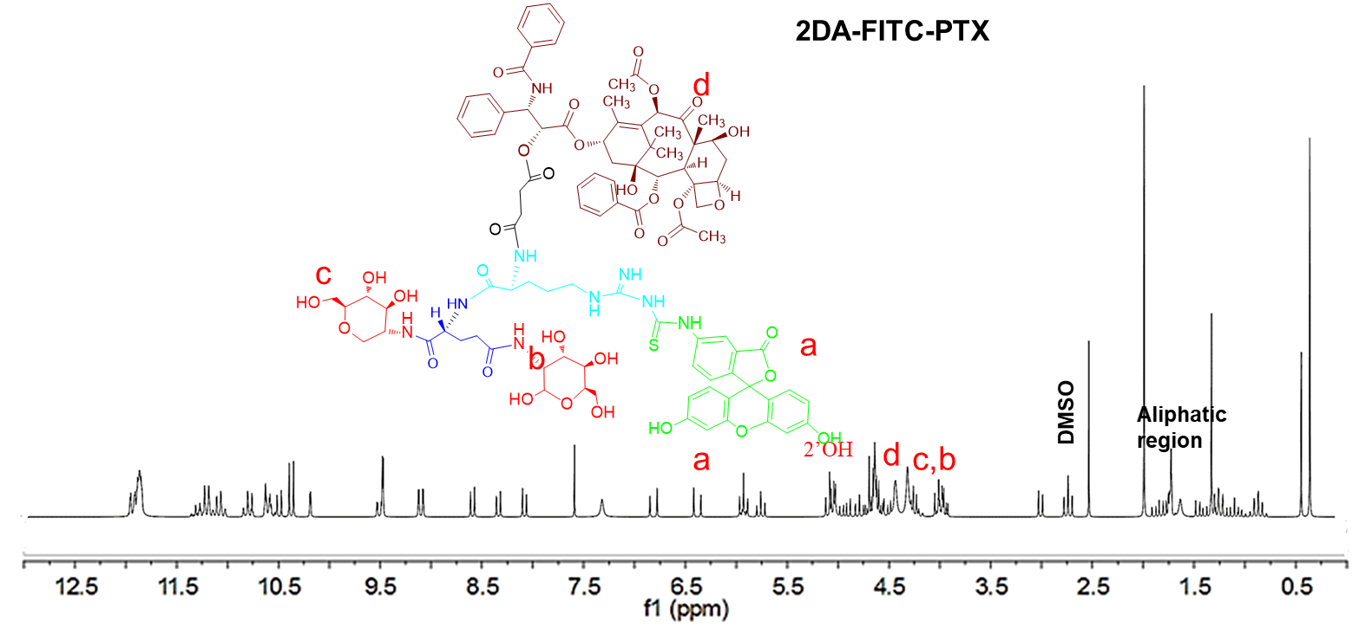

Figure S5: ¹H NMR spectrum of 2DA-FITC-PTX. ¹H NMR (400MHz, DMSO)

Figure S6: Zeta potential (mV) measurement of 2DA-FITC-PTX NPs

Figure S7. mRNA levels of GLUT1 expression on the MDA-MB-231 and 293T cells were determined by reverse transcriptase PCR.

Figure S8. H&E stained images of heart after various administrations. Scale bars are 50 μm.

Figure S9. H&E-stained liver and kidney tissues after treated by PBS (control), PTX,
2DA-FITC-PTX and 2DA-FITC-PTX NPs, respectively. Scale bar, 50 μm.

Table S1: The drug loading efficiency, drug loading capacity and stability of 2DA-FITC-PTX NPs.
Sample name | 2DA-FITC-PTX NPs conc.(ug/mL) | Calc. PTX  conc. (ug/mL) | Actual PTX  conc. (µg/Ml) | Drug loading efficiency | Drug loading capacity | Diameter (nm) | Stability
2DA-FITC-PTX NPs-20% | 500 | 100 | 95 | 95% | 15.9% | 43 ± 9 | No visible precipitation in 2, 4, 8 weeks at 4 ºC or RT
2DA-FITC-PTX NPs-50% | 200 | 100 | 96 | 96% | 32.4% | 42 ± 10 | No visible precipitation in 2, 4, 8 weeks at 4 ºC or RT
2DA-FITC-PTX NPs-80% | 125 | 100 | 96 | 96% | 43.4% | 39 ± 8 | No visible precipitation in 2, 4, 8 weeks at 4 ºC or RT
2DA-FITC-  PTX NPs-  100% | 100 | 100 | 97 | 97% | 49.2% | 40 ± 13 | No visible precipitation in 2, 4, 8 weeks at 4 ºC or RT
2DA-FITC-PTX NPs-  200% | 50 | 100 | 98 | 98% | 66.2% | 41 ± 6 | No visible precipitation in 2, 4, 8 weeks at 4 ºC or RT
2DA (2-glucosamine), FITC (Fluorescein-5(6)-isothiocyanate, green), PTX (Paclitaxel), 2DA-FITC-PTX NPs (2-glucosamine-fluorescein-5(6)-isothiocyanate-glutamicacid-paclitaxel nanoparticles), and RT (Room temperature).
Entrapment efficiency calculated as follows:
%EE = [(Drug added - Free "unentrapped drug")/Drug added] *100
Loading capacity calculated using the following equation:
%LC = [Entrapped Drug/nanoparticles weight] * 100

