Supplementary appendix

Modelling the Cost-Effectiveness of Indacaterol/ Glycopyrronium Versus Salmeterol/Fluticasone Using a Novel Markov Exacerbation-Based Approach
Bhavesh Lakotia,¹ Ronan Mahon,¹ Florian S. Gutzwiller,² Andrii Danyliv,¹ Ivan Nikolaev,² Praveen Thokala³
¹Novartis Ireland Limited, Dublin, Ireland; ²Novartis Pharma AG, Basel, Switzerland; ³PT Health Economics Ltd, Sheffield, UK

Correspondence:
Ronan Mahon
Team Head, Patient Access Services
Product Lifecycle Services - NBS
Novartis Global Service Center Dublin
Vista Building, Elm Park Business Campus, Merrion Road
Dublin 4, IRELAND
Tel +353873647443
Fax +353 1 2601263
Email ronan.mahon@novartis.com

Section 1.
Regression equation from Rutten-van Mölken et al. 2006¹
Utility value = 0.688 + Gender * 0.057 + FEV1 percent predicted * 0.003
+ Emergency Room visits in the last year * -0.029
+ Hospital admissions in the last year * -0.02
+ Number of concomitant diseases * -0.01 + BMI * -0.003S

Table S1. Transition probabilities for the three different health states with salmeterol/fluticasone
From \ to | IE | FE | Dead
IE | (1-mortality) * 0.7026925 | (1-mortality) * 0.2973075 | mortality
FE | (1-mortality) * 0.4628369 | (1-mortality) * 0.5371631 | mortality
Dead | 0 | 0 | 1

The mortality parameter depends on age, sex and percentage of predicted forced expiratory volume in 1 second.
Abbreviations: FE, frequent exacerbator; IE, infrequent exacerbator.

Table S2 ‒Transition probabilities for the three different health states with indacaterol/glycopyrronium

From \ to | IE | FE | Dead
IE | (1-mortality) * 0.7724824 | (1-mortality) * 0.2275176 | mortality
FE | (1-mortality) * 0.5478352 | (1-mortality) * 0.4521648 | mortality
Dead | 0 | 0 | 1

The mortality parameter depends on age, sex and percentage of predicted forced expiratory volume in 1 second.

Abbreviations: FE, frequent exacerbator; IE, infrequent exacerbator.

Figure S1 ‒ Probabilistic sensitivity analysis of cost-effectiveness.
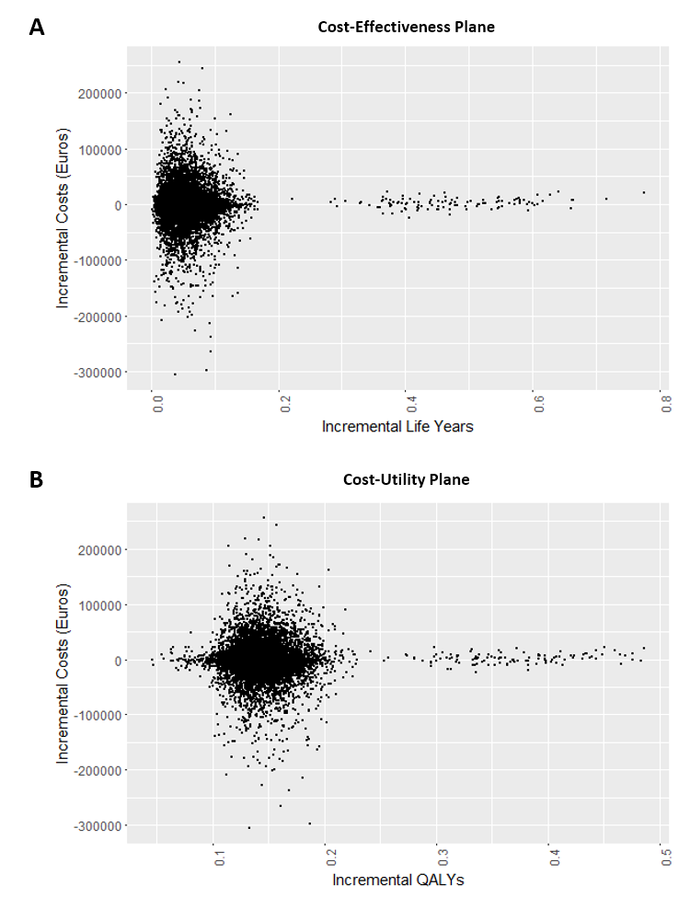
(Panel A) and cost-utility (Panel B) for indacaterol/glycopyrronium compared with salmeterol/fluticasone.
Probabilistic sensitivity analysis performed with input parameters characterized as statistical distributions to reflect uncertainty around the point estimates; a total of 10,000 simulations were run, sampling random values of the parameters from those distributions. In the probabilistic sensitivity analysis, almost 60% of the 10,000 sample results generated were concordant with IND/GLY dominating SFC, indicating that the results were consistent even when parameter uncertainty was included in the model.
Abbreviation: QALYs, quality-adjusted life years.
Figure S2 ‒ Cost-effectiveness acceptability curve for indacaterol/glycopyrronium compared with salmeterol/fluticasone.
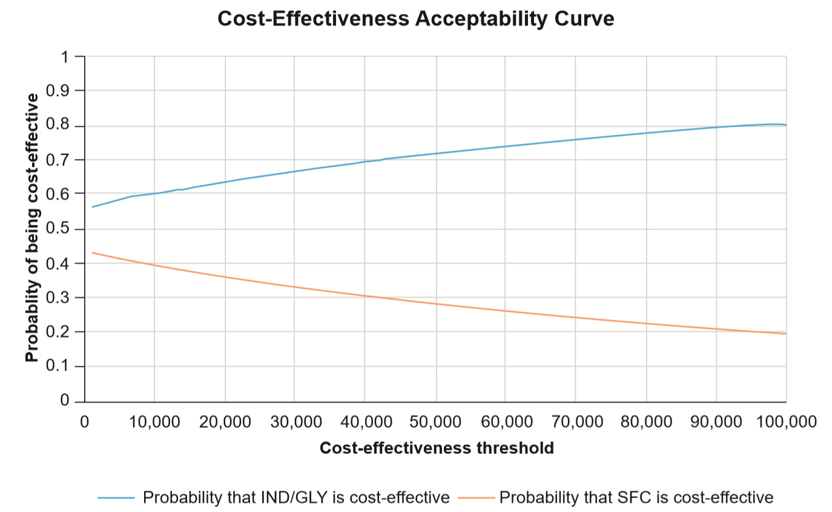
Abbreviations: IND/GLY, indacaterol/glycopyrronium; SFC, salmeterol/fluticasone.

Reference:
1. Rutten-van Molken MP, Oostenbrink JB, Tashkin DP, et al. Does quality of life of COPD patients as measured by the generic EuroQol five-dimension questionnaire differentiate between COPD severity stages? Chest 2006;130(4):1117-28. doi: 10.1378/chest.130.4.1117 [published Online First: 2006/10/13]

