Supporting Information for

Injectable chitosan-based thermosensitive hydrogel/ nanoparticle-loaded system for local delivery of vancomycin for the treatment of osteomyelitis

Jin Tao¹, Yang Zhang², Ao Shen³, Yunxu Yang¹, Lu Diao⁴, Luye Wang¹, Danwei Cai⁴， Ying Hu^{1,4}*

¹ Zhejiang Pharmaceutical College, Ningbo, Zhejiang, China
² Department of Medicine, Zhejiang Academy of Traditional Chinese Medicine, Hangzhou, Zhejiang, China
³ The University of Queensland, Brisbane 4072, Queensland, Australia
⁴ School of Pharmaceutical Sciences, Wenzhou Medical University, Wenzhou, Zhejiang, China

*Correspondence:
Prof. Ying Hu
Zhejiang Pharmaceutical College
No. 888, East section, Yinxian Main Road, The Zone of Higher Education, Ningbo, Zhejiang, 315100, China.
Tel: +86 574 8822 2707; Fax: +86 574 8822 3023
E-mail: pharmhawk@126.com

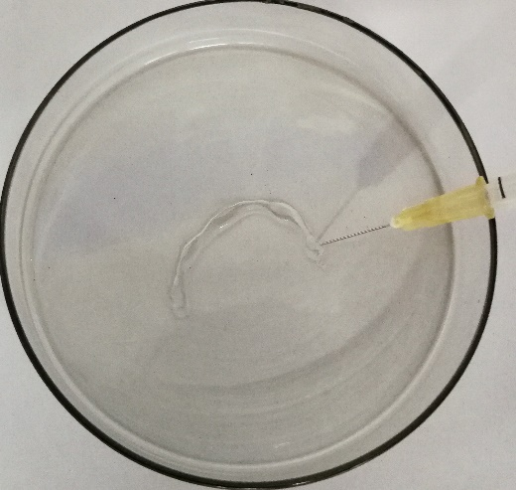
Figure S1. Injectability test with needle of VCM-NPs/Gel

Figure S2. The G' and G'' of blank Gel, NPs/Gel, VCM-NPs/Gel from 25 to 45 °C.

Figure S3. Particles size of VCM-NPs collect from VCM-NPs/Gel release medium at day 1(A) and day 10 (B).

Figure S4. ALP activity of OB cells treated with VCM-NPs, VCM/Gel and VCM-NPs/Gel with different concentration at 4 days.

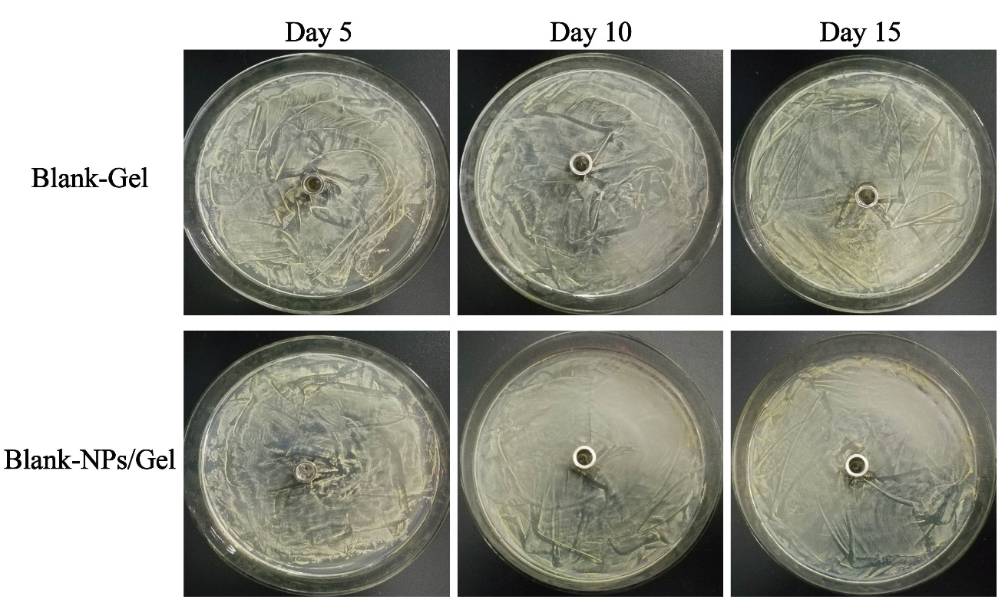
Figure S5. Optical images of antibacterial activity of Blank-Gel and Blank-NPs/Gel against S. aureus at 5 day, 10 day and 15 day.

