Supporting Information
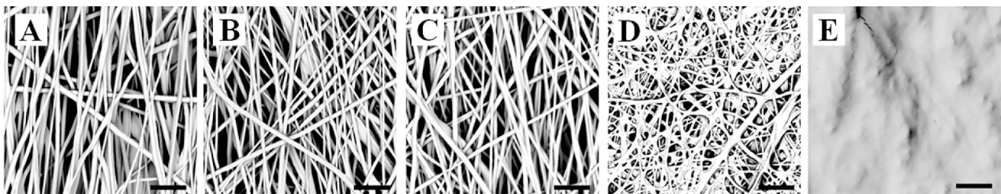
Figure S1. The SEM images of crosslinked scaffolds after immersion in PBS. (A) Pure PCL, (B) PCL/PTMC-MA (3:1), (C) PCL/PTMC-MA (1:1), (D) PCL/PTMC-MA (1:3) and (E) PTMC-MA. Scale bar: 10 μm.

Table S1. Average molecular weight and polydispersity index (PDI) of PTMC characterized by GPC.
 | Mn (kg/mol) | Mw (kg/mol) | PDI
PTMC | 21.90 | 34.30 | 1.56

Table S2. The optimum exposure time of pure PTMC-MA
Exposure time/min | 5 | 10 | 15
Dry mass-initial/g | 0.0268 | 0.0159 | 0.0318
Dry mass-final/g | 0.0241 | 0.0158 | 0.0288
Sol content | 89.93% | 99.37% | 90.57%

