Table S1: Descriptive data on the items scores of the Generalized anxiety disorder-7 (GAD-7) scale in Saudi university male students

Items of the GAD-7 scale | Skewness (SE) | Kurtosis (SE) | Cronbach's Alpha  if Item Deleted | Item-total  correlations | percentage distribution across item scores
 |  |  |  |  | 0 | 1 | 2 | 3
Item-1 | .65 (.18) | -.42 (.35) | .81 | .66* | 38.5 | 37.5 | 18.8 | 5.2
Item-2 | .81 (.18) | -.57 (.35) | .79 | .73* | 51.0 | 22.9 | 19.8 | 5.7
Item-3 | .88 (.18) | -.38 (.35) | .79 | .76* | 52.1 | 25.0 | 18.2 | 3.6
Item-4 | .91 (.18) | -.03 (.35) | .81 | .61* | 49.0 | 31.8 | 14.6 | 3.1
Item-5 | 1.57 (.18) | 1.48 (.35) | .81 | .64* | 65.6 | 18.8 | 8.9 | 5.2
Item-6 | .87 (.18) | -.43 (.35) | .83 | .61* | 49.0 | 25.5 | 16.1 | 8.3
Item-7 | .86 (.18) | -.24 (.35) | .81 | .67* | 46.9 | 30.2 | 16.1 | 5.2
SE: Standard Error; *p<.01
Table S2: Homogeneity - Inter-item correlations of the Generalized anxiety disorder-7 (GAD-7) scale in Saudi university male students
Items of the  GAD-7 scale | Item-1 | Item-2 | Item-3 | Item-4 | Item-5 | Item-6 | Item-7
Item-1 |  | .51* | .50* | .36* | .32* | .30* | .29*
Item-2 |  |  | .57* | .36* | .43* | .32* | .41*
Item-3 |  |  |  | .43* | .40* | .36* | .50*
Item-4 |  |  |  |  | .42* | .22* | .31*
Item-5 |  |  |  |  |  | .38* | .44*
Item-6 |  |  |  |  |  |  | .34*
Item-7
*p<.01

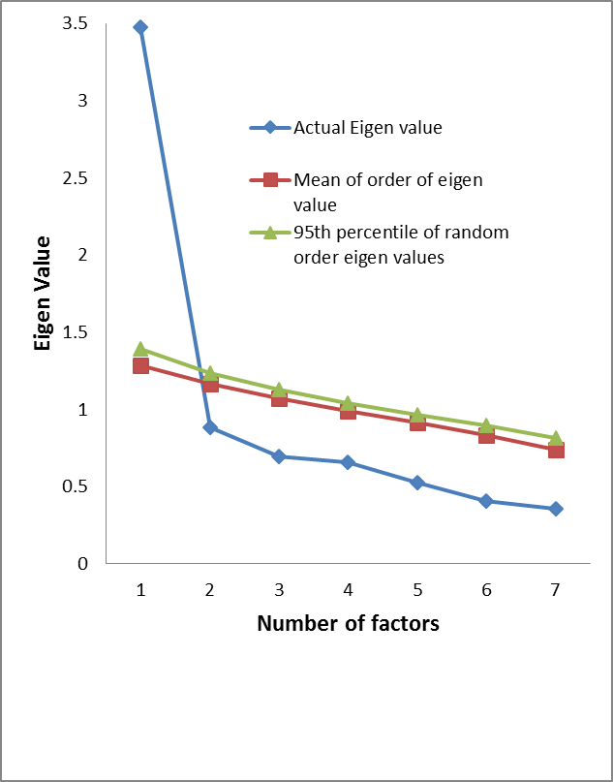
Figure S1: Parallel analysis Sequence plot of the Generalized anxiety disorder-7 (GAD-7) scale in Saudi university male students

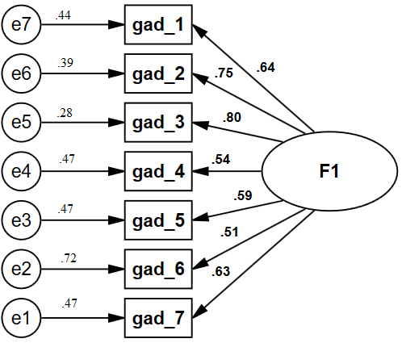

Figure S2: Confirmatory factor analysis models of the Generalized anxiety disorder-7 (GAD-7) scale in Saudi university male students. All coefficients are standardized.
gad_1 to gad_7: items of the GAD-7 scale
Ovals latent variables, rectangles measured variables, circles error terms, single-headed arrows between ovals and rectangles factor loadings, single-headed arrows between circles and rectangles error terms, numerical value on the single-headed arrows between circles and rectangles: uniqueness (error terms)

Figure legends (Supplementary files)
Supplementary figure S1 Parallel analysis Sequence plot of the Generalized anxiety disorder-7 (GAD-7) scale in Saudi university male students

Supplementary figure S2 Confirmatory factor analysis models of the Generalized anxiety disorder-7 (GAD-7) scale in Saudi university male students. All coefficients are standardized.
gad_1 to gad_7: items of the GAD-7 scale
Ovals latent variables, rectangles measured variables, circles error terms, single-headed arrows between ovals and rectangles factor loadings, single-headed arrows between circles and rectangles error terms, numerical value on the single-headed arrows between circles and rectangles: uniqueness (error terms)

