Supplementary Figure 1. This figure depicts the inputs that were selected from each one of the machine learning prediction models for the four different outcomes. Total number of features selected from each model as well as total number of times that each feature was selected are also calculated.

 |  | 5-fold Cross Validation |  |  | Test Set
 | Number of Random Trees | Accuracy | Geometric Mean of Sensitivity-Specificity | MSE | Accuracy | Geometric Mean of Sensitivity-Specificity | MSE
Total Drugs Change | 100 | 75% | 61.44% | 0.832 | 76.38% | 66.68% | 0.622
Total Drugs Change | 250 | 75% | 62.54% | 1.031 | 75.59% | 65.26% | 0.603
Total Drugs Change | 500 | 75% | 62.43% | 1.03 | 75.59% | 65.26% | 0.598
Total Drugs Change | 1000 | 75% | 61.74% | 1.03 | 75.59% | 65.26% | 0.597
Total Interference Change | 100 | 79.76% | 50.17% | 3.902 | 81.89% | 54.88% | 3.365
Total Interference Change | 250 | 81.15% | 52.28% | 3.891 | 83.46% | 55.44% | 3.308
Total Interference Change | 500 | 81.35% | 53.15% | 3.864 | 82.67% | 55.16% | 3.353
Total Interference Change | 1000 | 81.15% | 53.07% | 3.854 | 81.89% | 51.60% | 3.334
Total Severity Change | 100 | 74.60% | 23.41% | 3.274 | 74.80% | 25.28% | 3.617
Total Severity Change | 250 | 74.80% | 21.73% | 3.264 | 74.80% | 25.28% | 3.631
Total Severity Change | 500 | 74.20% | 10.26% | 3.293 | 74.80% | 25.28% | 3.596
Total Severity Change | 1000 | 74.80% | 19.87% | 3.282 | 74.80% | 25.28% | 3.601
Total Complaints Change | 100 | 67.85% | 69.17% | 4.257 | 75.80% | 25.28% | 3.617
Total Complaints Change | 250 | 67.66% | 68.96% | 4.326 | 67.71% | 69.14% | 2.563
Total Complaints Change | 500 | 68.65% | 69.97% | 4.352 | 66.93% | 68.44% | 2.611
Total Complaints Change | 1000 | 69.04% | 70.35% | 4.33 | 67.71% | 69.14% | 2.588
Supplementary Table 1. Comparative results using different number of Random Trees for the Random Forest based predictors.

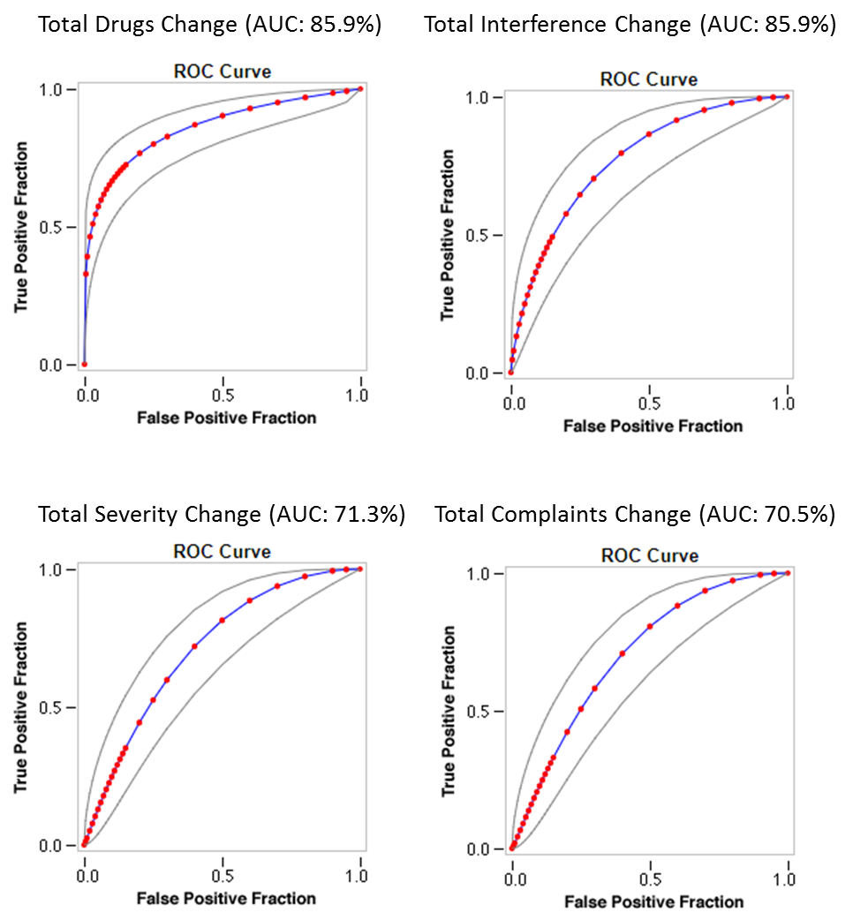
Supplementary Figure 2. Roc curve analysis on the test set using the best performing RF models from the cross validation exercise.

