Supplementary material
Macroscopic Findings of Tumor Tissues after Peptide Loaded DC Injection
An in vivo study was designed based on the obtained data in vitro. Furthermore, after tumor induction and 17 days after treatment of mice with peptide-loaded DCs, the mice were euthanized, and the tumors were dissected and utilized for further analysis. Therefore, the size of dissected tumors was perceived physically, and in the treated group, 2 out of five tumors (approximately 40% of treated mice) showed a very significant decrease in their volume. This phenomenon indicates the efficacy of loaded peptide in elucidating the predicted CTL responses. The sizes of all the extracted tumors are shown in Fig S1.
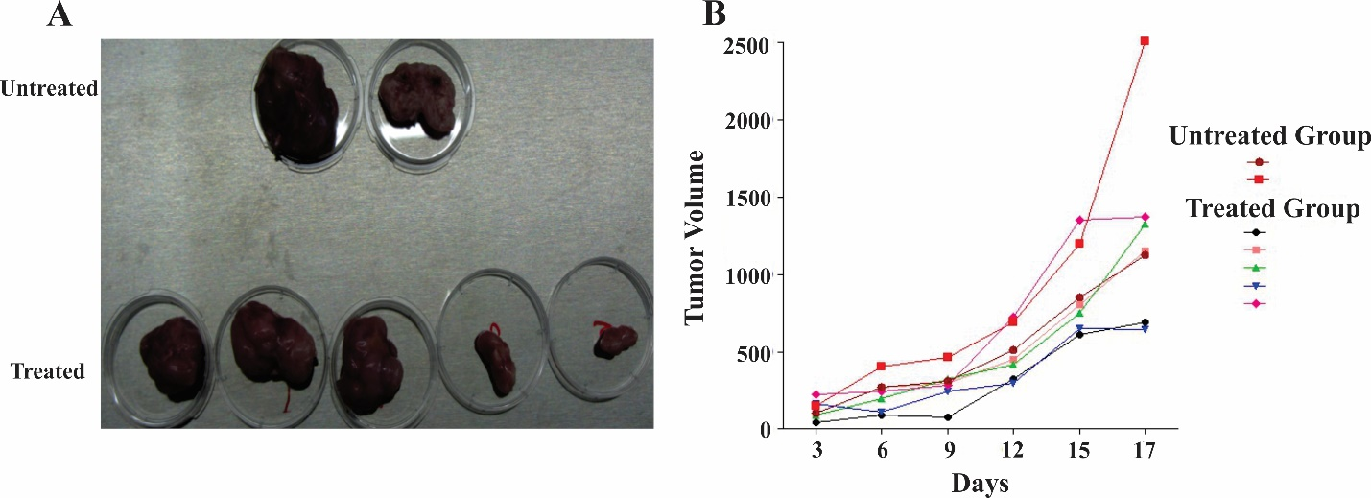
Figure S1. The size and tumor volume graph of dissected tumors from untreated and treated groups
A) The size of tumors indicates the efficacy of loaded DCs with LY6E in provoking the immune system against induced tumors. B) The tumor volume graph illustrates the effectiveness of loaded DC with LY6E delaying tumor growth during therapy.

