Supplementary material
Figure S1
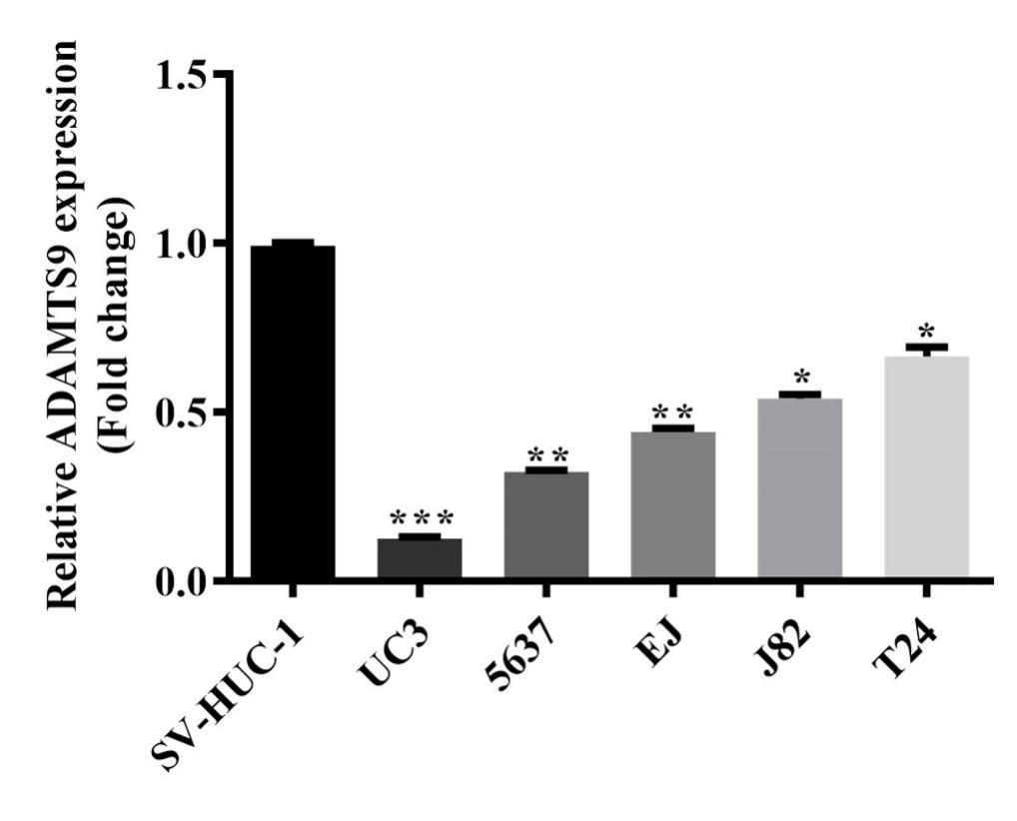
Figure S1. Downregulation of ADAMTS9 was identified in bladder tumor cells using qPCR
Notes: qPCR assays were conducted to exam the ADAMTS9 expression in one normal cell line SV-HUC-1 and five bladder tumor cell lines (UC3, 5637, J82, T24, and EJ). We found that compared to normal cell line SV-HUC-1, the expression of ADAMTS9 was downregulated in UC3, 5637, J82, T24, and EJ cell lines, especially in UC3 and 5637 cells, *, P < 0.05, **, P < 0.01; *** P < 0.001
Abbreviations: ADAMTS9, ADAM metallopeptidase with thrombospondin type 1 motif, 9; q-PCR, quantitative PCR

Figure S2
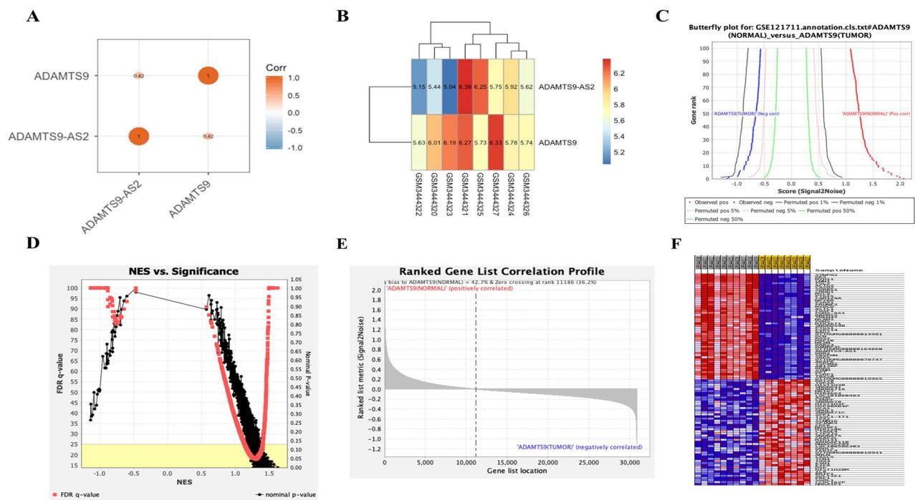
Figure S2. The correlation analysis between ADAMTS9-AS2 and ADAMTS9 using GEO
Notes: (A) From the GEO analysis results, red represents positive correlation, which indicated that ADAMTS9-AS2 and ADAMTS9 had a weak positive correlation, and the correlation coefficient is 0.42. (B) The heatmap from bladder tumor dataset GSE121711, we obtained the matrix of ADAMTS9-AS2 and ADAMTS9 expression value, which showed the difference in expression between them. (C) GSEA butterfly plot showed observed association between gene rank and ranking metric score, as well as permuted (1%, 5%, 50%) positive and negative association. (D) GSE121711 dataset, in which genes with nominal p-value < 0.05 and FDR q-value < 0.25 were further selected to obtain relatively significant data. (E) Ranked gene list showed the top 100 genes in the correlation profile. (F) The heatmap showed that the first 100 genes are significant differences in expression between tumor and normal samples.
Abbreviations: ADAMTS9, ADAM metallopeptidase with thrombospondin type 1 motif, 9, ADAMTS9-AS2, ADAMTS9 antisense RNA 2; GEO, Gene Expression Omnibus; GSEA, Gene Set Enrichment Analysis; FDR, false discovery rate

