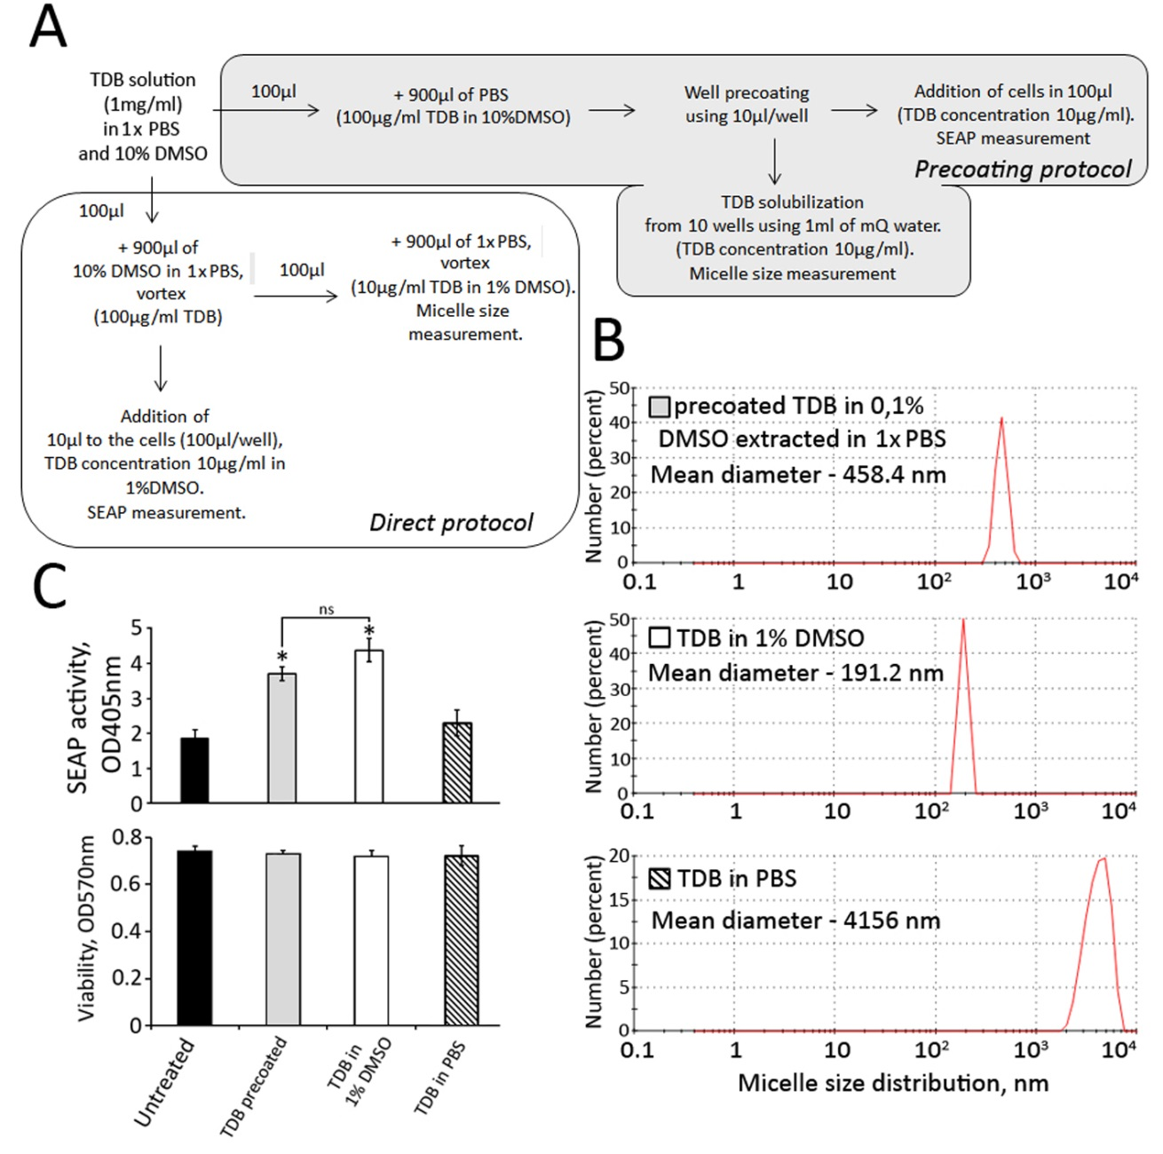

SUPPLEMENTARY FIGURE 1. Comparison of relative NF-κB/AP-1-dependent reporter inducing activity of TDB applied to THP-1-XBlue-CD14 cells using different techniques. (A) The initial reconstitution of TDB and further plate precoating steps were performed according manufacturer’s (Invivogen) instructions (filled with gray). According to another approach TDB from stock solution was further diluted using 1xPBS containing 10% DMSO (filled with white). After addition of such TDB samples the final concentration of DMSO in cell culture was 1%. (B) Micelles of TDB diluted in 1x PBS containing 10% DMSO showed less mean diameter -191nm comparing to TDB presented in cultural media after precoating (mean diameter of micelles - 458nm). Maximal micelle diameter was observed in TDB diluted in 1xPBS. Micelle diameter was measured by Dynamic Light Scattering (DLS) method using Malvern Zetasizer Nano instrument (Malvern Instruments, UK). (C) SEAP expression levels of THP-1-XBlue-CD14 cells directly stimulated with TDB diluted in 1x PBS (cross-hatched bars), or in 1x PBS containing 10% DMSO (white bars) or treated with precoated TDB (gray bars) at the same concentration (10µg/ml). Asterisks indicate significant differences (P<0.05) in SEAP activity levels between TDB-treated and untreated cells. Similar (not significant) SEAP activity levels were registered after direct addition of TBD diluted in 1x PBS containing 10% DMSO comparing to precoating method. There was no toxic effect observed in THP-1 cells treated with TDB samples containing 1% DMSO (cell viability was measured by MTT test) comparing to untreated cells.

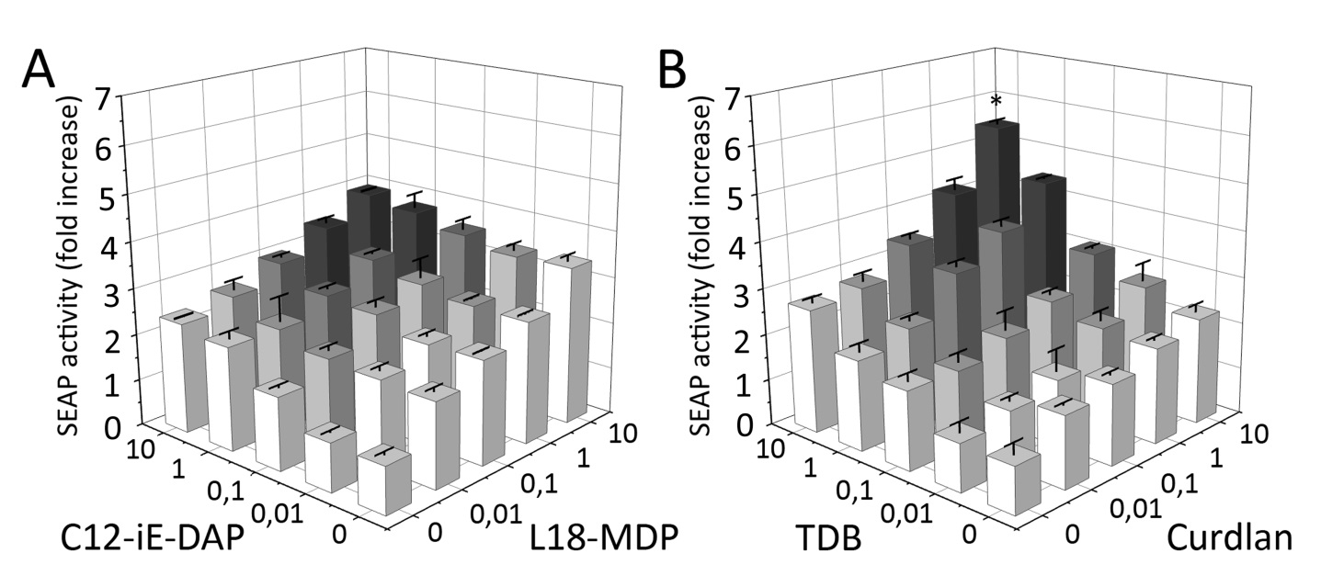
SUPPLEMENTARY FIGURE 2. Levels of NF-κB/AP-1-dependent SEAP activity in THP-1-XBlue-CD14 cells after combined stimulation of CLRs (Dectin-1-Mincle) or NLRs (NOD1-NOD2). THP1-XBlue-CD14 cells were either stimulated with individual PRR agonists (C12-iE-DAP, L18-MDP, TDB or Curdlan) or with combinations: (A) TDB plus Curdlan, or (B) C12-iE-DAP plus L18-MDP at the indicated concentrations (µg/ml) for 18 h. Intact cells (no treatment) were used as control. Results are expressed as the fold increase in NF-κB/AP-1-dependent SEAP activity relative to intact (untreated) cells (values are mean from three independent experiments, each performed in duplicate). Error bars indicated standard deviations (SD). * indicates potentiated (greater than the sum of the fold induction observed after stimulation of single PRR at the same doses of agonists) NF-κB/AP-1-dependent SEAP reporter gene expression level in group treated with combination of Dectin-1 and Mincle agonists.

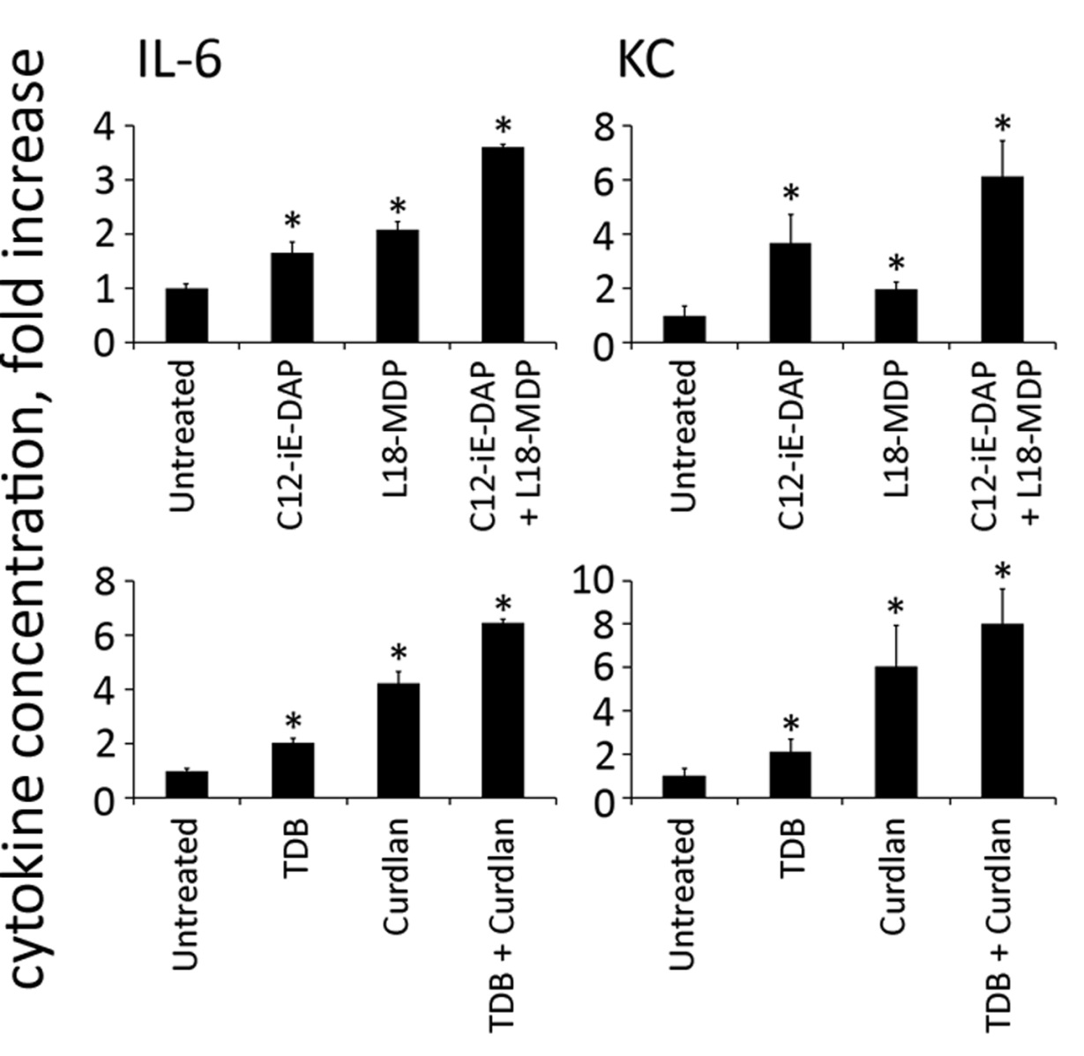

SUPPLEMENTARY FIGURE 3. Levels of cytokine production in mouse serum after combined stimulation of CLRs (Dectin-1, Mincle) or NLRs (NOD1,NOD2). Mice (n=5 per group) were injected i.m. with PBS or with PRR agonists C12-iE-DAP (1μg/mouse), L18-MDP (1μg/mouse), Curdlan (10μg/mouse), TDB (10μg/mouse) individually or in combinations: C12-iE-DAP-L18-MDP, Curdlan-TDB. Blood samples were collected 3 h after PRR ligand administration. The mean fold change in cytokine concentration relative to the mean concentration in PBS-treated animals is shown. Error bars indicate SD. * Indicates significant difference (P≤0.05, Student t-test) between PRR agonist (individually or in combinations) treated cells and the intact cells.

