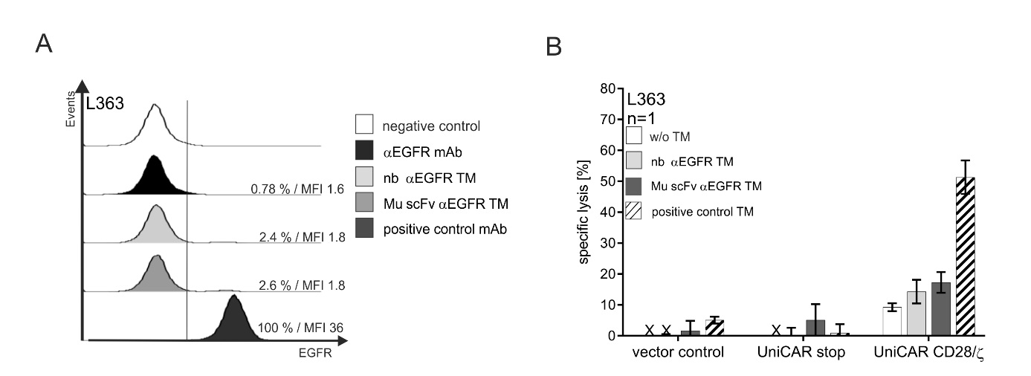
Supplementary information

Supplementary Figure S1. Binding and killing analysis using αEGFR TMs on EGFR-negative tumor cells.

Multiple myeloma L363 tumor cells were incubated with an αEGFR mAb and afterwards with a goat-α-mouse IgG-Pacific BlueTM mAb and analyzed by flow cytometry to confirm that they do not express EGFR on their cell surface (A, black histogram). Furthermore, EGFR-negative L363 tumor cells were incubated with 25 ng/µl of indicated TM, αE5B9 mAb and goat-α-mouse IgG-Pacific BlueTM mAb (A, grey histograms). L363 cells were positively stained with a positive control mAb (A, dark grey histogram). As negative control, cells were only stained with the detection mAb alone (white histogram). To further confirm specificity of indicated TMs, a chromium release cytotoxicity assay was performed with EGFR-negative L363 tumor cells (B). Therefore, L363 cells were incubated with genetically modified control T cells (vector control and UniCAR stop) or UniCAR CD28/ζ T cells in the presence or absence of indicated TMs (50 nM) at an effector to target cell ratio of 5:1 for 24 h. Bars represent the mean specific lysis with SEM of triplicates for one representative donor.

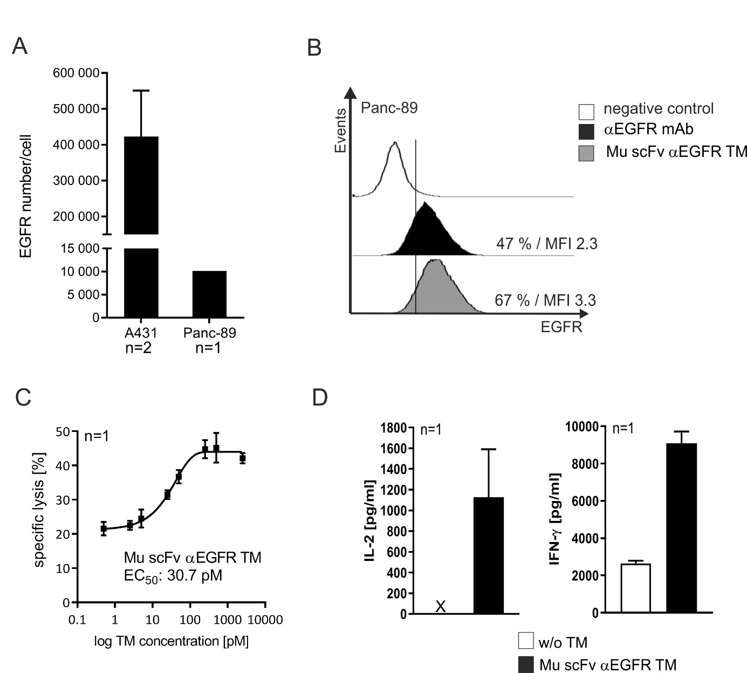

Supplementary Figure S2. Binding and functional analysis of αEGFR TM on Panc-89 tumor cells.

EGFR numbers on A431 and Panc-89 tumor cells were measured using the QIFIKIT® (A). Panc-89 cells were stained with αEGFR mAb and detected via goat-α-mouse IgG-Pacific BlueTM by flow cytometry analysis (B, black histogram). Furthermore, TM binding was analyzed by staining of Panc-89 cells with Mu scFv αEGFR TM, the αE5B9 mAb and goat-α-mouse IgG-Pacific BlueTM (B, grey histogram). As negative control, cells were incubated with detection Ab alone (B, white histogram). Cytotoxicity was analyzed by using a luciferase-based killing assay. Therefore, luciferase-expressing Panc-89 cells were incubated with UniCAR CD28/ζ T cells at an effector to target cell ratio of 5:1 in the presence of Mu scFv αEGFR TM. Increasing concentrations of Mu scFv αEGFR TM were used to estimate half-maximal effective concentration (EC₅₀) value. Mean specific lysis with SD of triplicates are shown for one representative donor (C). In addition, secreted cytokines were measured in the co-culture supernatants with or without (w/o) TM. Bars represent the average with SD of triplicates for one representative donor (D). (x, not detectable).

