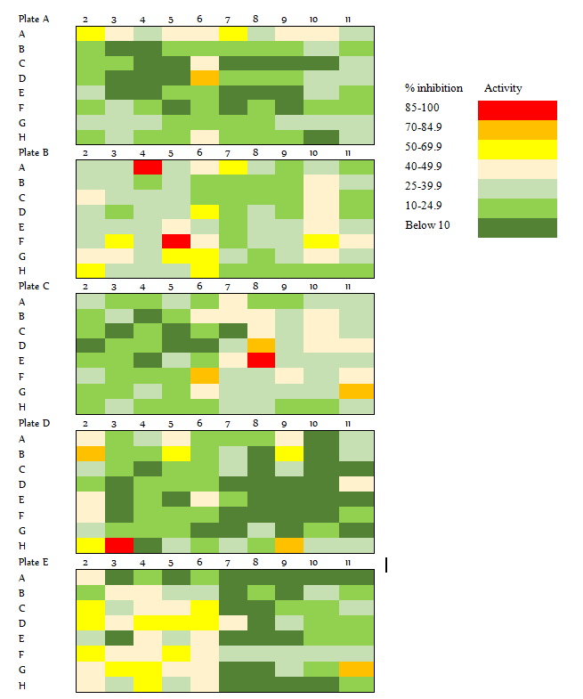
Supplementary files Fig S01. Heat map of percent inhibition of pathogen box compounds against Leishmania donovani promastigotes. The color key shown for the range of inhibition observed by the compounds. Red color corresponds to highest inhibitions (more than 85%), while dark green colors correspond to lowest inhibition. The experiment was conducted using amphotericin B and Pentamidine as standard drugs to check susceptibility of the parasites. Two compounds (Plate A well D06 and Plate B well A04) were purposively omitted from further investigation. Plate A well D06 despite its considerable activity on the primary screening was failed to demonstrate a dose dependent inhibitory effect the subsequent dose titration assay. The other compound B-A04 (pentamidine) is a standard drug for leishmaniasis. The heat map was generated using the average activity values of compounds from each microplate well in two independent experiments conducted in triplicate.

