SUPPLEMENTARY INFORMATION

Silver nanoparticle-induced apoptosis in ARPE-19 cells is inhibited by Toxoplasma gondii pre-infection through suppression of NOX4-dependent ROS generation

Juan-Hua Quan^{1,†}, Fei Fei Gao^{2,†}, Hassan Ahmed Hassan Ahmed Ismail^{3,†}, Jae-Min Yuk², Guang-Ho Cha², Jia-Qi Chu⁴, Young-Ha Lee^{2,}*

¹Department of Gastroenterology, The Affiliated Hospital of Guangdong Medical University, Zhanjiang 524-001, People’s Republic of China
²Department of Infection Biology and Department of Medical Science, Chungnam National University College of Medicine, Daejeon 301-131, Korea
³Communicable and Non-Communicable Diseases Control Directorate, Federal Ministry of Health, Khartoum, Sudan
⁴Stem Cell Research and Cellular Therapy Center, Affiliated Hospital of Guangdong Medical University, Zhanjiang, Guangdong Province 524-001, People’s Republic of China

*Correspondence: Young-Ha Lee, M.D.
Department of Infection Biology and Department of Medical Science, Chungnam National University College of Medicine 6 Munhwa-dong, Jung-gu, Daejeon 35015, Korea
Tel: +82-42-580-8273, Fax : +82-42-583-8216
E-mail address: yhalee@cnu.ac.kr.
ORCID number: https://orcid.org/0000-0002-5795-8960

†These authors contributed equally to this work.

Supplementary Figure 1. Size measurement of AgNPs using TEM. To enable the characterization of the AgNPs using TEM imaging with a reasonable resolution, a solution of AgNPs was diluted in alcohol and was dispersed evenly for prevention of aggregating particles and elimination of water. The diameter measurements were performed at random. Mean surface area and number of particles were calculated based on mass concentration and average TEM diameter. In addition, the size and the size distribution of the silver NPs were measured using a particle size analyzer (Nanotrac, Microtrac Inc, Largo, FL). The size distribution of AgNPs were determined for the synthesized samples by diluting samples in deionized water to approximately 1 OD and quantified using a zetasizer (Zetasizer NANO-ZS, Malvern Instruments Ltd, Malvern, UK). Hydrodynamic diameter was calculated based on the average of 10 runs of the intensity weighted Z-average performed at 25 using the cumulative fit function performed in triplicate.

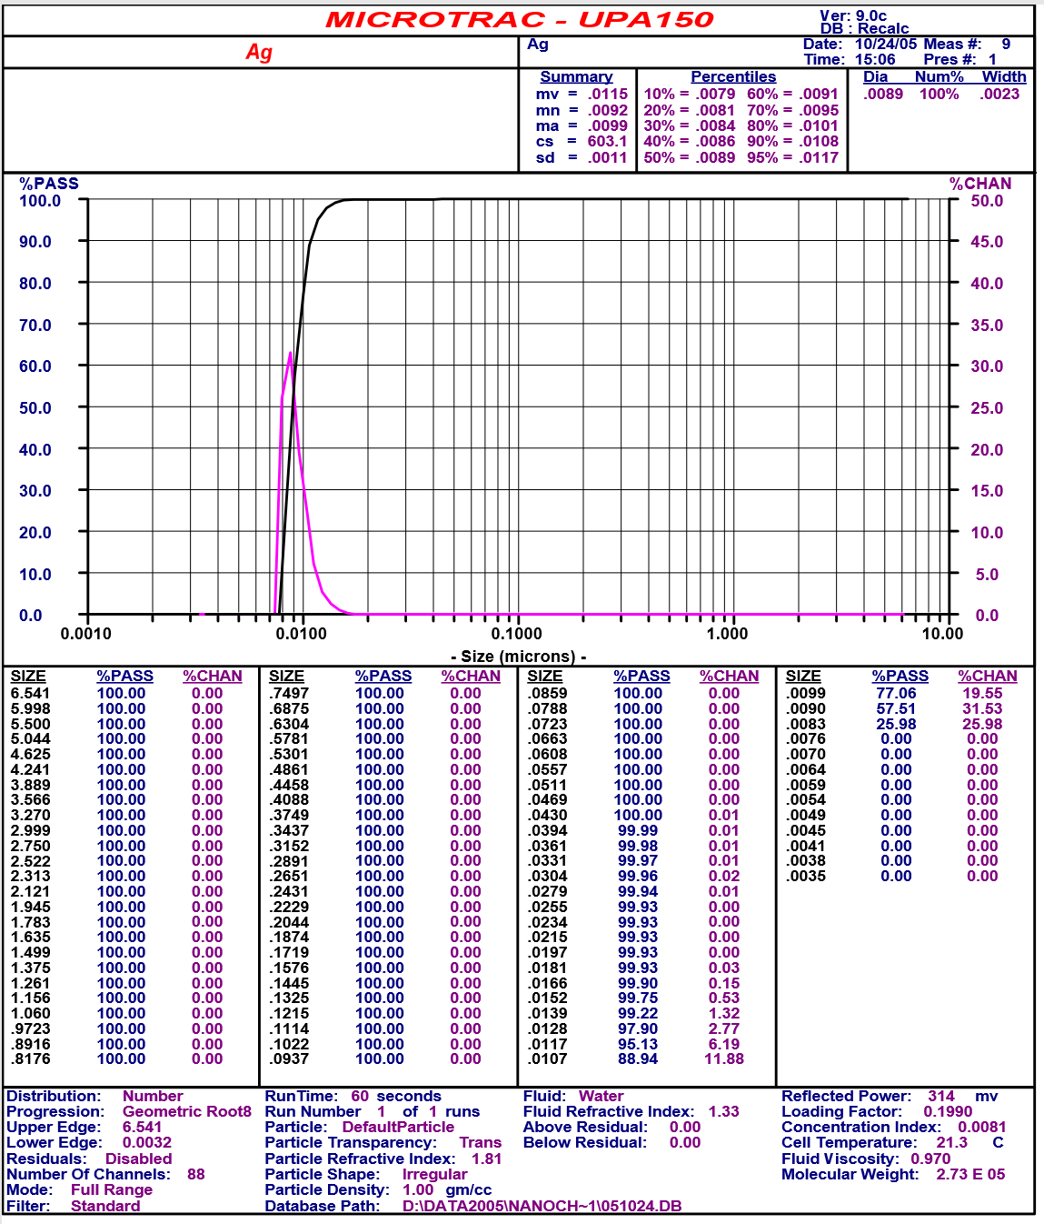
Supplementary Figure 2. AgNPs induced ARPE-19 cell and HFF cell apoptosis. ARPE-19 cells were treated with 5 μg/mL AgNPs for 24 h and 5% DMSO was used as positive control. (A) The protein levels of cleaved caspase-3 and PARP were determined by western blotting. (B) JC-1 stained cells were observed by confocal imaging. HFF cells were treated with 5 μg/mL AgNPs for 24 h and 5% DMSO was used as positive control. (C) The protein levels of cleaved caspase-3 and PARP were determined by western blotting. (D) JC-1 stained cells were observed by confocal imaging.
Abbreviations: HFF, human foreskin fibroblast; AgNPs, silver nanoparticles; DMSO, dimethyl sulfoxide; PARP, Poly (ADP-ribose) polymerase; JC-1, 5,5′,6,6′-Tetrachloro-1,1′,3,3′-tetraethyl-imidacarbocyanine iodide; DAPI, 4',6-diamidino-2-phenylindole.

