Figure S1. Plasmid profiles of C. freundii L91. (A) Plasmid size determination by S1-PFGE, with Salmonella enterica serotype Braenderup H9812 as the size marker. (B) Southern blotting hybridization with a bla_{IMP}-specific probe.
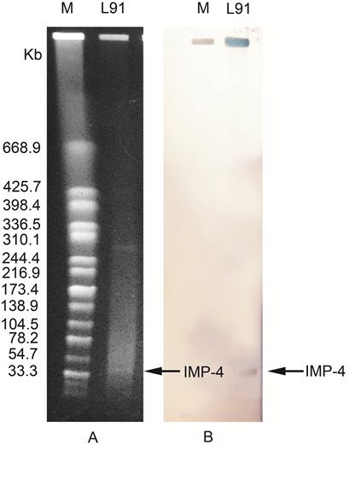
Table S1. Genomic features of the C. freundii L91
Feature | Chromosome | PIMP-4-L91 | P1-L91
Total number of bases (bp) | 4,951,125 | 51,042 | 304,128
G+C content (%) | 51.9 | 50.7 | 48.9
No. of protein-coding sequences | 4953 | 80 | 318
No. of tRNA genes | 83 | 0 | 0
Plasmid replicon type | - | IncN | -
Resistance genes | qnr-B38, bla_{CMY-109} | bla_{IMP-4}，qnrS1 | -
Accession numbers | SCVZ00000000 | SCVZ00000000 | SCVZ00000000

