Supporting information
Simple approaches for the synthesis of AgNPs in solution and solid phase using modified methoxypolyethylene glycol and evaluation of their antimicrobial activity
Ayman El-Faham*, Hessa H. Al-Rasheed, Essam N. Sholkamy, Sameh M. Osman, Zeid A. AL Othman

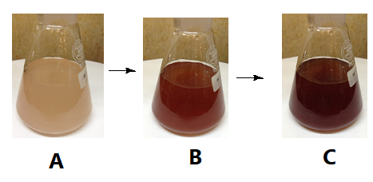
Figure S1 Changing the color during formation of AgNPs using mPEGTH2; A) after 2min from addition of AgNO₃ solution; B) after 5 min from addition of Ag solution; C) after 15 min from addition of Ag solution.
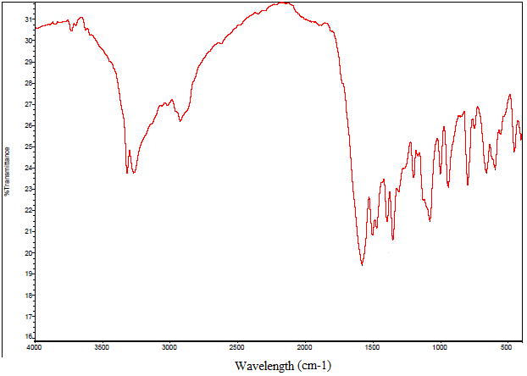

Figure S2 FTIR spectra for mPEGTH2.

Figure S3 FTIR spectra for mPEGTH2-AgNPs.

