Supporting Information

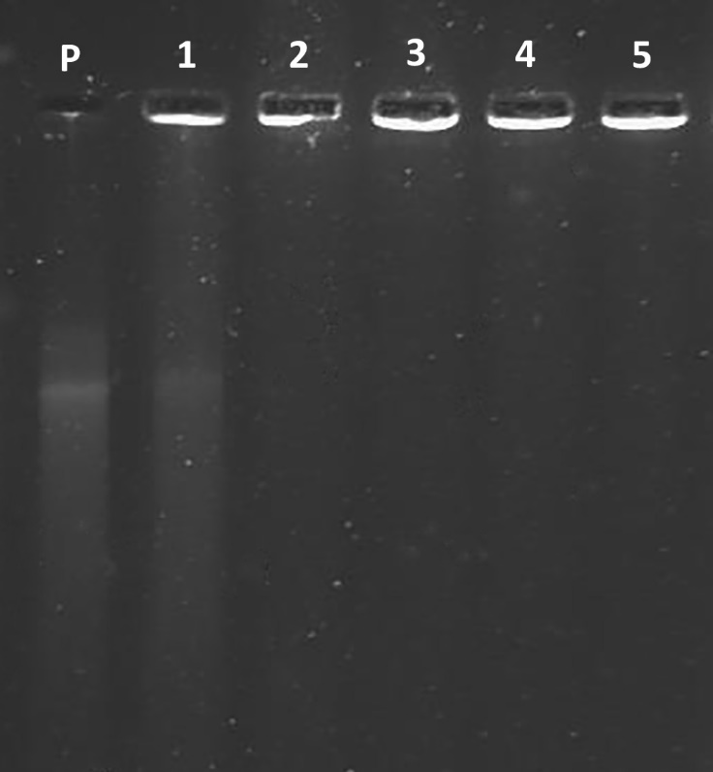
Figure S1. Gel electrophoresis of plasmid DNA, with different N/P ratio:
(P) Naked DNA, (1) N/P = 0.5, (2) N/P = 1, (3) N/P = 2, (4) N/P = 3 and (5) N/P = 5.

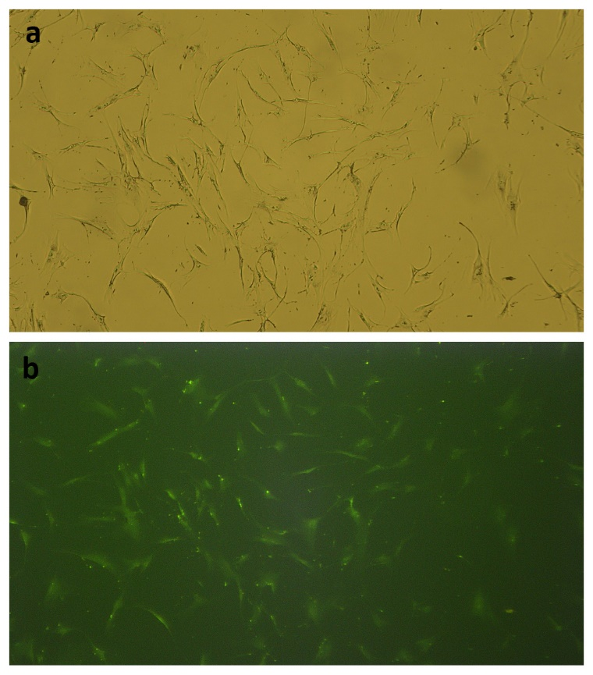
Figure S2. Transfection evaluation using microfluidic prepared nanoparticles with
GFP plasmid DNA, (a) light microscopy image, (b) florescent microscopy image
(N/P = 10, 1µg/well).

