Supplementary information

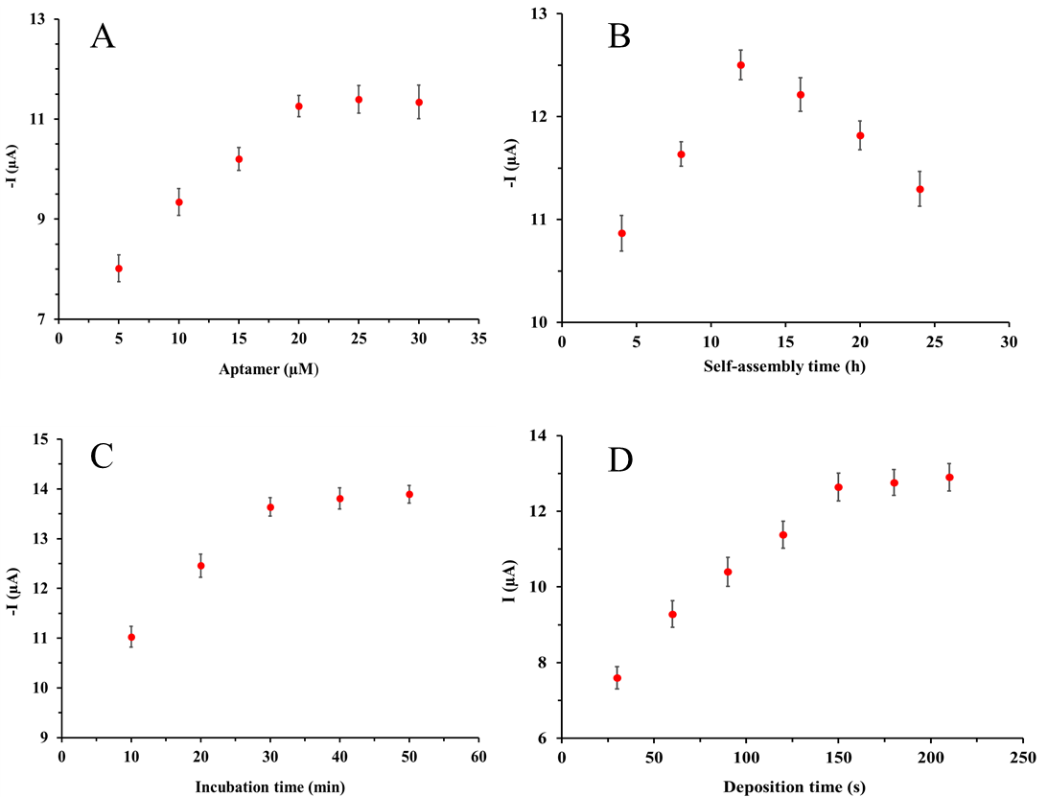
Figure S1 Optimization of the experimental conditions in terms of (A) aptamer concentration, (B) self-assembly time, (C) incubation time, and (D) electrodeposition time.

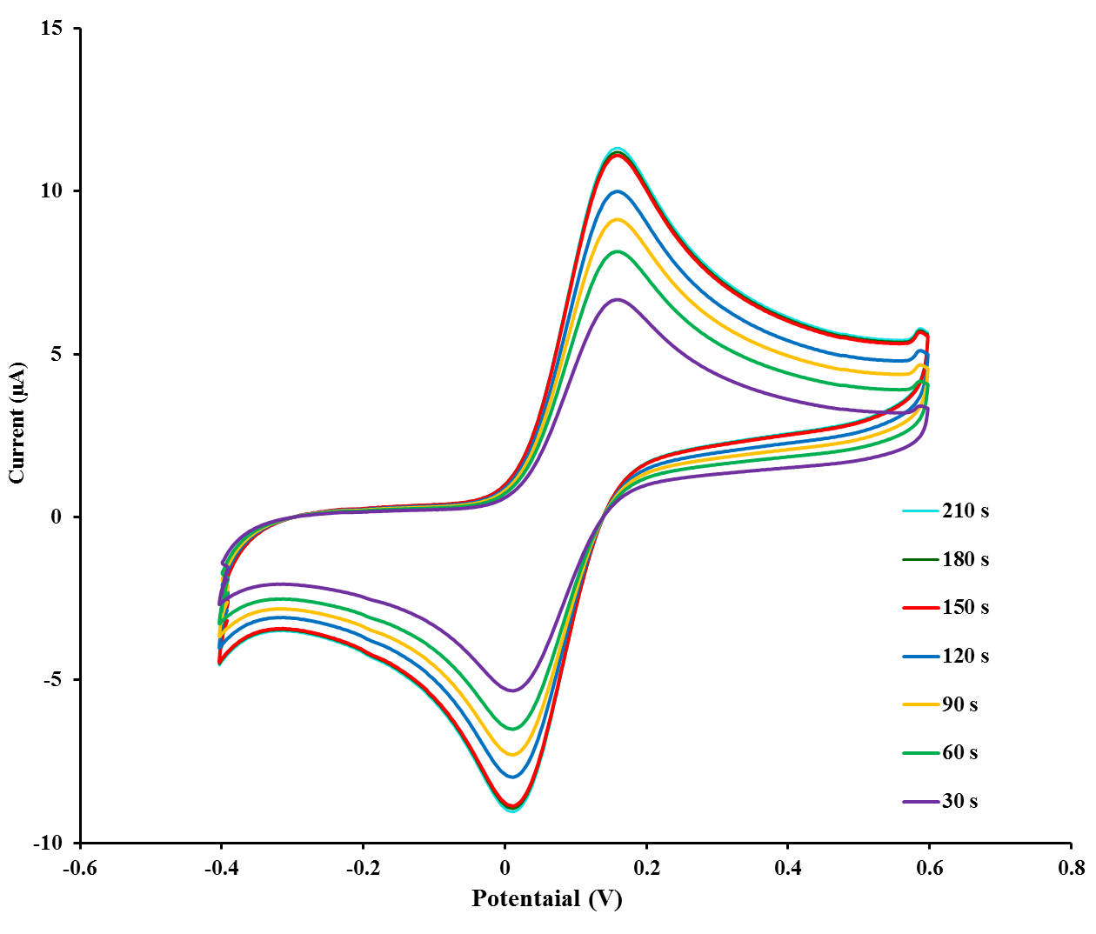Figure S2 The cyclic voltammograms of the fabricated aptasensor in various electrodeposition time of flower-like gold microstructures on electrode surface.

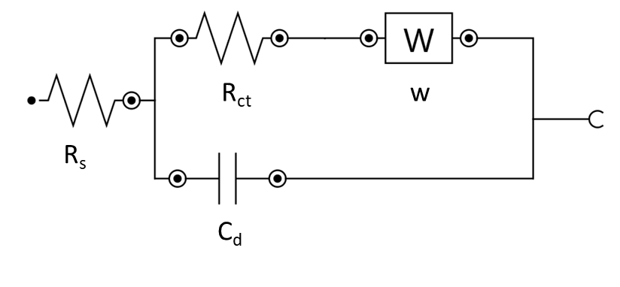
Figure S3 Randles equivalent circuit used for fitting the electrochemical impedance data (R_{s}: solution resistance, C_{d}: double layer capacitance, R_{ct}: charge transfer resistance, W: Warburg impedance).

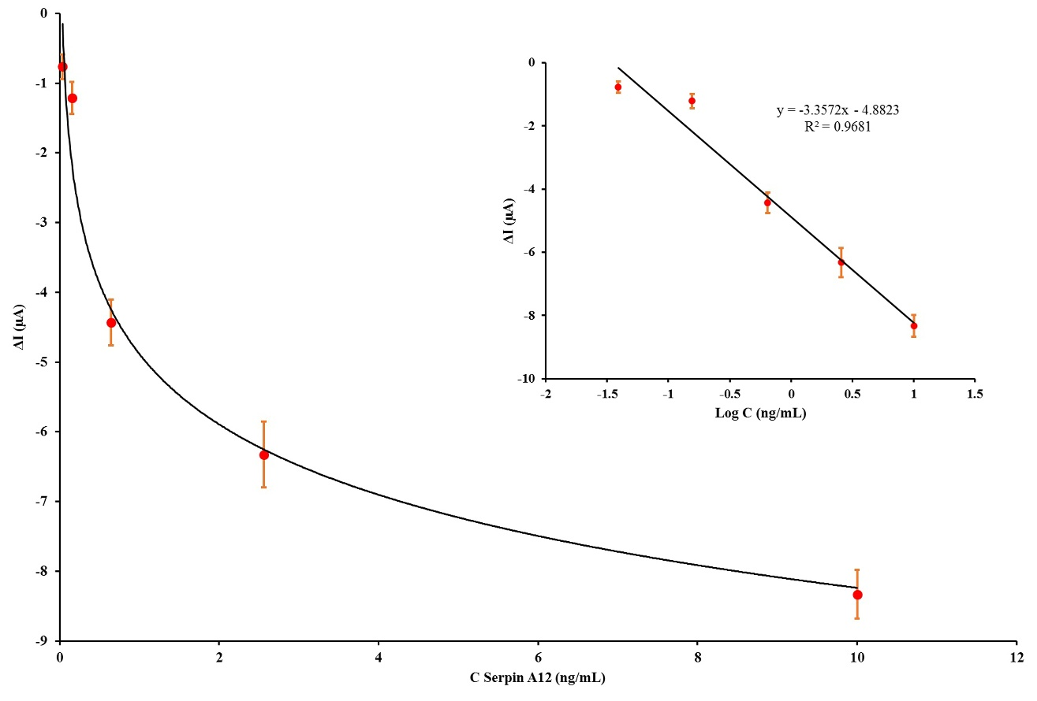
Figure S4 The calibration curve of the fabricated aptasensor after incubation with various concentration of serpin A12 in plasma samples: 0 ng/mL, 0.039 ng/mL, 0.156 ng/mL, 0.625 ng/mL, 2.56 ng/mL, and 10 ng/mL. The inset is the linear relationship between differential pulse voltammetry peak current response and serpin A12 concentration. The standard deviations of three duplicate measurements indicated by error bars.

