Supplementary Figure S1.
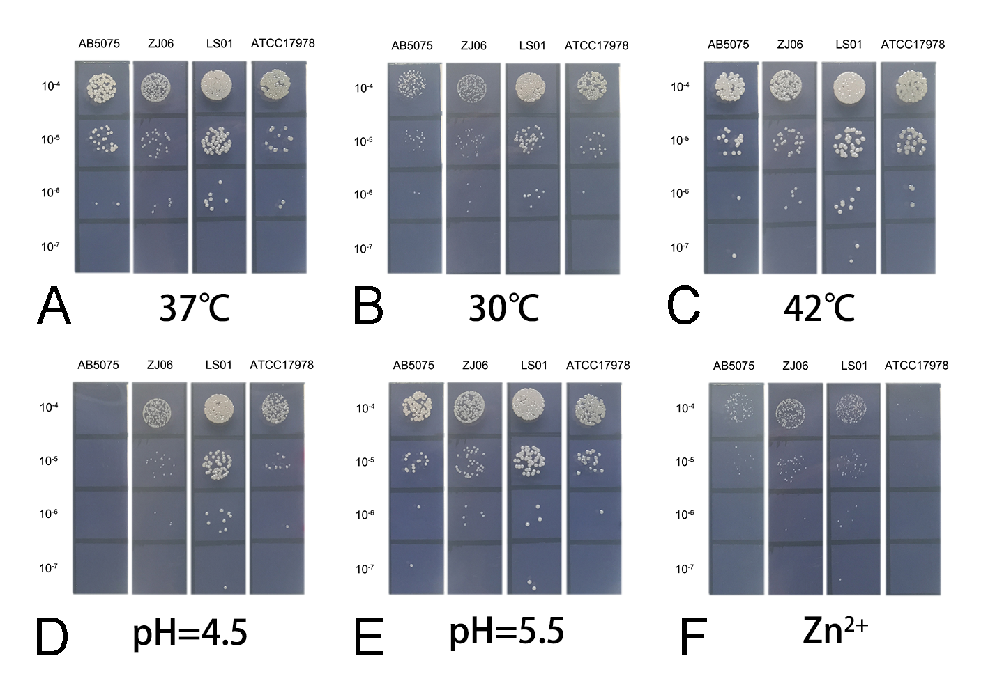
Supplementary Fig. S1. Representative colonies for efficiency of plating (EOP) experiments. AB5075, ZJ06, LS01, and ATCC17978 were plated at (A) 37℃, (B) 30℃, (C) 42℃, (D) pH=4.5, (E) pH=5.5, (F) Zn²⁺. EOP was calculated by dividing the CFU recovered on stress medium (B-F) by the CFU recovered on plain MH at 37°C (A). EOP experiments were repeated at least three times, with the most representative colonies shown.

Supplementary Table S1.

Supplementary Table S1. Virulence genes found in LS01

Supplementary Table S2.

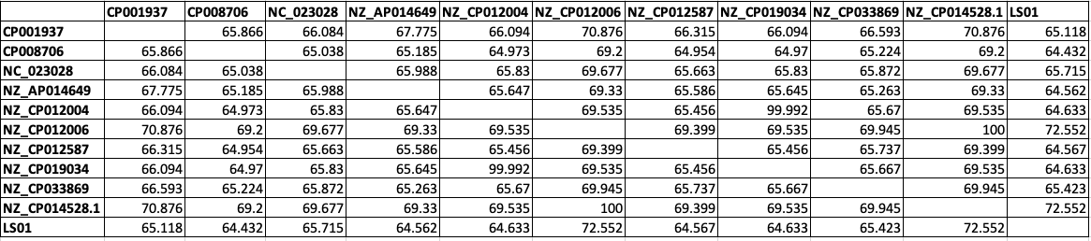
Supplementary Table S2. Genetic percent identity among different A. baumannii strains.

