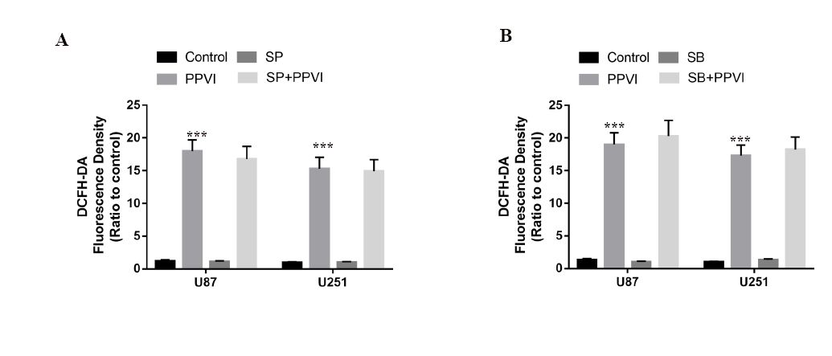

Fig. S1 (A) Cells were pre-treated with or without SP (20 µM) for 2 h, followed by PPVI (4 µM) treatment for an additional 24 h and then stained with 5 µM DCFH-DA. The level of ROS was detected using fluorescence microscopy and flow cytometry. The mean DCFH-DA fluorescence is shown in histograms. (B) Cells were pre-treated with or without SB (20 µM) for 2 h, followed by PPVI (4 µM) treatment for an additional 24 h and then stained with 5 µM DCFH-DA. The level of ROS was detected using fluorescence microscopy and flow cytometry. The mean DCFH-DA fluorescence is shown in histograms. Data are shown as mean ± SD (n=3). ***p<0.0001.

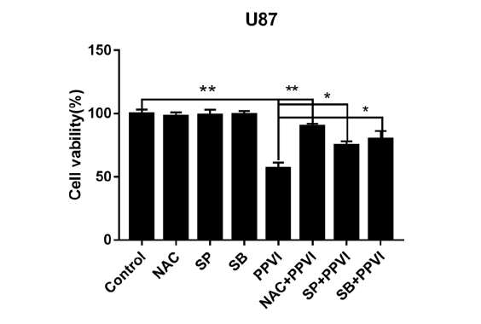
Fig. S2 Cells were pre-treated with or without indicated inhibitors for 2h followed by PPVI (4 µM) treatment for an additional 24 h. Cell viability was measured by CCK-8 assay. Data are shown as mean ± SD (n=3). * p < 0.05, ** p < 0.01.

