Figure S1:
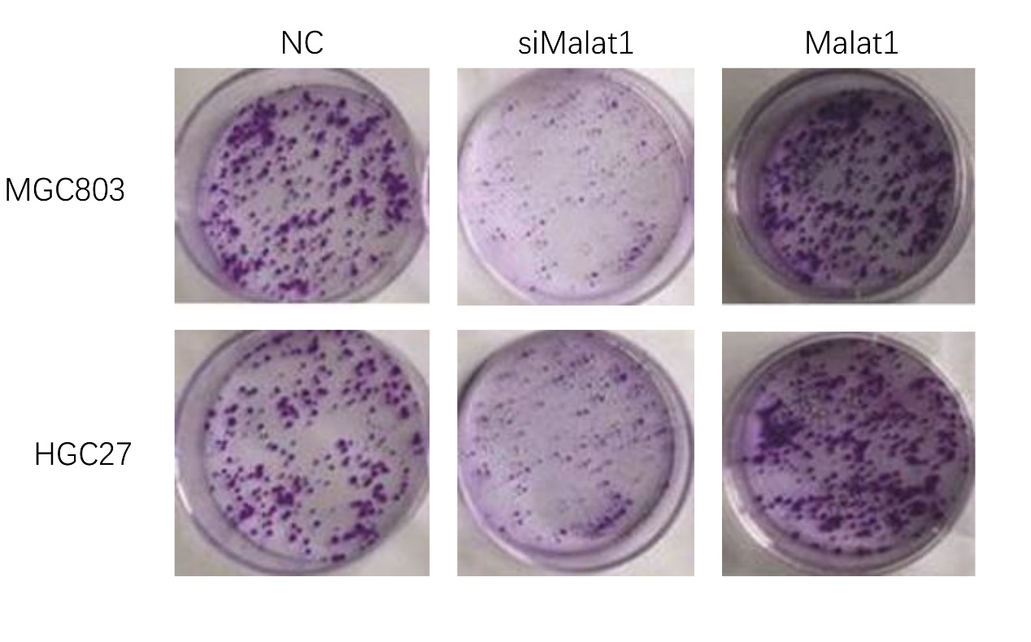
Figure S1. Overexpression of MALAT1 increased colony-formation ability in MGC803 and HGC27 cells and knockdown of MALAT1 led to inhibition of colony-formation ability in MGC803 and HGC27 cells.

