Supporting Information

Immunostimulatory potential of MoS2 nanosheets: enhancing dendritic cell maturation, migration and T cell elicitation

Lei Deng ^{1, 2}, Xiaoli Pan¹, Yulong Zhang¹, Sujing Sun¹, Liping LV¹, Lei Gao¹, Ping Ma¹, Huisheng Ai², Qianqian Zhou¹, Xiaohui Wang¹, Linsheng Zhan¹
¹Department of Emerging Transfusion Technology, Institute of Health Service and Transfusion Medicine, Academy of Military Medical Sciences, Beijing, P. R. China
²Department of Hematology, The Fifth Medical Center of Chinese PLA General Hospital, Beijing, P. R. China
Correspondence: Xiaohui Wang; Linsheng Zhan
Department of Emerging Transfusion Technology, Institute of Health Service and Transfusion Medicine, Academy of Military Medical Sciences, Beijing, P. R. China
Email: lszhan91@yahoo.com; lovechina1980@163.com.

Table S1. Zeta potential of MSNs
Designation | Dispersed  in water (mV) | Dispersed  in 1640 (mV)
S-MoS₂ | -42.53 ± 2.23 | -9.79 ± 0.73
L-MoS₂ | -42.43 ± 1.34 | -8.82 ± 0.65
Abbreviations: MSNs, MoS₂ nanosheets.

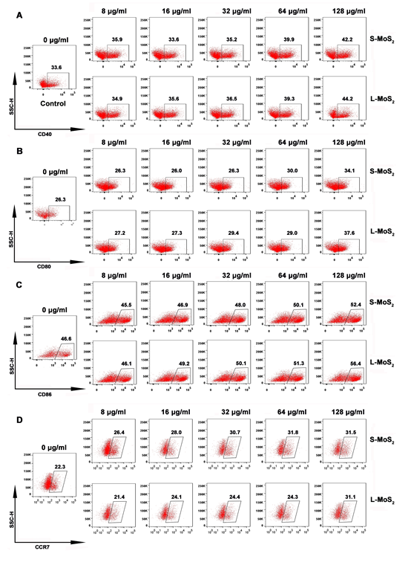
Figure S1. The dose effect of MSN-treatment on the expression of CD40, CD80, CD86 and CCR7 on DCs.
Notes: A representative dataset from there replicates is shown.
Abbreviations: DCs, dendritic cells; S-MoS₂, Small MoS₂; L-MoS₂, Large MoS₂; CD, cell differentiation; CCR7, chemokine C-C-Motif Receptor 7.
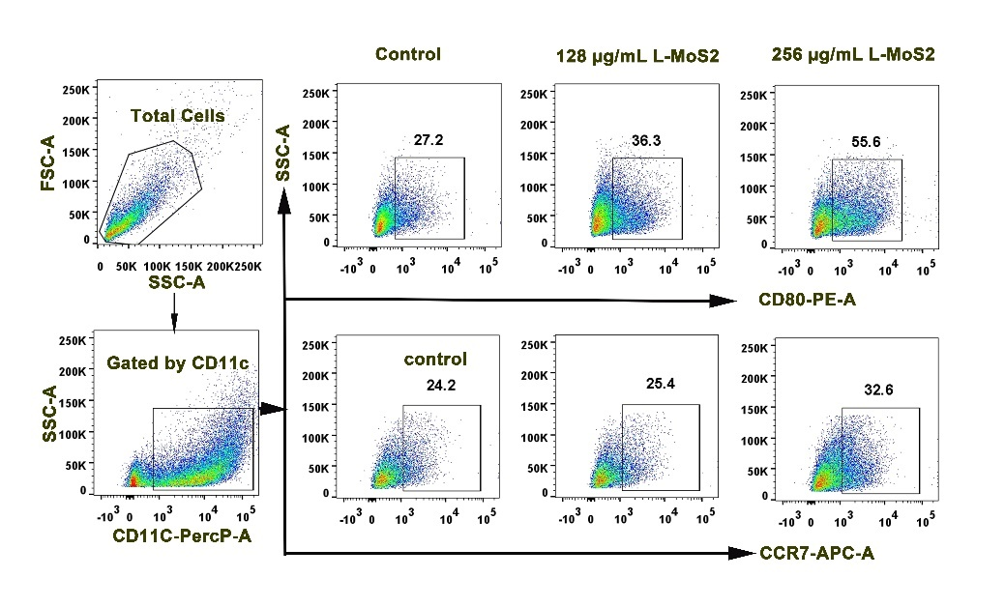
Figure S2. Improving incubation concentration promoted the expression of CD80 and CCR7 on MSN-treated DCs.
Notes: DCs were incubated with MSNs at a respective concentration of 128 µg/mL and 256 µg/mL for 48 h, the expression of CD80 and CCR7 on DCs was detected by FACS. Naïve DCs were set as control.
Abbreviations: DCs, dendritic cells; L-MoS₂, Large MoS₂; CD, cell differentiation; CCR7, chemokine C-C-Motif Receptor 7; MSNs, MoS2 nanosheets.

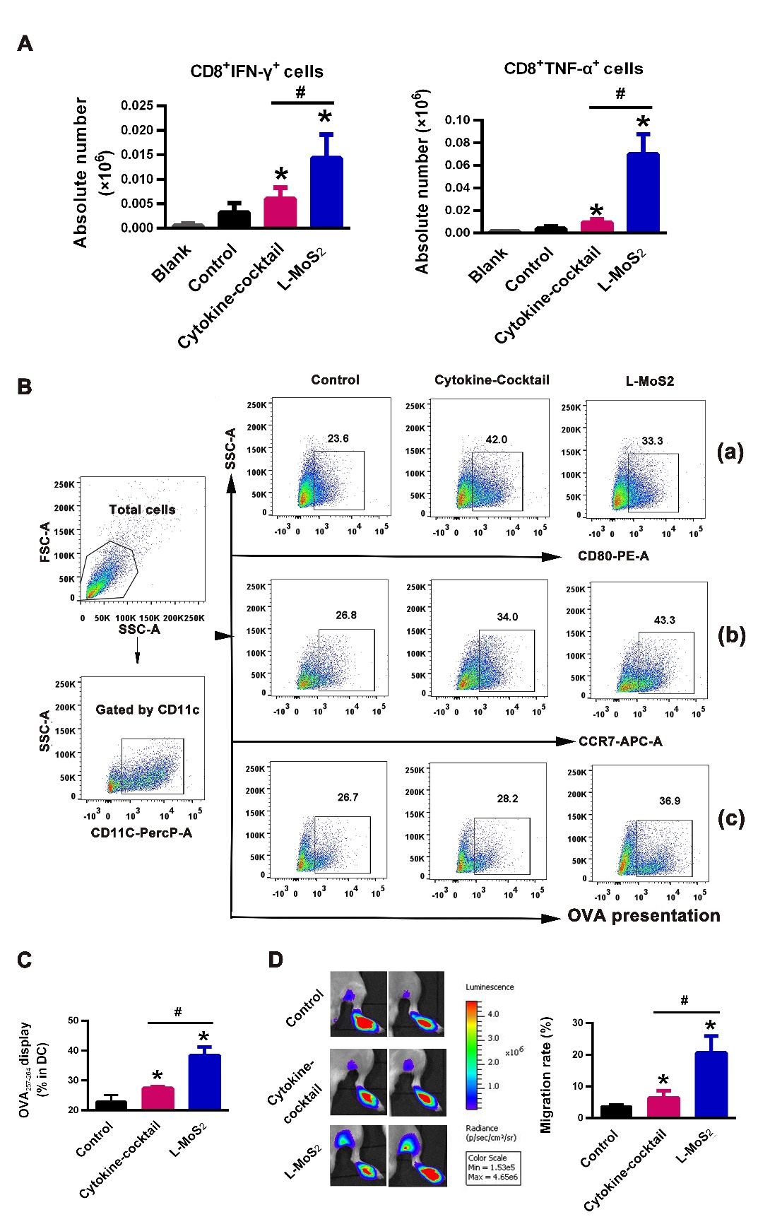
Figure S3 Comparing MSNs with the conventional adjuvant of cytokine-cocktails.
Notes: (A) Absolute number of IFN-γ+ CD8+ T cells and TNF-α+ CD8+ T cells in the PLNs. The vaccination process was shown in Figure 6A. (B) The expression of CD80 (a), CCR7 (b) and OVA₂₅₇₋₂₆₄ display (c) of DCs was detected by flow cytometry. (C) Statistical data of the OVA display in DCs. (D) The in vivo homing of tissue resident DCs. A total of 1 × 10⁶ DCs derived from L2G85.C57BL/6J mice were injected into the footpads of mice, and the in vivo migration to the PLNs was visualized at 48 h by bioluminescence imaging. N = 4 for each group. *p < 0.05 compared with the control group. #p < 0.05 compared with cytokine-cocktail group.
Abbreviations: PLN, popliteal lymph node; DCs, dendritic cells; MSNs, MoS2 nanosheets; IFN-γ, interferon-γ; TNF-α，tumor necrosis factor-α; CD, cell differentiation; OVA, ovalbumin; L-MoS₂, Large MoS₂.

