Figure S1
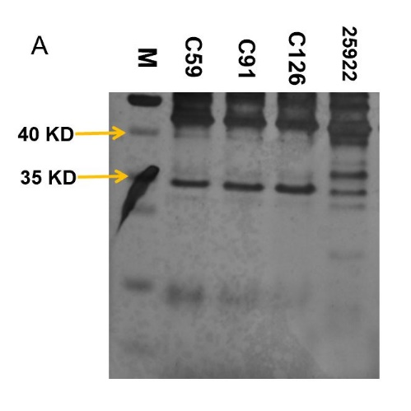
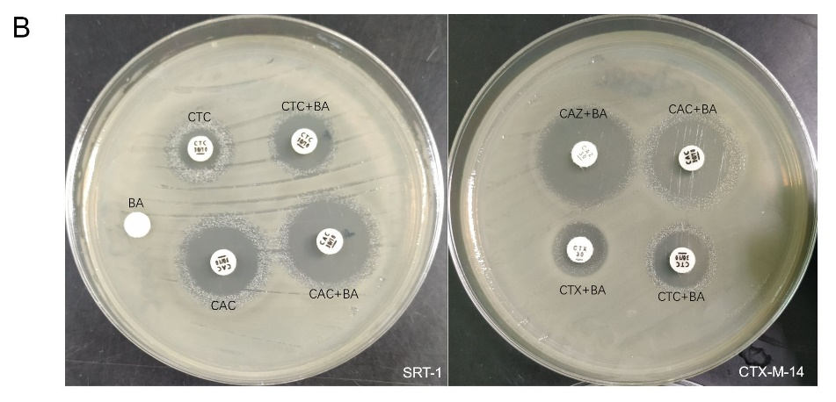
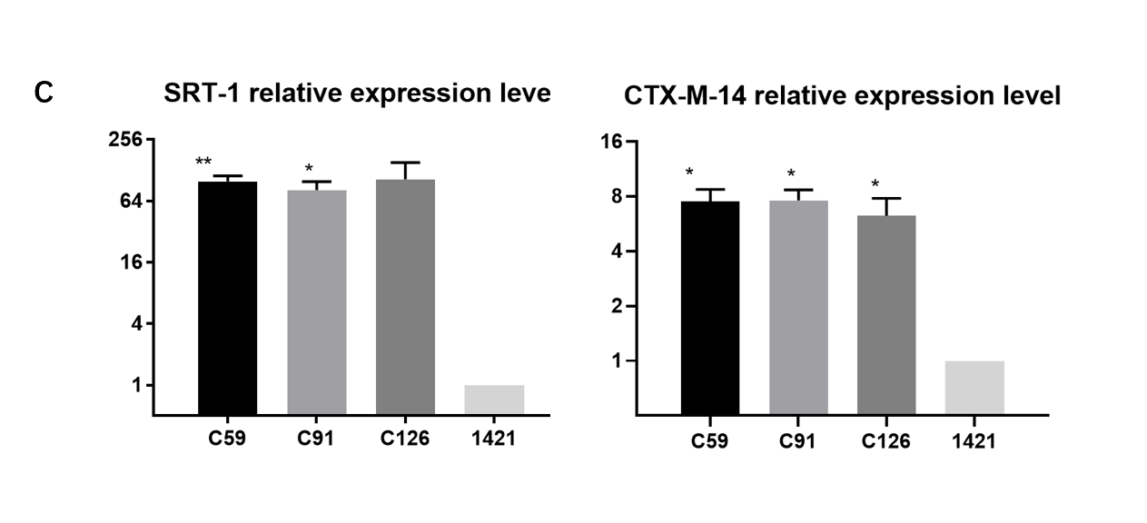
Figure S1. Detection of the expression of the outer membrane proteins ompF, ompC, SRT-1, and CTX-M-14 in isolates C59, C91, and C126 (A). The expression of ompF and ompC by SDS-PAGE and silver staining. M: marker, (B). The expression of bla_{SRT-1} and bla_{CTX-M-14} by the disk diffusion test. The figure shows the result of C59, which is consistent with the result of the other two isolates. (C). The relative expression of bla_{SRT-1} and bla_{CTX-M-14} by qPCR. Isolate 1421 was selected as a control harbouring bla_{CTX-M-14} and bla_{SRT-1.} *: P <0.05; **: P<0.01.

Figure S2
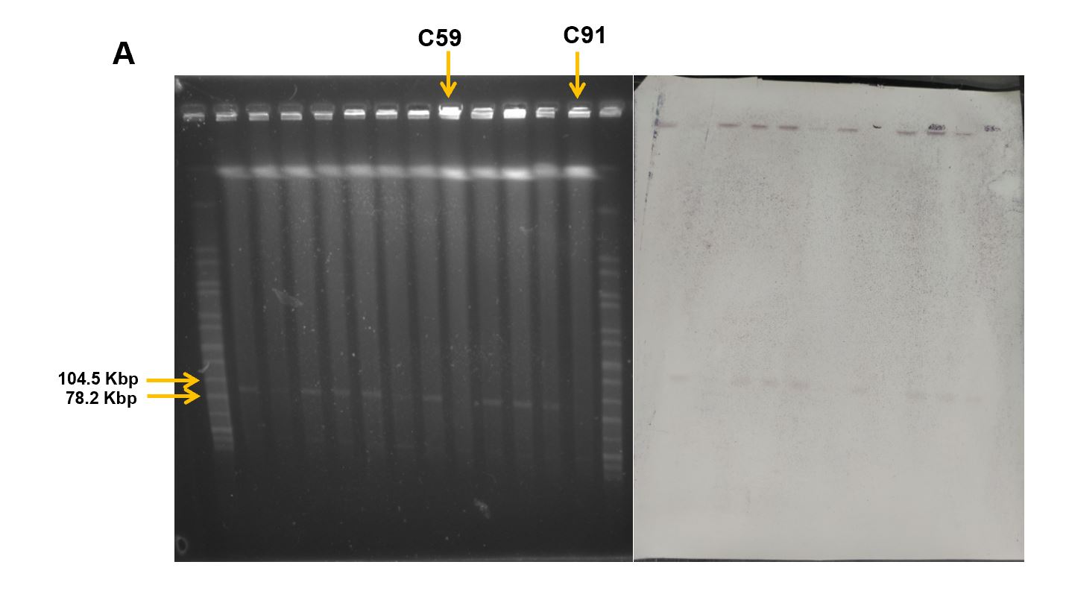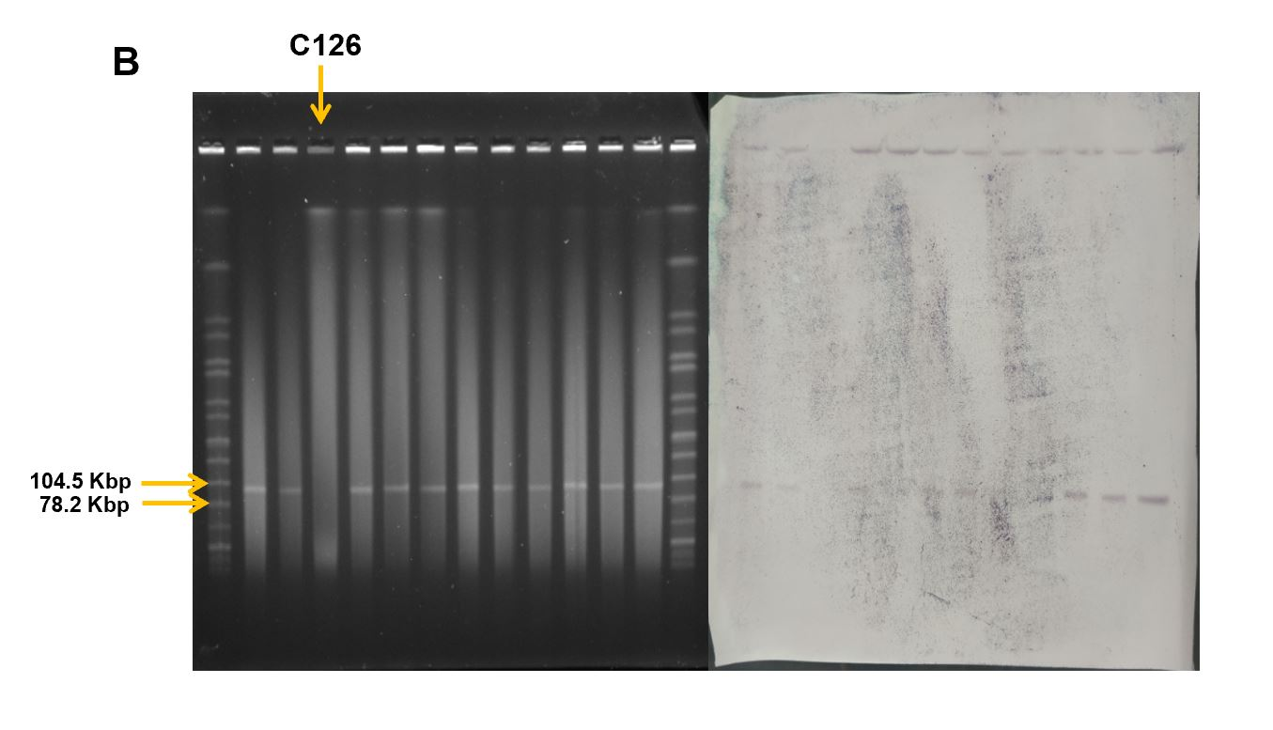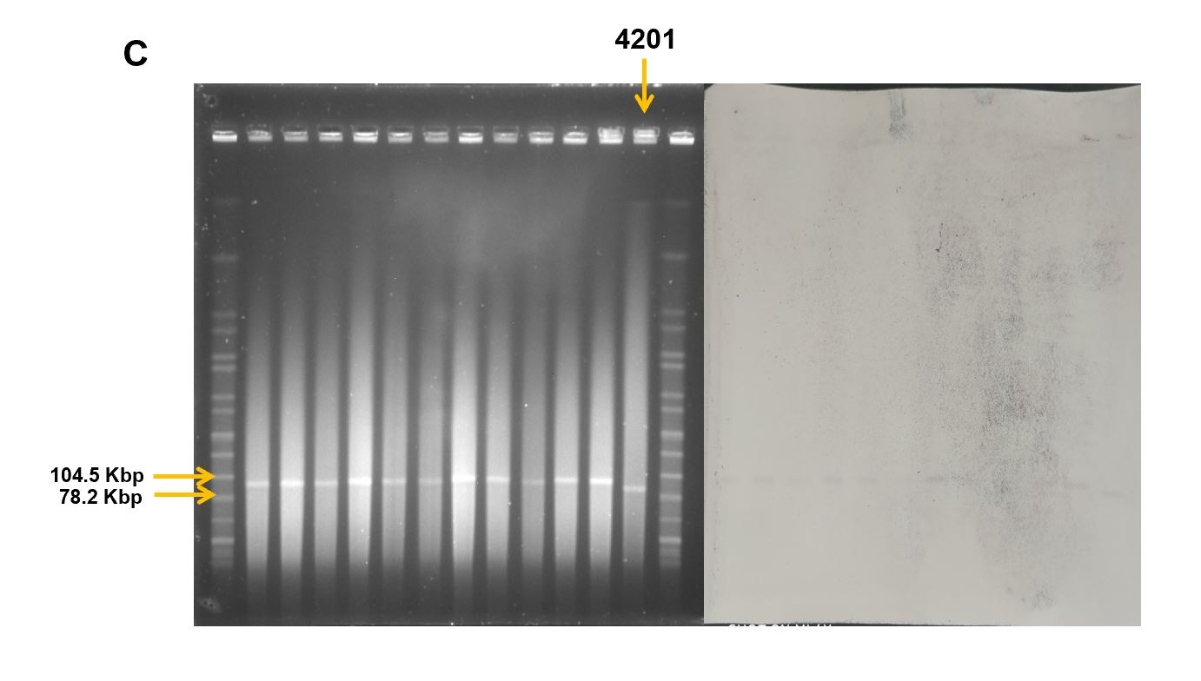
Figure S2. The bla_{KPC-2} gene was found in 33 isolates and localized on an ~78-104 Kbp plasmid, which was detected by S1 Southern blot (A). Order of isolates from left to right: Marker, C3, C5, C8, C21, C40, C45, C47, C59, C60, C64, C83, C91, Marker. (B). Order of isolates from left to right: Marker, C110, C112, C126, C141, C153, C156, 939, 1140, 972, 1203, 1330, 1486, Marker. (C). Order of isolates from left to right: Marker, 1614, 1758, 2079, 2291, 2686, 2730, 2838, 3024, 3410, 3717, 3725, 4201, Marker. The left side (gel image) was matched with the right side (Southern blot photo) in each figure. H9812 was selected as the size marker.

Figure S3
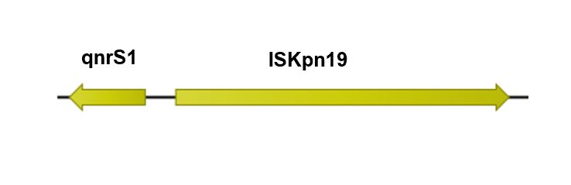
Figure S3. A schematic diagram of the segment containing the qnr gene in the bla_{KPC-2}-harbouring plasmid. The segment was present in all bla_{KPC-2}-harbouring plasmids except plasmid p4201-KPC. Genes qnrS1 and ISKpn19 were connected in the line with divergent transcription.

