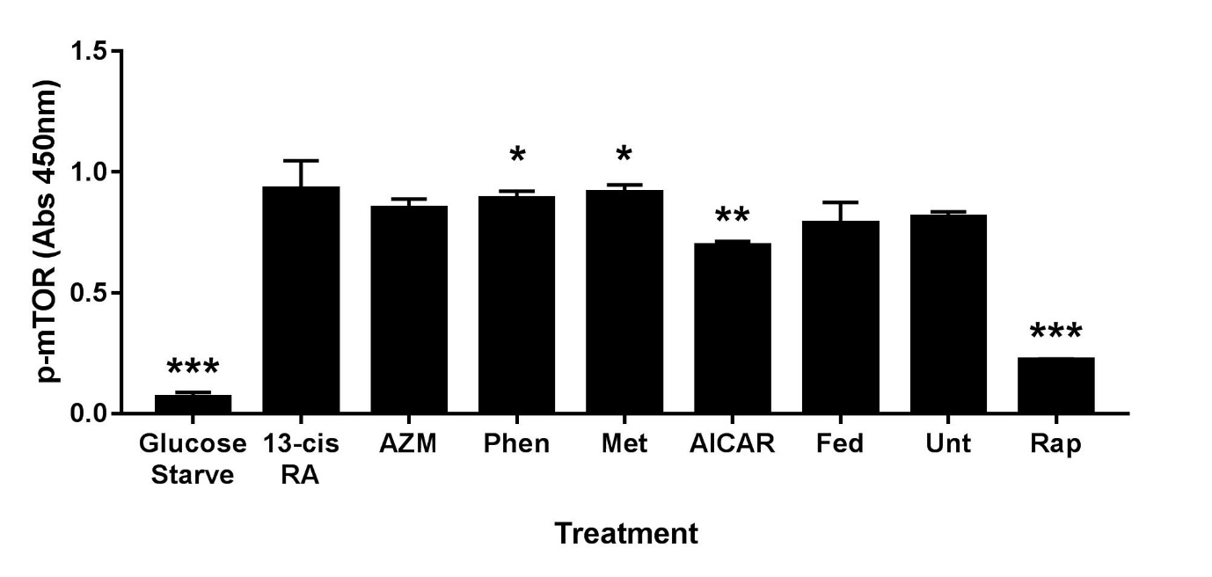

Figure S1. Biguanides effects on mTOR (S2448) phosphorylation. Sebocytes were treated with phenformin (Phen), metformin (Met), isotretinoin (13-cis RA), azithromycin (AZM), or AICAR for 16 hours before preparing protein lysates for a phospho-mTOR(S2448) ELISA. Controls are untreated (Unt-1% FBS), rapamycin (Rap, 100nM), 10% FBS medium (Fed), and glucose starved. Values are mean ± SD of three independent determinations. *p<0.05, **p<0.01, ***p<0.001 compared to untreated control.

