Table S1. Comparison between nomogram and TNM staging system
 |  | C-index | 95%CI | P value
Nomogram |  | 0.701 | 0.669—0.733 | 0.016
TNM system |  | 0.666 | 0.630—0.702 | 0.016
Notes: Calculation of C-index of nomogram model based on 500 Bootstrap. Abbreviations: CI=confidence interval

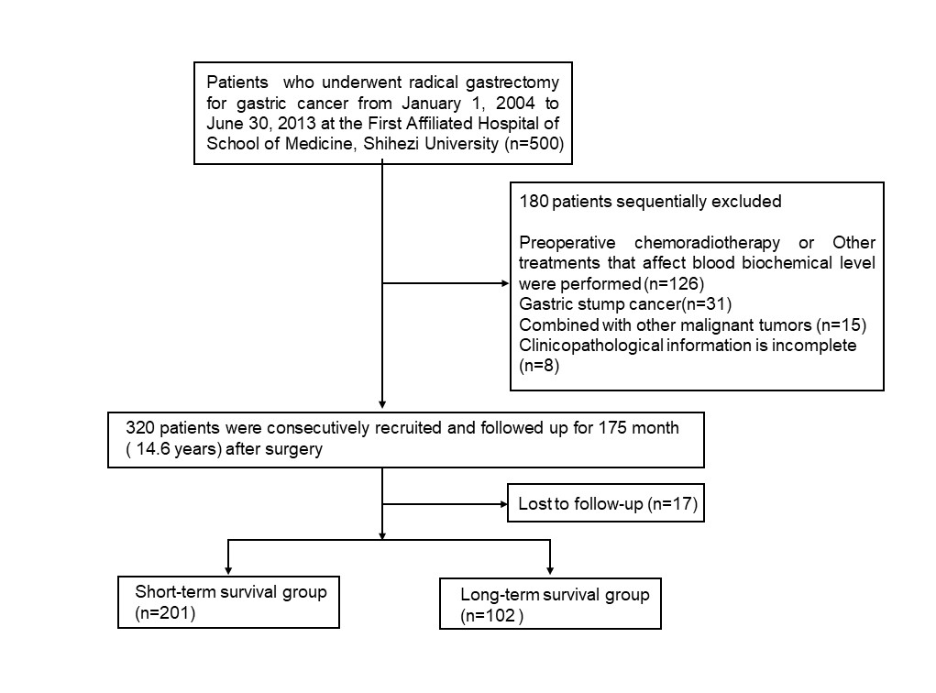
Figure S1: Flowchart of the study population.

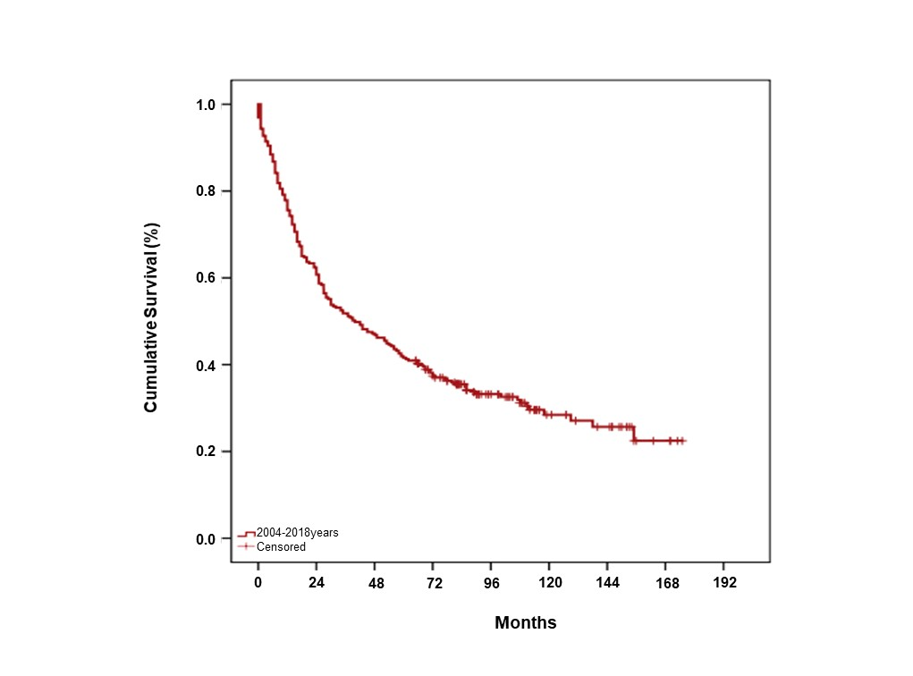
Figure S2: Kaplan-Meier survival curves of the 303 patients.

