Supplementary Materials

Figure S1 Interview 100-point allocation task.
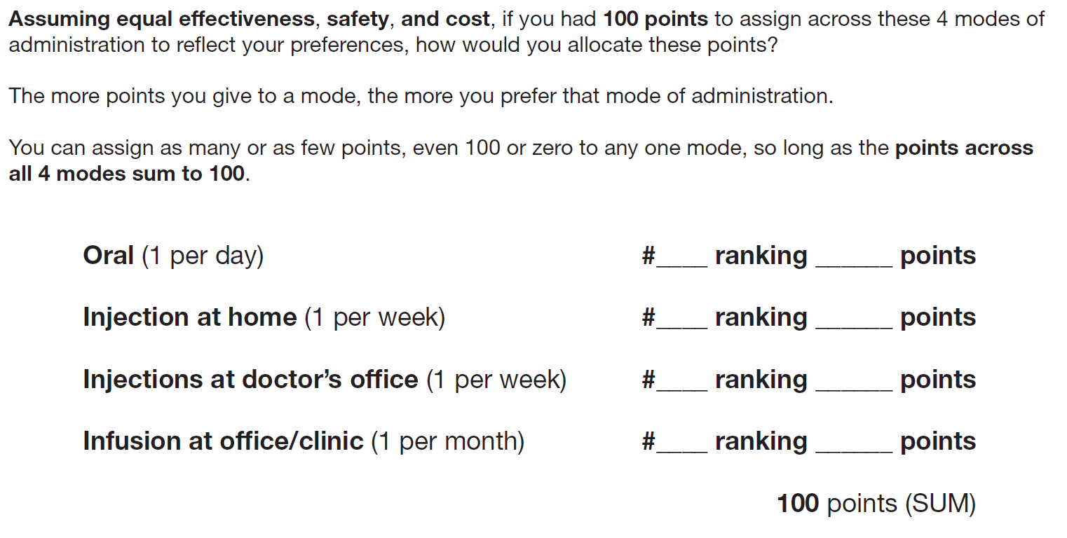

Figure S2 Coding trees for mode of treatment administration likes and dislikes: (A) oral, (B) self-injection, (C) clinic injection, and (D) infusion. 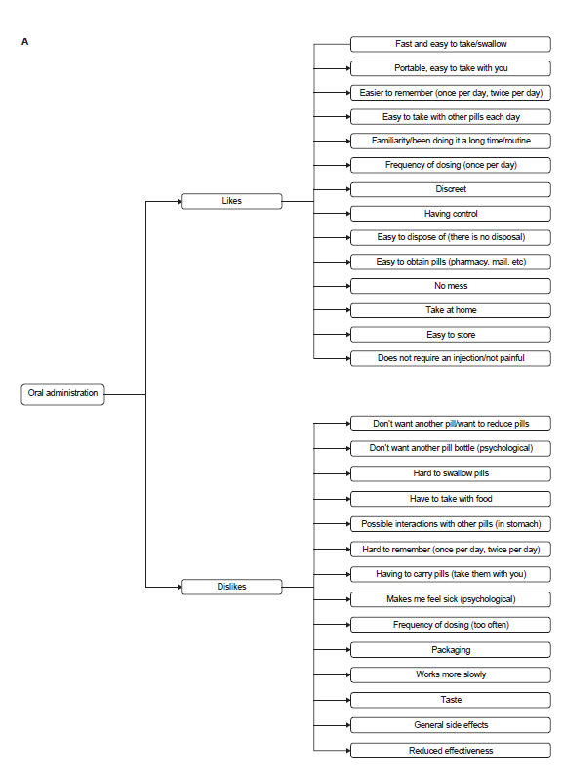 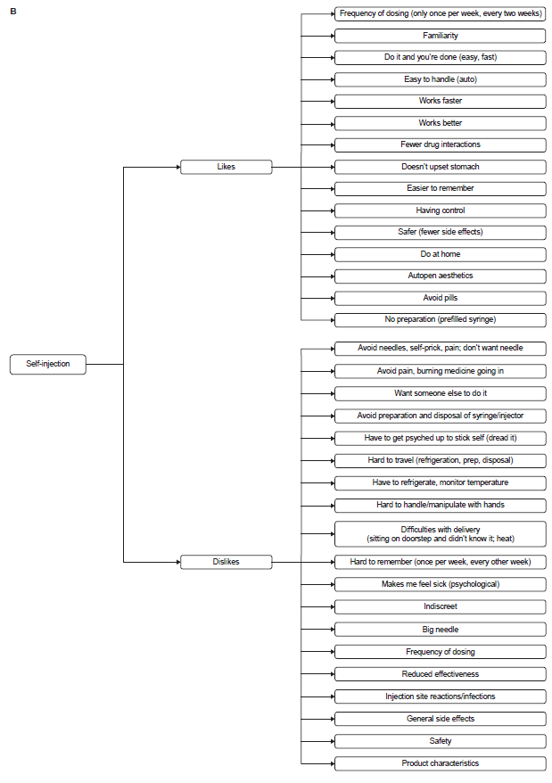 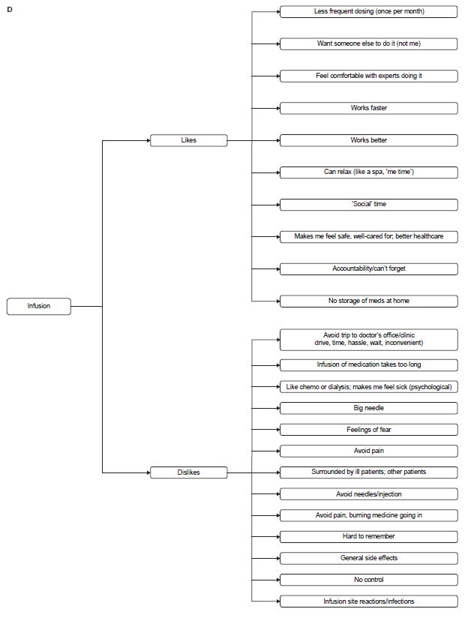
Figure S3 First-choiceª mode of treatment administration (ranking) with ‘strong’
first-choice preference defined as a mode with a point allocation^{b} of (A) ≥50 points, or (B) ≥70 points.
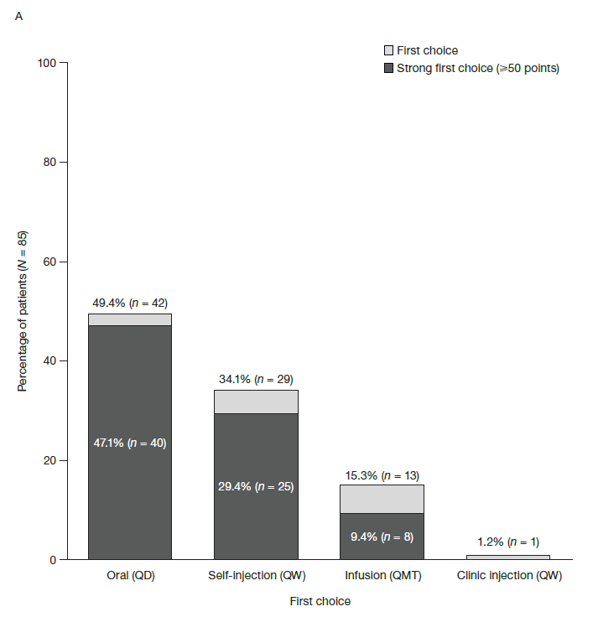
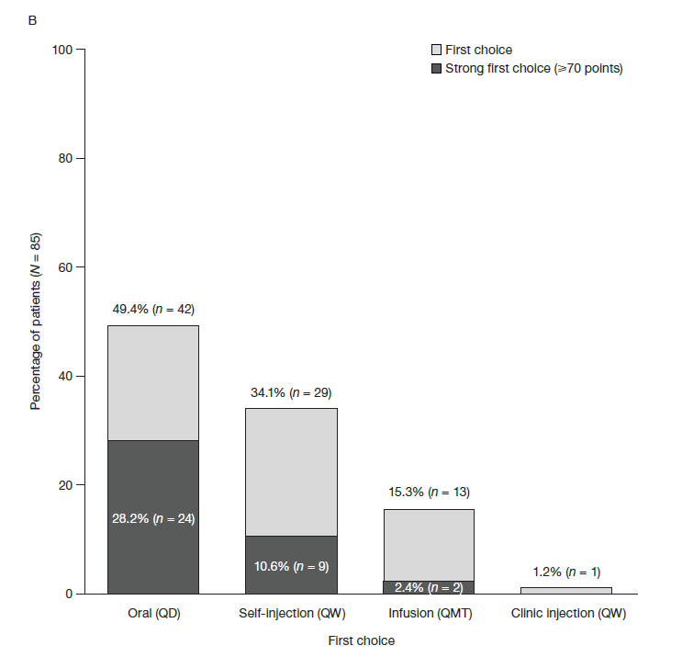
ªA patient’s first-choice mode was the mode with the most points allocated. ^{b}Patients were asked ‘Assuming equal effectiveness, safety, and cost, if you had 100 points to assign across these four modes of administration to reflect your preferences, how would you allocate these points? The more points you give to a mode, means the more you prefer that mode of administration. You can assign as many or as few points, even zero points, as you want to each of the four modes, so long as the points across all four modes sum to 100.’
Abbreviations: QD, once per day; QMT, once per month; QW, once per week.

Table S1 Participant Characteristics,ª by Region, Country and Overall
 | US  (N = 25) |  |  |  | Europe^{b}  (N = 50) |  | Brazil  (N = 10) |  | France  (N = 10) |  | Germany  (N = 10) |  | Italy  (N = 10) |  | Spain  (N = 10) |  | UK  (N = 10) |  | Total  (N = 85)
Demographic characteristics
Female, n (%) | 18 (72.0) |  |  |  | 27 (54.0) |  | 6 (60.0) |  | 8 (80.0) |  | 5 (50.0) |  | 6 (60.0) |  | 3 (30.0) |  | 5 (50.0) |  | 51 (60.0)
Current age (years), mean (SD) | 48.1 (12.4) |  |  |  | 51.1 (12.9) |  | 47.3 (10.0) |  | 52.6  (14.0) |  | 51.2  (9.7) |  | 53.6  (16.2) |  | 47.6  (12.9) |  | 50.6 (13.0) |  | 49.8 (12.5)
Education,^{c} n (%)
Primary school | 1 (4.0) |  |  |  | 6 (14.6) |  | 2 (20.0) |  | 1 (10.0) |  | 1 (10.0) |  | 1 (10.0) |  | 2 (20.0) |  | 1 (100.0) |  | 9 (11.8)
Secondary school | 6 (24.0) |  |  |  | 19 (46.3) |  | 3 (30.0) |  | 2 (20.0) |  | 6 (60.0) |  | 7 (70.0) |  | 4 (40.0) |  | 0 (0) |  | 28 (36.8)
College/university degree | 18 (72.0) |  |  |  | 16 (39.0) |  | 5 (50.0) |  | 7 (70.0) |  | 3 (30.0) |  | 2 (20.0) |  | 4 (40.0) |  | 0 (0) |  | 39 (51.3)
Prefer not to answer | 0 (0) |  |  |  | 9 (18.0) |  | 0 (0) |  | 0 (0) |  | 0 (0) |  | 0 (0) |  | 0 (0) |  | 9 (90.0) |  | 9 (10.6)
Relationship status,^{c} n (%)
Single | 7 (28.0) |  |  |  | 5 (12.2) |  | 2 (20.0) |  | 0 (0) |  | 2 (20.0) |  | 1 (10.0) |  | 2 (20.0) |  | 0 (0) |  | 14 (18.4)
Cohabiting, married, or civil partnership | 13 (52.0) |  |  |  | 33 (80.5) |  | 7 (70.0) |  | 10 (100.0) |  | 7 (70.0) |  | 7 (70.0) |  | 8 (80.0) |  | 1 (100.0) |  | 53 (69.7)
Other^{d} | 5 (20.0) |  |  |  | 3 (7.3) |  | 1 (10.0) |  | 0 (0) |  | 1 (10.0) |  | 2 (20.0) |  | 0 (0) |  | 0 (0) |  | 9 (11.8)
Prefer not to answer | 0 (0) |  |  |  | 9 (18.0) |  | 0 (0) |  | 0 (0) |  | 0 (0) |  | 0 (0) |  | 0 (0) |  | 9 (90.0) |  | 9 (10.6)
Race/ethnicity, n (%)^{c}
White | 19 (76.0) |  |  |  | 21 (100.0) |  | 10 (100.0) |  | 0 (0) |  | 0 (0) |  | 10 (100.0) |  | 10 (100.0) |  | 1 (100.0) |  | 50 (89.3)
Black | 2 (8.0) |  |  |  | 0 (0) |  | 0 (0) |  | 0 (0) |  | 0 (0) |  | 0 (0) |  | 0 (0) |  | 0 (0) |  | 2 (3.6)
Asian | 1 (4.0) |  |  |  | 0 (0) |  | 0 (0) |  | 0 (0) |  | 0 (0) |  | 0 (0) |  | 0 (0) |  | 0 (0) |  | 1 (1.8)
Hispanic | 3 (12.0) |  |  |  | 0 (0) |  | 0 (0) |  | 0 (0) |  | 0 (0) |  | 0 (0) |  | 0 (0) |  | 0 (0) |  | 3 (5.4)
Other | 0 (0) |  |  |  | 0 (0) |  | 0 (0) |  | 0 (0) |  | 0 (0) |  | 0 (0) |  | 0 (0) |  | 0 (0) |  | 0 (0)
Prefer not to answer | 0 (0) |  |  |  | 29 (58.0) |  | 0 (0) |  | 10 (100.0) |  | 10 (100.0) |  | 0 (0) |  | 0 (0) |  | 9 (90.0) |  | 29 (34.1)
Healthcare coverage, n (%)
Private | 18 (72.0) |  |  |  | 8 (19.5) |  | 4 (40.0) |  | 6 (60.0) |  | 0 (0) |  | 0 (0) |  | 2 (20.0) |  | 0 (0) |  | 30 (39.5)
Medicare, Medicaid, or public assistance | 7 (28.0) |  |  |  | 32 (78.0) |  | 6 (60.0) |  | 4 (40.0) |  | 10 (100.0) |  | 10 (100.0) |  | 8 (80.0) |  | 0 (0) |  | 45 (59.2)
Military | 0 (0) |  |  |  | 0 (0) |  | 0 (0) |  | 0 (0) |  | 0 (0) |  | 0 (0) |  | 0 (0) |  | 0 (0) |  | 0 (0)
Other | 0 (0) |  |  |  | 0 (0) |  | 0 (0) |  | 0 (0) |  | 0 (0) |  | 0 (0) |  | 0 (0) |  | 0 (0) |  | 0 (0)
None | 0 (0) |  |  |  | 1 (2.4) |  | 0 (0) |  | 0 (0) |  | 0 (0) |  | 0 (0) |  | 0 (0) |  | 1 (100.0) |  | 1 (1.3)
Prefer not to answer | 0 (0) |  |  |  | 9 (18.0) |  | 0 (0) |  | 0 (0) |  | 0 (0) |  | 0 (0) |  | 0 (0) |  | 9 (90.0) |  | 9 (10.6)
Clinical characteristics
Age (years) of PsA diagnosis, mean (SD) | 37.6 (13.3) |  |  |  | 41.1 (12.9) |  | 37.1 (12.5) |  | 42.9 (12.4) |  | 40.4 (14.6) |  | 45.7 (15.0) |  | 34.5  (11.5) |  | 42.2 (10.4) |  | 39.6 (13.0)
PsO, NRS (0–10),^{e} mean (SD) | 4.0 (2.8) |  |  |  | 2.7 (3.0) |  | 5.4 (3.1) |  | 3.0 (3.5) |  | 2.8 (1.5) |  | 2.5 (3.0) |  | 1.2 (1.8) |  | 4.0 (4.1) |  | 3.4 (3.0)
Joint/ligament pain, NRS (0–10),^{e} mean (SD) | 4.7 (2.5) |  |  |  | 4.6 (2.6) |  | 5.6 (2.0) |  | 4.1 (2.2) |  | 4.9 (1.9) |  | 3.3 (2.6) |  | 4.1 (3.5) |  | 6.4 (1.6) |  | 4.7 (2.5)
Fatigue, NRS  (0–10),^{e} mean (SD) | 5.3 (2.8) |  |  |  | 4.9 (2.9) |  | 6.5 (2.5) |  | 6.0 (2.5) |  | 6.1 (2.1) |  | 3.8 (2.9) |  | 4.4 (3.1) |  | 4.3 (3.5) |  | 5.2 (2.8)
Impact, NRS  (0– 10),^{e,f} mean (SD) | 5.7 (3.0) |  |  |  | 5.4 (3.1) |  | 9.1 (1.4) |  | 4.9 (3.4) |  | 6.8 (2.7) |  | 3.7 (3.2) |  | 4.4 (2.9) |  | 7.1 (2.2) |  | 5.9 (3.1)
Severity of PsA,
n (%)
Mild | 9 (36.0) |  |  |  | 15 (30.0) |  | 1 (10.0) |  | 3 (30.0) |  | 1 (10.0) |  | 6 (60.0) |  | 3 (30.0) |  | 2 (20.0) |  | 25 (29.4)
Moderate | 11 (44.0) |  |  |  | 23 (46.0) |  | 8 (80.0) |  | 4 (40.0) |  | 5 (50.0) |  | 3 (30.0) |  | 5 (50.0) |  | 6 (60.0) |  | 42 (49.4)
Severe | 5 (20.0) |  |  |  | 9 (18.0) |  | 0 (0) |  | 2 (20.0) |  | 2 (20.0) |  | 1 (10.0) |  | 2 (20.0) |  | 2 (20.0) |  | 14 (16.5)
Very severe | 0 (0) |  |  |  | 3 (6.0) |  | 1 (10.0) |  | 1 (10.0) |  | 2 (20.0) |  | 0 (0) |  | 0 (0) |  | 0 (0) |  | 4 (4.7)
Disease and symptom progression since diagnosis, n (%)
Worse | 15 (60.0) |  |  |  | 23 (46.0) |  | 4 (40.0) |  | 5 (50.0) |  | 5 (50.0) |  | 3 (30.0) |  | 3 (30.0) |  | 7 (70.0) |  | 42 (49.4)
Same | 6 (24.0) |  |  |  | 10 (20.0) |  | 5 (50.0) |  | 3 (30.0) |  | 2 (20.0) |  | 0 (0) |  | 2 (20.0) |  | 3 (30.0) |  | 21 (24.7)
Better | 13 (52.0) |  |  |  | 36 (72.0) |  | 8 (80.0) |  | 8 (80.0) |  | 5 (50.0) |  | 10 (100.0) |  | 8 (80.0) |  | 5 (50.0) |  | 57 (67.1)
Current PsO location,^{g} n (%)
Head, including scalp | 16 (64.0) |  |  |  | 20 (40.0) |  | 5 (50.0) |  | 3 (30.0) |  | 5 (50.0) |  | 2 (20.0) |  | 4 (40.0) |  | 6 (60.0) |  | 41 (48.2)
Face | 5 (20.0) |  |  |  | 8 (16.0) |  | 1 (10.0) |  | 3 (30.0) |  | 1 (10.0) |  | 2 (20.0) |  | 0 (0) |  | 2 (20.0) |  | 14 (16.5)
Trunk/chest and stomach | 11 (44.0) |  |  |  | 9 (18.0) |  | 3 (30.0) |  | 2 (20.0) |  | 2 (20.0) |  | 1 (10.0) |  | 1 (10.0) |  | 3 (30.0) |  | 23 (27.1)
Groin | 6 (24.0) |  |  |  | 2 (4.0) |  | 2 (20.0) |  | 0 (0) |  | 0 (0) |  | 0 (0) |  | 0 (0) |  | 2 (20.0) |  | 10 (11.8)
Buttocks | 6 (24.0) |  |  |  | 3 (6.0) |  | 3 (30.0) |  | 1 (10.0) |  | 0 (0) |  | 0 (0) |  | 0 (0) |  | 2 (20.0) |  | 12 (14.1)
Arms | 10 (40.0) |  |  |  | 16 (32.0) |  | 3 (30.0) |  | 1 (10.0) |  | 2 (20.0) |  | 5 (50.0) |  | 2 (20.0) |  | 6 (60.0) |  | 29 (34.1)
Hands, including nails | 8 (32.0) |  |  |  | 9 (18.0) |  | 2 (20.0) |  | 1 (10.0) |  | 3 (30.0) |  | 0 (0) |  | 2 (20.0) |  | 3 (30.0) |  | 19 (22.4)
Legs | 10 (40.0) |  |  |  | 15 (30.0) |  | 7 (70.0) |  | 2 (20.0) |  | 4 (40.0) |  | 3 (30.0) |  | 3 (30.0) |  | 3 (30.0) |  | 32 (37.6)
Feet, including nails | 5 (20.0) |  |  |  | 13 (26.0) |  | 4 (40.0) |  | 3 (30.0) |  | 4 (40.0) |  | 1 (10.0) |  | 3 (30.0) |  | 2 (20.0) |  | 22 (25.9)
Current PsA and PsO symptoms,^{g}
n (%)
Joint pain | 22 (88.0) |  |  |  | 44 (88.0) |  | 8 (80.0) |  | 10 (100.0) |  | 9 (90.0) |  | 8 (80.0) |  | 7 (70.0) |  | 10 (100.0) |  | 74 (87.1)
Skin patches or plaques (flaking, redness) | 20 (80.0) |  |  |  | 29 (58.0) |  | 10 (100.0) |  | 5 (50.0) |  | 10 (100.0) |  | 6 (60.0) |  | 3 (30.0) |  | 5 (50.0) |  | 59 (69.4)
Stiffness | 17 (68.0) |  |  |  | 25 (50.0) |  | 3 (30.0) |  | 4 (40.0) |  | 1 (10.0) |  | 5 (50.0) |  | 5 (50.0) |  | 10 (100.0) |  | 45 (52.9)
Joint swelling | 15 (60.0) |  |  |  | 24 (48.0) |  | 2 (20.0) |  | 5 (50.0) |  | 3 (30.0) |  | 4 (40.0) |  | 4 (40.0) |  | 8 (80.0) |  | 41 (48.2)
Skin discomfort (eg itching, painful, bleeding, etc.) | 15 (60.0) |  |  |  | 17 (34.0) |  | 5 (50.0) |  | 0 (0) |  | 6 (60.0) |  | 4 (40.0) |  | 1 (10.0) |  | 6 (60.0) |  | 37 (43.5)
Unusual fatigue | 9 (36.0) |  |  |  | 18 (36.0) |  | 2 (20.0) |  | 5 (50.0) |  | 3 (30.0) |  | 4 (40.0) |  | 4 (40.0) |  | 2 (20.0) |  | 29 (34.1)
Joint damage | 5 (20.0) |  |  |  | 17 (34.0) |  | 2 (20.0) |  | 6 (60.0) |  | 5 (50.0) |  | 3 (30.0) |  | 0 (0) |  | 3 (30.0) |  | 24 (28.2)
Joint tenderness | 5 (20.0) |  |  |  | 16 (32.0) |  | 2 (20.0) |  | 3 (30.0) |  | 0 (0) |  | 4 (40.0) |  | 2 (20.0) |  | 7 (70.0) |  | 23 (27.1)
Swollen or inflamed (‘sausage’) fingers or toes (dactylitis) | 4 (16.0) |  |  |  | 13 (26.0) |  | 2 (20.0) |  | 2 (20.0) |  | 4 (40.0) |  | 2 (20.0) |  | 0 (0) |  | 5 (50.0) |  | 19 (22.4)
Inflammatory back pain (back pain/stiffness) | 6 (24.0) |  |  |  | 12 (24.0) |  | 0 (0) |  | 3 (30.0) |  | 2 (20.0) |  | 2 (20.0) |  | 3 (30.0) |  | 2 (20.0) |  | 18 (21.2)
Sleep problems | 5 (20.0) |  |  |  | 10 (20.0) |  | 1 (10.0) |  | 4 (40.0) |  | 2 (20.0) |  | 2 (20.0) |  | 1 (10.0) |  | 1 (10.0) |  | 16 (18.8)
Nail changes  (ie pitting or small dents, separation from nail bed) | 6 (24.0) |  |  |  | 7 (14.0) |  | 1 (10.0) |  | 1 (10.0) |  | 1 (10.0) |  | 0 (0) |  | 1 (10.0) |  | 4 (40.0) |  | 14 (16.5)
Tenderness or swelling of ligament/tendon that connects to the bone, commonly the heel or elbow (enthesitis) | 3 (12.0) |  |  |  | 6 (12.0) |  | 1 (10.0) |  | 1 (10.0) |  | 2 (20.0) |  | 1 (10.0) |  | 0 (0) |  | 2 (20.0) |  | 10 (11.8)
Eye irritation, redness, disturbed vision | 1 (4.0) |  |  |  | 5 (10.0) |  | 0 (0) |  | 1 (10.0) |  | 2 (20.0) |  | 1 (10.0) |  | 0 (0) |  | 1 (10.0) |  | 6 (7.1)
ªAll variables were patient-reported. ^{b}Includes France, Germany, Italy, Spain, and the UK. ^{c}Percentages for responses other than ‘Prefer not to answer’ do not include any patients who selected ‘Prefer not to answer’. ^{d}Separated, widowed, or divorced. ^{e}0 indicated ‘none’ and 10 indicated the ‘worst possible’ of the variable. ^{f}Based on the question ‘How, if at all, have your PsA symptoms (including skin and musculoskeletal [joint, spine, swelling, tenderness] symptoms) impacted your life?’. ^{g}Patients could report >1 response; percentages may total >100%.
Abbreviations: NRS, numerical rating scale; PsA, psoriatic arthritis; PsO, psoriasis; SD, standard deviation.

Table S2 Lifestyle and General Health Characteristics, and Diagnosing and Managing Physician Specialties, by Region, Country, and Overall
 | US  (N = 25) |  | Europeª  (N = 50) |  | Brazil  (N = 10) |  | France  (N = 10) |  | Germany  (N = 10) |  | Italy  (N = 10) |  | Spain  (N = 10) |  | UK  (N = 10) |  | Total  (N = 85)
Current life stage,^{b}
n (%)
Before family – no children yet | 0 (0) |  | 4 (10.5) |  | 0 (0) |  | 0 (0) |  | 0 (0) |  | 4 (40.0) |  | 0 (0) |  | 0 (0) |  | 4 (5.5)
Never had children | 8 (32.0) |  | 4 (10.5) |  | 2 (20.0) |  | 0 (0) |  | 3 (30.0) |  | 0 (0) |  | 1 (14.3) |  | 0 (0) |  | 14 (19.2)
Young family – children younger than 11 years | 6 (24.0) |  | 11 (28.9) |  | 1 (10.0) |  | 4 (40.0) |  | 1 (10.0) |  | 5 (50.0) |  | 1 (14.3) |  | 0 (0) |  | 18 (24.7)
Older family – children 11 to 18 years | 4 (16.0) |  | 9 (23.7) |  | 1 (10.0) |  | 3 (30.0) |  | 4 (40.0) |  | 0 (0) |  | 1 (14.3) |  | 1 (100.0) |  | 14 (19.2)
Children no longer live at home | 5 (20.0) |  | 6 (15.8) |  | 2 (20.0) |  | 3 (30.0) |  | 2 (20.0) |  | 1 (10.0) |  | 0 (0) |  | 0 (0) |  | 13 (17.8)
Live with adult children | 2 (8.0) |  | 4 (10.5) |  | 4 (40.0) |  | 0 (0) |  | 0 (0) |  | 0 (0) |  | 4 (57.1) |  | 0 (0) |  | 10 (13.7)
Prefer not to answer | 0 (0) |  | 12 (24.0) |  | 0 (0) |  | 0 (0) |  | 0 (0) |  | 0 (0) |  | 3 (30.0) |  | 9 (90.0) |  | 12 (14.1)
Currently smoking,^{b}
n (%)
Yes – I currently smoke | 0 (0) |  | 7 (17.9) |  | 4 (40.0) |  | 0 (0) |  | 1 (11.1) |  | 5 (55.6) |  | 1 (10.0) |  | 0 (0) |  | 11 (14.9)
Yes – I smoked in the past | 9 (36.0) |  | 13 (33.3) |  | 1 (10.0) |  | 5 (50.0) |  | 6 (66.7) |  | 1 (11.1) |  | 1 (10.0) |  | 0 (0) |  | 23 (31.1)
No – I have never smoked | 16 (64.0) |  | 19 (48.7) |  | 5 (50.0) |  | 5 (50.0) |  | 2 (22.2) |  | 3 (33.3) |  | 8 (80.0) |  | 1 (100.0) |  | 40 (54.1)
Prefer not to answer | 0 (0) |  | 11 (22.0) |  | 0 (0) |  | 0 (0) |  | 1 (10.0) |  | 1 (10.0) |  | 0 (0) |  | 9 (90.0) |  | 11 (12.9)
Total alcoholic drinks per week,^{b} mean (SD) | 1.68 (3.3) |  | 1.17 (1.7) |  | 3.90 (10.4) |  | 1.40 (1.9) |  | 0.80 (1.3) |  | 1.20 (1.7) |  | 1.30 (2.3) |  | 1.00 (-) |  | 1.70 (4.3)
None, n (%) | 14 (56.0) |  | 23 (56.1) |  | 8 (80.0) |  | 6 (60.0) |  | 6 (60.0) |  | 5 (50.0) |  | 6 (60.0) |  | 0 (0) |  | 45 (59.2)
≥1 drink, n (%) | 11 (44.0) |  | 18 (43.9) |  | 2 (20.0) |  | 4 (40.0) |  | 4 (40.0) |  | 5 (50.0) |  | 4 (40.0) |  | 1 (100.0) |  | 31 (40.8)
Prefer not to answer | 0 (0) |  | 9 (18.0) |  | 0 (0) |  | 0 (0) |  | 0 (0) |  | 0 (0) |  | 0 (0) |  | 9 (90.0) |  | 9 (10.6)
Hours of physical activity per week,^{b}
n (%)
None | 2 (8.0) |  | 13 (32.5) |  | 4 (40.0) |  | 2 (22.2) |  | 1 (10.0) |  | 7 (70.0) |  | 2 (20.0) |  | 1 (100.0) |  | 19 (25.3)
Less than 1 hour | 3 (12.0) |  | 4 (10.0) |  | 0 (0) |  | 1 (11.1) |  | 1 (10.0) |  | 0 (0) |  | 2 (20.0) |  | 0 (0) |  | 7 (9.3)
1 to 2 hours | 10 (40.0) |  | 8 (20.0) |  | 5 (50.0) |  | 2 (22.2) |  | 1 (10.0) |  | 3 (30.0) |  | 2 (20.0) |  | 0 (0) |  | 23 (30.7)
2 to 3 hours | 4 (16.0) |  | 9 (22.5) |  | 1 (10.0) |  | 2 (22.2) |  | 6 (60.0) |  | 0 (0) |  | 1 (10.0) |  | 0 (0) |  | 14 (18.7)
4 or more hours | 6 (24.0) |  | 6 (15.0) |  | 0 (0) |  | 2 (22.2) |  | 1 (10.0) |  | 0 (0) |  | 3 (30.0) |  | 0 (0) |  | 12 (16.0)
Prefer not to answer | 0 (0) |  | 10 (20.0) |  | 0 (0) |  | 1 (10.0) |  | 0 (0) |  | 0 (0) |  | 0 (0) |  | 9 (90.0) |  | 10 (11.8)
Other health conditions,^{c} n (%)
No health conditions | 17 (68.0) |  | 16 (32.0) |  | 5 (50.0) |  | 3 (30.0) |  | 3 (30.0) |  | 1 (10.0) |  | 6 (60.0) |  | 3 (30.0) |  | 38 (44.7)
≥1 health condition | 8 (32.0) |  | 34 (68.0) |  | 5 (50.0) |  | 7 (70.0) |  | 7 (70.0) |  | 9 (90.0) |  | 4 (40.0) |  | 7 (70.0) |  | 47 (55.3)
Anxiety | 6 (24.0) |  | 2 (4.0) |  | 2 (20.0) |  | 0 (0) |  | 1 (10.0) |  | 0 (0) |  | 0 (0) |  | 1 (10.0) |  | 10 (11.8)
Heart problems | 2 (8.0) |  | 4 (8.0) |  | 1 (10.0) |  | 2 (20.0) |  | 1 (10.0) |  | 0 (0) |  | 0 (0) |  | 1 (10.0) |  | 7 (8.2)
Depression | 7 (28.0) |  | 1 (2.0) |  | 1 (10.0) |  | 0 (0) |  | 0 (0) |  | 0 (0) |  | 0 (0) |  | 1 (10.0) |  | 9 (10.6)
Diabetes | 2 (8.0) |  | 3 (6.0) |  | 1 (10.0) |  | 1 (10.0) |  | 0 (0) |  | 1 (10.0) |  | 0 (0) |  | 1 (10.0) |  | 6 (7.1)
High blood pressure | 7 (28.0) |  | 12 (24.0) |  | 3 (30.0) |  | 3 (30.0) |  | 1 (10.0) |  | 0 (0) |  | 6 (60.0) |  | 2 (20.0) |  | 22 (25.9)
High cholesterol | 5 (20.0) |  | 5 (10.0) |  | 2 (20.0) |  | 0 (0) |  | 1 (10.0) |  | 1 (10.0) |  | 2 (20.0) |  | 1 (10.0) |  | 12 (14.1)
IBD | 3 (12.0) |  | 0 (0) |  | 0 (0) |  | 0 (0) |  | 0 (0) |  | 0 (0) |  | 0 (0) |  | 0 (0) |  | 3 (3.5)
Uveitis | 0 (0) |  | 1 (2.0) |  | 0 (0) |  | 0 (0) |  | 1 (10.0) |  | 0 (0) |  | 0 (0) |  | 0 (0) |  | 1 (1.2)
Number of daily prescription medications, n (%)
0 to 2 | 9 (36.0) |  | 27 (54.0) |  | 7 (70.0) |  | 7 (70.0) |  | 6 (60.0) |  | 3 (30.0) |  | 7 (70.0) |  | 4 (40.0) |  | 43 (50.6)
3 to 6 | 12 (48.0) |  | 18 (36.0) |  | 1 (10.0) |  | 3 (30.0) |  | 1 (10.0) |  | 7 (70.0) |  | 3 (30.0) |  | 4 (40.0) |  | 31 (36.5)
7 or more | 4 (16.0) |  | 5 (10.0) |  | 2 (20.0) |  | 0 (0) |  | 3 (30.0) |  | 0 (0) |  | 0 (0) |  | 2 (20.0) |  | 11 (12.9)
Diagnosing physician, n (%)
Dermatologist | 3 (12.0) |  | 1 (2.0) |  | 6 (60.0) |  | 0 (0) |  | 1 (10.0) |  | 0 (0) |  | 0 (0) |  | 0 (0) |  | 10 (11.8)
Rheumatologist | 20 (80.0) |  | 47 (94.0) |  | 3 (30.0) |  | 10 (100.0) |  | 7 (70.0) |  | 10 (100.0) |  | 10 (100.0) |  | 10 (100.0) |  | 70 (82.4)
General practitioner/internist, primary care physician | 1 (4.0) |  | 1 (2.0) |  | 1 (10.0) |  | 0 (0) |  | 1 (10.0) |  | 0 (0) |  | 0 (0) |  | 0 (0) |  | 3 (3.5)
Other | 1 (4.0) |  | 1 (2.0) |  | 0 (0) |  | 0 (0) |  | 1 (10.0) |  | 0 (0) |  | 0 (0) |  | 0 (0) |  | 2 (2.4)
Managing doctor,
n (%)
Dermatologist | 1 (4.0) |  | 7 (14.0) |  | 5 (50.0) |  | 2 (20.0) |  | 5 (50.0) |  | 0 (0) |  | 0 (0) |  | 0 (0) |  | 13 (15.3)
Rheumatologist | 22 (88.0) |  | 40 (80.0) |  | 4 (40.0) |  | 8 (80.0) |  | 3 (30.0) |  | 10 (100.0) |  | 10 (100.0) |  | 9 (90.0) |  | 66 (77.6)
General practitioner/internist, primary care physician | 2 (8.0) |  | 3 (6.0) |  | 1 (10.0) |  | 0 (0) |  | 2 (20.0) |  | 0 (0) |  | 0 (0) |  | 1 (10.0) |  | 6 (7.1)
Other | 0 (0) |  | 0 (0) |  | 0 (0) |  | 0 (0) |  | 0 (0) |  | 0 (0) |  | 0 (0) |  | 0 (0) |  | 0 (0)
ªIncludes France, Germany, Italy, Spain, and the UK. ^{b}Percentages for responses other than ‘Prefer not to answer’ do not include any patients who selected ‘Prefer not to answer’. ^{c}Multiple response item; percentages may total ≥100%.
Abbreviations: IBD, inflammatory bowel disease; SD, standard deviation.

Table S3 Current Psoriatic Arthritis Medication and Mode of Administration, by Region, Country and Overall
Current PsA medication type^{b} | US  (N = 25) |  | Europeª  (N = 50) | Brazil  (N = 10) | France  (N = 10) | Germany  (N = 10) | Italy  (N = 10) | Spain  (N = 10) | UK  (N = 10) | Total  (N = 85)
DMARD type, n (%)
Any DMARD | 25 (100.0) |  | 50 (100.0) | 10 (100.0) | 10 (100.0) | 10 (100.0) | 10 (100.0) | 10 (100.0) | 10 (100.0) | 85 (100.0)
csDMARD monotherapy (no bDMARD) | 5 (20.0) |  | 25 (50.0) | 5 (50.0) | 4 (40.0) | 6 (60.0) | 5 (50.0) | 4 (40.0) | 6 (60.0) | 35 (41.2)
MTX (included in csDMARD monotherapy) | 5 (100.0) |  | 19 (76.0) | 2 (40.0) | 4 (100.0) | 4 (66.7) | 5 (100.0) | 4 (100.0) | 2 (33.3) | 26 (74.3)
bDMARD monotherapy (no csDMARD) | 9 (36.0) |  | 15 (30.0) | 4 (40.0) | 5 (50.0) | 2 (20.0) | 4 (40.0) | 2 (20.0) | 2 (20.0) | 28 (32.9)
csDMARD + bDMARD (combination therapy) | 9 (36.0) |  | 10 (20.0) | 1 (10.0) | 1 (10.0) | 2 (20.0) | 1 (10.0) | 4 (40.0) | 2 (20.0) | 20 (23.5)
MTX (included in csDMARD + bDMARD) | 7 (77.8) |  | 8 (80.0) | 1 (100.0) | 1 (100.0) | 2 (100.0) | 1 (100.0) | 2 (50.0) | 2 (100.0) | 16 (80.0)
tsDMARDs (apremilast) | 2 (8.0) |  | 0 (0) | 0 (0) | 0 (0) | 0 (0) | 0 (0) | 0 (0) | 0 (0) | 2 (2.4)
Steroid, n (%) | 0 (0) |  | 10 (20.0) | 0 (0) | 1 (10.0) | 1 (10.0) | 5 (50.0) | 2 (20.0) | 1 (10.0) | 10 (11.8)
csDMARDs,^{c} n (%) | 16 (64.0) |  | 35 (70.0) | 6 (60.0) | 5 (50.0) | 8 (80.0) | 6 (60.0) | 8 (80.0) | 8 (80.0) | 57 (67.1)
MTX | 12 (75.0) |  | 27 (77.1) | 3 (50.0) | 5 (100.0) | 6 (75.0) | 6 (100.0) | 6 (75.0) | 4 (50.0) | 42 (73.7)
Oral | 9 (75.0) |  | 17 (63.0) | 3 (100.0) | 4 (80.0) | 5 (83.3) | 0 (0) | 4 (66.7) | 4 (100.0) | 29 (69.0)
Injection | 3 (25.0) |  | 9 (33.3) | 0 (0) | 1 (20.0) | 1 (16.7) | 6 (100.0) | 1 (16.7) | 0 (0) | 12 (28.6)
Oral and injection | 0 (0) |  | 1 (3.7) | 0 (0) | 0 (0) | 0 (0) | 0 (0) | 1 (16.7) | 0 (0) | 1 (2.4)
Other^{d} | 3 (18.8) |  | 12 (34.3) | 3 (50.0) | 0 (0) | 5 (62.5) | 0 (0) | 3 (37.5) | 4 (50.0) | 18 (31.6)
bDMARDs, n (%) | 18 (72.0) |  | 25 (50.0) | 5 (50.0) | 6 (60.0) | 4 (40.0) | 5 (50.0) | 6 (60.0) | 4 (40.0) | 48 (56.5)
Adalimumab | 6 (33.3) |  | 9 (36.0) | 2 (40.0) | 1 (16.7) | 3 (75.0) | 3 (60.0) | 1 (16.7) | 1 (25.0) | 17 (35.4)
Etanercept | 6 (33.3) |  | 8 (32.0) | 1 (20.0) | 1 (16.7) | 0 (0) | 1 (20.0) | 3 (50.0) | 3 (75.0) | 15 (31.3)
Secukinumab | 4 (22.2) |  | 1 (4.0) | 1 (20.0) | 1 (16.7) | 0 (0) | 0 (0) | 0 (0) | 0 (0) | 6 (12.5)
Infliximab | 2 (11.1) |  | 2 (8.0) | 1 (20.0) | 1 (16.7) | 1 (25.0) | 0 (0) | 0 (0) | 0 (0) | 5 (10.4)
Golimumab | 0 (0) |  | 4 (16.0) | 0 (0) | 2 (33.3) | 0 (0) | 1 (20.0) | 1 (16.7) | 0 (0) | 4 (8.3)
Ustekinumab | 0 (0) |  | 1 (4.0) | 0 (0) | 0 (0) | 0 (0) | 0 (0) | 1 (16.7) | 0 (0) | 1 (2.1)
Current administration mode,^{c,e} n (%)
Oral^{f} | 14 (56.0) |  | 34 (68.0) | 5 (50.0) | 4 (40.0) | 8 (80.0) | 5 (50.0) | 9 (90.0) | 8 (80.0) | 53 (62.4)
Injections^{g} | 17 (68.0) |  | 32 (64.0) | 5 (50.0) | 6 (60.0) | 4 (40.0) | 10 (100.0) | 8 (80.0) | 4 (40.0) | 54 (63.5)
Infusion^{h} | 2 (8.0) |  | 2 (4.0) | 1 (10.0) | 1 (10.0) | 1 (10.0) | 0 (0) | 0 (0) | 0 (0) | 5 (5.9)
ªIncludes France, Germany, Italy, Spain, and the UK. ^{b}At screening, patients were asked to specify any current prescription medications for PsA other than pain medication or topical medication for plaque psoriasis. This information was reviewed during the subsequent study interview. ^{c}Patients could report >1 response; percentages may total >100%. ^{d}Leflunomide, sulfasalazine, azathioprine, hydroxychloroquine, and others. ^{e}Patients were asked whether current PsA medications were taken orally (tablet or pill), by injection (self-injected at home or at doctor’s office or hospital clinic), or by intravenous infusion. ^{f}Regardless of mode, the 53 patients receiving an oral mode of treatment for PsA were taking the following types of PsA treatments: steroids (n = 10); csDMARDs (n = 50); MTX (n = 36); bDMARDs (n = 21). ^{g}Regardless of mode, the 54 patients receiving an injection for PsA were taking the following types of PsA treatments: steroids (n = 8); csDMARDs (n = 27); MTX (n = 23); bDMARDs (n = 43). ^{h}Regardless of mode, the five patients receiving an infusion for PsA were taking the following types of PsA treatments: steroids (n = 0); csDMARDs (n = 4); MTX (n = 3); bDMARDs (n = 5).
Abbreviations: bDMARD, biologic DMARD; csDMARD, conventional synthetic DMARD; DMARD, disease-modifying antirheumatic drug; MTX, methotrexate; PsA, psoriatic arthritis; tsDMARD, targeted synthetic DMARD.

Table S4 Illustrative Quotations from Patients in the US, Europe, and Brazil: Most Commonª Reasons for Choosing and Not Choosing Oral Administration
Most commonª reasons | Illustrative quotations [patient country of origin]
For choosing oral administration
Speed/ease of administration | It just takes a second to pop a pill in your mouth and swallow. [US]  They are fairly small, easy to swallow. I take it in the morning and then that’s it, it’s done, not much effort, no drama. [Germany]  It’s easy, I just swallow it and it’s done! [Brazil]
Familiarity | It’s just what I’ve always done, it’s familiar to me. [US]  I have been living with medications for a very long time. It is integrated into my life. It is a way of life. It is like eating. [France]  I liked it, because I also take another medication. [Brazil]
Ease of remembering^{b} | It’s really easy to remember taking something on a daily basis. [US]  If you are used to taking other drugs every day, it is easier to remember. [Spain]
Portability | At least with a pill I just put it in my purse or my carry-on. [US]  It’s convenient to carry around, if you travel you just carry a box with tablets. [Italy]  You can carry it in your bag. [Brazil]
Easy to take with other pills each day^{b} | I take other medications for various reasons so it’s not something out of the ordinary for me to schedule myself to take a particular medication. [US]  The oral form is easy to take. I already take vitamins in the morning, so I can take a medication as well. [France]
At-home administration | Easy, convenient, at home, once a day, bam. [US]  I don’t like the idea of spending ages in a hospital. I’d rather it be done at home. [UK]  I don’t have to go anywhere, not a doctor’s office/clinic. [Brazil]
For not choosing oral administration
Possible interactions with other pills (in stomach) | The medicine I was taking for polycystic ovarian syndrome mixed with the [apremilast] did not agree well with my stomach. [US]  I have to take blood pressure medication as well so having to take another pill… sometimes I feel… even if the pharmacists tell me that there are no effects on my stomach… sometimes I feel that there’s a lot of turmoil in my tummy. [Germany]  The pills may give me an ulcer. [Brazil]
Difficulty remembering | The only issue I’m running into is the night dose because I take morning medication but I don’t take night medication so I have to constantly remind myself to take it. [US]  I prefer avoiding needing to take a pill every day. It’s the type of thing I could forget. [France]  It’s bad because I may forget. [Brazil]
Avoid another pill/reduce pills^{b,c} | I do not like taking so many pills. [Spain]
Frequency of dosing^{b} | I wouldn’t say I had been spoiled before on the once a month, but having to take something every day, especially…because up until that point, I really wasn’t taking any supplements or anything like that. So, I went from having basically no pills to having to take six pills every night. [US]  I had to remember to take four pills a day sometimes and to remember if you go, if I’m going away for two weeks like oh god, counting out the pills that I have to take. [UK]
General side effects | Personal experience with oral medication is I had counter indications with other medications and things like that, sick to my stomach, dizzy, that sort of thing, I have never had that problem with the injections. [US]  It can be scary. You wonder if you’ll tolerate this drug. However, if it is effective, you’re happy. [France]  I don’t like it because I know it affects the liver. [Brazil]
ªReported by ≥25% of patients. ^{b}No quotations from patients in Brazil. ^{c}No quotations from patients in the US.

Table S5 Illustrative Patient Quotations from Patients in the US, Europe, and Brazil: Most Commonª Reasons for Choosing and Not Choosing Self-Injection
Most commonª reasons | Illustrative quotations [patient country of origin]
For choosing self-injection
At-home administration | I can do it myself at home. [US]  I see doctors so much. I want to keep some of my independence. If I administer the drug to myself at home, I can choose for myself when to do so. [Germany]  The good side of the home injection is that there is no need for someone else to administer it and I don’t have to go somewhere else. [Brazil]
Speed/ease of administration | The pen makes it very simple, you just point and click and it’s very easy. [US]  It’s quite useful the fact that it’s pre-filled, and you don’t have to prepare the different things, it’s convenient, fast and immediate I almost can’t feel it. [Italy]  Because of the ease. You go, buy, and take at home. [Brazil]
Frequency of dosing | It’s not something that I have to necessarily do every single day. [US]  I prefer taking an injection once a week rather than a pill every day. [Spain]  You don’t have to take it every day. [Brazil]
Having control^{b} | I think the slow injection through the syringe is easier for me than the pen, because the pen makes a clicking noise and all that stuff, and so you’re anticipating, at least with the syringe you can see it’s going to happen. [US]  I don’t have to go out, no one has to come home and most of all I’m independent. [Italy]
Ease of remembering^{b} | It was easier to just mark it on the calendar and do that. [US]  You haven’t got to worry about taking it every day. [UK]
Familiarity^{c} | I know I have to do it and I got used to it. [Italy]  It’s fine by me because I have taken others before. [Brazil]
Easy to handle | The pen makes it very simple, you just point and click and it’s very easy. [US]  I like the fact that I don’t see the needles and I just have to press on a button and I don’t have to do anything. [Italy]  With the pen, it’s even easier to administrate it. [Brazil]
Speed of action | I could see where an injectable could possibly work faster, because it’s probably breaking down in your body quicker than a pill. [US]  It takes too long until oral administration works, it took forever…with [adalimumab], I inject it and I can move. [Germany]  I think straight in the vein it’s faster. [Brazil]
Better efficacy^{b} | I would guess that injectable worked better because it’s going more directly into the system, and it’s not in another form that has to be changed. [US]  It has always been said that the injection is more effective because your body assimilates the drug faster. [Spain]
For not choosing self-injection
Avoidance of needles/pain/sticking self | They hurt and it’s just not fun. [US]  When you are injected in the muscle, when the liquid penetrates the muscle it hurts. [France]  I would never choose injection, I hate it, I’m afraid, I’m traumatized, I don’t want to. [Brazil]
Avoid syringe preparation/disposal^{b} | With the syringe you have to take it out of plastic wrapper, you have to get the medicine, you have to pull the right dosage up and then I have to get the alcohol and rub down the skin area, inject it, it’s a little bit longer process. [US]  I’d have to prepare the injection, disinfect, the garbage, where do I throw it away…it’s just much more effort. [Germany]
Need for mental preparation^{b} | Still takes me 10 minutes to try to shoot myself. [US]  Even today, I am still a little hesitant. [France]
Need to refrigerate^{b} | It had to be refrigerated so if I got a shipment sent to my house I had to be there to accept it. [US]  It’s got to go in the fridge and it’s got to be monitored. [UK]
Avoidance of pain^{b} | The injection hurts so bad. [US]  Some substances felt disagreeable to me as soon as you inject them. They would feel like fire. [Germany]
ªReported by ≥25% of patients. ^{b}No quotations from patients in Brazil. ^{c}No quotations from patients in the US.

Table S6 Illustrative Patient Quotations from Patients in the US, Europe, and Brazil: Most Commonª Reasons for Choosing and Not Choosing Infusion
Most commonª reasons | Illustrative quotations [patient country of origin]
For choosing infusion
Less-frequent dosing | It was one day and then it didn’t happen again for the next six weeks or whatever, it was done. [US]  Once a month only means that you are busy on that day but then throughout the month you are free. [Italy]  It would be only once a month and it would be more comfortable than every week. [Brazil]
Feelings of safety and care^{b,c} | At the hospital, they know everything. When I have my infusion, I can talk about that. I can talk with the physician, as he comes to see us. [France]
Feelings of comfort with experts administering the medicine^{b,c} | I do not have to worry about the dosage and in case something happens, I am already at the hospital and they can help me. [Spain]
Accountability^{b,c} | The fact that you have to move once a month and everything is planned, they call you and you have alerts that warn you. [Italy]
For not choosing infusion
Inconvenient^{b} | It would require a little bit more planning in terms of you know, your work schedule and stuff and then a couple of hours of your time possibly. [US]  That means wasting half a day each time…If someone works, it means taking half a day off to be able to go. So I find that it is more complicated. [France]
Long infusion time | Four hours would be a lot of time away from work or other personal duties that I have to take care of. [US]  Two hours stuck in a chair whilst something is pumped into you. No. Honestly, there’s nothing there that would make that attractive. [UK]  It’s uncomfortable to stay in the same position for two hours. [Brazil]
ªReported by ≥25% of patients. ^{b}No quotations from patients in Brazil. ^{c}No quotations from patients in the US.

Table S7 Illustrative Patient Quotations from Patients in the US, Europe, and Brazil: Most Commonª Reasons for Choosing and Not Choosing Clinic Injection
Most commonª reasons | Illustrative quotations [patient country of origin]
For choosing clinic injection
Feelings of comfort with experts administering the medicine^{b} | I would rather let the doctor do it. [Germany]  The nurse that administers it does this for a very long time and she does it good. She has a light hand, it’s not painful. [Brazil]
Feelings of safety and care | I do think the doctor’s office has its advantages. They’re skilled at performing these injections, they know what to look for if there’s any reaction or anything, and it’s a controlled environment. [US]  I would like the fact that you are safer because the specialist does it. [Italy]  You would be seen by a doctor, you could ask a lot of questions, and if anything happens you can tell him. [Brazil]
Rapid results^{c} | It seemed to me that an injection would probably work much faster than a pill because it’s directly in the bloodstream. [US]  The results are faster with injections. [Brazil]
For not choosing clinic injection
Inconvenient | My doctor is pretty darn busy so I don’t want to have to wait 30 minutes for a procedure that’s going to take 30 seconds to do. [US]  There are days when you feel so bad that you’re glad you don’t have to leave the house, that the medicine is in the fridge. [Germany]  In this case the problem for me is the waiting. Sometimes you get at the clinic early, but you have to wait a lot for your turn, even if you have an appointment. I think everything that involves third parties are complicated options. [Brazil]
ªReported by ≥25% of patients. ^{b}No quotations from patients in the US. ^{c}No quotations from patients in Europe.

Table S8 Negative Perceptions of the Oral Mode of Treatment Administration by the Mode-Avoidant (n = 11)
Dislikes, n (%) | Patients who avoided oral administration  (n = 11)
Possible interactions with other pills | 7 (63.6)
Don’t want another pill/want to reduce pills | 6 (54.5)
Hard to remember (1 time per day; 2 times per day) | 4 (36.3)
Hard-to-swallow pill | 3 (27.2)
Have to carry pills (take them with you) | 2 (18.1)
Works slower | 1 (9.1)
Reduced effectiveness | 1 (9.1)

Table S9 Negative Perceptions of the Self-Injection Mode of Treatment Administration by the Mode-Avoidant (n = 15)
Dislikes, n (%) | Patients who avoided  self-injection  (n = 15)
Avoid needles, self-prick, pain/don’t want needle | 10 (66.7)
Want someone else to do it | 5 (33.3)
Avoid preparation and disposal of syringe/injector | 5 (33.3)
Have to get psyched up to stick self (dread it) | 4 (26.7)
Indiscreet | 4 (26.7)
Avoid pain/burning/medicine going in | 3 (20.0)
Difficulties with delivery | 3 (20.0)

