supplementary figures
Supplementary Figure 1. The percentage of children who tolerate the formula over the time by formula type.

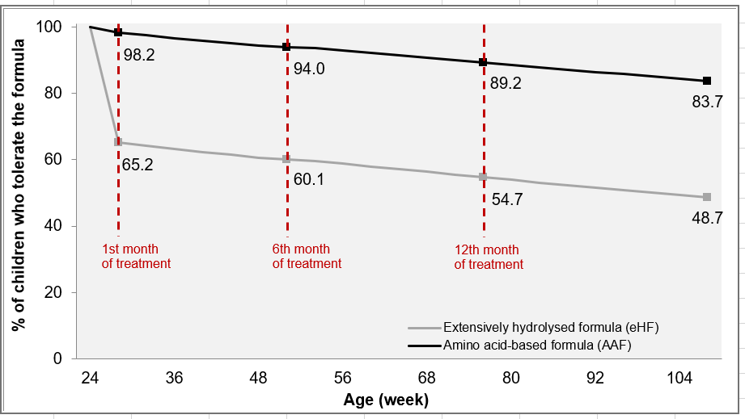
Notes: The figure represents the percentage of children with CPMA who can tolerate formula over time in amino acid-based formula and extensively hydrolysed formula scenarios
Abbreviations: AAF: amino acid-based formula; eHF: extensively hydrolysed formula.

Supplementary Figure 2. The possibility of being cost advantageous regarding maximum willingness to pay (Euro) per additional child who tolerates the formula at the end of the 24th month.

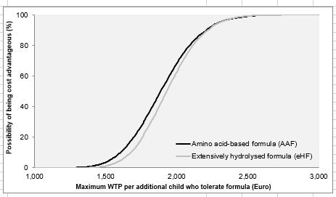
Abbreviation: WTP: willingness to pay.

