Antiviral activity of chitosan nanoparticles encapsulating curcumin against hepatitis C virus genotype-4a in human hepatoma cell lines
Samah A Loutfy^{1,2,}, Mostafa H. Elberry¹, Khaled Yehia Farroh³, Hossam Taha Mohamed⁴,
Aya A Mohamed⁴, ElChaimaa B Mohamed¹, Ahmed Hassan Farraag⁵, Shaker A. Mousa⁶

¹ Virology and Immunology Unit, Cancer Biology Department, National Cancer Institute, Cairo University, Egypt
² Nanotechnology Research Center, British University, Cairo, Egypt,
³ Nanotechnology and Advanced Materials Central Lab, Agricultural Research Center, Giza, Egypt
⁴ Faculty of Biotechnology, October University for Modern Sciences and Arts, 6th October, Egypt
⁵ Botany and Microbiology Department, Bioinformatics Center, Faculty of Science, Helwan University, Helwan, Egypt
⁶ The Pharmaceutical Research Institute, Albany College of Pharmacy and Health Sciences, Rensselaer, NY, USA

Figure S1. Curcumin release profile from chitosan nanoparticles in grams
Figure S2. mRNA expression of caspase 3 and BCL-2, RQ: fold change by real time quantitative PCR relative to β-actin housekeeping gene.
Table S1. Actual Combination index (CI) and dose reduction index (DRI) values for chitosan curcumin nanocomposite calculated at experimental points on huh7 cell line using CompuSyn Software.

Table S2. Simulated combination index (CI) and dose reduction (DRI) values for chitosan curcumin nanocomposite on huh7 cell line using CompuSyn Software.

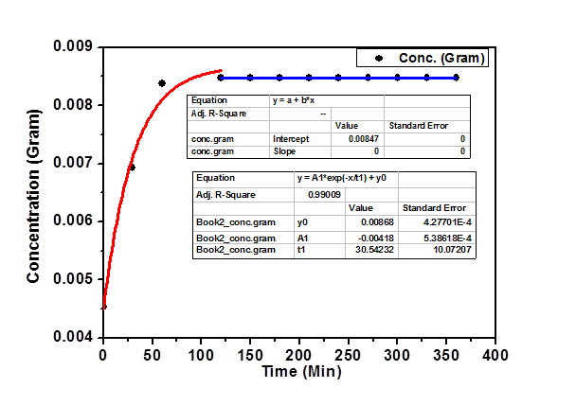

Figure S1. Curcumin release profile from chitosan nanoparticles in grams:
Release behavior profile of curcumin-encapsulated in chitosan nanoparticles dispersed in phosphate buffer saline (PBS), where the amount of curcumin released for 6 hours (i.e. 360 min) at 37°C was calculated and determined spectroscopically via the following equations:
(Beer's Lambert Law) (1)
(2)

Figure S2. mRNA expression of caspase 3 and BCL-2, RQ: fold change by real time quantitative PCR relative to β-actin housekeeping gene.

Table S1. Actual Combination index (CI) and dose reduction index (DRI) values for chitosan curcumin nanocomposite calculated at experimental points on huh7 cell line using CompuSyn Software
CSNPs/Cur |  |  | Cur |  |  | CSNPs
Fa | CI | Total Dose | Fa | Dose | DRI | Fa | Dose | DRI
0.27337 | 0.23709 | 6.25 | 0.27337 | 21.9178 | 4.38355 | 0.27337 | 139.425 | 111.540
0.48577 | 0.33708 | 12.5 | 0.48577 | 31.0968 | 3.10968 | 0.48577 | 161.268 | 64.5074
0.71494 | 0.47037 | 25 | 0.71494 | 45.0650 | 2.25325 | 0.71494 | 188.187 | 37.6373
0.85112 | 0.69568 | 50 | 0.85112 | 61.6304 | 1.54076 | 0.85112 | 214.366 | 21.4366
0.88770 | 1.23630 | 100 | 0.88770 | 69.7069 | 0.87134 | 0.88770 | 225.636 | 11.2818

CI of each individual data without simulation and Fa: Effect of each dose, which
comes from triplicate assays.

Table S2. Simulated combination index (CI) and dose reduction (DRI) values for chitosan curcumin nanocomposite on huh7 cell line using CompuSyn Software
CSNPs/Cur |  |  | Cur |  |  | CSNPs
Fa | CI | Dose | Fa | Dose | DRI | Fa | Dose | DRI
0.05 | 0.07769 | 1.22887 | 0.05 | 10.3809 | 13.1992 | 0.05 | 102.164 | 519.602
0.1 | 0.11325 | 2.36907 | 0.1 | 13.7891 | 9.09448 | 0.1 | 114.974 | 303.321
0.15 | 0.14308 | 3.55692 | 0.15 | 16.4390 | 7.22139 | 0.15 | 123.698 | 217.355
0.2 | 0.17065 | 4.83011 | 0.2 | 18.7651 | 6.07035 | 0.2 | 130.700 | 169.122
0.25 | 0.19741 | 6.21887 | 0.25 | 20.9326 | 5.25934 | 0.25 | 136.782 | 137.467
0.3 | 0.22423 | 7.75516 | 0.3 | 23.0300 | 4.64004 | 0.3 | 142.326 | 114.702
0.35 | 0.25176 | 9.47708 | 0.35 | 25.1165 | 4.14100 | 0.35 | 147.556 | 97.3109
0.4 | 0.28060 | 11.4329 | 0.4 | 27.2397 | 3.72277 | 0.4 | 152.623 | 83.4342
0.45 | 0.31138 | 13.6863 | 0.45 | 29.4439 | 3.36147 | 0.45 | 157.645 | 71.9902
0.5 | 0.34484 | 16.3247 | 0.5 | 31.7768 | 3.04148 | 0.5 | 162.726 | 62.3007
0.55 | 0.38193 | 19.4717 | 0.55 | 34.2944 | 2.75194 | 0.55 | 167.972 | 53.9153
0.6 | 0.42393 | 23.3096 | 0.6 | 37.0695 | 2.48486 | 0.6 | 173.499 | 46.5202
0.65 | 0.47272 | 28.1200 | 0.65 | 40.2031 | 2.23390 | 0.65 | 179.457 | 39.8863
0.7 | 0.53115 | 34.3637 | 0.7 | 43.8456 | 1.99364 | 0.7 | 186.051 | 33.8386
0.75 | 0.60396 | 42.8528 | 0.75 | 48.2388 | 1.75889 | 0.75 | 193.592 | 28.2350
0.8 | 0.69979 | 55.1738 | 0.8 | 53.8106 | 1.52390 | 0.8 | 202.600 | 22.9502
0.85 | 0.83664 | 74.9232 | 0.85 | 61.4248 | 1.28100 | 0.85 | 214.069 | 17.8573
0.9 | 1.06127 | 112.490 | 0.9 | 73.2291 | 1.01716 | 0.9 | 230.312 | 12.7963
0.95 | 1.56072 | 216.862 | 0.95 | 97.2713 | 0.70084 | 0.95 | 259.190 | 7.46990
0.97 | 2.05621 | 345.954 | 0.97 | 119.046 | 0.53767 | 0.97 | 281.917 | 5.09311

Fa: fraction effect, CI: Combination Index, DRI: Dose Reduction Index
CI< 1: Synergism, CI> 1: Antagonism, CI=1: additive

Cytoplasm

