Supplementary Material

In vivo comparison of the biodistribution and toxicity of InP/ZnS quantum dots with different surface modifications

Li Li, Yajing Chen, Gaixia Xu, Dongmeng Liu, Zhiwen Yang, Tingting Chen, Xiaomei Wang, Wenxiao Jiang, Dahui Xue, Guimiao Lin

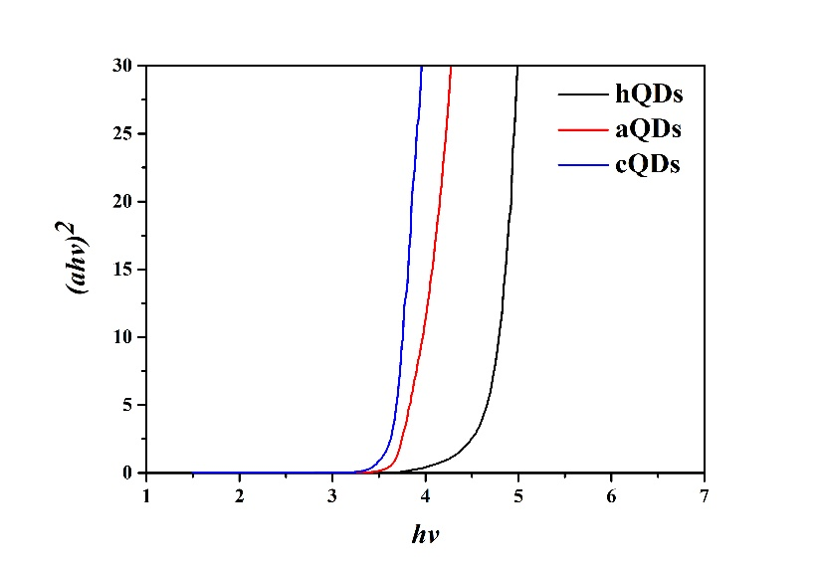
Figure S1. The plot of (αhv)² vs. (hv) of QDs.

