Fig.S1
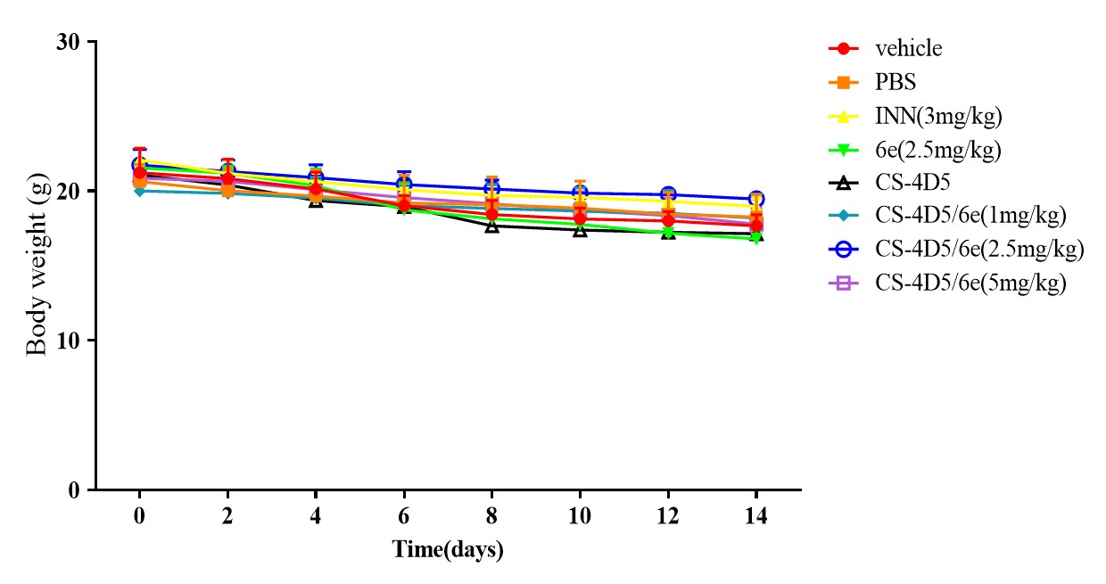

Fig.S2
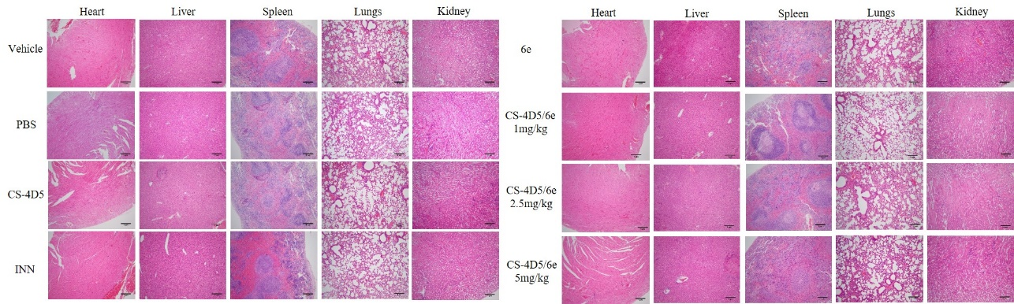

Supplementary information legend

Fig.S1:
Notes: Body weight of nude mice in each group for 14 days after administration. (n=6, means ± SD, ns means no significant difference vs. vehicle, P >0.05.)
Abbreviations: PBS: Phosphate Buffered Saline; INN: Indomethacin; CS: Chemically Chitosan;6e: A Derivative of Mansonone F; 4D5: Single Chain Antibody Fragment 4D5; SD: Standard Deviation.

Fig.S2:
Notes: H&E-stained slice images of major organs from different groups in nude mice.
Abbreviations: CS: Chemically Chitosan 4D5: Single Chain Antibody Fragment 4D5;6e: A Derivative of Mansonone F; INN: Indomethacin; PBS: Phosphate Buffered Saline; H&E: Hematoxylin and Eosin.

