Multifunctional superparamagnetic iron oxide nanoparticles conjugated with Aβ oligomer-specific scFv antibody and class A scavenger receptor activator show early diagnostic potentials for Alzheimer’s Disease

Xiao-ge Liu ^{1,2}, Lun Zhang ^{1,2}, Shuai Lu ¹, Dong-qun Liu ^{1,2}, Ling-xiao Zhang ^{1,2}, Xiao-lin Yu ^{1*}, Rui-tian Liu ^{1*}

¹ State Key Laboratory of Biochemical Engineering, Institute of Process Engineering, Chinese Academy of Sciences, Beijing 100190, China
² School of Chemistry and Chemical Engineering, University of Chinese Academy of Science, Beijing 100049, China

*Corresponding authors.
Rui-tian Liu
Email: rtliu@ipe.ac.cn; Fax: +86 10 82545075; Tel: +86 10 82545017
or
Xiao-lin Yu
Email: yuxiaolin@ipe.ac.cn; Fax: +86 10 82545025; Tel: +86 10 82545025

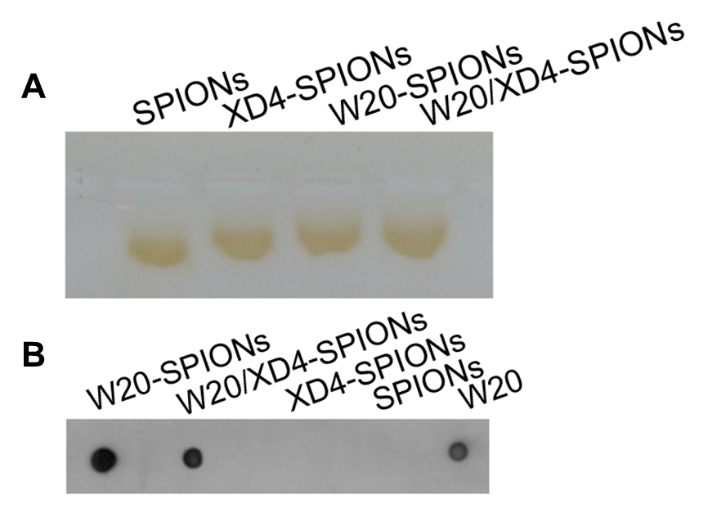
Figure S1. Characterization of W20/XD4-SPIONs. (A) Gel electrophoresis in 1% agarose of unconjugated-SPIONs, XD4-, W20- and W20/XD4-SPIONs. (B) W20 conjugated on the nanoparticles was detected by dot-blot using anti-c-myc antibody.

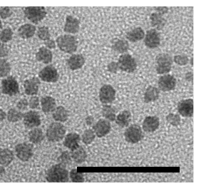
Figure S2. The morphology of W20/XD4-SPIONs at 6 months were imaged by TEM at an accelerating voltage of 100 KV. Scale bars, 50 nm.
Figure S3. Fe content in the brain lysate of BALB/c mice intravenously injected with mannitol combined with unconjugated-SPIONs, W20-, XD4-, or W20/XD4-SPIONs was determined by inductively coupled plasma spectrometry (ICP).

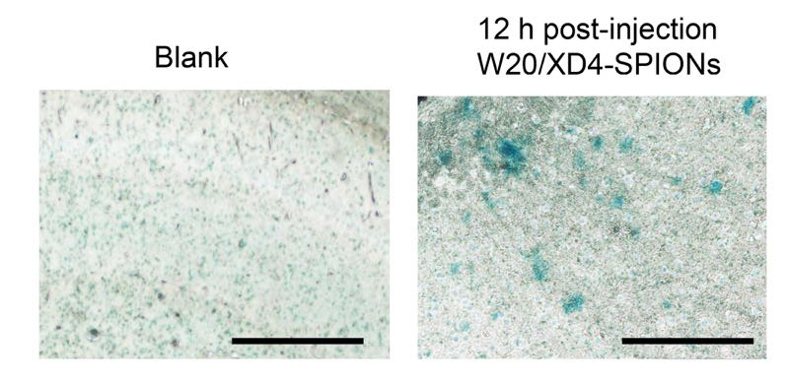
Figure S4. Prussian blue staining in the hippocampus area of AD mice treated with or without W20/XD4-SPIONs 12 h later. Scale bars, 100 μm.

Table S1. The conjugative efficiency of W20 and XD4 on nanoparticles

mg/mg (input) | mol/mol (input) | mg/mg (output) | mol/mol (output) | conjugative efficiency
W20:XD4= 1:0.1 | 1:3 | 0.5118 / 0.0192 | 1:1 | 51.18% / 19.2%
W20 = 1 |  | 0.5612 |  | 56.12%
XD4 = 0.1 |  | 0.0511 |  | 51.1%

