Supplementary data

Paclitaxel/IR1061-co-loaded protein nanoparticle for tumor targeted and pH/NIR-II triggered synergistic photothermal-chemotherapy
Li He^{†,1}, Fangzhen Qing^{†,2}, Maode Li³, Daitian Lan*^{,3}

¹ Department of Thyroid and Breast Surgery, Sichuan Academy of Medical Sciences & Sichuan Provincial People’s Hospital (East Hospital), Chengdu 610100, Sichuan, China
² Department of Stomatology, Sichuan Academy of Medical Sciences & Sichuan Provincial People’s Hospital (East Hospital), Chengdu 610100, Sichuan, China
³ Department of Hepatobiliary and Pancreatic Surgery, Sichuan Academy of Medical Sciences & Sichuan Provincial People’s Hospital (East Hospital), Chengdu 610100, Sichuan, China
*Correspondence: Daitian Lan
E-mail: doctor_yinl@126.com; Tel: +86-18349176311
Address: Department of Hepatobiliary and Pancreatic Surgery, Sichuan Academy of Medical Sciences & Sichuan Provincial People’s Hospital (East Hospital), Chengdu 610100, Sichuan, China
† These authors contributed equally to this paper.

Figure S1. The FTIR spectra of IR-AFN-FA.

Figure S2. The fluorescence spectra of free IR1061 and IR-AFN@PTX-FA in PBS.

Figure S3. Cell uptake ratio of free FITC, IR-AFN@PTX, IR-AFN@PTX-FA + FA, and IR-AFN@PTX-FA on normal human breast cells MDA-kb2.

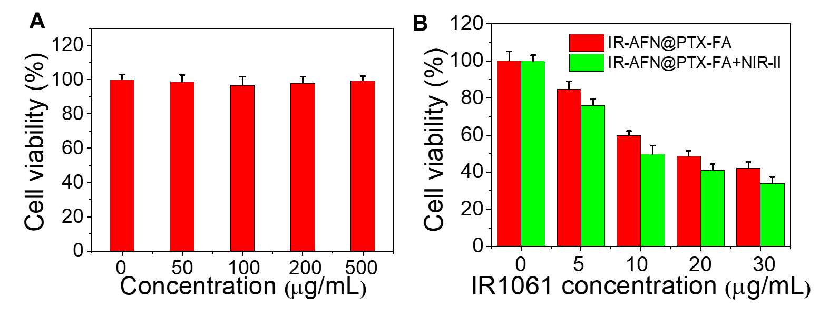
Figure S4. (A) Cell viability of MDA-kb2 cells treated with various concentrations of IR-AFN-FA. (B) Cell viability of MDA-kb2 cells treated with various concentrations of IR-AFN@PTX-FA with or without NIR-II irradiation (at the same IR1061 concentration).

