Mitochondria-modulating porous Se@SiO₂ nanoparticles provide resistance to oxidative injury in airway epithelial cells: implications for acute lung injury

Muyun Wang, MD^{a,#}, Kun Wang, MD^{a,#}, Guoying Deng, PhD^{b,#}, Xijian Liu, PhD^{c}, Xiaodong Wu, PhDª, Haiyang Hu, PhD^{d}, Yanbei Zhang, PhDe, Wei Gao, PhD^{a,*},
Qiang Li, MD^{a,*}

^{a.} Department of Pulmonary and Critical Care Medicine, Shanghai East Hospital, Tongji University, Shanghai 200120, China
^{b.} Department of Orthopedics, Shanghai General Hospital, Shanghai Jiao Tong University School of Medicine, Shanghai 201620, China
^{c.} College of Chemistry and Chemical Engineering, Shanghai University of Engineering Science, Shanghai, 201620, China
^{d.} Department of Cardiothoracic Surgery, Shanghai General Hospital, Shanghai Jiao Tong University School of Medicine, Shanghai 201620, China
^{e.} Department of Geriatric Pulmonary and Critical Care Medicine, the First Affiliated Hospital of Anhui Medical University, Anhui 230022, China

# These authors contributed equally to the paper
* Corresponding author:
Wei Gao. Email: grace19881118@126.com
Qiang Li. Email: liqressh2@hotmail.com

Funding: This work was supported by National Natural Science Foundation of China (grant number: 81870064), “Gaoyuan” project of Pudong Health and Family Planning Commission (grant number: PWYgy2018-06) and Shanghai Jiao Tong University Medical & Engineering Cross Fund (grant number: YG2019QNA65).

Conflict of interest: The authors declare no conflict of interest.

Methods
1. Cell culture and processing
Airway epithelial cell line (Beas-2B) was purchased from Shanghai Institutes for Biological Sciences, China Academy of Science (Shanghai, China) and cultured in complete RPMI-1640 medium (Hyclone) containing 10% fetal bovine serum (BioInd), 100 U/mL penicillin and 100 μg/mL streptomycin (Thermo Fisher Scientific). Cells were incubated with LPS (10 ng/mL) in the presence or absence of the pretreatment of porous Se@SiO₂ NPs (10 μg/mL). The cells were harvested for further experiments after 24 h of incubation.

2. In vitro cytotoxicity of the Se@SiO₂ NPs
The effects of our Se@SiO₂ NPs on cellular viability were evaluated by Cell Counting Kit-8 (CCK-8) assay. Specifically, Beas-2B cells were seeded at 5×10⁴ cells/well in 96-well plates. After 24 h of resting, cells were incubated with different concentrations of Se@SiO₂ NPs or combined with LPS for another 24 h. Then, the cells in each group were washed twice using sterile phosphate buffered saline (PBS) solution, followed by incubating with CCK-8 working solution at 37 °C for 1-2 h. The color change in each well was measured at 450 nm absorption through a microplate reader (SpectraMax iD3, Molecular Devices, Sunnyvale, USA).

3. Detection of intracellular ROS and mitochondrial ROS
The Beas-2B cells were plated in either 8 well glass-bottom chamber (Sigma-Aldrich, Canada) or 96-well black plate and stimulated with LPS with or without Se@SiO₂ NPs. After 24 h treatment, cells were incubated with CellROX™ deep red reagent (excitation at 644 nm, emission at 665 nm) (Invitrogen, USA) at 37°C for 30 mins. Then cells were washed and stained by Hoechst for cell nucleus. Intracellular ROS was determined under a confocal microscope (Leica SP5, Germany).
For mitochondrial ROS analysis, cells in each group were incubated with MitoSOX™ Red probe (excitation at 510 nm, emission at 580 nm) (Invitrogen, USA) at 37°C for 10 mins. The fluorescence of MitoSOX was observed under a confocal microscope or quantified by a fluorescent plate reader.

4. Evaluation of mitochondrial respiratory chain (MRC) activities
The activities of mitochondrial respiratory chains were measured by MRC Complex I-V Activity Assay Kit (Solarbio Life Sciences, China) according to their manufacturer’s instructions. MRC activities were determined using a colorimetric assay at 340 nm (MRC complex I), 605 nm (MRC complex II), 550 nm (MRC complex III and IV) and 660 nm (MRC complex V), respectively. The enzyme activity was exhibited as nmol/min/mg protein.

5. Western blotting (WB) analysis
Whole cell extracts in all groups were prepared and the concentrations were quantified by a BCA protein assay kit (Beyotime, China). Equivalent amounts of protein samples were loaded on a 10% (w/v) sodium dodecyl sulfate-polyacrylamide gels, electrophoresed and transferred to PVDF membranes (Millipore, Bedford, Massachusetts). The membranes were then blocked by tris-buffered saline containing 5% (w/v) non-fat milk powder and 0.1% (v/v) Tween 20 for 1.5 h at room temperature. Each strip was washed, incubated with distinct primary antibody: anti-phospho-p65, anti-GAPDH, anti-β-actin, anti-phospho-ERK1/2, anti-phospho-p38, anti-NRF2, anti-NQO1, anti-ZO-1, anti-E-Cadherin, anti-OPA1 and anti-MFN2 (all 1:1000, Cell Signaling Technology, USA) at 4°C overnight. Afterwards, all blots were washed 3 times with TBS containing 0.05% Tween-20 followed by incubating with HRP-labeled secondary antibody (1:15000, Cell Signaling Technology, USA) for 1.5 h at room temperature. The protein signals were imaged by a image analyzer (Tanon-4200, Tanon Biotechnology, China) by the use of ECL chemiluminescence method.

6. Measurement of mitochondrial morphology and activity
For transmission electron microscopic (TEM) imaging, Beas-2B cells were incubated with LPS in the presence and absence of porous Se@SiO₂. After 24 h, cells were gently scraped off from the culture dish and then centrifuged at 800 rpm for 10 mins, with the supernatant discarded. Glutaraldehyde (2.5%) was added carefully into cell pellets and fixed at 4°C for 1.5 hours. The mixture was then washed triple times with sucrose buffer, and the conventional process of TEM sample preparation such as post-fixation, dehydration, soaking, embedding, ultrathin sectioning and heavy metal staining were performed subsequently. The mitochondrial morphology in each cell was determined by HITACHI HT7700 electron microscope (Tokyo, Japan) at an accelerating voltage of 220 kV. Image J software was adopted to manage the images and obtain related data. Mitochondrial morphological parameters, the form factors (FF) of mitochondria = perimeter²/(4π×area).
The mitochondrial morphology of AECs was also observed under confocal microscope. Beas-2B cells were plated in an 8 well cover glass-bottom chamber and stimulated by LPS with or without NPs pretreatment. After 24 h incubation, mitochondria were labeled with the MitoTracker Red CMXRos (MTR) staining solution. The mitochondrial morphology was observed under the confocal microscope (Leica SP5, Germany). Meanwhile, MTR fluorescence staining of mitochondria in live cells was determined by Image J software. A minimum of 50 cells were analyzed and three independent experiments were conducted for each treatment.

7. RNA-Sequencing and data analysis
Total RNAs were extracted using TRIzol (Invitrogen, USA)-based method and the following procedures were conducted by Genergy Biotechnology Co. Ltd. (Shanghai, China). Briefly, RNA samples were purified using magnetic oligo (dT) beads after denaturation, followed by reversing into first-strand cDNA and further synthesizing a second cDNA. The fragmented DNA samples were then blunt ended as well as adenylated at the 3’ ends. The library was obtained and quantified by use of Qubit® dsDNA HS Assay Kit (Invitrogen, USA). After cBot clusters generation, the DNA samples were sequenced under Illumina HiSeq X Ten SBS instrument from Genergy Bio (Shanghai, China). Afterwards, raw data were transformed into Fastq format. Cuffnorm software was adopted to calculate the fragments per kilobase of transcript per million fragments mapped (FPKM) for each sample, and the values were log2 transformed. Meanwhile, the DESeq software was adopted to determine distinct gene transcripts between differential samples.
For GO enrichment and KEGG pathway analysis, the entire gene library was used as a background list, the target gene was listed as candidates selected from the background. Fisher's test was conducted to calculate whether the GO or KEGG pathway set was significantly enriched in the target gene list, and then the P value was further calculated.

8. Establishment of acute lung injury murine model
The 6-8-week-old male C57BL/6 mice (Shanghai Laboratory Animal Co. Ltd., China) were randomly divided into four groups. The ALI model was achieved by intranasal instillation of 10 mg/Kg LPS. One hour before the challenge, porous Se@SiO₂ NPs (100 μg/Kg body weight) or PBS control were also administrated intranasally. After 24 h of LPS challenge, mice were sacrificed and certain samples were collected for subsequent experiments.

9. Bronchoalveolar lavage fluid (BALF) acquisition and analysis
After anesthetization, disinfection and tracheotomy of mice, pre-cooled PBS (0.8 mL) was slowly injected through tracheal cannula and carefully withdrawn. The retrieving volume was generally >70% of total injected fluid. Then, the obtained bronchoalveolar lavage fluid BALF sample was centrifuged at 1200 rpm for 10 mins at 4°C to collect BAL cells. Total cell counts were determined under a hemocytometer with trypan blue dye exclusion assay. BALF aliquots were fixed on a glass slide by cytocentrifuging and stained with Wright-Giemsa dye (Baso Diagnostics, China). Then, the differential cell counts were determined through counting at least 200 cells under a microscope at 400× magnification. Besides, BALF supernatants were dispensed and then stored at -80°C for further experiments. The levels of cytokines interlukin-1β (IL-1β), macrophage chemotactic protein-1 (CCL-2) and interlukin-6 (IL-6) within airway were assessed by ELISA kits (eBioscience, USA) according to respective manufacturer’s instructions. Moreover, BALF protein content was determined by BCA protein assay kit.

10. Histological analysis of lung injury
In a separate experiment, the left lung lobes of mice were removed without bronchoalveolar lavage and placed in tissue clips immersed in 10% neutral formaldehyde. Then paraffin embedding and pathological sections were performed successively. The embedded waxes were cut into 4 μm slices and flattened on a glass slide, followed by hematoxylin-eosin (H&E) staining, dehydration and mounting. All sections were assessed by two independent physicians who were blinded to treatment group according to international standards. Six independent fields were randomly chosen from each section and the severity of lung injury was evaluated following five main criteria: alveolar neutrophil infiltration (A), interstitial neutrophil infiltration (B), hyaline membrane formation (C), proteinaceous debris filling the airspaces (D), and alveolar septal thickness (E). Results were weighted according to the correlation with the injury, a continuous value between 0-1 was obtained, which represented the pathological score of lung injury. Score = [(20 × A) + (14 × B) + (7 × C) + (7 × D) + (2 × E)] / (number of fields × 100).

11. Lung wet-to-dry (W/D) weight ratio
The right lung lobes were excised and weighed immediately to get the wet weight. All the lung samples were then kept in an oven at 65°C for 48 h until the constant weight to obtain the dry weight. The ratio of wet weight to dry weight (W/D) was calculated ultimately.

Results

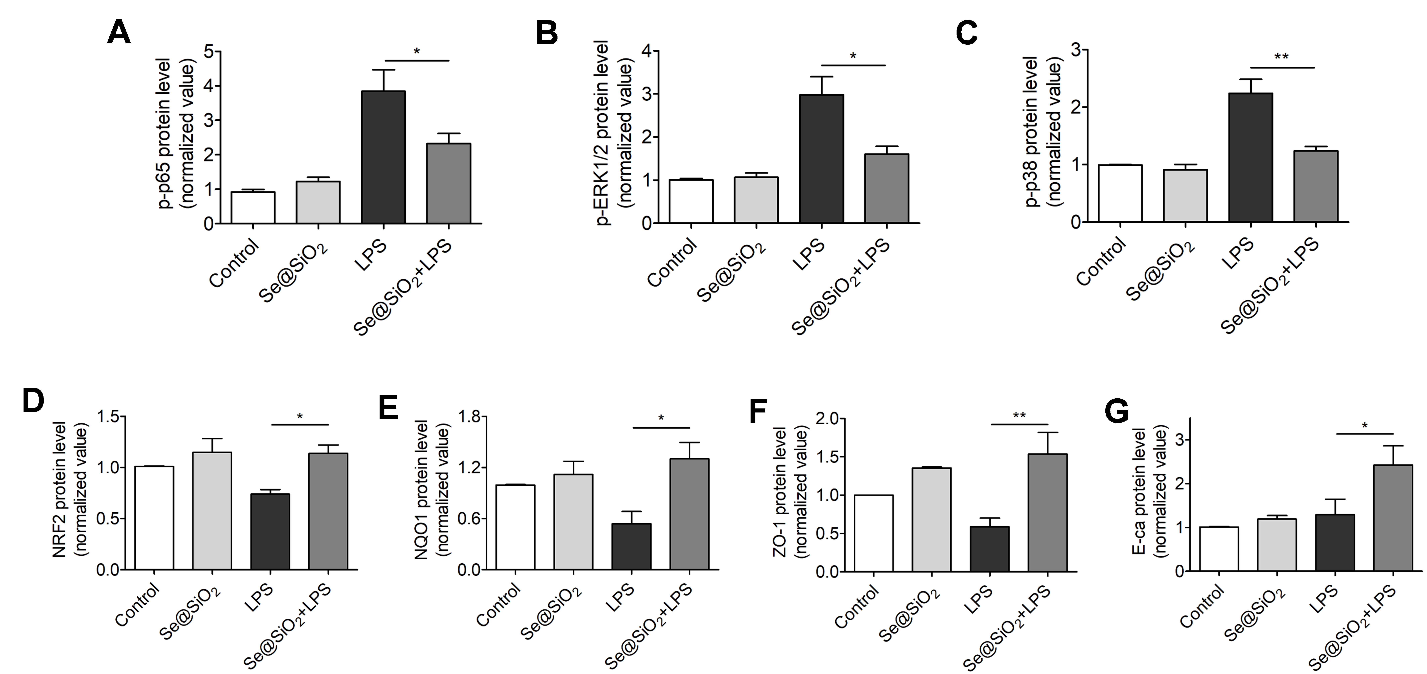

Figure S1. Impact of LPS and porous Se@SiO₂ NPs on the expression of proteins related to oxidative injury in human airway epithelial cells (AECs). (A-G) Densitometry analysis of p-p65, p-ERK1/2, p-p38, NRF2, NQO1, ZO-1 and E-Ca from three independent experiments. NP concentration = 10 μg/mL, LPS = 10 ng/mL. *p < 0.05, **p < 0.01.

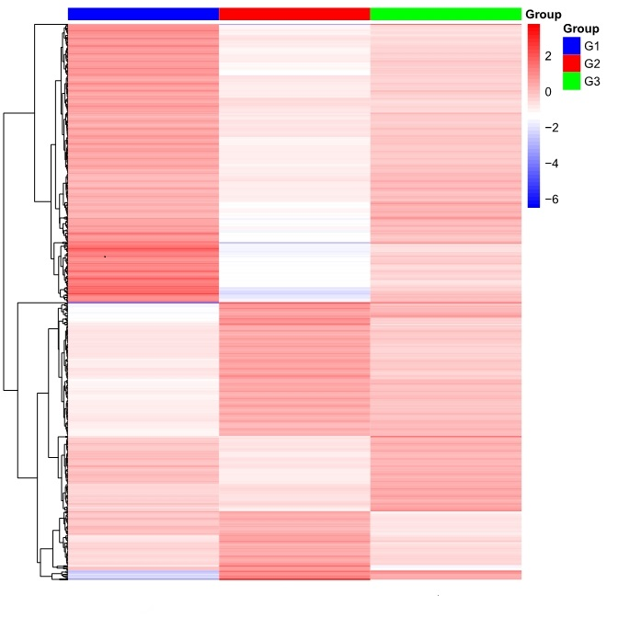
Figure S2. Effect of porous Se@SiO₂ NPs treatment on RNA-Seq transcriptome analysis of LPS-challenged human airway epithelial cells (Beas-2B). G1 = Control group, G2 = LPS group, G3 = Se@SiO₂ + LPS group.

