Supplementary Appendix

This appendix has been provided by the authors to give readers additional information about their work.

Supplement to: Onset of Effect, Changes in Airflow Obstruction and Lung Volume, and Health-Related Quality of Life Improvements with Benralizumab for Patients with Severe, Eosinophilic Asthma: Phase IIIb Randomized Controlled Trial (SOLANA)

Table of Contents

1. Appendix 1: Principal Investigators and Study Locations...……………………………………….…3
2. Appendix 2: Tables and Figures………………………………………….……………………….….4
2.1 Figure S1. SOLANA Study Flow Chart……………………………………………….………….….4
2.2 Figure S2. Exponential Regression Analysis of Prebronchodilator FEV₁ (L) Change from Baseline
(Full Analysis Set)……………………………………………………………………………………5
2.3 Figure S3. ACQ-6 Average Change from Baseline by Subgroup, Repeated Measures Analysis
(Full Analysis Set)……………………………………………………………………………………6
2.4 Figure S4. SGRQ Average Change from Baseline by Subgroup, Repeated Measures Analysis
(Full Analysis Set)……………………………………………………………………………………7
2.5 Table S1. Additional Secondary Endpoints………………………………………………….……….8
2.6 Table S2. ACQ-6 Comparisons of Percentages of Patients with Well-Controlled Asthma or
Well-Controlled/Partially Controlled Asthma, Logistic Regression (Full Analysis Set)..…………..10
2.7 Table S3. MMRM Change from Baseline in Blood Eosinophils…………….……….……………..11
2.8 Table S4. Body Plethysmography Substudy Additional Outcomes…………….….………………..12

- Appendix 1: Principal Investigators and Study Locations

The following principal investigators participated in the study:

Chile
Absalon Silva, Patricia Schönffeldt, Victor Martinez, Rosa Feijoo, Fabian Galleguillos, Francisco Rivas,
Roxana Fuentes

Germany
Tobias Welte, Margret Jandl, Claus Keller, Joachim Kirschner, Katrin Milger-Kneidinger, Martin Hoffmann,
Tibor Schmoller, Lutz Volgmann, Stephanie Korn, Marc Kornmann, Richard Linde, Andreas Forster

Hungary
Márta Papp, Teréz Kecskés, Magdolna Póczi, Lajos Molnár, Balázs Medgyasszay, Judit Schlezák,
Melinda Szabó, Edina Kurucz, János Mucsi

The Philippines
Teresita Aquino, Ronnie Samoro, Albert Albay Jr., Tito Atienza

South Korea
Heung-Woo Park, Mi-Kyeong Kim, Jung-Won Park, Sang Haak Lee, You Sook Cho, Sook Young Lee,
Byung Jae Lee, Kwan Ho Lee, Yongchul Lee

United States
Louise Thurman, David Bernstein, Luis De Armas, John Hagan, Octavian Ioachimescu, Younus Ismail,
Flavia Hoyte, Edward Kerwin, Reynold Panettieri, Kartik Shenoy, John Suen, James Cain,
Shahrukh Kureishy, Sady Alpizar, David Maybee, Faisal Fakih, Manuel Villareal, Neal Jain

- Appendix 2: Tables and Figures

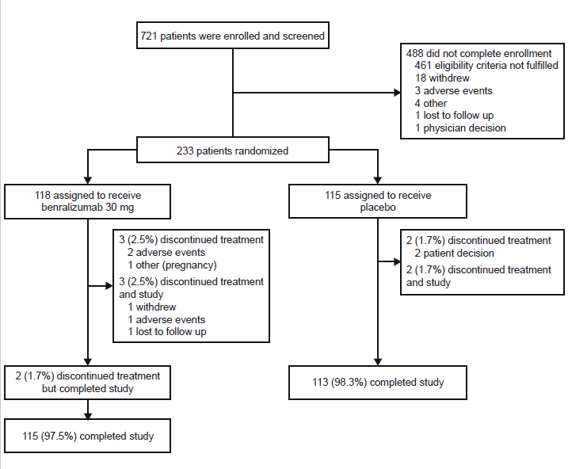
2.1 Figure S1. SOLANA Study Flow Chart

2.2 Figure S2. Exponential Regression Analysis of Prebronchodilator FEV₁ (L) Mean Change from Baseline (Full Analysis Set)

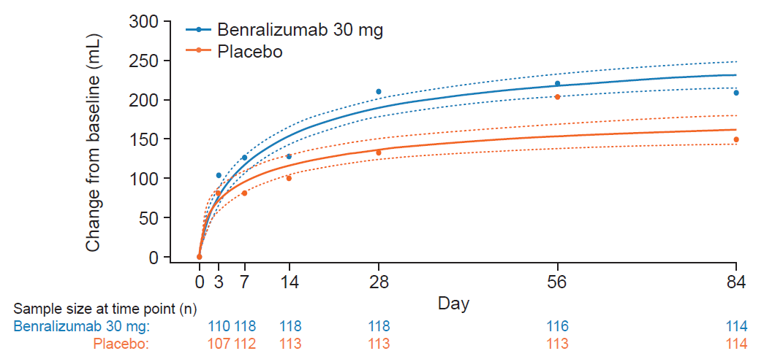

Fitted lines based on estimates from Bayesian nonlinear mixed-effects model assuming an exponential relationship over time with 95% credible intervals. n=number of patients with change from baseline data observed at the time point. Mean changes from baseline (derived from observed values) were represented by points. Baseline was defined as the last nonmissing value with acceptable quality (acceptable or borderline quality grade) prior to the first dose of study treatment. FEV₁, forced expiratory volume in 1 second.

2.3 Figure S3. ACQ-6 Average Change from Baseline by Subgroup, Repeated Measures Analysis (Full Analysis Set)

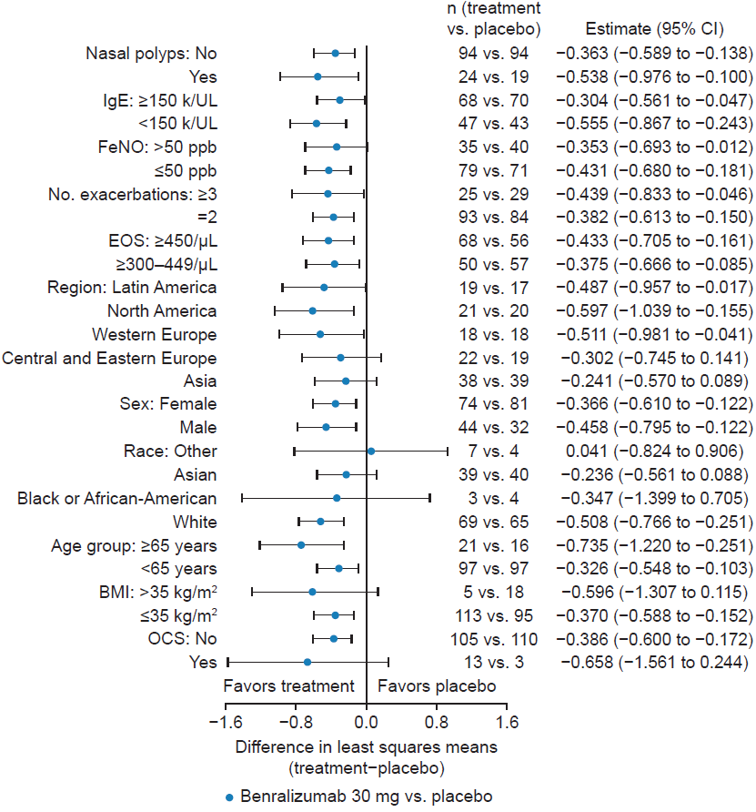

Average change from baseline over Days 28, 56, and 84. Baseline was defined as the last nonmissing value prior to randomization. ACQ-6, Asthma Control Questionnaire 6; BMI, body mass index; CI, confidence interval; Eos, eosinophils; FeNO, fractional inhaled nitric oxide; IgE, immunoglobulin E; OCS, oral corticosteroids.

2.4 Figure S4. SGRQ Average Change from Baseline by Subgroup, Repeated Measures Analysis (Full Analysis Set)

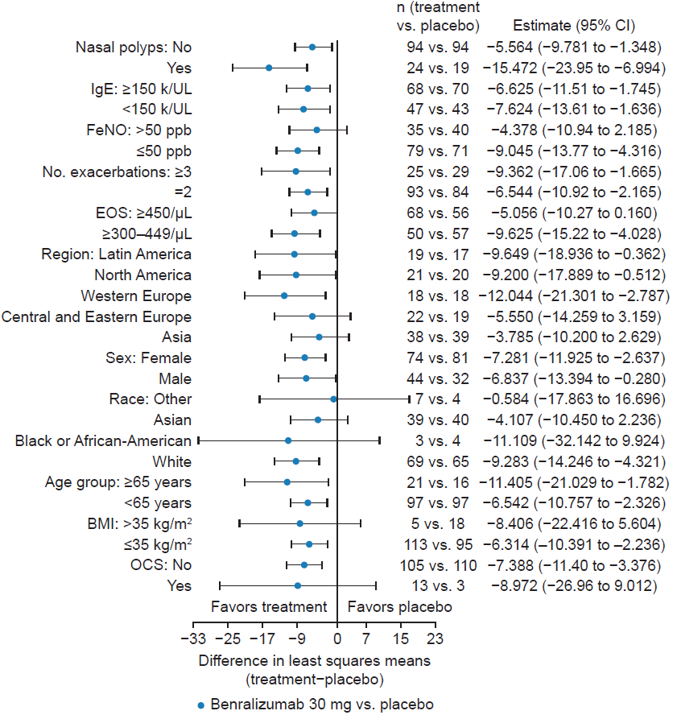

Average change from baseline over Days 28, 56, and 84. Baseline was defined as the last nonmissing value prior to randomization. BMI, body mass index; CI, confidence interval; EOS, eosinophils; FeNO, fractional inhaled nitric oxide; IgE, immunoglobulin E; OCS, oral corticosteroids; SGRQ, St. George’s Respiratory Questionnaire.

2.5 Table S1. Additional Secondary Endpoints

 | LS mean change from baselineª |  | LS mean difference^{b}
 | Benralizumab  30 mg^{b} (n) | Placebo (n) | Benralizumab vs. placebo  (95% CI) | P-value
Change from baseline in prebronchodilator FVC, mL
Day 3 | 118 (110) | 112 (107) | 6 (−62 to 73) | 0.87
Day 7 | 138 (118) | 97 (112) | 41 (−33 to 115) | 0.27
Day 14 | 126 (118) | 111 (113) | 15 (−68 to 98) | 0.73
Day 28 | 210 (118) | 135 (113) | 75 (−14 to 164) | 0.098
Day 56 | 210 (116) | 187 (113) | 23 (−77 to 122) | 0.65
Day 84 | 223 (114) | 131 (114) | 92 (−4 to 188) | 0.06
Average over Days 28, 56, and 84 | 214 (118) | 151 (114) | 63 (−20 to 147) | 0.14
Change from baseline in FeNO, ppb
Day 3 | 8.6 (101) | −1.3 (99) | 9.9 (3.7 to 16.0) | 0.0017
Day 7 | 7.0 (106) | −3.0 (99) | 10.0 (3.3 to 16.7) | 0.0037
Day 14 | 6.3 (100) | −0.55 (94) | 6.9 (0.1 to 13.6) | 0.047
Day 28 | 7.4 (96) | −4.1 (92) | 11.5 (3.3 to 19.7) | 0.0063
Day 56 | 6.0 (101) | −1.4 (106) | 7.4 (−1.3 to 16.1) | 0.095
Day 84 | 4.9 (103) | −0.5 (106) | 5.4 (−4.5 to 15.3) | 0.28
Average over Days 28, 56, and 84 | 6.1 (114) | −2.0 (111) | 8.1 (0.1 to 16.1) | 0.048
Change from baseline in FEF25–75%, mL^{c}
Day 3 | 88 (110) | 59 (107) | 29 (−55 to 113) | 0.50
Day 7 | 109 (118) | 50 (112) | 59 (−13 to 131) | 0.11
Day 14 | 132 (118) | 102 (113) | 30 (−78 to 137) | 0.59
Day 28 | 198 (118) | 110 (113) | 88 (−25 to 201) | 0.13
Day 56 | 240 (116) | 177 (113) | 63 (−60 to 186) | 0.32
Day 84 | 223 (114) | 165 (114) | 58 (−67 to 182) | 0.36
Average over Days 28, 56, and 84 | 220 (118) | 151 (114) | 69 (−38 to 177) | 0.20

ªBaseline was defined as the last nonmissing value with acceptable quality (acceptable or borderline quality grade) prior to the first dose of study treatment. A patient with missing value for change from baseline at a visit was excluded from the calculation of proportion of responders at that visit. ^{b}Estimate of the mean change from baseline at each day in the active treatment group was compared with the placebo group using a repeated measures analysis. Estimates were least squares means. The model was: Change from baseline in FeNO=treatment+baseline FeNO+region+visit+treatment×visit. ^{c}Performed as a post-hoc analysis. CI, confidence interval; FVC, forced vital capacity; FEF25–75, forced expiratory flow at 25–75% of forced vital capacity; FeNO, fractional exhaled nitric oxide; LS, least squares.

2.6 Table S2. ACQ-6 Comparisons of Percentages of Patients with Well-Controlled Asthma or Well-Controlled/Partially Controlled Asthma, Logistic Regression (Full Analysis Set)

 | Well-controlled |  | Well-controlled/partially controlled
 | Benralizumab 30 mg  (n=118) | Placebo (n=115) | Benralizumab 30 mg  (n=118) | Placebo (n=115)
Patients at Day 14,  n (%) | 18 (15) | 8 (7) | 48 (41) | 32 (28)
OR benralizumab vs. placebo (95% CI) | 2.57 (1.12–5.89)  p=0.025 |  | 1.98 (1.14–3.43)  p=0.015
Patients at Day 28,  n (%) | 27 (23) | 7 (6) | 54 (46) | 39 (34)
OR benralizumab vs. placebo (95% CI) | 5.12 (2.18–12.06)  p=0.0002 |  | 1.81 (1.03–3.19)  p=0.04
Patients at Day 56,  n (%) | 32 (27) | 15 (13) | 64 (54) | 46 (40)
OR benralizumab vs. placebo (95% CI) | 2.74 (1.34–5.59)  p=0.0055 |  | 1.98 (1.12–3.50)  p=0.019
Patients at Day 84,  n (%) | 45 (38) | 23 (20) | 71 (60) | 50 (43)
OR benralizumab vs. placebo (95% CI) | 2.78 (1.46–5.30)  p=0.0019 |  | 2.21 (1.24–3.94)  p=0.0071

Estimate of the log odds of asthma being well-controlled (or partially controlled, as applicable) in the treatment group was compared with the placebo group via a logistic regression with repeated measures. The model was: ln(p/1-p)=treatment+region+baseline ACQ-6 score+visit+treatment×visit, where p is the percentage of patients who were well-controlled (defined as ACQ-6 score ≤0.75) or partially controlled (defined as ACQ-6 score ≤1.5), as applicable. ACQ-6 score was defined as the average of the first six items of the ACQ-6 questionnaire on symptoms, activity limitations, and rescue medication. Scores range from 0 (totally controlled) to 6 (severely uncontrolled). Baseline was defined as the last nonmissing value prior to randomization. Patients with missing or nonevaluable ACQ-6 scores at the post-baseline visit were considered as having not well-controlled or partially controlled asthma, as applicable. ACQ-6, Asthma Control Questionnaire 6; CI, confidence interval; OR, odds ratio.

2.7 Table S3. MMRM Change from Baseline in Blood Eosinophils

Time point | n  (benralizumab vs. placebo) | Estimates  (benralizumab vs. placebo) | Estimate (95% CI) | P-value
Day 3 | 108 vs. 107 | −85.32 vs. 15.70 | −101.0  (−113.2 to −88.83) | <0.0001
Day 7 | 116 vs. 110 | −86.27 vs. 17.04 | −103.3  (−115.4 to −91.22) | <0.0001
Day 14 (Week 2) | 118 vs. 113 | −84.08 vs. 18.38 | −102.5  (−116.3 to −88.65) | <0.0001
Day 28 (Week 4) | 117 vs. 112 | −80.03 vs. 27.67 | −107.7  (−147.5 to −67.90) | <0.0001
Day 56 (Week 8) | 117 vs. 113 | −85.85 vs. 15.48 | −101.3  (−117.6 to −85.10) | <0.0001
Day 84 (Week 12) | 113 vs. 112 | −89.09 vs. 11.91 | −101.0  (−118.9 to −83.06) | <0.0001
Average over Day 28 to 84 | 118 vs. 114 | −84.99 vs. 18.36 | −103.3  (−124.3 to −82.39) | <0.0001

Analysis via MMRM adjusting for treatment, baseline eosinophil count, region, visit and treatment×visit. Baseline was defined as the last nonmissing value prior to randomization. CI, confidence interval; MMRM, mixed-effect model repeated measure.

2.8 Table S4. Body Plethysmography Substudy Additional Outcomes

 | n,  benralizumab vs. placebo | Benralizumab  30 mg | Placebo
Change from BLª in pre-BD FEV₁, mL
Day 3 | 16 vs. 21 | 151 (253) | −39 (205)
Day 7 | 18 vs. 21 | 151 (244) | 44 (265)
Day 14 | 18 vs. 22 | 168 (320) | 98 (212)
Day 28 | 18 vs. 22 | 232 (406) | −31 (251)
Day 56 | 18 vs. 22 | 152 (418) | 108 (325)
Day 84 | 18 vs. 22 | 201 (349) | 53 (341)
Day 112 (follow-up) | 18 vs. 22 | 178 (500) | 93 (292)
Change from BL^{b} in ACQ-6 score
Day 14 | 18 vs. 22 | −0.880 (0.794) | −0.795 (0.661)
Day 28 | 18 vs. 22 | −1.028 (0.776) | −0.902 (0.745)
Day 56 | 18 vs. 22 | −0.880 (1.315) | −1.068 (0.948)
Day 84 | 18 vs. 22 | −1.241 (0.959) | −1.326 (1.120)
Change from BL^{b} in SGRQ score
Day 28 | 18 vs. 22 | −13.383 (13.904) | −15.380 (15.828)
Day 56 | 18 vs. 22 | −12.982 (19.337) | −18.253 (15.964)
Day 84 | 18 vs. 22 | −16.075 (14.613) | −20.449 (18.152)

Data are presented as mean (SD). ªBaseline defined as the last nonmissing value with acceptable quality (acceptable or borderline quality grade) prior to the first dose of study treatment. ^{b}Baseline defined as the last nonmissing value prior to randomization. ACQ-6, Asthma Control Questionnaire 6; BD, bronchodilator; BL, baseline; FEV₁, forced exploratory volume in 1 second; SD, standard deviation; SGRQ, St. George’s Respiratory Questionnaire.

