Surface engineering of metal organic framework as pH/NIR-responsive nanocarrier for imaging-guided chemo-photothermal therapy
Haibin Guo^{a, 1}, Yanqing Xia^{a, 1}, Ke Fengª, Xiaowei Quª, Cuilian Zhangª*, Feng Wanª*

ªHenan Provincial People’s Hospital, Henan Provincial Reproductive Hospital, People's Hospital of Zhengzhou University, People's Hospital of Henan University, Zhengzhou, Henan, 450003, China.

Correspondence:
Feng Wan.
Henan Provincial People’s Hospital, Henan Provincial Reproductive Hospital, People's Hospital of Zhengzhou University, People's Hospital of Henan University, Zhengzhou, Henan, 450003, China.
Tel +86 0371 87160762
Email: fengwanscholar@163.com

¹ Contributed equally to this work.
*Corresponding authors

Fig. S1. TEM images of (A) ZIF-8 and (B) ZIF-8/MPP without DOX incorporation during the synthetic process.

Fig. S2. UV-vis spectra of ZIF-8/DOX, ZIF-8/DMPP and supernatant solution of ZIF-8/DMPP after high-speed centrifugation. Inset represents the digital photos of the corresponding samples.

Fig. S3. The fluorescent intensity of PC-3 cells incubated with FITC-labelled drug-free ZIF-8/MPP for 2 h with or without NIR laser irradiation (measured by ImageJ software).

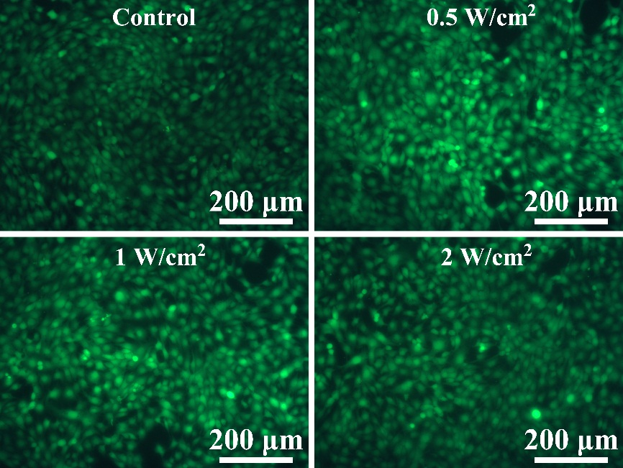
Fig. S4. Live-dead staining images of PC-3 cells after exposed to 808 nm laser with different power density.

Fig. S5. Cell viability of PC-3 cells and HUVECs incubated with free ZIF-8/MPP for 24 h.

