Appendix A
Sample search strategy from CINAHL database
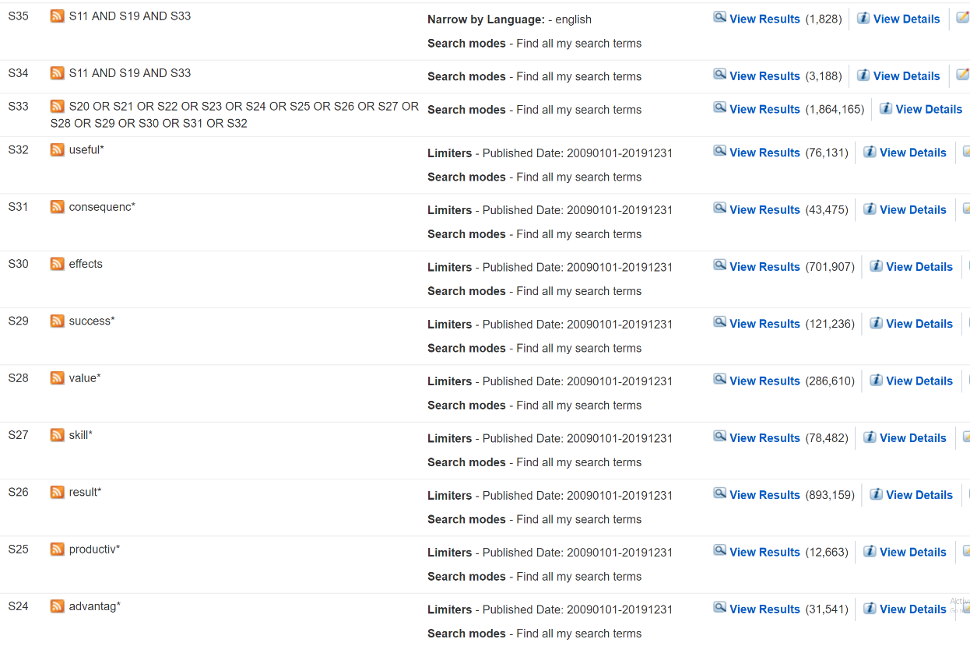
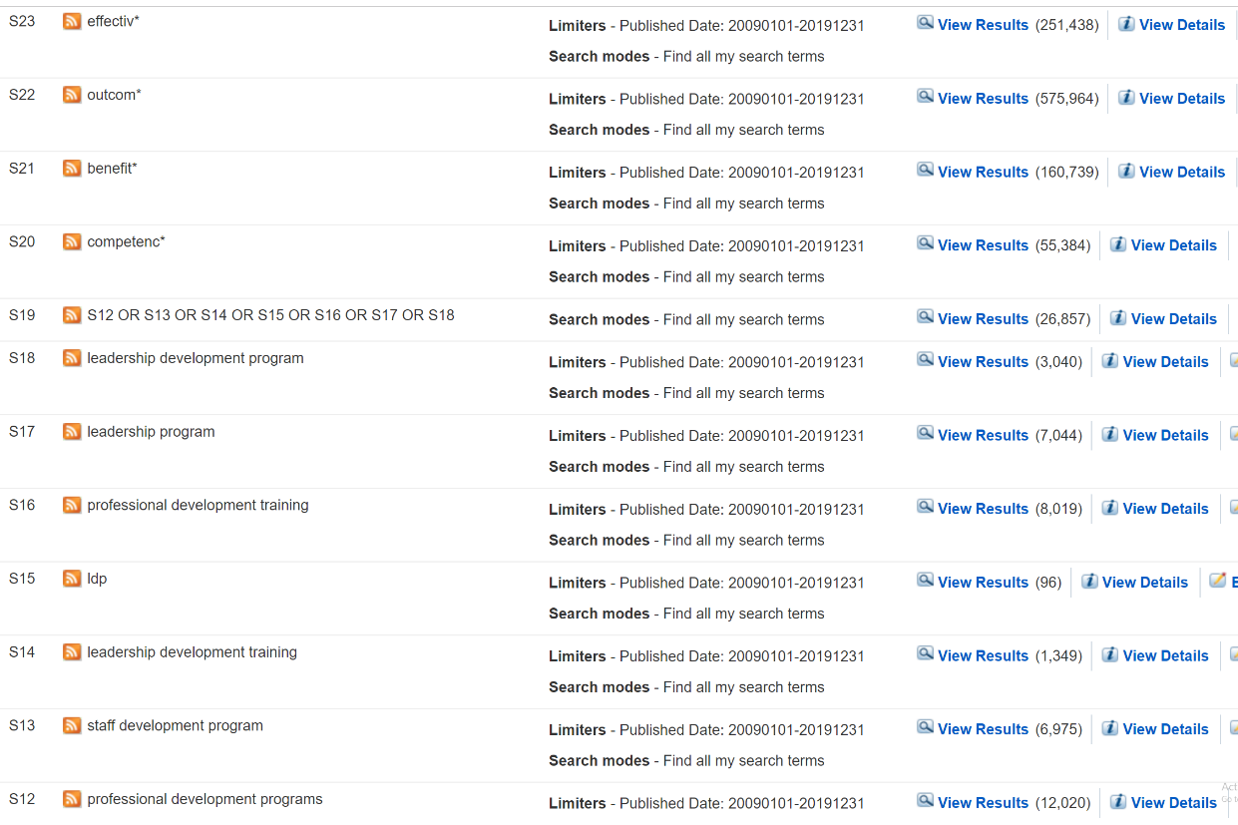
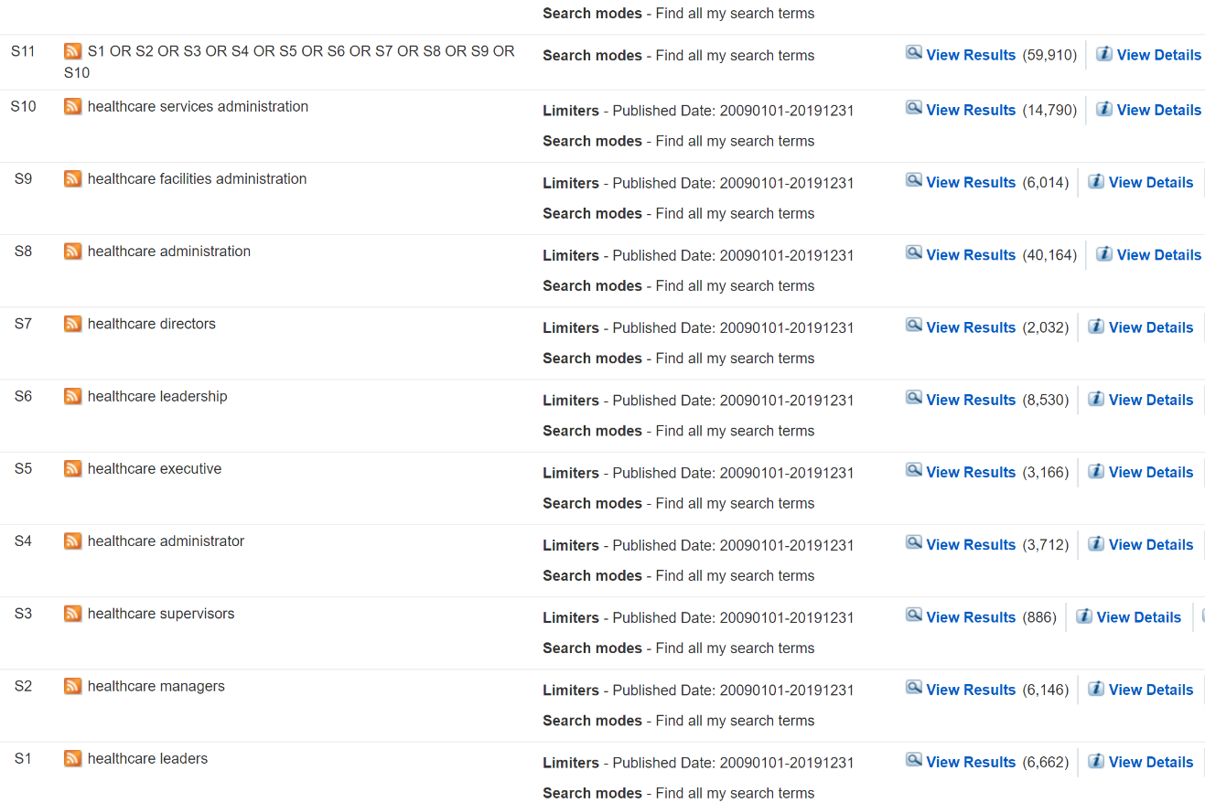

Appendix B: Sample article extraction form.
RESEARCH ARTICLE TITLE AND ABSTRACT SCREENING FORM
Researcher:
Title of Article:
Date:

Level of Review (please check): Title _____ Abstract _____ Article _____
Selection Criteria:
(Please indicate with a check mark if each of the following criteria are met)
Population: Was the population hospital managers and leaders? Yes _____ No _____
Study Intervention: Was the intervention a leadership development program? Yes _____ No ____
Outcome Measures*: Was there a positive influence from the intervention? Yes _____ No _____
*To meet inclusion criteria, all must be yes, except for outcome measures. Article must have evaluated at least one outcome measurement
Result: Include _____
Exclude _____
Reason For Exclusion:
DATA EXTRACTION FORM
Study Identification
Citation
Country of origin
Study Characteristics
Study aim
Study setting
Study inclusion criteria
Study exclusion criteria
Study Participant Characteristics
Total Number of Participants for the Program
Population Description
Intervention and Setting
Method Used For The LDP
Duration & Frequency of the LDP
Outcomes Data
Beneficial Outcomes Listed
Study Conclusions
Additional Comments
Additional Comments/ Findings

