Anti-inflammatory potential of green synthesized silver nanoparticles of the soft coral Nephthea sp. supported by Metabolomics analysis and Docking studies

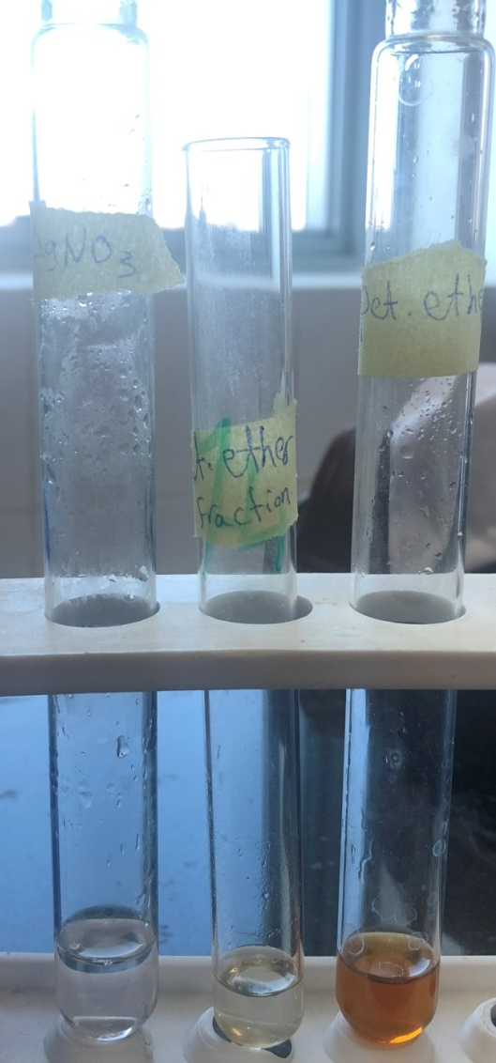
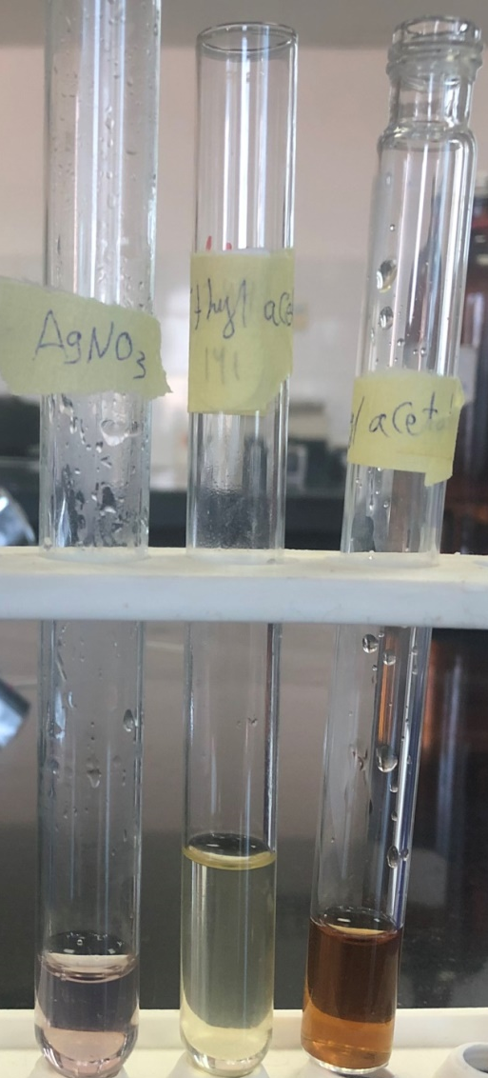
Supplementary material

A B
Figure S1: Colour change during the formation of nanoparticles (A), pet. ether fraction, (B) ethyl acetate fraction.
Table S1: compounds identified and dereplicated from high resolution mass spectral data sets of the Nephthea sp.
M/Z | Retention time (min.) | Molecular weight | Name | Molecular formula
175.112 | 3.87 | 174.1051 | (4aS*, 8S*)-5, 6, 7, 8-tetrahydro-4a, 8-dimethylnaphthalen-2(4aH)-one | C₁₂H₁₆O
215.144 | 7.89 | 214.137 | Furanotriene | C₁₅H₁₈O
217.159 | 3.72 | 216.152 | Cyclocolorenone | C₁₅H₂₂O
233.154 | 4.10 | 232.147 | Lemnalactone | C₁₅H₂₂O₂
235.170 | 3.72 | 234.162 | (2E, 6E)-3-isopropyl-6-methyl-10-oxoundec-2,6-dienal | C₁₅H₂₄O₂
251.127 | 4.90 | 250.120 | 1(10)-epoxy-2-hydroxy-12-nornardosin-7,11-dione | C₁₄H₂₀O₄
273.148 | 7.35 | 272.141 | 7-acetoxycalamenen-3-one | C₁₇H₂₂O₃
275.163 | 6.24 | 274.155 | Ethyl 5-[(1E, 5Z)-2, 6-dimethylocta-1, 5, 7-trienyl] furan-3-carboxylate | C₁₇H₂₂O₃
281.138 | 4.92 | 280.131 | Sinularioperoxide E | C₁₅H₂₀O₅
313.164 | 4.29 | 312.157 | Rubifolide | C₂₀H₂₄O₃

Table S2: Results of the in silico study of the dereplicated compounds into the active site of COX-1 (pdb code: 5WBE) and COX-2 (pdb code: 5KIR) compared to the co-crystallized ligands.
Ligand | ΔG (kcal/mol)
Ligand | COX-1 | COX-2
Mofezolac | ˗9.5 | ˗ 8.3
Rofecoxib | ˗ 7.7 | ˗ 8.6
1 | ˗ 5.6 | ˗ 5.0
2 | ˗ 6.1 | ˗ 6.0
3 | – | ˗ 5.8
4 | ˗ 5.1 | ˗ 4.6
5 | ˗ 7.6 | ˗ 7.6
6 | ˗ 4.7 | ˗ 4.8
7 | ˗ 7.1 | ˗ 7.6
8 | ˗ 7.0 | ˗ 7.2
9 | ˗ 7.2 | ˗ 7.5
10 | ˗ 6.8 | ˗ 5.8

