Identification of Apolipoprotein E as a potential biomarker for nasopharyngeal carcinoma
Ying Xue^{1#}, Shuo Hung¹, Jing Huang¹, Shuang Li¹, Cen Zhang¹, Xuhong Zhou^{1*}

¹The Department of Otorhinolaryngology-Head and Neck Surgery, Zhongnan Hospital, Wuhan University, Wuhan 430071, Hubei, P.R. China

Address correspondence to: Dr. Xuhong Zhou. The Department of Otorhinolaryngology-Head and Neck Surgery, Zhongnan Hospital of Wuhan University. NO. 169 Donghu Road, Wuhan 430071, Hubei, China. E-mail: xuhongzz@sina.com

Raw data of western blot

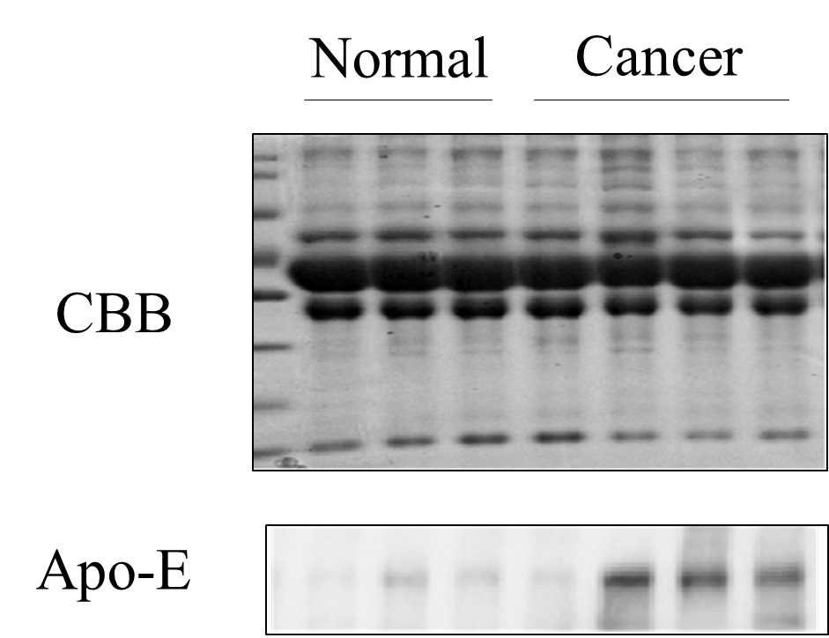
Supplementary Figurer 1. Western blot analysis of Apo-E expression in serum of normal healthy and NPC patients.

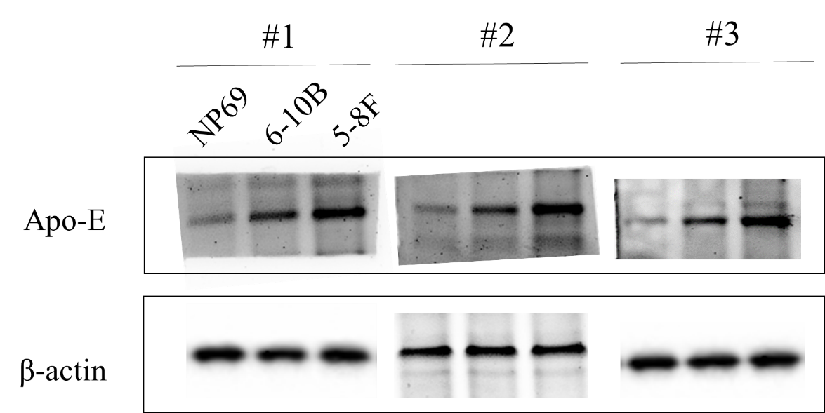
Supplementary Figure 2. Western blot analysis of Apo-E level in NP-69, 6-10B and 5-8F cell lines.

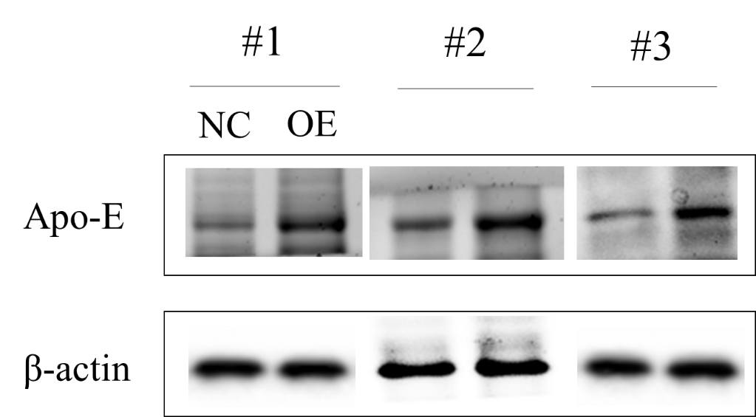
Supplementary Figure 3. Western blot was performed to check the Apo-E knockdown efficiency.

