Supplemental figure 1
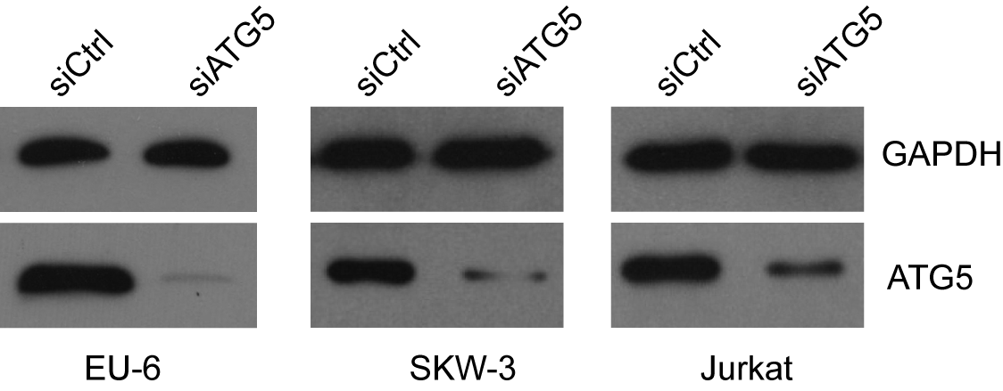

Supplemental figure 2
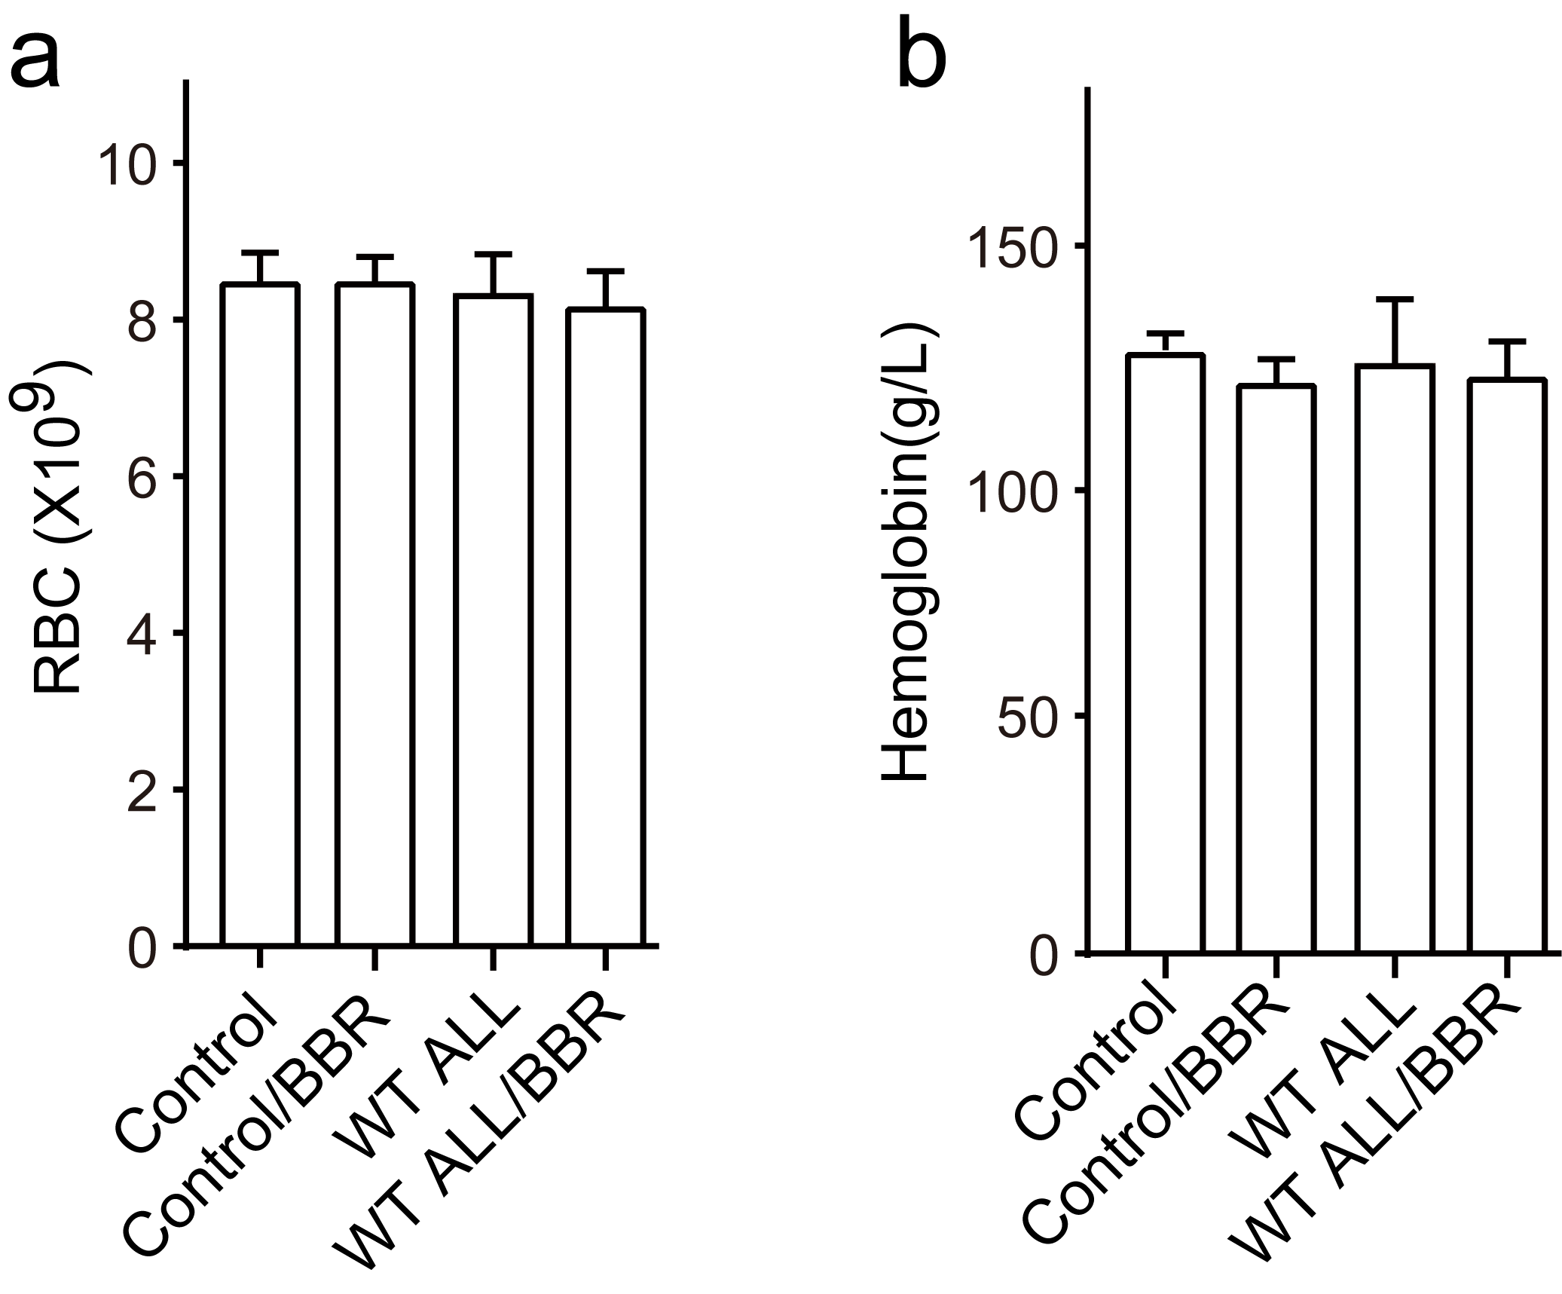

Supplemental figure 3
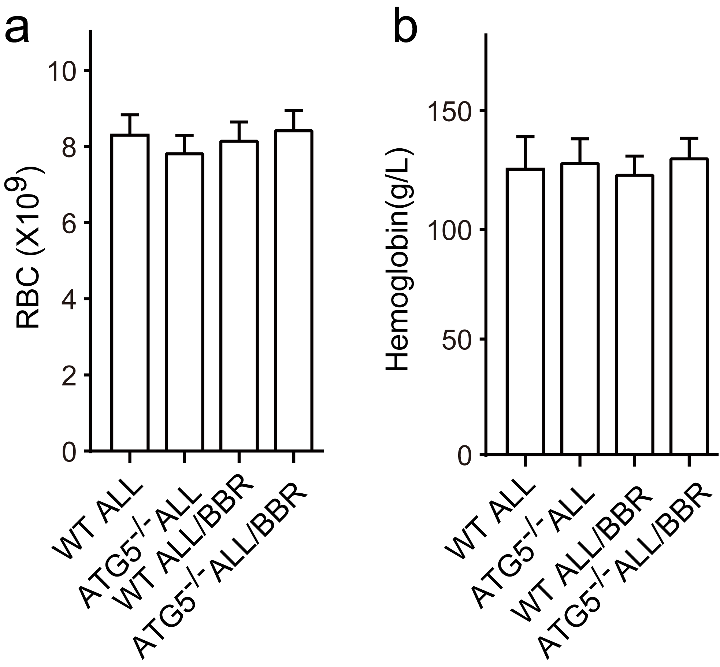

Supplemental table 1
Table 1 Clinical pathologic characteristics of the 26 enrolled ALL patients
Patients demographics | Number of patients
Gender
Male | 17
Female | 9
Splenic enlargement
Yes | 6
No | 20
Hemoglobin (g/L)
<110.0 | 18
>110.0 | 8
WBC Count (10⁹/L)
20-100 | 4
>100 | 22
Platelet count (10⁹/L)
<100 | 17
100-300 | 9
Subtype
T-ALL | 10
B-ALL | 16

Supplemental figure legend
Supplemental figure 1 Effects of ATG5 knockdown in ALL cells. Jurkat, EU-6 or SKW-3 were transfected with siRNA targeting ATG5 or scrambled sequence for 48 hours. And then, the cells were subjected to western blot to analyze the expression of ATG5 in each group cells.

Supplemental figure 2 Effects of BBR on hemoglobin and erythrocyte in ALL xenograft mice. NOD-SCID mice were intravenously injected with 1 x 10⁶ EU-6 cells dissolved in 100 μL PBS to generate ALL xenograft mice. Then the ALL mice and control mice were treated with 10 mg/kg/d BBR or vehicle solution for 2 weeks. (a, b) the hemoglobin and erythrocyte/ red blood cell was detected by an automatic blood cell analyzer in each group. mean±SD, n=3.

Supplemental figure 3 Effects of BBR on hemoglobin and erythrocyte in ATG5 knockout ALL xenograft mice. EU-6 cells were transfected with siRNA targeting ATG5 (ATG5^{-/-}) or scrambled sequence (WT) and then intravenously injected into NOD-SCID mice. The WT and ATG5^{-/-} mice were treated with 10 mg/kg/d BBR or vehicle solution for 2 weeks, respectively. (a, b) the hemoglobin and erythrocyte/ red blood cell was detected by an automatic blood cell analyzer in each group. mean±SD, n=3.

